**Python way**

* Download and install python and pip
  + What is pip?
    - <https://pypi.org/project/pip/>
* Install Robot Framework base and Selenium library on top of it.
  + *pip install robotframework*
  + *pip install robotframework-seleniumlibrary*

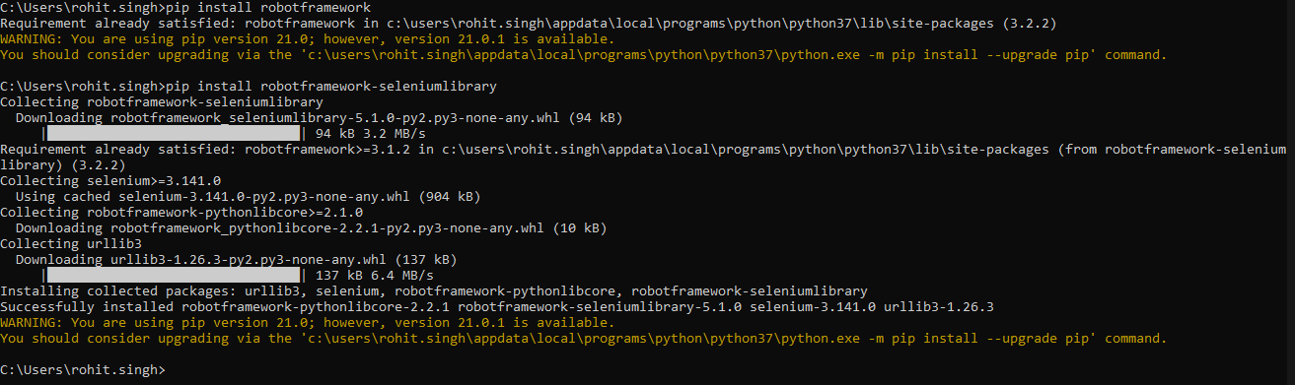

* Install Pycharm
  + <https://www.jetbrains.com/pycharm/>
* Install Intellibot plugin for Pycharm (The one on the marketplace might have issues and might not work as expected)
  + <https://github.com/lte2000/intellibot>
* Setup the Robot options in Pycharm as is convenient for you
  + Settings -> Robotoptions

**Java way**

* Create a Maven project
* Get the Jar from the Maven repo
  + <https://search.maven.org/search?q=a:robotframework>

**Final steps**

* Download and unzip Web drivers.