Computer Vision
Spring 2024
Experiment #1
Image Smoothing with Bilateral Filtering

Write a program (Matlab) to implement Bilateral Filtering, and apply this filter to image noise reduction. The definition of bilateral filter is as below,
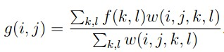
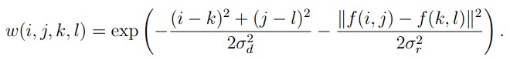

Your program should take an image (fruit.jpg) as input and output the filtered image. Analyze the effect of different parameters σ_{d} and σ_{r} on filtering results. Compare the results of bilateral filter with traditional Gaussian filter.

Submission instructions:
(1) your source code (.m file); (2) a report in a PDF file including all your experimental results and discussion.
Upload a single zip file containing your source code and report to FTP, and the file name should be exp01_name.zip.

Due date: 2024/03/20

