


《社交网络技术与应用》

视觉问答系统

厦门大学
信息学院

目录
目录 1
1 实验介绍 1
实验目的 1
实验清单 2
2 视觉问答 3
2.1实验介绍 3
2.2实验目的 3
2.3实验步骤 3
2.3.1 模型训练 3
2.3.2测试效果 14
实验小结 14
思考题 15

1 实验介绍
本实验重点试验模型训练与推理用于视觉问答下游任务，重点探索如何使用已有数据集训练一个基础模型，并将其集成到网页端系统中进行测试。实验将结合后端模型与网页框架（Django），实现在前端页面中对训练模型的调用与交互。
本章实验将通过使用本地数据集进行模型训练，并使用Django实现推理测试。

实验目的
掌握视觉问答模型的训练与推理

实验清单
实验 | 简述 | 难度 | 软件环境 | 开发环境
视觉问答模型训练 | 通过下载的数据集训练模型 | 初级 | Python3 | 本地PC
视觉问答模型测试 | 在网页端中实现上传图片，并根据图片和提问内容，使用模型回答问题 | 中级 | Python3 | 本地PC

2 视觉问答

2.1实验介绍
本章内容将围绕模型训练与前端应用展开，重点探索如何使用已有数据集训练一个基础模型，并将其集成到网页端系统中进行测试。实验将结合后端模型与网页框架（Django），实现在前端页面中对训练模型的调用与交互。
本章实验将通过使用本地数据集进行模型训练，并使用Django实现推理测试。

2.2实验目的
本章实验将通过使用本地数据集进行模型训练，并使用Django实现推理测试。

2.3实验步骤

2.3.1 模型训练

2.3.1.1数据处理
根据自己配置情况从下载的数据中抽取部分数据：
注意下面代码中的各项文件路径需要根据自己实际情况修改，并且需要安装所需包
代码：
def split_vqa_data(annotations_path, questions_path, test_ratio=0.2, seed=42):
# 加载数据
with open(annotations_path) as f:
annotations = json.load(f)['annotations']
with open(questions_path) as f:
questions = json.load(f)['questions']
# 按image_id分组保证同一图片的所有问答一起划分
img_to_data = defaultdict(list)
for q, a in zip(questions, annotations):
img_to_data[q['image_id']].append((q, a))
# 随机划分
img_ids = list(img_to_data.keys())
random.seed(seed)
test_size = int(len(img_ids) * test_ratio)
test_img_ids = set(random.sample(img_ids, test_size))
# 分离数据
test_questions, test_annotations = [], []
train_questions, train_annotations = [], []
for img_id in img_ids:
for q, a in img_to_data[img_id]:
if img_id in test_img_ids:
test_questions.append(q)
test_annotations.append(a)
else:
train_questions.append(q)
train_annotations.append(a)
return {
'train': {'questions': train_questions, 'annotations': train_annotations},
'test': {'questions': test_questions, 'annotations': test_annotations}
}
result = split_vqa_data(
annotations_path='../v2_mscoco_val2014_annotations.json',
questions_path='../v2_OpenEnded_mscoco_val2014_questions.json',
test_ratio=0.01 # 抽取10%作为测试集
)
# 保存结果
with open('mini_train.json', 'w') as f:
json.dump(result['train'], f)
with open('mini_test.json', 'w') as f:
json.dump(result['test'], f)
# 检查训练集和测试集的图片无重叠
train_images = {q['image_id'] for q in result['train']['questions']}
test_images = {q['image_id'] for q in result['test']['questions']}
assert len(train_images & test_images) == 0

使用抽取的数据训练模型：
import json
import torch
import torch.nn as nn
from torch.utils.data import Dataset, DataLoader
from torchvision import transforms
from torchvision.models import mobilenet_v2
from PIL import Image
from collections import defaultdict
import os
from tqdm import tqdm
# 数据加载
def load_data(split_json):
with open(split_json) as f:
split_data = json.load(f)
return split_data['questions'], split_data['annotations']
# 数据集定义
class VQADataset(Dataset):
def __init__(self, questions, annotations, img_dir, transform=None):
self.questions = questions
self.annotations = annotations
self.img_dir = img_dir
self.transform = transform or transforms.Compose([
transforms.Resize(256),
transforms.CenterCrop(224),
transforms.ToTensor(),
transforms.Normalize(mean=[0.485, 0.456, 0.406],
std=[0.229, 0.224, 0.225])
])
self.word2idx = {'<pad>': 0, '<unk>': 1}
self.ans2idx = {}
self._build_vocab()
def _build_vocab(self):
word_counter = defaultdict(int)
for q in self.questions:
for word in q['question'].lower().split():
word_counter[word] += 1
for word, cnt in word_counter.items():
if cnt >= 3:
self.word2idx[word] = len(self.word2idx)
ans_counter = defaultdict(int)
for ann in self.annotations:
ans = ann['answers'][0]['answer']
ans_counter[ans] += 1
for ans, cnt in ans_counter.items():
if cnt >= 2:
self.ans2idx[ans] = len(self.ans2idx)
def __len__(self):
return len(self.questions)
def __getitem__(self, idx):
img_id = self.questions[idx]['image_id']
img_path = os.path.join(self.img_dir, f"COCO_val2014_{img_id:012d}.jpg")
image = self.transform(Image.open(img_path).convert('RGB'))
words = self.questions[idx]['question'].lower().split()[:10]
word_ids = [self.word2idx.get(w, 1) for w in words]
word_ids += [0] * (10 - len(word_ids))
answer = self.annotations[idx]['answers'][0]['answer']
answer_id = self.ans2idx.get(answer, 0)
return image, torch.tensor(word_ids), torch.tensor(answer_id)
# 模型定义
class TinyVQA(nn.Module):
def __init__(self, vocab_size, ans_size):
super().__init__()
self.cnn = mobilenet_v2(weights="DEFAULT")
for param in self.cnn.parameters():
param.requires_grad = False
self.img_proj = nn.Linear(1000, 128)
self.embed = nn.Embedding(vocab_size, 64)
self.lstm = nn.LSTM(64, 128, batch_first=True)
self.classifier = nn.Sequential(
nn.Linear(256, 128),
nn.ReLU(),
nn.Linear(128, ans_size)
)
def forward(self, img, ques):
img_feat = self.img_proj(self.cnn(img))
txt_feat, _ = self.lstm(self.embed(ques))
combined = torch.cat([img_feat, txt_feat[:, -1, :]], dim=1)
return self.classifier(combined)
# -------------------- 4. 训练 --------------------
def train():
device = torch.device("cpu") # 明确指定为 CPU
train_questions, train_annotations = load_data("../mini_train_new.json")
train_dataset = VQADataset(train_questions, train_annotations, "../val2014_new")
train_loader = DataLoader(train_dataset, batch_size=4, shuffle=True)
model = TinyVQA(
vocab_size=len(train_dataset.word2idx),
ans_size=len(train_dataset.ans2idx)
).to(device)
optimizer = torch.optim.Adam(model.parameters(), lr=1e-3)
criterion = nn.CrossEntropyLoss()
for epoch in range(5):
model.train()
total_loss = 0
# 显示进度条
progress_bar = tqdm(train_loader, desc=f"Epoch {epoch + 1}", ncols=100)
for images, questions, answers in progress_bar:
images, questions, answers = images.to(device), questions.to(device), answers.to(device)
optimizer.zero_grad()
outputs = model(images, questions)
loss = criterion(outputs, answers)
loss.backward()
optimizer.step()
total_loss += loss.item()
# 更新进度条上的显示信息
progress_bar.set_postfix(loss=loss.item())
print(f"Epoch {epoch + 1} | Avg Loss: {total_loss / len(train_loader):.4f}")
torch.save({
'model_state': model.state_dict(),
'word2idx': train_dataset.word2idx,
'ans2idx': train_dataset.ans2idx
}, "tiny_vqa_model.pth")
print("模型已保存为 tiny_vqa_model.pth")
# -------------------- 5. 主程序 --------------------
if __name__ == '__main__':
train()

2.3.1.2 修改网页端
添加上传图片按钮：在html文件中，添加按钮相应事件。
代码：
<form id="wxlform" action="" method="post" class="form-horizontal" role="form">
<input id="submit2index" name="submit2index" type="button" class="form-control btn btn-success" value="新建索引">
<input id="upload_image" name="upload_image" type="button" class="form-control btn btn-primary" value="上传图片">
</form>
<!-- 添加图片上传表单 -->
<form action="" id="upload_image_form" enctype="multipart/form-data" hidden>
{% csrf_token %}
<input type="file" name="imagefile" id="imagefile" accept="image/*" required>
<input id="submit_image" type="submit" value="确认上传">
</form>

在movierecommendation/url.py中定义路由：
#添加路由
url(r'^uploadimage', views.uploadimage, name='uploadImage'),
在doubanrecommendation/url.py中定义路由：
#添加路由
url(r'^uploadimage', views.uploadimage),
添加视觉问答按钮：在html文件中，添加按钮相应事件。
代码：
<button id="vqabtn">视觉问答</button>

在movierecommendation/url.py中定义路由：
#添加路由
url(r'^vqaanswer', views.vqaanswer, name='vqaAnswer'),
在doubanrecommendation/url.py中定义路由：
#添加路由
url(r'^vqaanswer', views.vqaanswer),

2.3.1.3定义页面响应代码
在movierecommendation/views.py中定义相应页面（注意添加相应的包）：
图片上传代码：
# 定义图片上传请求链接
@csrf_exempt
def uploadimage(request):
res = {
'status': 404,
'text': 'Unknown request!',
'image_url': ''
}
if request.method == 'POST':
# 获取上传的图片文件
image_file = request.FILES.get('imagefile')
if not image_file:
res['status'] = 400
res['text'] = '没有选择图片文件'
return HttpResponse(json.dumps(res), content_type='application/json')

# 检查文件类型
allowed_types = ['image/jpeg', 'image/png', 'image/gif']
if image_file.content_type not in allowed_types:
res['status'] = 400
res['text'] = '不支持的图片格式'
return HttpResponse(json.dumps(res), content_type='application/json')

try:
# 创建临时图片目录
temp_filepath = os.path.join(settings.STATIC_ROOT, 'temp_images')
if not os.path.exists(temp_filepath):
os.makedirs(temp_filepath)
else:
# 清理临时目录中的所有文件
for file in os.listdir(temp_filepath):
os.remove(os.path.join(temp_filepath, file))

# 使用固定文件名保存图片
ext = image_file.name.split('.')[-1]
filename = f'current_image.{ext}'
file_path = os.path.join(temp_filepath, filename)

# 保存图片文件
with open(file_path, 'wb+') as f:
for chunk in image_file.chunks():
f.write(chunk)

# 返回图片URL路径
image_url = os.path.join(settings.STATIC_URL, 'temp_images', filename)
res = {
'status': 200,
'text': '图片上传成功',
'image_url': image_url
}
except Exception as e:
res = {
'status': 500,
'text': f'图片上传失败：{str(e)}',
'image_url': ''
}

return HttpResponse(json.dumps(res), content_type='application/json')
)
模型处理代码：
# 定义模型架构
class TinyVQA(nn.Module):
def __init__(self, vocab_size, ans_size):
super().__init__()
self.cnn = mobilenet_v2(weights="DEFAULT")
for param in self.cnn.parameters():
param.requires_grad = False
self.img_proj = nn.Linear(1000, 128)

self.embed = nn.Embedding(vocab_size, 64)
self.lstm = nn.LSTM(64, 128, batch_first=True)

self.classifier = nn.Sequential(
nn.Linear(256, 128),
nn.ReLU(),
nn.Linear(128, ans_size)
)

def forward(self, img, ques):
img_feat = self.img_proj(self.cnn(img))
txt_feat, _ = self.lstm(self.embed(ques))
combined = torch.cat([img_feat, txt_feat[:, -1, :]], dim=1)
return self.classifier(combined)

# 加载模型（在全局范围内只加载一次）
checkpoint = torch.load('../tiny_vqa_model.pth')
model = TinyVQA(vocab_size=len(checkpoint['word2idx']), ans_size=len(checkpoint['ans2idx']))
model.load_state_dict(checkpoint['model_state'])
model.eval()

# 获取词汇表和答案映射
word2idx = checkpoint['word2idx']
ans2idx = checkpoint['ans2idx']
idx2ans = {v: k for k, v in ans2idx.items()}

# 图像转换
transform = transforms.Compose([
transforms.Resize(256),
transforms.CenterCrop(224),
transforms.ToTensor(),
transforms.Normalize(mean=[0.485, 0.456, 0.406], std=[0.229, 0.224, 0.225])
])

@csrf_exempt
def vqaanswer(request):
res = {
'status': 404,
'text': 'Unknown request!',
'answer': '无法回答该问题'
}

if request.method == 'GET':
name = request.GET['id']
if name == 'vqabtn':
try:
# 获取问题文本
question = request.GET['text']
if not question:
res['status'] = 400
res['text'] = '问题不能为空！'
return HttpResponse(json.dumps(res), content_type='application/json')

# 获取当前上传的图片路径
image_path = os.path.join(settings.STATIC_ROOT, 'temp_images', 'current_image.jpg')
if not os.path.exists(image_path):
res['status'] = 400
res['text'] = '请先上传图片！'
return HttpResponse(json.dumps(res), content_type='application/json')

# 处理图片
image = transform(Image.open(image_path).convert('RGB')).unsqueeze(0)

# 处理问题文本
words = question.lower().split()[:10]
word_ids = [word2idx.get(w, 1) for w in words]
word_ids += [0] * (10 - len(word_ids)) # 补齐到10个词
question_tensor = torch.tensor(word_ids).unsqueeze(0)

# 预测
with torch.no_grad():
output = model(image, question_tensor)
_, predicted_idx = torch.max(output, dim=1)

# 获取预测答案
predicted_answer = idx2ans[predicted_idx.item()]

res = {
'status': 200,
'text': '预测成功',
'answer': predicted_answer
}

except Exception as e:
res = {
'status': 500,
'text': f'预测失败：{str(e)}',
'answer': '预测出错'
}

return HttpResponse(json.dumps(res), content_type='application/json')
修改js文件：
代码：
// 点击上传图片按钮，触发文件选择
$("#upload_image").on("click", function () {
$("#imagefile").click();
})

// 监听图片文件选择变化
$("#imagefile").on("change", function () {
var files = $(this)[0].files;
if (files.length === 0) {
alert("你没有选择文件");
} else {
var formData = new FormData($("#upload_image_form")[0]);
$.ajax({
url: "/uploadimage",
type: 'POST',
data: formData,
dataType: "JSON",
contentType: false,
processData: false,
cache: false,
beforeSend: function() {
$("#upload_image").attr("disabled", "disabled");
},
complete: function () {
$("#upload_image").removeAttr("disabled");
},
success: function(result){
if(result.status == 200){
$("#imagefile").val("");
alert("图片上传成功！");

// 将上传的图片显示在聊天窗口中
var image_html = '<div class="item item-left">'
+ '<div class="avatar avatar-bot"></div>'
+ '<div class="bubble bubble-left">图片上传成功！</div>'
+ '<img src="' + result.image_url + '" style="max-width: 200px; margin: 10px;">'
+ '</div>';
$('.content').append(image_html);

// 滚动条置底
var height = $('.content').scrollTop();
$(".content").scrollTop(height);
} else {
alert("上传失败：" + result.message);
}
},
error: function (jqXHR, textStatus, e) {
alert("提交异常：" + e);
}
});
}
})

$("#vqabtn").on("click", function () {
console.log("vqabtn clicked")
var searchtext = $.trim($('#chattextarea').val());
if (searchtext == "") {
alert("请输入您的问题");
return;
}

// 将问题添加到聊天窗口的末尾
var question_html = '<div class="item item-right">'
+ '<div class="bubble bubble-right">' + searchtext + '</div>'
+ '<div class="avatar avatar-user"></div>'
+ '</div>';
$('.content').append(question_html);
// 清空问题文本框
$('#chattextarea').val('');
$('#chattextarea').focus();
// 滚动条置底
var height = $('.content').scrollTop();
$(".content").scrollTop(height);

$.ajax({
type: "get",
url: "/vqaanswer",
data: {
"id": $("#vqabtn").attr("id"),
"text": searchtext
},
dataType: "json",
beforeSend: function() {
$("#vqabtn").attr("disabled", "disabled");
},
complete: function () {
$("#vqabtn").removeAttr("disabled");
},
success: function(result){
if(result.status == 200){
var answer_html = '<div class="item item-left">'
+ '<div class="avatar avatar-bot"></div>'
+ '<div class="bubble bubble-left">' + result.answer + '</div>'
+ '</div>';
$('.content').append(answer_html);

// 滚动条置底
var height = $('.content').scrollTop();
$(".content").scrollTop(height);
} else {
var answer_html = '<div class="item item-left">'
+ '<div class="avatar avatar-bot"></div>'
+ '<div class="bubble bubble-left">对不起，我无法回答这个问题。请确保已上传图片。</div>'
+ '</div>';
$('.content').append(answer_html);
}
},
error: function (jqXHR, textStatus, e) {
alert("提交异常："+e);
}
});
})

2.3.2测试效果
命令行环境中，在工程目录下键入“python manage.py runserver”启动服务器，效果如下所示：
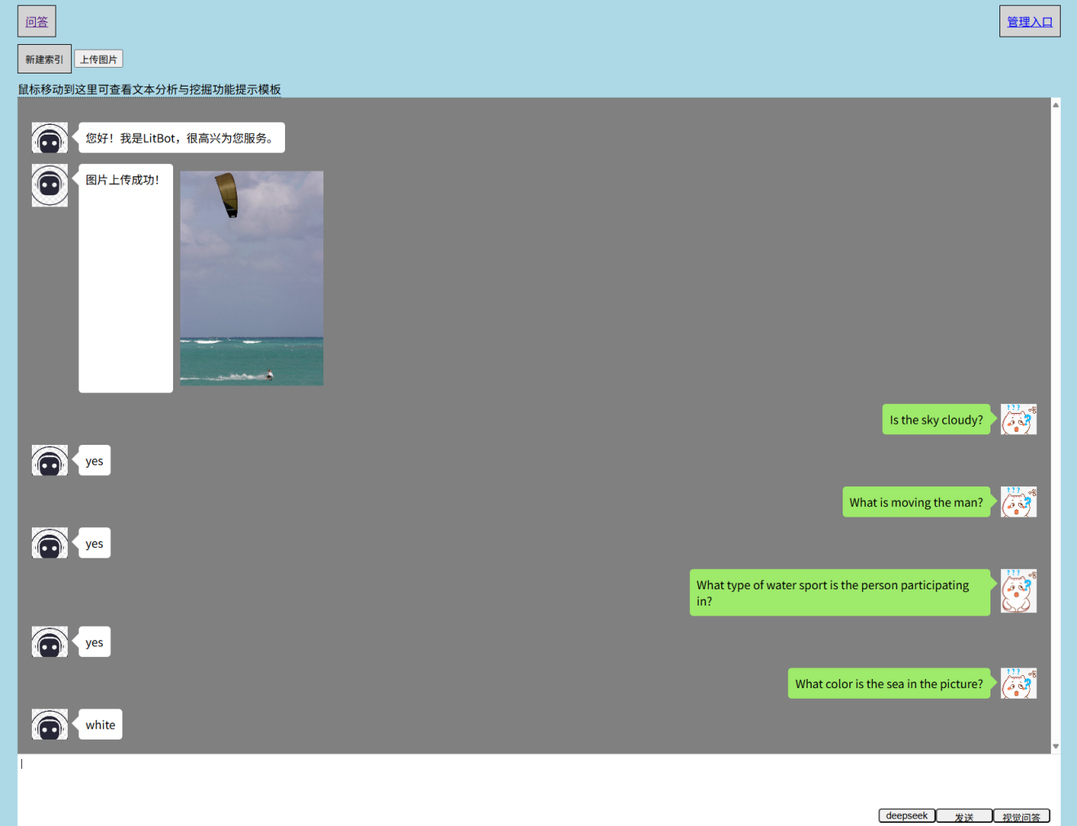

实验小结
本实验我们使用下载的数据集对一个简单模型进行了训练，并使用训练的模型在网页端中进行了测试。

思考题
接下来，请大家根据上面的学习内容，训练模型，并进行测试，完成实验七的相关实验内容。

