修改模板 questionAnswering.html

在导航栏按钮列表 <ul class="nav-menu">…</ul> 末尾（“管理入口”之前）复制粘贴：
<li class="nav-item" id="uploadDatasetNav"><i class="fas fa-file-archive"></i> 上传数据</li>
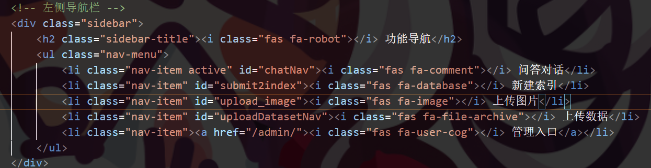

在 </body> 前（隐藏表单区）复制粘贴：
<form id="uploadZipForm" enctype="multipart/form-data" hidden>
{% csrf_token %}
<input type="file" name="file" id="datasetFile" accept=".zip">
</form>
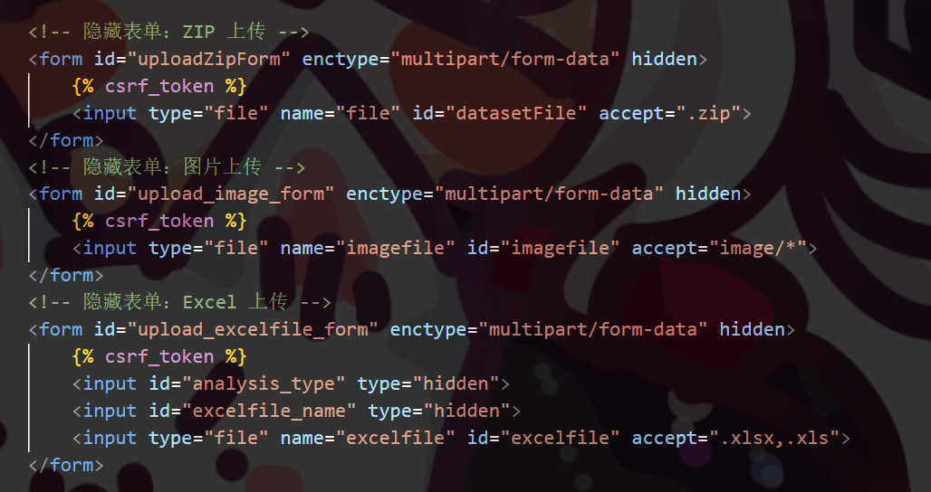

修改脚本 static/js/WXLsearch.js

在文件开头的 $(function(){ … }) 内部，找到现有按钮事件绑定，紧接其后复制粘贴
// —— 上传 ZIP —— //
$("#uploadDatasetNav").click(()=>{
$("#datasetFile").click();
});
$("#datasetFile").change(function(){
const file = this.files[0];
if (!file) return;
const fd = new FormData();
fd.append("file", file);
fd.append("csrfmiddlewaretoken",
$("#uploadZipForm input[name=csrfmiddlewaretoken]").val()
);

$.ajax({
url: "/upload_dataset/",
type: "POST",
data: fd,
processData: false,
contentType: false,
success(res){
appendUserBubble(`已上传数据包：${file.name}`);
appendBotBubble(res.msg || "上传并解压成功！请输入“文本聚类”开始。");
$("#datasetFile").val("");
},
error(){
appendBotBubble("上传失败，请重试。");
$("#datasetFile").val("");
}
});
});

// —— 聊天/命令入口 —— //
$("#chatbotsendbtn").click(()=>{
const text = $("#chattextarea").val().trim();
if (!text) return;
$("#chattextarea").val("");
appendUserBubble(text);

// 1) 如果正在等下载确认
if (waitingDownload) {
waitingDownload = false;
if (text === "是") {
appendBotBubble("正在下载…");
window.location.href = "/download_results/";
} else {
appendBotBubble("已取消下载。");
}
return;
}

// 2) 用户发“文本聚类”时，先提示下一步命令
if (text === "文本聚类") {
appendBotBubble('请发送“聚类”命令');
return;
}

// 3) 用户发“聚类”时，真正触发聚类
if (text === "聚类") {
showLoading("cluster");
$.ajax({
url: "/cluster_text/",
type: "GET",
data: { text }, // 注意一定要把 text 参数传给后端
dataType: "json",
success(res){
removeLoading("cluster");
if (res.status === 200) {
appendBotBubble("聚类完成，结果预览：");
appendBotBubble(`<img src="${res.tsne_url}" style="max-width:100%;">`);
res.wc_urls.forEach(u=>{
appendBotBubble(`<img src="${u}" style="max-width:100%;">`);
});
appendBotBubble('是否下载结果文件？（是/否）');
waitingDownload = true;
} else {
appendBotBubble(res.msg || "聚类失败，请重试。");
}
},
error(){
removeLoading("cluster");
appendBotBubble("聚类请求出错，请检查服务器。");
}
});
return;
}

// 4) 用户直接发“下载”也可触发下载
if (text.includes("下载")) {
appendBotBubble("正在下载…");
window.location.href = "/download_results/";
return;
}

// 5) 其它走已有的检索接口
showLoading("chat");
$.ajax({
url: "/searchanswer/",
type: "GET",
data: { id: "chatbotsendbtn", text },
dataType: "json",
success(res){
removeLoading("chat");
const reply = res.answer_exact || res.answer_app || res.text;
appendBotBubble(reply);
},
error(){
removeLoading("chat");
appendBotBubble("检索服务出错，请稍后重试。");
}
});
});

注册路由

根目录的urls.py
url(r'^upload_dataset/$', views.dataset_upload),
url(r'^cluster_text/$', views.cluster_text),
url(r'^download_results/$', views.download_results),
# 静态文件 & 媒体文件
urlpatterns += staticfiles_urlpatterns()
urlpatterns += static(settings.MEDIA_URL, document_root=settings.MEDIA_ROOT)

app/urls.py
# 1. 上传数据集 ZIP 并解压
url(r'^upload_dataset/$', views.dataset_upload, name='upload_dataset'),

# 2. 文本聚类（t-SNE + 词云）
url(r'^cluster_text/$', views.cluster_text, name='cluster_text'),

# 3. 下载聚类可视化结果
url(r'^download_results/$', views.download_results, name='download_results'),

功能实现

上传文件
在app的目录中新建forms.py
# movierecommendation/forms.py

from django import forms
from django.core.exceptions import ValidationError
from .models import DataSet

MAX_UPLOAD_SIZE = 1024 * 1024 * 1024 # 1 GB

class DataSetUploadForm(forms.ModelForm):
class Meta:
model = DataSet
fields = ['file']

def clean_file(self):
f = self.cleaned_data['file']
# 后缀检查
if not f.name.lower().endswith('.zip'):
raise ValidationError("只支持 .zip 格式的压缩包")
# 大小检查
if f.size > MAX_UPLOAD_SIZE:
raise ValidationError("文件大小不能超过 1 GB")
return f
views.py中
def extract_zip_gbk_or_utf8(zip_path, extract_dir):
"""
对于文件名可能是 GBK 编码也可能是 UTF-8 编码的 ZIP，做兼容解压。
"""
with zipfile.ZipFile(zip_path, 'r') as zf:
for info in zf.infolist():
raw_name = info.filename

# 1) 如果 ZIP 标记了 UTF-8，就直接用它
if info.flag_bits & 0x800:
filename = raw_name
else:
# 2) CP437 -> UTF-8
try:
filename = raw_name.encode('cp437').decode('utf-8')
except Exception:
# 3) CP437 -> GBK
try:
filename = raw_name.encode('cp437').decode('gbk')
except Exception:
# 4) 都不行就保留原始
filename = raw_name

target_path = os.path.join(extract_dir, filename)

if info.is_dir():
os.makedirs(target_path, exist_ok=True)
else:
os.makedirs(os.path.dirname(target_path), exist_ok=True)
with zf.open(info) as src, open(target_path, 'wb') as dst:
dst.write(src.read())
@csrf_exempt
def dataset_upload(request):
if request.method != 'POST':
return JsonResponse({'status':405,'msg':'仅支持 POST'},status=405)

form = DataSetUploadForm(request.POST, request.FILES)
if not form.is_valid():
return JsonResponse({'status':400,'msg':'上传失败，请检查文件格式'})

with transaction.atomic():
# 1) 删除旧的记录及文件
for old in DataSet.objects.all():
old.file.delete(save=False)
shutil.rmtree(
os.path.join(settings.MEDIA_ROOT, 'extracted', str(old.id)),
ignore_errors=True
)
old.delete()

# 2) 保存新上传并解压
ds = form.save()
extract_dir = os.path.join(settings.MEDIA_ROOT, 'extracted', str(ds.id))
os.makedirs(extract_dir, exist_ok=True)
extract_zip_gbk_or_utf8(ds.file.path, extract_dir)

return JsonResponse({'status':200,'msg':'上传并解压成功'})

文本聚类
Views.py中添加
@csrf_exempt
def cluster_text(request):
"""
文本聚类：接收 text='聚类' →
中文分词 TF–IDF → TruncatedSVD → MiniBatchKMeans 聚类 →
TSNE 可视化 → 分类词云 → 返回 tsne_url 和 wc_urls
"""
# 1. 接收命令
cmd = (request.POST.get('text') or request.GET.get('text') or '').strip()
if '聚类' not in cmd:
return JsonResponse({'status': 400, 'msg': '请发送“聚类”命令'},
json_dumps_params={'ensure_ascii': False})

# 2. 获取最新数据集
try:
ds = DataSet.objects.latest('id')
except DataSet.DoesNotExist:
return JsonResponse({'status': 404, 'msg': '未找到已上传数据集'},
json_dumps_params={'ensure_ascii': False})

extract_dir = os.path.join(settings.MEDIA_ROOT, 'extracted', str(ds.id))
if not os.path.isdir(extract_dir):
return JsonResponse({'status': 404, 'msg': '解压目录不存在，请先上传并解压'},
json_dumps_params={'ensure_ascii': False})

# 3. 读取文本
docs = []
for root, _, files in os.walk(extract_dir):
for fn in files:
path = os.path.join(root, fn)
if fn.lower().endswith('.txt'):
with open(path, 'r', encoding='utf-8', errors='ignore') as f:
docs += [ln.strip() for ln in f if ln.strip()]
elif fn.lower().endswith('.csv'):
df = None
for enc in ('utf-8', 'gb18030', 'latin1'):
try:
df = pd.read_csv(path, encoding=enc)
break
except:
continue
if df is None:
continue
if 'question' in df.columns and 'answer' in df.columns:
docs += df['question'].dropna().astype(str).tolist()
docs += df['answer'].dropna().astype(str).tolist()
else:
for col in df.columns:
docs += df[col].dropna().astype(str).tolist()
if not docs:
return JsonResponse({'status': 204, 'msg': '未找到任何文本数据'},
json_dumps_params={'ensure_ascii': False})

# 4. TF–IDF + TruncatedSVD
vec = TfidfVectorizer(tokenizer=jieba.lcut, token_pattern=None)
X = vec.fit_transform(docs)
n_comp = max(1, min(50, X.shape[1] - 1))
X_svd = TruncatedSVD(n_components=n_comp, random_state=42).fit_transform(X)

# 5. MiniBatchKMeans 聚类
n_clusters = 3 if len(docs) >= 3 else 1
mbk = MiniBatchKMeans(
n_clusters=n_clusters,
batch_size=1000,
random_state=42,
max_iter=100,
reassignment_ratio=0.1
)
labels = mbk.fit_predict(X_svd)

# 6. TSNE 可视化
perp = min(30, len(docs) - 1)
tsne_xy = TSNE(n_components=2, perplexity=perp, random_state=42)\
.fit_transform(X_svd)

# 7. 输出目录
vis_dir = os.path.join(settings.MEDIA_ROOT, 'visuals', str(ds.id))
shutil.rmtree(vis_dir, ignore_errors=True)
os.makedirs(vis_dir, exist_ok=True)

# 8. 保存 TSNE 图
tsne_path = os.path.join(vis_dir, f'tsne_{ds.id}.png')
plt.figure(figsize=(6, 6))
for c in range(n_clusters):
pts = tsne_xy[labels == c]
plt.scatter(pts[:, 0], pts[:, 1], label=f'Cluster {c}')
plt.legend()
plt.tight_layout()
plt.savefig(tsne_path)
plt.close()

# 9. 词云字体路径自动检测
if os.name == 'nt':
# Windows 默认黑体字体
font_path = r'C:\Windows\Fonts\simhei.ttf'
else:
# Linux/部署环境请放置 SimHei.ttf 到 static/fonts
font_path = os.path.join(settings.STATIC_ROOT, 'fonts', 'SimHei.ttf')
if not os.path.isfile(font_path):
font_path = None # 找不到字体时使用默认

# 10. 生成词云
wc_urls = []
for c in range(n_clusters):
segment_text = " ".join([docs[i] for i, lab in enumerate(labels) if lab == c])
wc = WordCloud(
font_path=font_path,
width=400, height=200
).generate(segment_text)
wc_path = os.path.join(vis_dir, f'wc_{ds.id}_{c}.png')
wc.to_file(wc_path)
wc_urls.append(settings.MEDIA_URL + f'visuals/{ds.id}/' + os.path.basename(wc_path))

# 11. 返回结果
return JsonResponse({
'status': 200,
'tsne_url': settings.MEDIA_URL + f'visuals/{ds.id}/' + os.path.basename(tsne_path),
'wc_urls': wc_urls
}, json_dumps_params={'ensure_ascii': False})

下载功能
Views.py文件中添加：
@csrf_exempt
def download_results(request):
"""
打包 media/visuals/<ds.id>/ 下最新数据集的所有可视化，返回 ZIP 下载。
"""
# 1. 获取最新数据集
try:
ds = DataSet.objects.latest('id')
except DataSet.DoesNotExist:
return HttpResponse('No dataset found', status=404)

# 2. 定位到该数据集的 visuals 子目录
vis_ds_dir = os.path.join(settings.MEDIA_ROOT, 'visuals', str(ds.id))
if not os.path.isdir(vis_ds_dir):
return HttpResponse('Visualization directory not found', status=404)

# 3. 确保 results 目录存在
zip_dir = os.path.join(settings.MEDIA_ROOT, 'results')
os.makedirs(zip_dir, exist_ok=True)

# 4. 生成 ZIP 路径
zip_path = os.path.join(zip_dir, f'results_{ds.id}.zip')

# 5. 打包 tsne_ 和 wc_ 开头的所有文件
# 使用 ZIP_DEFLATED 压缩，提高兼容性
with zipfile.ZipFile(zip_path, 'w', zipfile.ZIP_DEFLATED) as zf:
for fn in os.listdir(vis_ds_dir):
if fn.startswith(f'tsne_{ds.id}') or fn.startswith(f'wc_{ds.id}'):
abs_path = os.path.join(vis_ds_dir, fn)
# arcname 只保留文件名，不带目录
zf.write(abs_path, arcname=fn)

# 6. 返回 FileResponse 供前端下载
return FileResponse(
open(zip_path, 'rb'),
as_attachment=True,
filename=os.path.basename(zip_path)
)

Views.py中加载的所有库
# === 标准库 (Standard Library) ===
import json
import logging
import os
import re
import shutil
import time
import zipfile
from collections import defaultdict

# === 第三方库 (Third-Party Libraries) ===
import jieba
import pandas as pd
import torch
import matplotlib
matplotlib.use('Agg')
import matplotlib.pyplot as plt
from fuzzywuzzy import fuzz, process
from openai import APIError, OpenAI
from sklearn.cluster import MiniBatchKMeans
from sklearn.decomposition import TruncatedSVD
from sklearn.feature_extraction.text import TfidfVectorizer
from sklearn.manifold import TSNE
from torch_kmeans import KMeans
from wordcloud import WordCloud

# === Django 相关 (Django Imports) ===
from django.conf import settings
from django.core.exceptions import ObjectDoesNotExist
from django.core.paginator import EmptyPage, PageNotAnInteger, Paginator, Page
from django.db import transaction
from django.http import FileResponse, HttpResponse, JsonResponse
from django.shortcuts import render
from django.views.decorators.csrf import csrf_exempt

# === 本地模块 (Local Modules) ===
from movierecommendation.models import (
DataSet,
DoubanMovie,
QuestionAmswerKB,
QuestionIndex,
)
from .forms import DataSetUploadForm

