Computer Vision
Spring 2025
Experiment #3
Blob Detection

Write a program to implement blob detection based on Laplacian of Gaussian (LoG) filter.
Algorithm outline:
- Generate a Laplacian of Gaussian filter.
- Build a Laplacian scale space, starting with some initial scale and going for n iterations:
(1) Filter image with scale-normalized Laplacian at current scale.
(2) Save square of Laplacian response for current level of scale space.
(3) Increase scale by a factor k.
- Perform nonmaximum suppression in scale space.
- Display resulting circles at their characteristic scales.

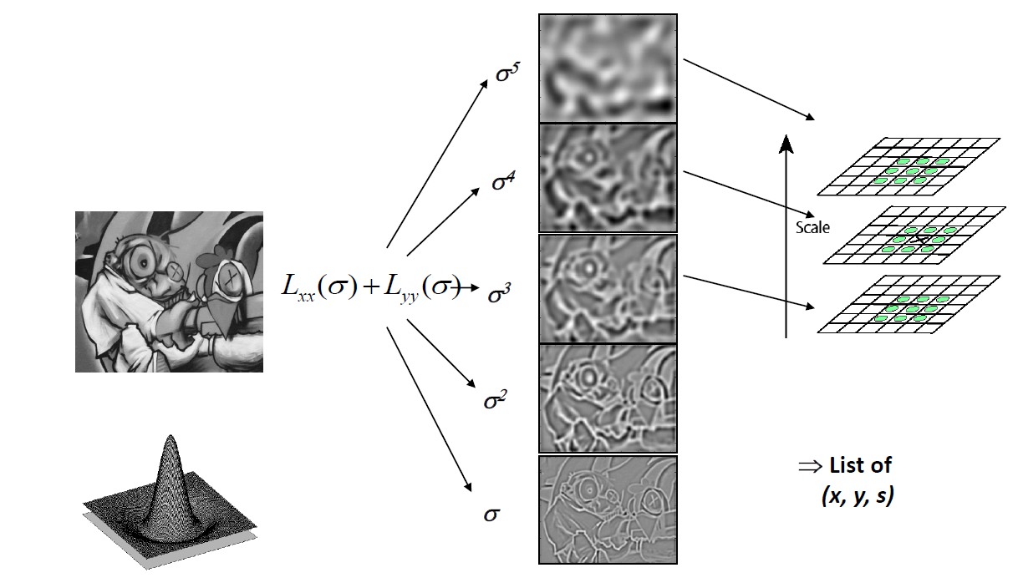

Submission instructions:
(1) your source code (.m file); (2) a report in a PDF file including input images (“butterfly.jpg”, “sunflowers.jpg”) and corresponding output images with detected circles, followed by discussions.
Upload a single zip file containing your source code and report to FTP, and the file name should be exp03_name.zip.

Due date: 2025/04/08

