Computer Vision

Spring 2025

**Experiment #3**

**Blob Detection**

Question: Write a program to implement blob detection based on Laplacian of Gaussian (LoG) filter.

**Algorithm outline:**

1. Generate a Laplacian of Gaussian filter.
2. Build a Laplacian scale space, starting with some initial scale and going for n iterations:

(1) Filter image with scale-normalized Laplacian at current scale.

(2) Save square of Laplacian response for current level of scale space.

(3) Increase scale by a factor k.

1. Perform nonmaximum suppression in scale space.
2. Display resulting circles at their characteristic scales.

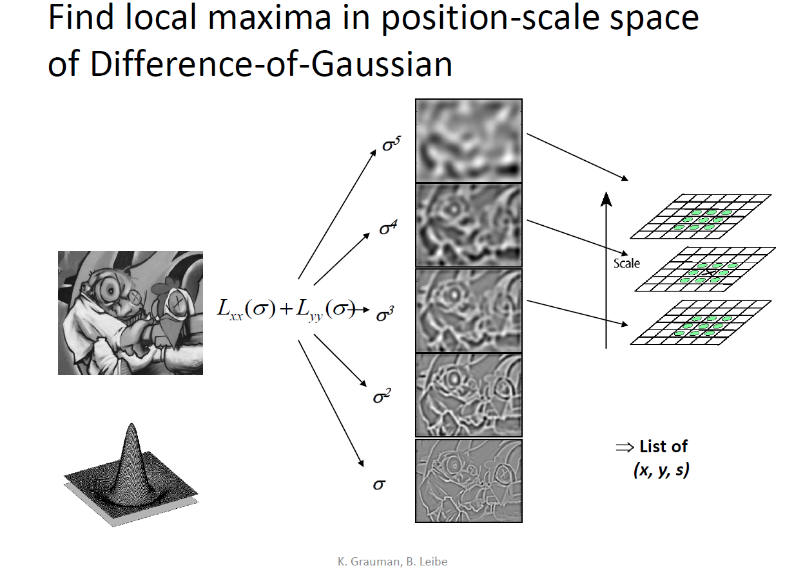

**Result**:

Original Image: (“Butterfly.jpg”)

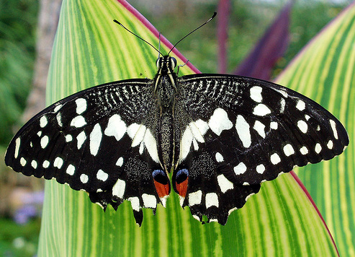

Detected Blobs: (“Butterfly.jpg”)

Sigma = 1:20 threshold = 0.2

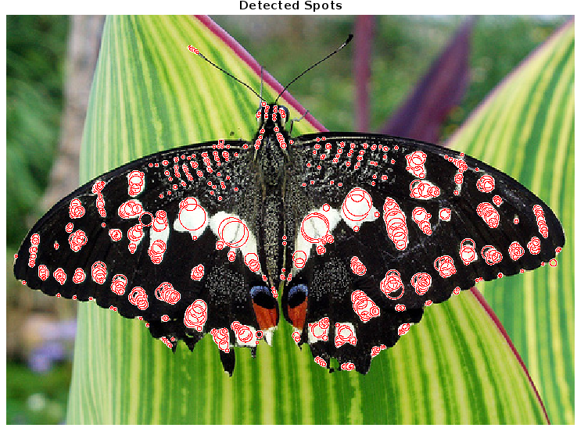

Original Image: (“sunflowers.jpg”)

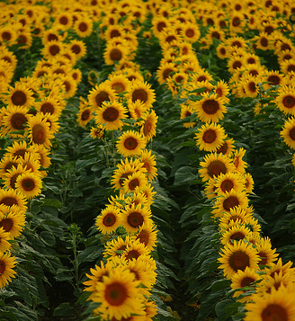

Detected Blobs: (“sunflowers.jpg”)

Sigma = 3:8 threshold = 0.15

