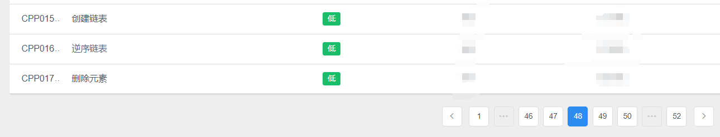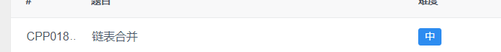

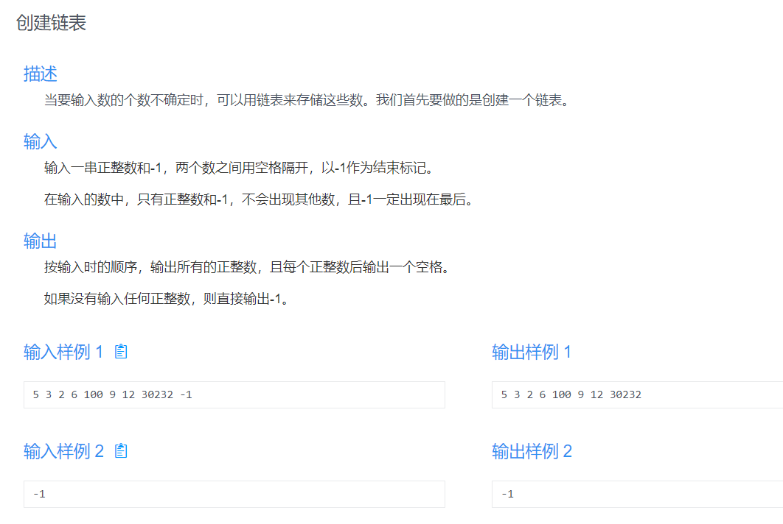

提示

单测试用例，不用处理多组数据输入。

本题为程序填空题，代码如下。

#include<iostream>

using namespace std;

struct node

{

int val;

node\* next;

};

node\* createList()

{

//请你将这个函数补充完整

}

int main()

{

node\* head = NULL;

head = createList();

if (head == NULL)

{

cout << "-1 ";

}

else

{

node\* p = head;

while (p != NULL)

{

cout << p->val << " ";

p = p->next;

}

}

return 0;

}

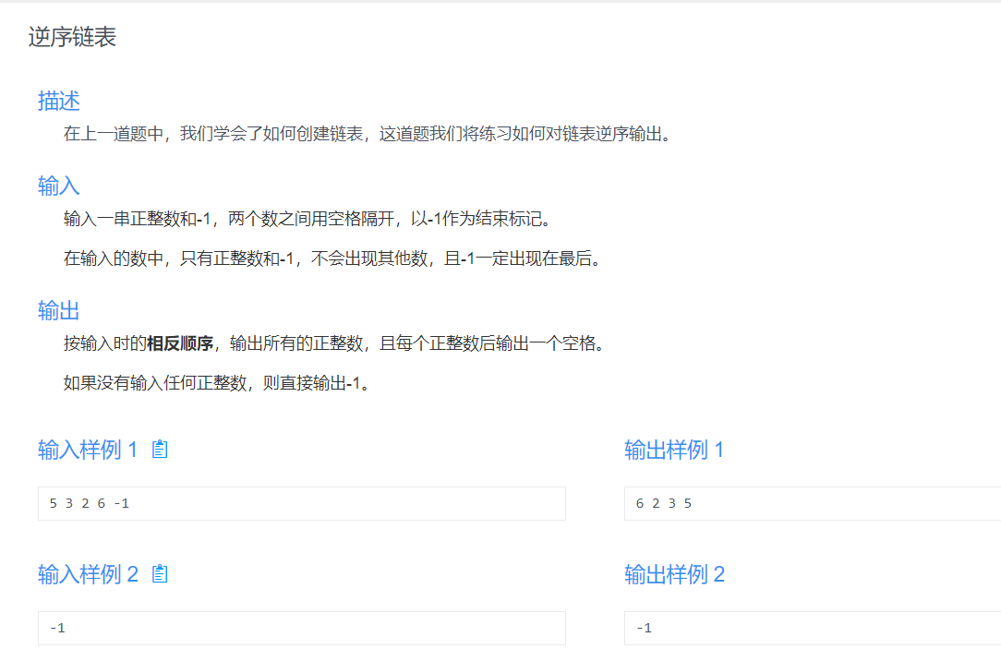

提示

本题为程序填空题，代码如下。

#include<iostream>

using namespace std;

struct node

{

int val;

node\* next;

};

node\* createList()

{//请你将这个函数补充完整

}

node\* reverseList(node\* head)

{//请你将这个函数补充完整

}

int main()

{

node\* head = NULL;

head = createList();

node\* head1 = NULL;

head1 = reverseList(head);

if (head1 == NULL)

{

cout << "-1 ";

}

else

{

node\* p = head1;

while (p != NULL)

{

cout << p->val << " ";

p = p->next;

}

}

return 0;

}

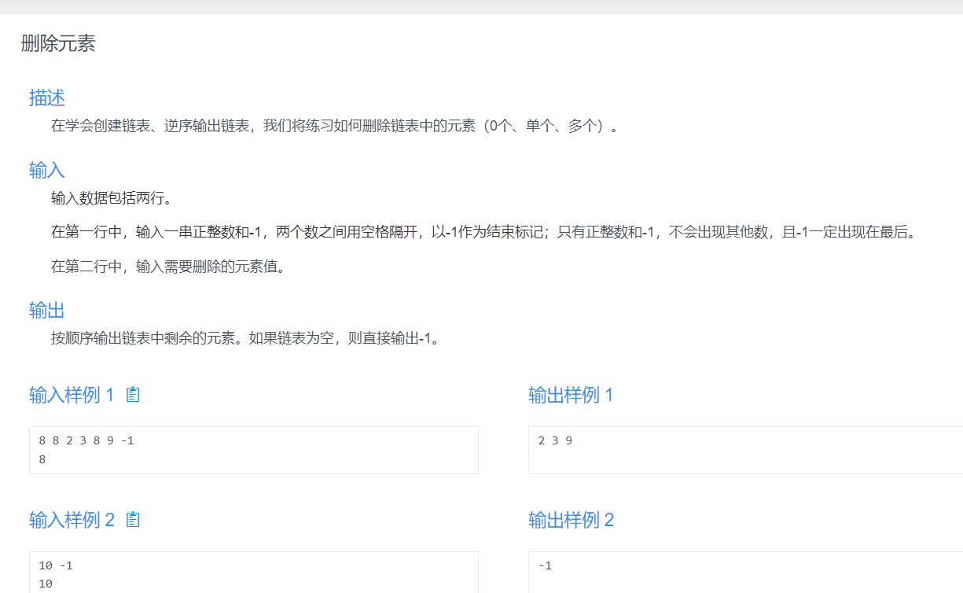

提示

本题为程序填空题，代码如下。

#include<iostream>

using namespace std;

struct node

{

int val;

node\* next;

};

node\* createList()

{ // 请将这函数补充完整

}

node\* deleteElements(node\* head, int v)

{ // 请将这函数补充完整

}

int main()

{

node\* head = NULL;

head = createList();

int v;

cin >> v

head = deleteElements(head, v);

if (head == NULL)

{

cout << "-1 ";

}

else

{

node\* p = head;

while (p != NULL)

{

cout << p->val << " ";

p = p->next;

}

}

return 0;

}

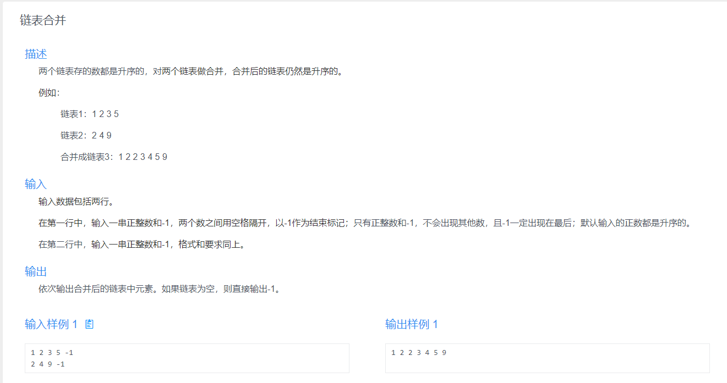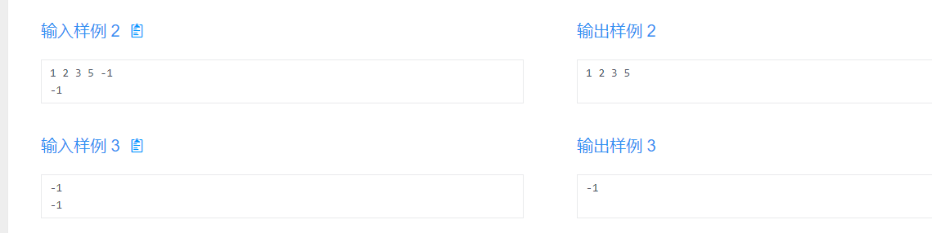

提示

本题为程序填空题，代码如下。

#include <iostream>

using namespace std;

struct node

{

int val;

node\* next;

};

node\* createList()

{//将这个函数补充完整

}

node\* merge(node\* head1, node\* head2)

{//将这个函数补充完整

}

int main()

{

node \*head1, \*head2, \*head3;

head1 = createList();

head2 = createList();

head3 = merge(head1, head2);

if (head3 == NULL)

{

cout << "-1 ";

}

else

{

node\* p = head3;

while (p != NULL)

{

cout << p->val << " ";

p = p->next;

}

}

return 0;

}