Workshop Purchase Requisition
& Approval System
Solution Report
A Power Platform model-driven data model, Dataverse-triggered approval flow, and a purpose-built Power Apps Code App
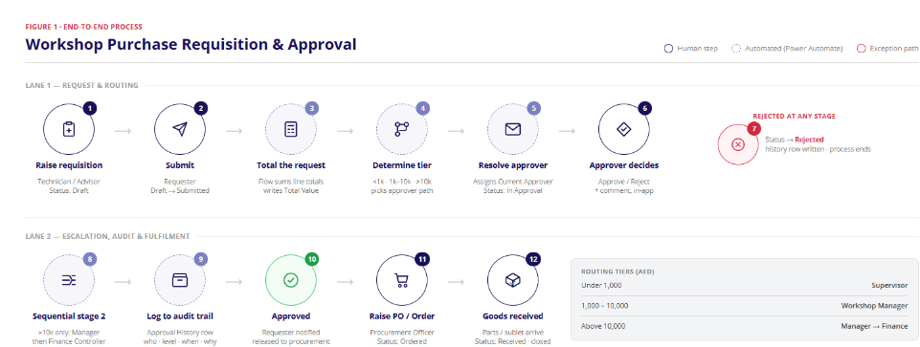
Environment: my_dev
Solution: Workshop Requisition & Approval
Prepared: 29 August 2026

1. Executive Summary
The Workshop Purchase Requisition & Approval System digitizes how an automotive service department raises, routes, approves, and fulfils purchase requests for parts, tools, sublet work, and consumables. It replaces an informal, email/paper-driven process with a governed Dataverse data model, an automated tiered-approval flow, and a purpose-built web application (a Power Apps Code App) that gives requesters, approvers, and procurement staff a single, real-time system of record.
The solution is built entirely on Microsoft Power Platform inside the "Workshop Requisition & Approval" Dataverse solution: six tables, one Dataverse-triggered cloud flow, and one React-based code app, all packaged together in the my_dev environment. A parallel model-driven app was used during initial delivery for back-office administration and has since been retired now that the code app covers every requester, approver, and procurement workflow end to end.
Every screenshot and number in this report — the AED 14,380 example requisition, its risk score of 74, its routing to Manager then Finance, its two-decision approval history — is a real, live output of the running system, not a mock-up.

2. The Business Problem This Solves
Before this system, workshop purchase requests were typically raised informally — a verbal request, a WhatsApp message, or a paper job card note — with approval happening ad hoc over email or in person. This created several concrete, costly problems:
- No consistent audit trail. There was no single, queryable record of who requested what, who approved it, when, and why — a problem for internal audit, warranty disputes, and finance reconciliation.
- Approval routing was inconsistent. Low-value parts purchases and high-value sublet jobs went through the same informal channel, so small purchases were sometimes over-escalated while large purchases occasionally slipped through without the right sign-off.
- No visibility into duplicate spend. Two technicians could independently request the same part for the same job card without either knowing, since there was no shared, searchable record of in-flight requests.
- No budget accountability. Cost centres (Mechanical Workshop, Body Shop, Parts & Accessories, Detailing & Valet, Warranty & Recalls) had no live view of committed spend against their monthly budget until invoices arrived.
- No risk signal at the point of decision. Approvers had no advisory indicator of which requests were unusually risky (e.g. high value, off-contract supplier, ageing in the queue) before deciding — every request looked the same.
- Manual, error-prone handoff to procurement. Once approved, there was no structured way to track a request through "ordered" to "received," so procurement had to chase status manually.
The solution addresses every one of these directly, as detailed in Sections 6 and 10.

3. Solution Architecture
The solution has three layers, all packaged in a single Dataverse solution so they deploy, version, and travel together:
- Data layer (Dataverse). Six tables model requisitions, their line items, suppliers, cost centres, the approval audit trail, and the platform’s built-in user table.
- Automation layer (Power Automate). A single Dataverse-triggered cloud flow ("Workshop Requisition Approval Routing") reacts to a requisition being submitted, sums its line items into a total value, classifies it into a value tier, and assigns the correct first-line approver.
- Presentation layer (Power Apps Code App). A React + TypeScript web application, deployed through the Power Apps code-app pipeline, that gives Requesters, Approvers, and Procurement Officers every screen they need.
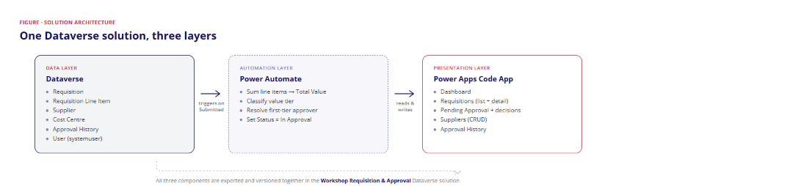
Figure 2 — Solution architecture: how the three layers connect and where each piece of work happens.
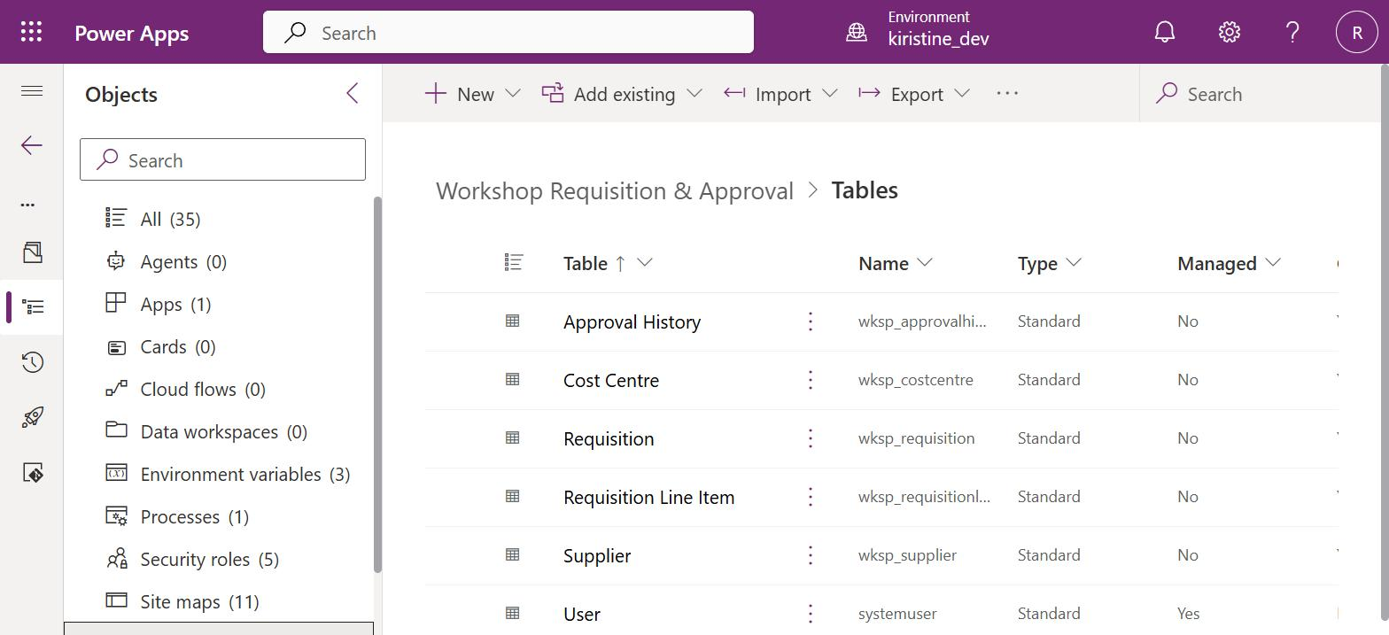
Figure 3 — The six Dataverse tables as seen inside the "Workshop Requisition & Approval" solution in the Power Apps maker portal.

4. End-to-End Process Flow
The diagram below traces a requisition from creation through to goods received, split into the two natural phases of the process: request & routing (lane 1), and escalation, audit & fulfilment (lane 2). It reflects exactly how the system behaves today — including that the approve/reject decision itself is made in the code app (step 6), not via an external Outlook or Teams card.
Figure 4 — End-to-end process flow, 12 steps across 2 lanes, with the exception (rejection) path and routing-tier reference table.

5. Dataverse Data Model
All six tables live inside one Dataverse solution, so the schema, the flow, and the code app are exported, versioned, and deployed as a single unit.

5.1 Entity-Relationship Overview
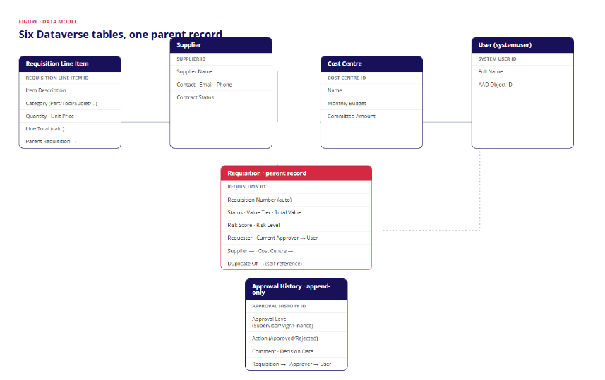
Figure 5 — Entity-relationship diagram: Requisition is the parent record, referenced by its line items and the audit trail, and itself referencing Supplier, Cost Centre, and User.

5.2 Table Overview
Table | Purpose | Key relationship
Requisition | The parent record for a purchase request: status, value tier, total value, current approver, risk score, dates. | N:1 to Supplier, Cost Centre, User (Requester / Current Approver)
Requisition Line Item | One row per item being purchased on a requisition (description, category, qty, unit price, line total). | N:1 to Requisition
Supplier | Vendor directory used when raising a requisition and maintained by Procurement. | Referenced by Requisition
Cost Centre | Workshop budget centres (e.g. Mechanical Workshop, Body Shop) with a monthly budget and a running committed amount. | Referenced by Requisition
Approval History | Append-only audit trail — one row per decision, ever made, on any requisition. | N:1 to Requisition, N:1 to User (Approver)
User (systemuser) | Dataverse’s built-in user table, used to resolve requester and approver names throughout the app. | Referenced by Requisition and Approval History

5.3 Requisition Table Schema
The Requisition table carries the full job/vehicle context needed by a workshop, not just the purchase amount — this is what lets the requester capture everything Procurement and Finance need in one place.
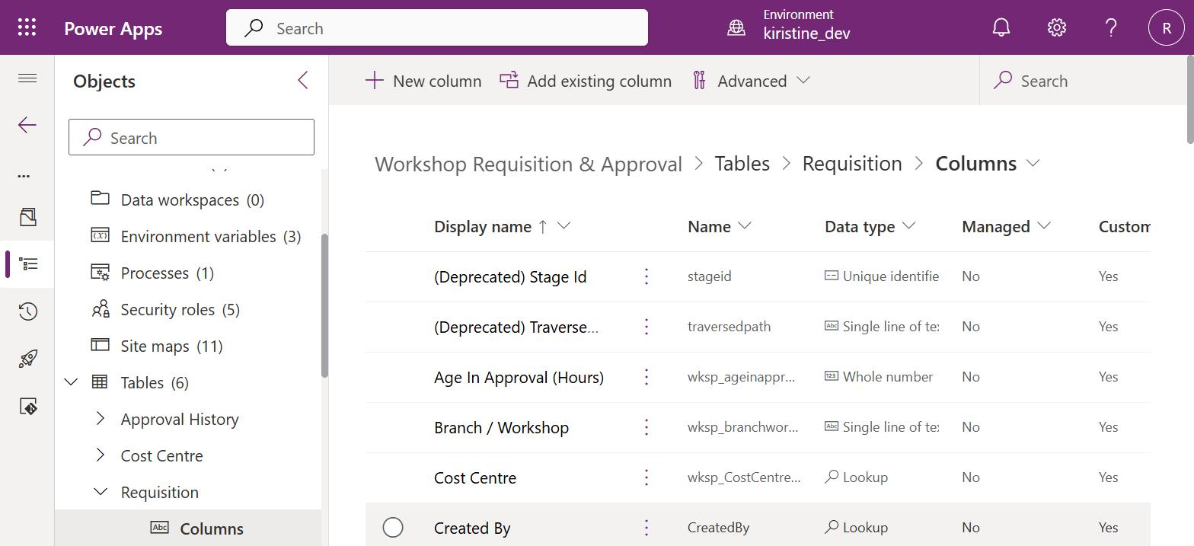
Figure 6 — Requisition table columns, viewed in the Dataverse maker portal.

5.4 Choice Fields Used for Routing and Risk
Field | Values
Status | Draft → Submitted → In Approval → Approved / Rejected → Ordered → Received
Value Tier | Under 1,000 AED · 1,000–10,000 AED · Above 10,000 AED
Risk Level | Low · Medium · High (derived from the advisory Risk Score, 0–100)
Category (line item) | Part · Tool · Sublet · Consumable · Other — each with its own icon in the app (Section 6.3)
Priority | Urgent · Normal · Low
Approval Level (history) | Supervisor · Manager · Finance

6. Features & Capabilities (Code App)
The code app is organised around five screens plus a dashboard, matching how each role — Requester, Approver, and Procurement Officer — actually works day to day. Every screenshot below is the live app, captured against a real requisition (REQ-001022) that was pushed through the actual submission, routing, and approval logic.

6.1 Dashboard
A personalised, single-glance operational view. The header greets the signed-in manager by name and states, in plain language, how many requisitions are waiting on them and how much value is currently held in approval, with one-click actions to jump straight to the pending queue, export the full requisition list to CSV, or refresh. Five KPI tiles follow — Pending Approval, Avg. Approval Time, Approval Rate, Rejection Rate, and High-Risk Open — each carrying a small caption line explaining exactly what real data and time window the number is drawn from, so nothing on the dashboard is a number without context.
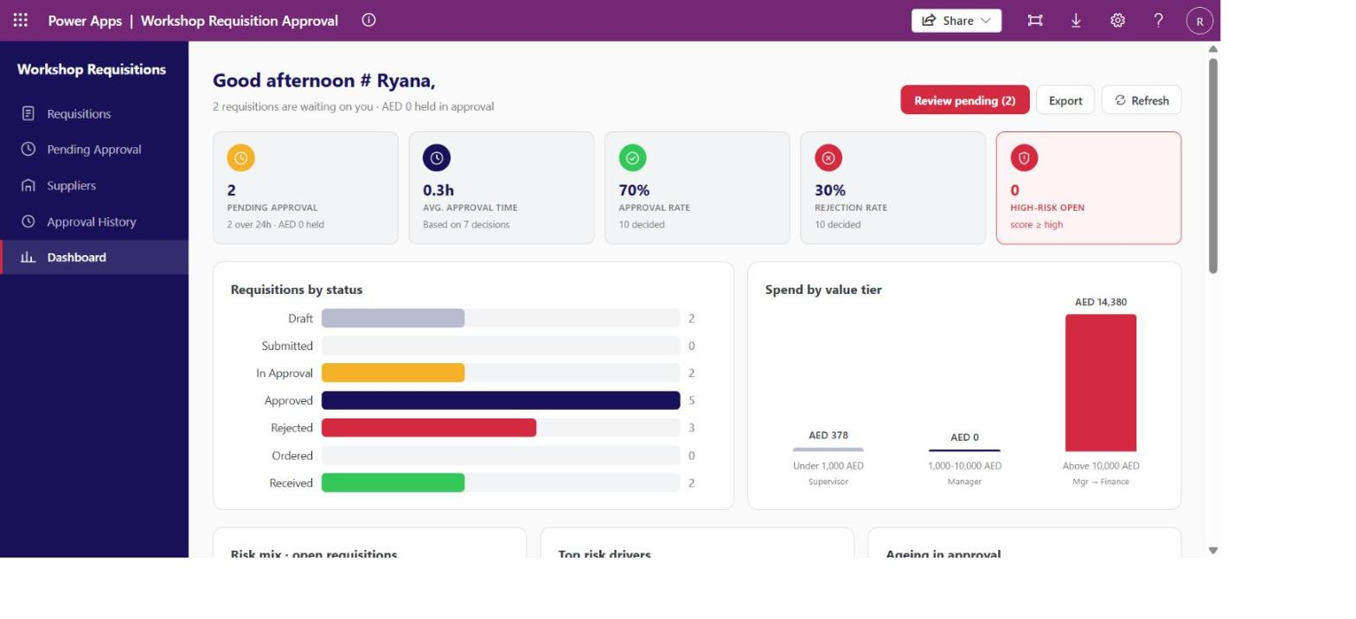
Figure 7 — Dashboard header and KPI row: a live 70% approval rate / 30% rejection rate computed from 10 real decided requisitions, and an avg. approval time of 0.3h based on 7 real decisions.
Below the KPI row, a status breakdown chart and a spend-by-value-tier chart give managers a live picture of workload and exposure without opening a single record — note the AED 14,380 bar landing exactly in the "Above 10,000 AED · Mgr → Finance" tier once the showcase requisition was submitted.
A three-panel risk row follows: a Risk Mix donut-bar (Low/Medium/High open requisitions), a Top Risk Drivers chart counting how many open requisitions currently show each real risk signal (off-contract supplier, duplicate job-card match, single/no quote attached, missing justification), and an Ageing in Approval breakdown bucketing every in-flight requisition by real elapsed hours since submission (Under 24 hours / 1–2 days / Over 2 days) — the same signals the flow uses to compute each requisition's own risk score, rolled up so a manager can see systemic exposure at a glance.
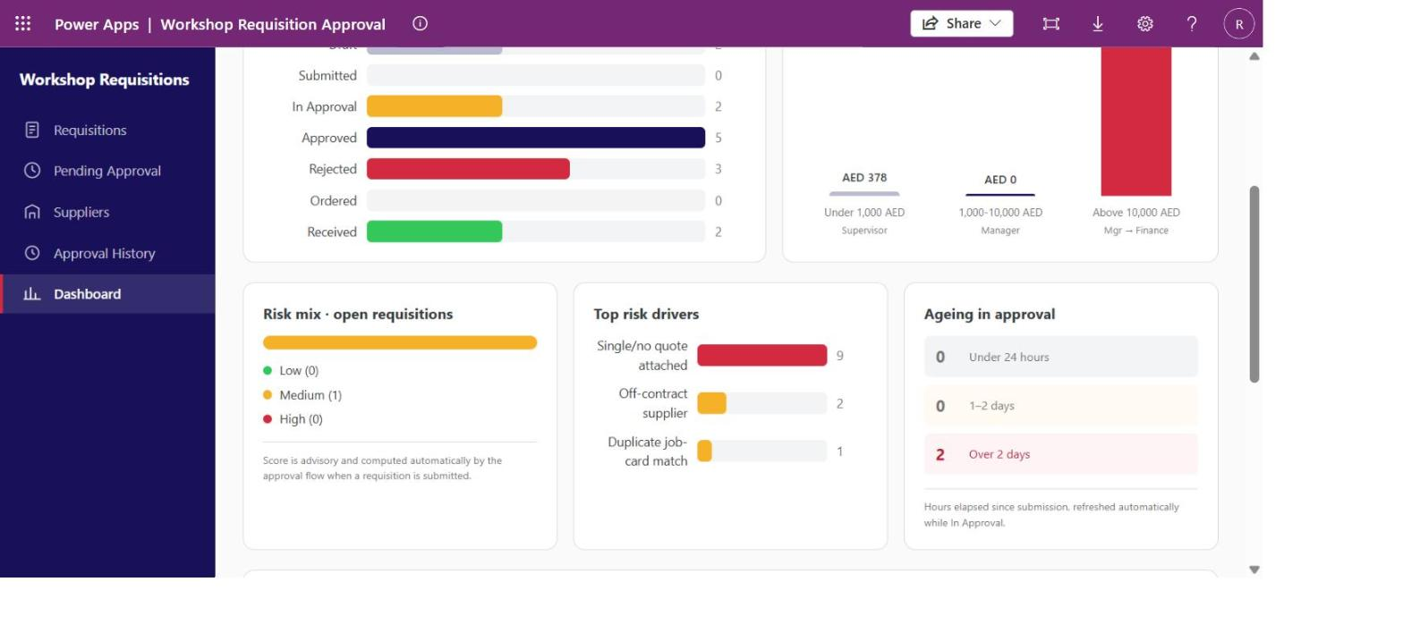
Figure 7c — Risk mix, top risk drivers, and ageing-in-approval, computed live: 9 open requisitions with a single/no quote attached, 2 on an off-contract supplier, 1 duplicate job-card match, and 2 requisitions over 2 days in approval.
A "Risk watchlist" table lists every open requisition with a non-zero risk score, sorted highest-risk first, with a one-click link into the record — this is the direct answer to "which of my open requests actually need a second look right now," rather than requiring a manager to open every record to find out.
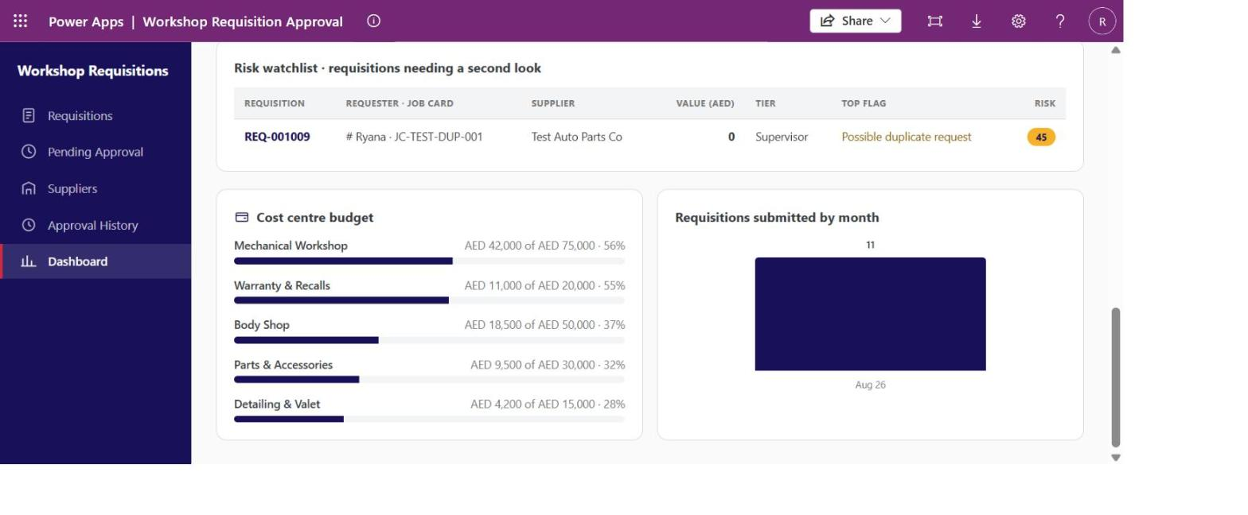
Figure 7b — Risk watchlist flagging REQ-001009 with a real "Possible duplicate request" match and a risk score of 45, alongside the Cost Centre Budget and Requisitions-by-Month panels.

6.2 Requisitions List & Creation
The Requisitions screen is the main worklist, with tabbed views (My Requisitions, Pending Approval, Approved This Month, Rejected, All Requisitions), free-text search, and a colour-coded status pill per row so the state of every request is visible without opening it.
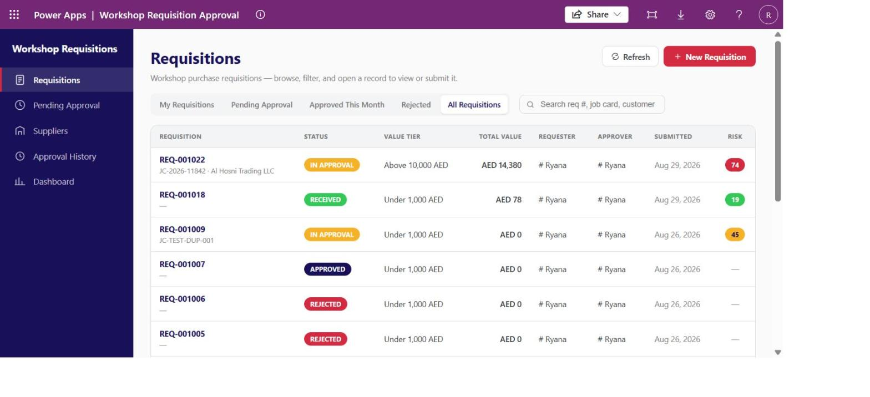
Figure 8 — Requisitions list: REQ-001022 shows its job card, customer, value tier, and a risk score of 74 the moment it reaches the top row.
A "New Requisition" action creates a Draft record bound to the signed-in user in a single click and opens it directly for editing — the requester never has to know or guess any internal Dataverse identifiers. Every draft-editable field carries example placeholder text so a first-time requester knows exactly what format is expected, without training or a help document.
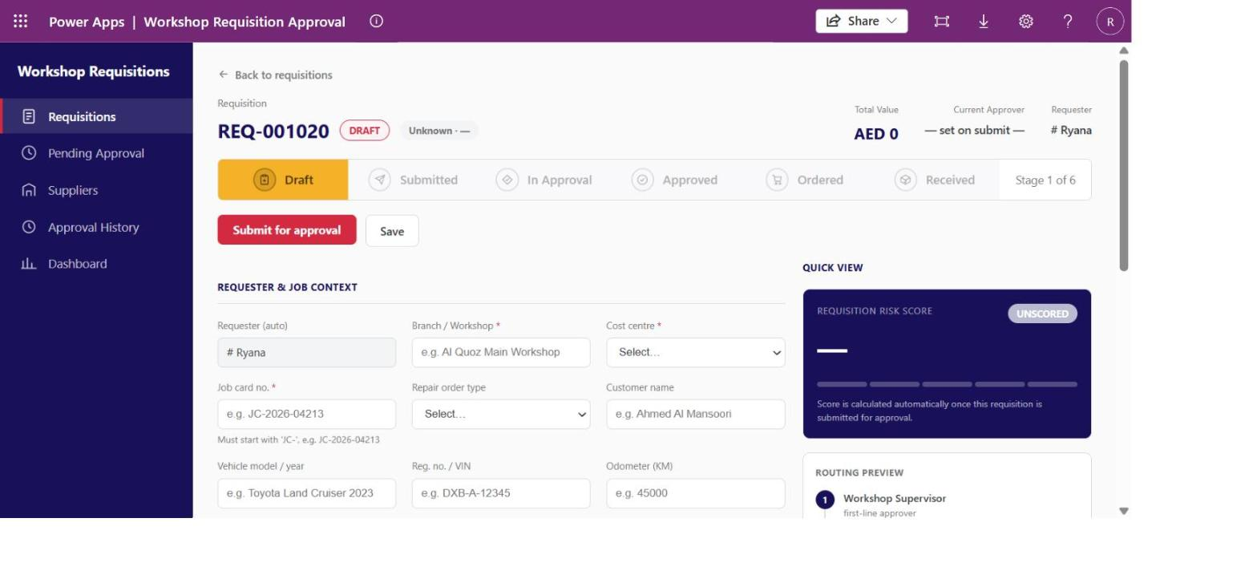
Figure 9 — A freshly created Draft requisition, showing placeholder guidance on every field.

6.3 Requisition Detail — the Core Working Screen
This is where a requisition is built, reviewed, and tracked through its life. It combines a visual stage tracker, full job/vehicle context, an editable line-items grid with per-category icons, an automatically computed risk score, a routing preview, a duplicate-warning banner, a live budget-impact panel, and the complete approval history for that record.
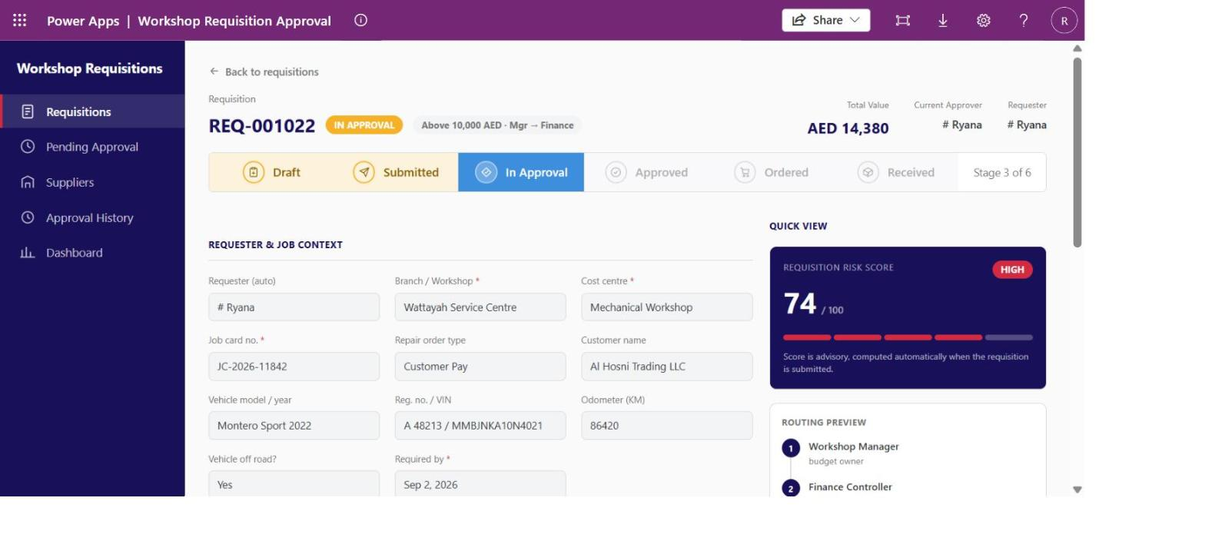
Figure 10 — REQ-001022 in approval: stage tracker, a real risk score of 74/100 (HIGH), and the routing preview showing Workshop Manager then Finance Controller.
Scrolling down reveals the line items — each category (Part, Tool, Sublet, Consumable, Other) now renders with its own icon inside the status pill, not colour alone — followed by supplier and justification detail, the full two-decision approval history, and the budget-impact panel drawing on the Mechanical Workshop cost centre’s real committed spend.
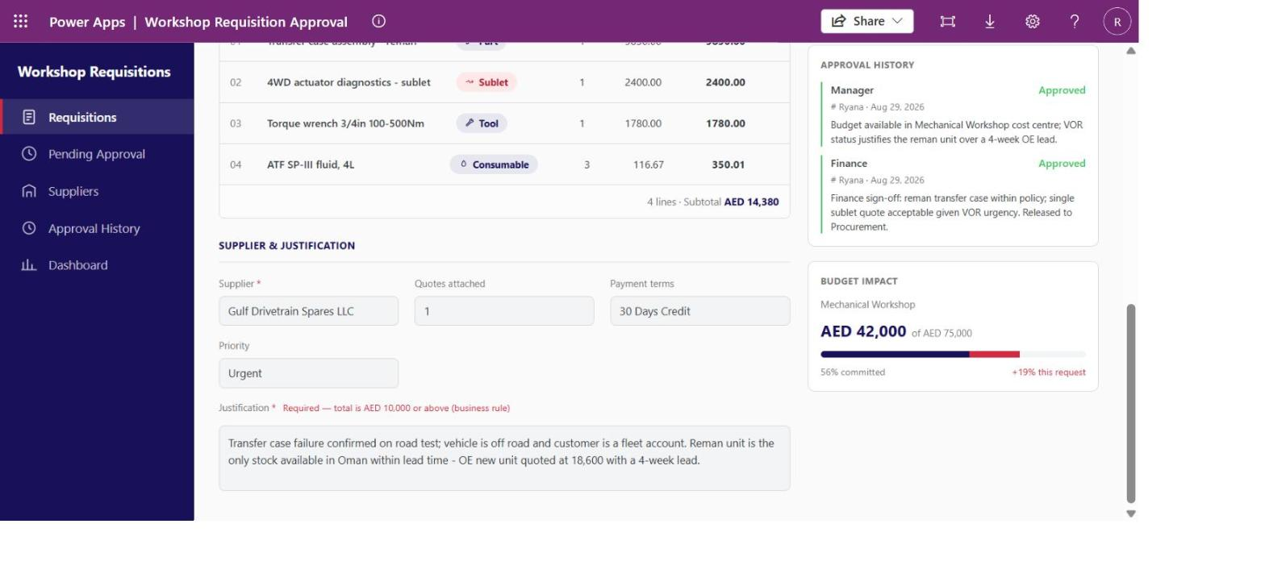
Figure 11 — Line items with category icons, a completed two-level approval history (Manager → Finance, both Approved with real comments), and the budget-impact panel showing AED 42,000 of AED 75,000 committed (56%), +19% from this request.
Once a requisition completes its full lifecycle, the stage tracker shows every phase it passed through, coloured by its "tier spectrum" palette — amber for requester-driven steps, blue for automated/routing and fulfilment steps, green for Approved.
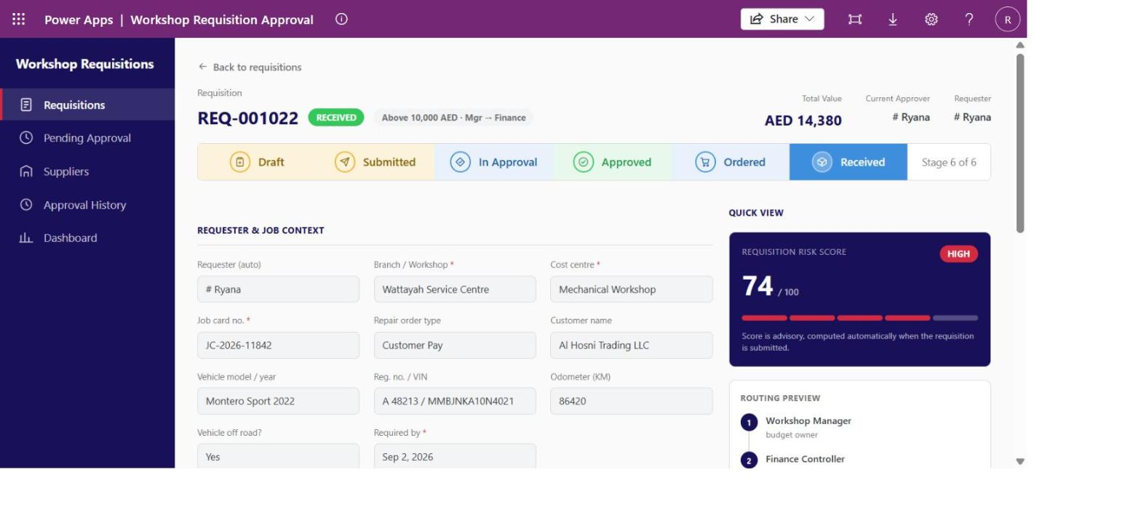
Figure 12 — REQ-001022 at "Received" — Stage 6 of 6, having passed through Draft, Submitted, In Approval, Approved, and Ordered.

6.4 Pending Approval & In-App Decisions
Approvers get a dedicated worklist of exactly what is assigned to them, with age-in-queue (highlighted when ageing) and risk score visible before opening a record. Selecting a request shows its line items, its total, any duplicate warning, a comment box, and Approve/Reject actions — the decision is recorded directly against the requisition and logged to Approval History in the same action, with no separate email or Teams approval card required.
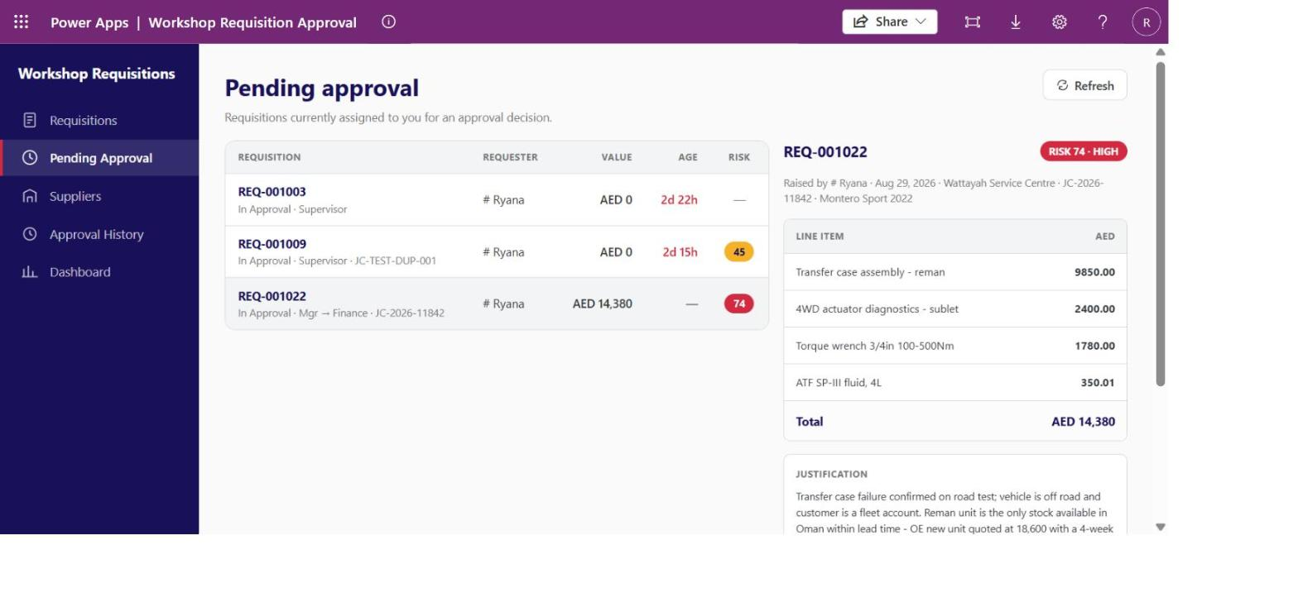
Figure 13 — Pending Approval: REQ-001022’s full line-item breakdown, justification, and risk badge, ready for an in-app decision.
Solves: removes the ambiguity of "did anyone approve this yet?" and gives Finance/Management a single audit trail of every decision, reason included.

6.5 Procurement Actions — Ordered & Received
Once a requisition is Approved, a "Mark as Ordered" action becomes available; once Ordered, "Mark as Received" becomes available. This gives Procurement a simple, explicit way to track fulfilment status all the way through — closing the gap where, previously, nobody outside Procurement’s head knew whether an approved request had actually been ordered.

6.6 Suppliers — Vendor Directory
A searchable supplier directory with on-contract / off-contract status, referenced by every requisition’s Supplier field. Procurement can create and edit suppliers directly in the app (name, contact, email, phone, contract status) — no separate back-office tool is needed to keep the vendor list current.
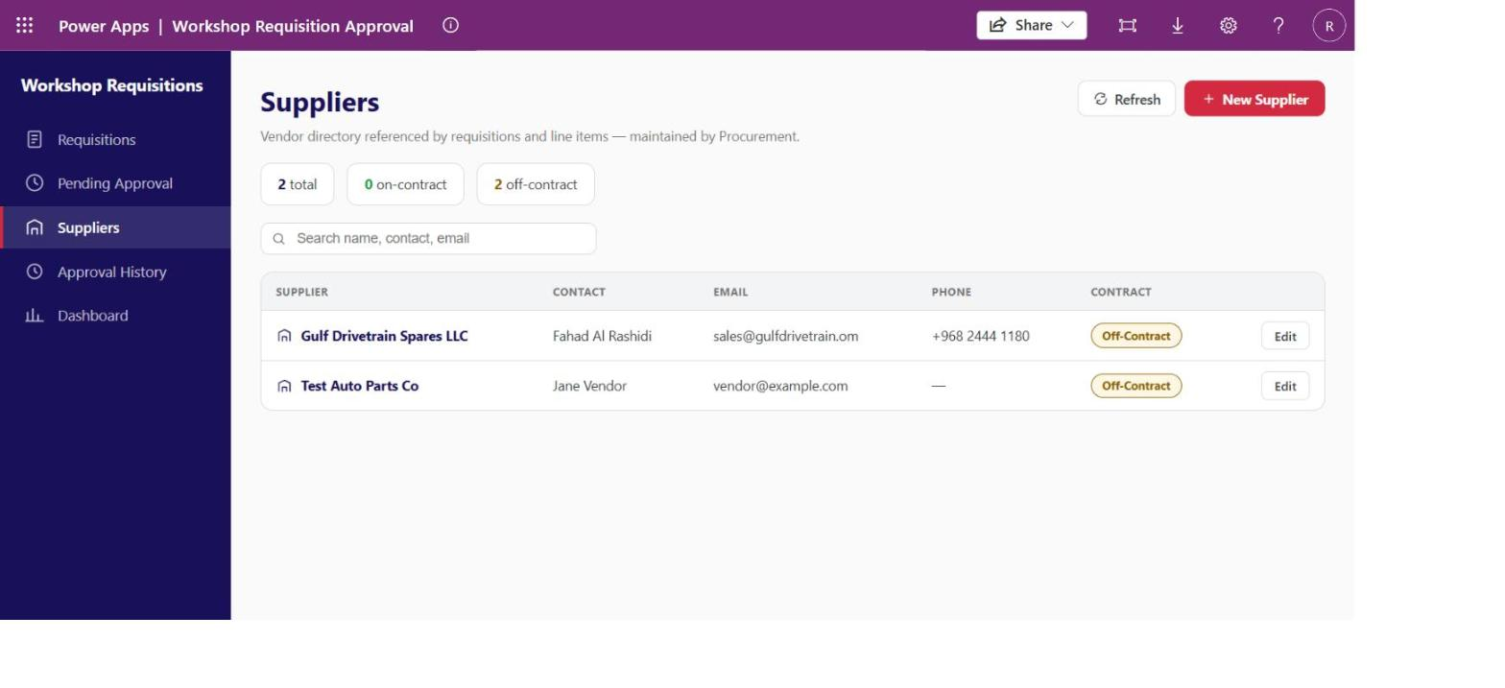
Figure 14 — Suppliers directory, including the off-contract vendor sourced for the showcase requisition.

6.7 Approval History — Full Audit Trail
An append-only, searchable log of every approval decision ever made, across every requisition — approver, level (Supervisor/Manager/Finance), action, comment, and timestamp, with a one-click link back to the originating requisition. This is the definitive answer to "who approved this, and why" for any audit, warranty dispute, or finance query.
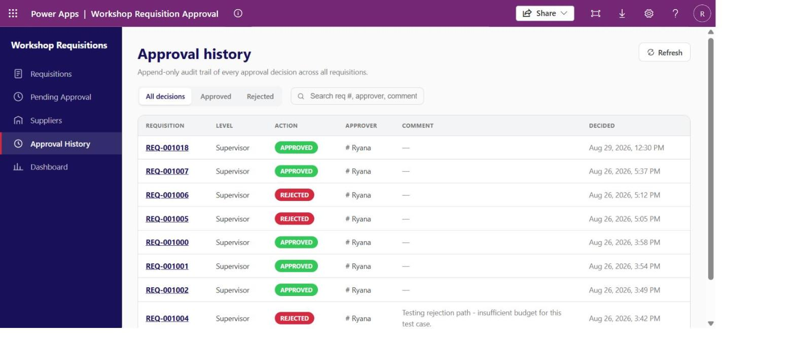
Figure 15 — Approval History: complete, filterable audit trail across all requisitions.

7. Validation & Data Quality Rules
The app enforces the rules a paper or email process could never reliably enforce, catching mistakes at the point of entry instead of after the fact.
- Required fields before submission. A requisition cannot be submitted for approval without Branch/Workshop, Cost Centre, Job card number, Required-by date, Supplier, and at least one line item.
- Conditional justification requirement. Justification becomes mandatory the moment the running total reaches AED 10,000 or more — a live business rule, not a static form field.
- Job card number format validation. Must start with the prefix ‘JC-’ (e.g. JC-2026-04213). This keeps the field reliable as the key the duplicate-detection logic uses to flag possible repeat requests — a free-text field with no format check would silently break that safeguard.
- Duplicate-request detection. The system flags when a new requisition’s job card number matches an existing open request, surfacing a warning banner with a direct link to the suspected duplicate before it gets approved twice.
- Advisory risk scoring. A 0–100 risk score and Low/Medium/High risk level are computed automatically on submission, giving approvers a consistent, computed signal instead of a personal judgement call.
- Segregation of duties (role-based). A requester can never approve their own requisition, and an approver is never the one who raises the purchase order — enforced through Dataverse security roles, not just UI hiding.
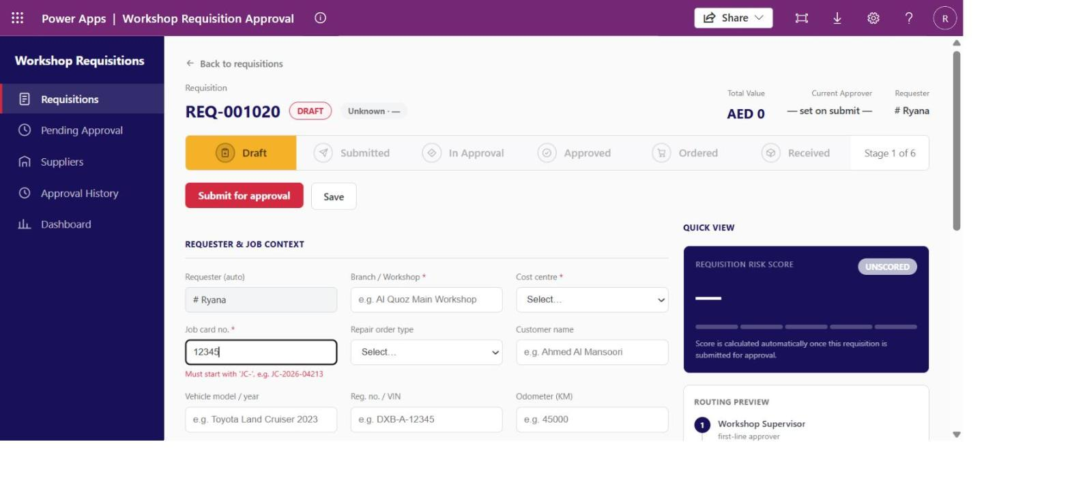
Figure 16 — Live validation: an invalid Job card number (missing the ‘JC-’ prefix) is flagged in red with guidance text, and blocks submission until corrected.

8. Approval Automation (Power Automate)
A single Dataverse-triggered cloud flow, "Workshop Requisition Approval Routing," handles everything that needs to happen the instant a requisition is submitted:
- Triggers when a Requisition row is added or modified, filtered to Status = Submitted.
- Fetches the requisition’s line items and sums them into the Total Value field.
- Classifies the request into a value tier and resolves the correct first-line approver for that tier.
- Sets Status = In Approval and assigns the Current Approver — the point at which the requisition appears on that approver’s Pending Approval worklist in the code app.
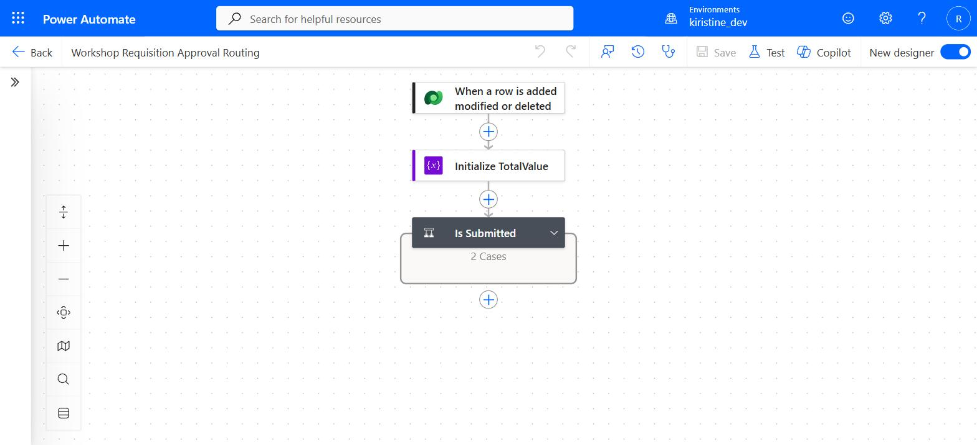
Figure 17 — The approval-routing flow, viewed in the Power Automate designer: Dataverse trigger, total-value calculation, and tier-based branching.
The tiered routing table the flow implements:
Total value | Approver(s) | Order
Under 1,000 AED | Workshop Supervisor | Single
1,000 – 10,000 AED | Workshop Manager | Single
Above 10,000 AED | Workshop Manager, then Finance Controller | Sequential — Finance only sees it if the Manager approves first
A rejection at any stage immediately sets Status = Rejected and ends the process — no further approvers are contacted. Once the code app was introduced, the Approve/Reject decision itself moved from the flow into the app (see Section 6.4), so the flow’s job is now specifically the submission-time calculation and first-tier routing, while the code app owns tier advancement, finalization, and the audit-trail write.

9. Roles & Segregation of Duties
Role | Can do | Cannot do
Requester (Service Advisor / Technician) | Create and read own requisitions and line items; read suppliers. | Approve any requisition, including their own.
Approver (Supervisor / Manager / Finance Controller) | Read requisitions assigned to them; record Approve/Reject decisions with comments. | Edit line items; raise the purchase order.
Procurement Officer | Read approved requisitions; update Status to Ordered/Received; maintain suppliers. | Approve requisitions — acts only after approval is complete.
System Administrator | Full control of app, flow, thresholds, and roles. | Approve requisitions.
These rules are enforced through Dataverse security roles, so they hold regardless of which client (the code app, or a future integration) is used to access the data.

10. What This Solution Solves — Summary
Business problem (before) | How the solution solves it
No audit trail of who approved what, or why. | Append-only Approval History table, visible per-requisition and as a searchable global log.
Inconsistent, ad hoc approval routing. | Automated tiered routing (Supervisor / Manager / Manager→Finance) driven purely by requisition value.
Duplicate purchase requests going unnoticed. | Automatic duplicate-job-card detection with an in-app warning and direct link to the suspected duplicate.
No budget visibility at the point of request. | Live Budget Impact panel per cost centre, showing committed spend vs. monthly budget before a request is approved.
No risk signal for approvers. | Automatic 0–100 advisory risk score and Low/Medium/High risk level, shown on every request.
Manual, untracked handoff to procurement after approval. | Explicit Ordered → Received status actions owned by the Procurement Officer role.
Vendor list maintained outside the system. | In-app Supplier directory with full create/edit, referenced directly by every requisition.
Data-entry errors breaking downstream logic silently. | Field-level validation (required fields, conditional justification, job-card-number format) that blocks submission until corrected.
Line-item types indistinguishable at a glance. | Part, Tool, Sublet, Consumable, and Other each carry a distinct icon, not colour alone.

11. Conclusion
The Workshop Purchase Requisition & Approval System turns an informal, unaudited purchasing process into a governed, automated, and fully traceable workflow — without adding friction for the person raising the request. Every role in the process (Requester, Approver, Procurement Officer, and Administrator) has exactly the screen and the actions it needs, all backed by one Dataverse solution that keeps the data model, the automation, and the application deployable and versioned as a single unit.

