SOLUTION DESIGN DOCUMENT
Workshop Purchase Requisition
& Approval System
A Microsoft Power Platform Model-Driven Application

Built with Dataverse • Model-Driven Apps • Power Automate • Outlook Approvals
Domain: Automotive Service Department
Version 1.0

Table of Contents

1. Solution Overview 3
1.1 What this document contains 3
2. Business Context & Objectives 3
3. Applications & Services Used 3
3.1 How the components fit together 4
4. People & Roles in the Approval Process 4
5. Approval Routing Logic 5
5.1 Rules that support the routing 5
6. Dataverse Data Model 5
6.1 Tables at a glance 5
6.2 Requisition table — key columns 6
6.3 Requisition Line Item table — key columns 6
6.4 Approval History table — key columns 6
7. End-to-End Process Flow 7
7.1 Step-by-step walkthrough 8
8. Model-Driven App Design 8
8.1 Navigation areas 8
8.2 The requisition form 9
8.3 Business Process Flow 9
8.4 Business rules 9
9. Power Automate Flow — Detailed Steps 9
10. Security Roles 10
11. Notifications 10
12. Implementation Roadmap 10
13. Benefits & Success Measures 11
Suggested metrics to track 11
Appendix A — Glossary 11

1. Solution Overview
This document describes the complete design of the Workshop Purchase Requisition & Approval System — a Microsoft Power Platform solution that replaces informal, email-based purchase requests inside an automotive service department with a single, governed, auditable workflow.
In a busy workshop, service advisors and technicians regularly need to buy things to complete a job: a specialist tool, a sublet (outsourced) repair, an out-of-warranty part, or consumables. Without a system, these requests travel by email, WhatsApp, and word of mouth, which makes them slow to approve, hard to track, and almost impossible to audit. This solution captures every request as a structured record, routes it automatically to the right approver based on its value, delivers the approval decision directly inside Outlook and Microsoft Teams, and records a permanent history of who approved what and when.
In one sentence
A technician raises a requisition in a model-driven app; Power Automate evaluates its total value and routes it for one or more approvals through Outlook; once approved, the record advances to procurement and the requester is notified automatically — with a full audit trail stored in Dataverse.

1.1 What this document contains
- The exact people and roles involved in every approval decision.
- A visual process-flow diagram of the end-to-end workflow.
- Every Microsoft application and service used in the solution, and what each one does.
- The complete Dataverse data model — tables, key columns and relationships.
- The model-driven app structure and the Power Automate approval flow, step by step.
- Security roles, notifications, an implementation roadmap and success measures.

2. Business Context & Objectives
The service department currently handles purchase requests informally. The table below states the problems the solution is designed to solve and the measurable objective attached to each.

Current problem | Objective the solution delivers
Requests are made by email and chat, with no standard format. | One structured requisition form capturing all required details before submission.
Approvals depend on catching the right manager; requests stall. | Automatic routing to the correct approver the moment a requisition is submitted.
No visibility of what is pending, approved, or ordered. | Live dashboards and views showing the status of every requisition.
No record of who approved a spend, or why. | A permanent, tamper-evident approval history for every request.
Spending controls are inconsistent and manual. | Value-based approval tiers enforced automatically by the workflow.
Managers approve from wherever they are, often late. | One-click Approve / Reject directly inside Outlook and Teams.

3. Applications & Services Used
The solution is built entirely on the Microsoft Power Platform and Microsoft 365. No custom code or third-party servers are required. Each component below has a single, clear responsibility.

Application / service | Role in this solution
Microsoft Dataverse | The secure database. Stores every requisition, its line items, suppliers and the full approval history, and enforces relationships and security.
Model-Driven App | The user interface. Where requesters create requisitions and where approvers and managers view status through forms, views and dashboards.
Power Automate (cloud flow) | The automation engine. Triggers on submission, calculates the total, routes approvals, updates status and sends notifications.
Approvals connector | Generates the interactive approval request and captures the approver’s Approve / Reject decision and comments.
Microsoft Outlook | Delivers the approval card to the approver’s inbox and sends confirmation / rejection emails to the requester.
Microsoft Teams | Optional second channel that shows the same actionable approval card for mobile approvers.
Microsoft Entra ID | Identity and sign-in. Determines who each user is and which security role they hold.
Power Platform environment | The managed container that holds the Dataverse database, the app and the flow together as one deployable solution.

3.1 How the components fit together
The model-driven app writes to and reads from Dataverse. A change in Dataverse (a submitted requisition) starts the Power Automate flow. The flow uses the Approvals connector, which surfaces through Outlook and Teams, then writes the result back into Dataverse — which the app immediately reflects. Entra ID sits underneath, authenticating every user.

4. People & Roles in the Approval Process
Five distinct roles participate in the workflow. A single person may hold more than one role in a small department, but the responsibilities below remain separate so that duties stay segregated and the audit trail is meaningful.

Role | Who typically holds it | Responsibility in the workflow
Requester | Service Advisor or Technician | Raises the requisition, adds line items and a justification, selects the supplier, and submits.
First-level approver | Workshop Supervisor / Service Team Leader | Approves low-value requisitions (the first gate). Confirms the request is operationally necessary.
Second-level approver | Workshop Manager / Service Manager | Approves medium and high-value requisitions. Owns the departmental budget.
Third-level approver | Finance Controller / Finance Manager | Approves high-value requisitions only, after the manager. Confirms budget and financial policy.
Procurement Officer | Purchasing / Parts Department | Acts only after approval: raises the purchase order with the supplier and marks the requisition as Ordered, then Received.
System Administrator | IT / Power Platform maker | Maintains the app, flow, thresholds and security roles. Does not approve requisitions.

Segregation of duties
The person who raises a requisition can never be the person who approves it, and the person who approves can never be the one who raises the purchase order. This separation is what makes the audit trail trustworthy.

5. Approval Routing Logic
When a requisition is submitted, the flow adds up the value of all its line items and compares the total against three tiers. The tier decides how many approvers are involved and in what order. The thresholds below are examples in UAE Dirhams (AED) and are configurable by the administrator without changing the flow.

Total value (AED) | Approver(s) required | Order | Rationale
Under 1,000 | Workshop Supervisor | Single | Routine, low-risk operational spend.
1,000 – 10,000 | Workshop Manager | Single | Departmental budget owner sign-off.
Above 10,000 | Workshop Manager, then Finance Controller | Sequential (two stages) | High-value spend needs both departmental and financial approval.

Sequential means the request only reaches the Finance Controller if the Workshop Manager approves first. If any approver rejects at any stage, the requisition is immediately marked Rejected and no further approvers are contacted.

5.1 Rules that support the routing
- A justification is mandatory when the total value is 10,000 or above (enforced by a business rule).
- A requester cannot approve their own requisition, even if they also hold an approver role.
- If an approver does not respond within a set time, the flow can send a reminder or escalate (optional).

6. Dataverse Data Model
Four custom Dataverse tables hold the data. One requisition has many line items and one approval history; suppliers are referenced by a lookup. The relationships are what allow the model-driven app to show line items as a sub-grid on the requisition form and to build a complete audit trail.

6.1 Tables at a glance
Table | Purpose | Relationship
Requisition | The main record: requester, total value, status, justification, dates. | Parent record.
Requisition Line Item | Each item requested: description, quantity, unit price, line total. | Many line items to one Requisition (N:1).
Supplier | Vendors the department buys from. | Referenced by a lookup on Requisition and line items.
Approval History | One row per approval decision: approver, action, comment, timestamp. | Many history rows to one Requisition (N:1).

6.2 Requisition table — key columns
Column | Data type | Notes
Requisition Number | Autonumber | Human-readable ID, e.g. REQ-000123.
Requester | Lookup (User) | Set automatically to the person creating the record.
Total Value | Currency | Rolled up from the line items.
Status | Choice | Draft, Submitted, In Approval, Approved, Rejected, Ordered, Received.
Justification | Multiline text | Required when Total Value ≥ 10,000.
Supplier | Lookup (Supplier) | The chosen vendor.
Date Submitted | Date/Time | Stamped when the requester submits.
Current Approver | Lookup (User) | Set by the flow so views can show who is holding the request.

6.3 Requisition Line Item table — key columns
Column | Data type | Notes
Item Description | Single line text | What is being purchased.
Category | Choice | Part, Tool, Sublet, Consumable, Other.
Quantity | Whole number | Units required.
Unit Price | Currency | Price per unit.
Line Total | Currency (calculated) | Quantity × Unit Price.
Parent Requisition | Lookup (Requisition) | Links the line to its requisition.

6.4 Approval History table — key columns
Column | Data type | Notes
Requisition | Lookup (Requisition) | The request being decided.
Approver | Lookup (User) | Who made the decision.
Approval Level | Choice | Supervisor, Manager, Finance.
Action | Choice | Approved, Rejected.
Comment | Multiline text | The approver’s note.
Decision Date | Date/Time | When the decision was recorded.

7. End-to-End Process Flow
The diagram below shows the complete journey of a requisition from the moment a technician raises it to the moment the parts or service are received. The written walkthrough follows.
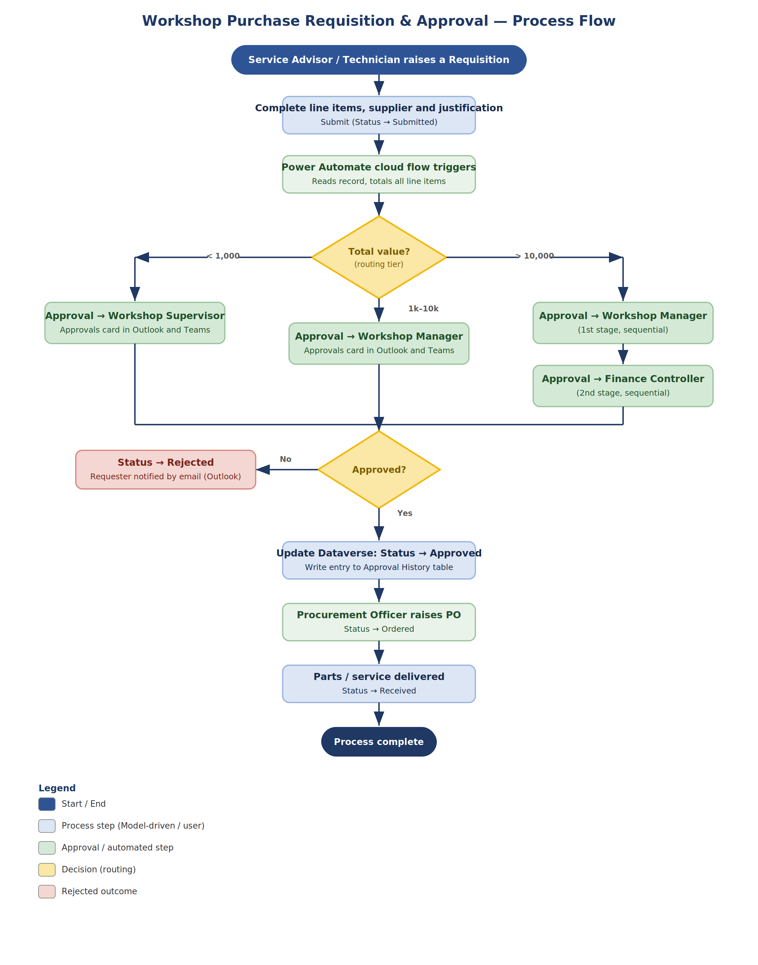
Figure 1 — Workshop Purchase Requisition & Approval process flow

7.1 Step-by-step walkthrough
Step 1 — Raise the requisition
A Service Advisor or Technician opens the model-driven app and creates a new requisition, adding one or more line items, choosing a supplier, and writing a justification.
Step 2 — Submit
The requester submits. The record’s Status changes from Draft to Submitted. This single change is the trigger for everything that follows.
Step 3 — Flow starts and totals the request
Power Automate detects the submitted record, reads its line items and calculates the Total Value.
Step 4 — Determine the routing tier
The flow compares the total against the thresholds and decides whether one or two approvers are needed, and who they are.
Step 5 — Send the approval
The Approvals connector creates an approval request. It appears as an actionable card in the approver’s Outlook inbox and Microsoft Teams. Status becomes In Approval.
Step 6 — Approver decides
The approver clicks Approve or Reject and can add a comment — without leaving Outlook. The decision is captured by the flow.
Step 7 — Handle rejection
If rejected, the flow sets Status to Rejected, writes the decision to Approval History, and emails the requester with the reason. The process ends here.
Step 8 — Handle sequential approval
For high-value requests, an approval from the Workshop Manager advances the request to the Finance Controller for a second decision. Either rejection stops the process.
Step 9 — Record the outcome
On full approval, the flow sets Status to Approved and writes each decision to the Approval History table, building the audit trail.
Step 10 — Procurement
The Procurement Officer sees the approved requisition, raises the purchase order with the supplier, and sets Status to Ordered.
Step 11 — Receipt
When the parts or sublet service arrive, the record is set to Received and the requester is notified. The requisition is complete.

8. Model-Driven App Design
The model-driven app is the front door for every user. Its structure is generated from the Dataverse tables, so the data model above is what gives the app its shape. The elements below make it usable and self-explanatory.

8.1 Navigation areas
- Requisitions — the main area, with views for My Requisitions, Pending Approval, Approved This Month and All Requisitions.
- Suppliers — maintain the vendor list.
- Approval History — a read-only area for auditing past decisions.
- Dashboards — charts showing requisitions by status, by value tier and by month.

8.2 The requisition form
- A header showing the requisition number, status and total value.
- A main section for supplier, justification and dates.
- A sub-grid of line items, so the whole request is edited in one place.
- A related sub-grid of approval history, visible once decisions exist.

8.3 Business Process Flow
A business process flow runs across the top of the form and guides the record through visible stages: Draft → Submitted → In Approval → Approved → Ordered → Received. It gives every user an at-a-glance sense of where the request stands.

8.4 Business rules
- Make Justification required when Total Value is 10,000 or more.
- Lock the line items once the status passes Submitted, so an approved request cannot be quietly changed.
- Hide the Current Approver field while the record is still in Draft.

9. Power Automate Flow — Detailed Steps
The automation is a single Dataverse-triggered cloud flow. Its internal logic is summarised below in the order it executes.

# | Flow action | What it does
1 | Trigger | When a row is added or modified in the Requisition table, filtered to fire only when Status equals Submitted.
2 | Get line items | List the related Requisition Line Item rows for the triggering requisition.
3 | Calculate total | Sum the Line Total of every line item to get the Total Value, and write it back to the requisition.
4 | Set status | Update Status to In Approval and stamp the Date Submitted.
5 | Condition — routing tier | A switch or nested condition on Total Value selects the correct approver path (Supervisor, Manager, or Manager then Finance).
6 | Start and wait for approval | The Approvals connector creates an approval assigned to the chosen approver, delivered to Outlook and Teams, and pauses until a response arrives.
7 | Log the decision | Create a row in Approval History recording the approver, level, action, comment and timestamp.
8 | Branch on outcome | If Rejected: set Status to Rejected and email the requester. If Approved and a further level is required: repeat the approval step for the next approver.
9 | Finalise | When all required approvals are granted, set Status to Approved and email the requester that the request may proceed to procurement.

10. Security Roles
Dataverse security roles decide what each person can see and do. Roles are assigned through Microsoft Entra ID group membership so that access follows job function, not individuals.

Security role | Can do
Requester | Create and read their own requisitions and line items; read suppliers. Cannot approve.
Approver | Read requisitions assigned to them; record approval decisions. Cannot edit line items.
Procurement Officer | Read approved requisitions; update status to Ordered and Received; maintain suppliers.
Administrator | Full control of the app, flow, tables, thresholds and role assignments.

11. Notifications
Every notification is delivered through Outlook (and optionally Teams) by the flow, so no one has to check the app to know an action is needed.

Event | Recipient | Message
Requisition submitted | Selected approver | Actionable approval card with the request details and Approve / Reject buttons.
Approved (final) | Requester | Confirmation that the request is approved and moving to procurement.
Rejected | Requester | Notice of rejection, including the approver’s comment.
Ordered | Requester | Confirmation that the purchase order has been raised.
Received | Requester | Notice that the parts or service have arrived.

12. Implementation Roadmap
A practical order for building the solution, suitable for a single maker working incrementally.

Phase | Focus | Key deliverables
1 | Data foundation | Create the four Dataverse tables, columns, choices and relationships.
2 | App interface | Build the model-driven app: forms, views, sub-grids, dashboards, business process flow.
3 | Automation | Build the Power Automate flow with tiered routing and the Approvals connector.
4 | Security & rules | Configure security roles, business rules and the justification requirement.
5 | Test & pilot | Test each value tier end to end, then pilot with a small group of advisors.
6 | Deploy | Package as a managed solution and roll out to the department.

13. Benefits & Success Measures
- Faster approvals — requests reach the right person instantly and can be actioned from a phone.
- Full auditability — every decision is recorded with who, what, when and why.
- Consistent spending control — value tiers are enforced automatically, every time.
- Complete visibility — dashboards show the live state of all requisitions.
- No custom code — the whole solution is maintainable inside the Power Platform.

Suggested metrics to track
Metric | What it tells you
Average time from submission to approval | How responsive the approval process is.
Percentage of requisitions approved on first pass | Quality of requests and clarity of justification.
Number of requisitions per value tier | Where spend is concentrated.
Rejection rate and reasons | Whether policy or training gaps exist.

Appendix A — Glossary
Term | Meaning
Dataverse | Microsoft’s secure, cloud database that underpins Power Platform apps.
Model-driven app | An app whose screens are generated from the underlying data tables and relationships.
Power Automate | The Power Platform service for building automated workflows (“flows”).
Approvals connector | A built-in Power Automate component that creates and tracks approval requests.
Business Process Flow | A guided set of stages shown on a form to move a record through a process.
Business rule | No-code logic on a form, e.g. making a field required under a condition.
Sublet | Work outsourced to an external repairer that the workshop pays for on the customer’s behalf.
Requisition | A formal request to purchase goods or services.

