AIM:
To create a multi-page static website named "My profile" using HTML5, containing Home, About Me, Hobbies and Contact pages connected through navigation links.
PROCEDURE:
1. Create a project folder named MyProfile to store all HTML files.
2. Design the Home Page (index.html) with a welcome message and navigation links.
3. Create the About Me Page (about.html) to display personal information.
4. Create the Hobbies Page (hobbies.html) using headings, paragraphs and lists.
5. Create the Contact Page (contact.html) to display contact details and an email hyperlink.
6. Add navigation links to all pages using the anchor (a) tag and href attribute.
7. Open index.html in a web browser and test all the pages and links.

- HOME PAGE
<!DOCTYPE html>
<html>
<head>
<title>My Profile</title>
</head>
<body>
<header>
<h1>Welcome to My Profile</h1>
<p>Know more about me! </p>
</header>
<nav>
<a href="index.html">Home</a> |
<a href="hobbies.html">Hobbies</a> |
<a href="about.html">About Me</a> |
<a href="contact.html">Contact</a>
</nav>
<h2>Hello Everyone!</h2>
<p>Welcome to my personal website.</p>
<h2>My Interests</h2>
<ul>
<li>Learning new skills</li>
<li>Listening to music</li>
<li>Exploring technology</li>
</ul>
</body>
</html>

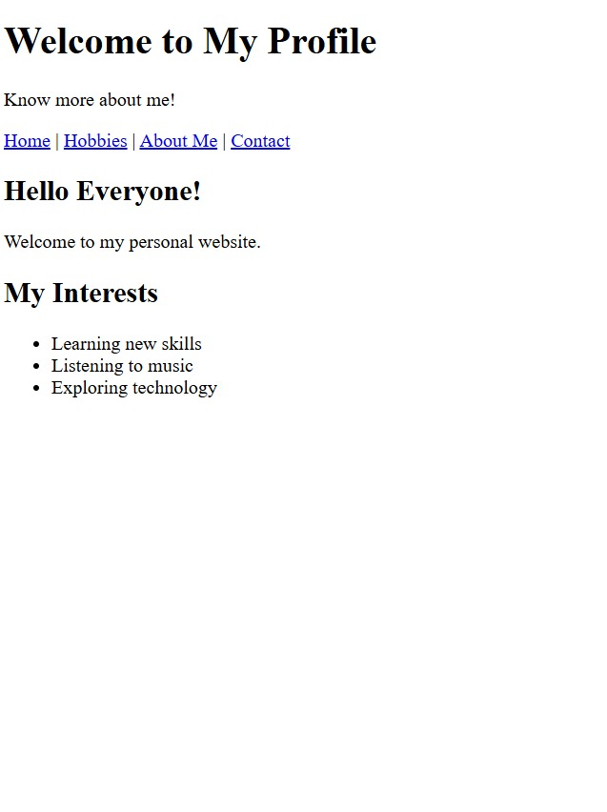

- ABOUT ME:
<!DOCTYPE html>
<html>
<head>
<title>About Me</title>
</head>
<body>
<h1>About Me</h1>
<hr>
<a href="index.html">Home</a> |
<a href="hobbies.html">Hobbies</a> |
<a href="contact.html">Contact</a>
<h2>Personal Information</h2>
<p>My name is Kirithika. </p>
<p>I am a college student. </p>
<p>I am learning HTML and web development. </p>
<h2>My Goal</h2>
<p>My goal is to improve my technical skills
and become a successful professional. </p>
</body>
</html>
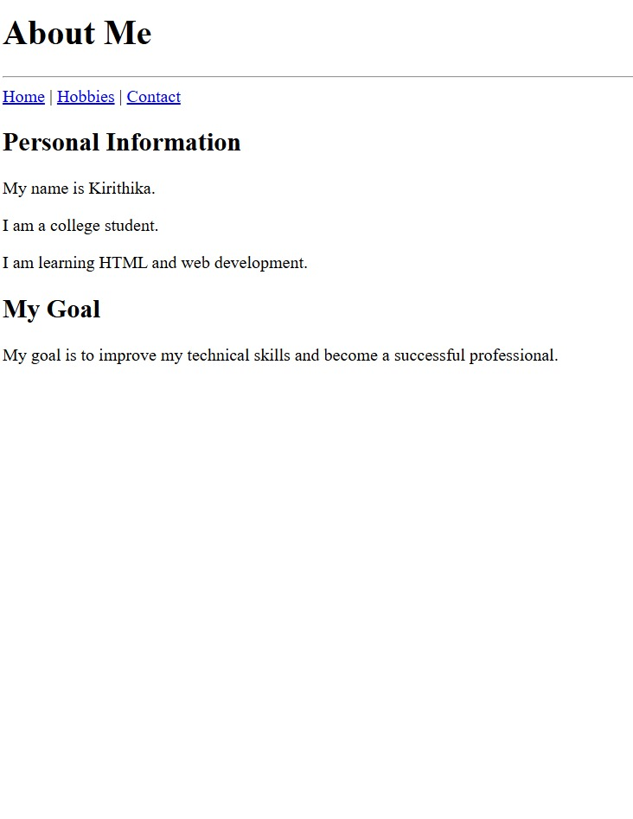
MY HOBBIES:
<!DOCTYPE html>
<html>
<head>
<title>My Hobbies</title>
</head>
<body>
<h1>My Hobbies</h1>
<hr>
<a href="index.html">Home</a> |
<a href="about.html">About Me</a> |
<a href="contact.html">Contact</a>
<h2>My Favourite Hobbies</h2>
<ul>
<li>Listening to music</li>
<li>Singing</li>
<li>Cooking</li>
<li>Learning new things</li>
</ul>
<h2>My Favourite Activity</h2>
<p>Listening to music makes me feel relaxed.</p>
</body>
</html>
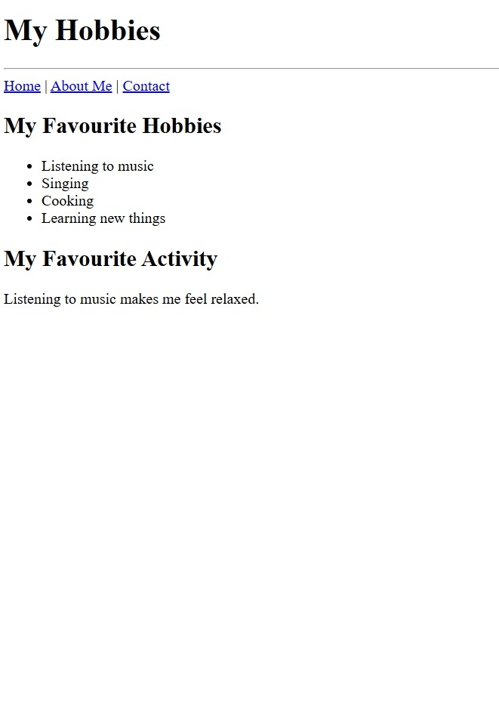
- CONTACT ME:
<!DOCTYPE html>
<html>
<head>
<title>Contact Me</title>
</head>
<body>
<h1>Contact Me</h1>
<hr>
<a href="index.html">Home</a> |
<a href="about.html">About Me</a> |
<a href="hobbies.html">Hobbies</a>
<h2>Get in Touch</h2>
<p>You can contact me through email. </p>
<p>Email: student@example.com</p>
<h2>Send a Message</h2>
<form>
<label for="name">Name:</label>
<input type="text" id="name" name="name">
<br><br>
<label for="message">Message:</label>
<textarea id="message" name="message"></textarea>
<br><br>
<input type="submit">
</form>
</body>
</html>



