Date: {DATED}

**Dear {USERNAME},**

**Congratulations!** On behalf of Navgurukul Admissions Team, I am delighted to offer you admission to the **NavGurukul Software Engineering Scholarship**.

Your hard work and persistence during the selection process convinced us that you have the right energy and talent to make great use of this. We are thrilled to welcome you to **NavGurukul family**.

NavGurukul was started with a vision to enable each and every student to have access to a meaningful and high-growth career. While there are many options for people who have resources, our focus is to help students like you to have a choice and a voice - to bring good to you, your family and the community alike.

This scholarship is going to involve **exceptional hard work**, dedication and community work from your end. While, you would work on your skills that would help you with job, you will also go through a **journey of self awareness** through various activities that are waiting for you.

You have earned your way to the fellowship, and we are excited to work with you in the year ahead.

Please **contact Rahit Roy (**+91-9354978726) for any help you need to plan your travel and arrival at our campus.

Once again, a warm welcome to Navgurukul community. Hope to see you soon!

Warmly,

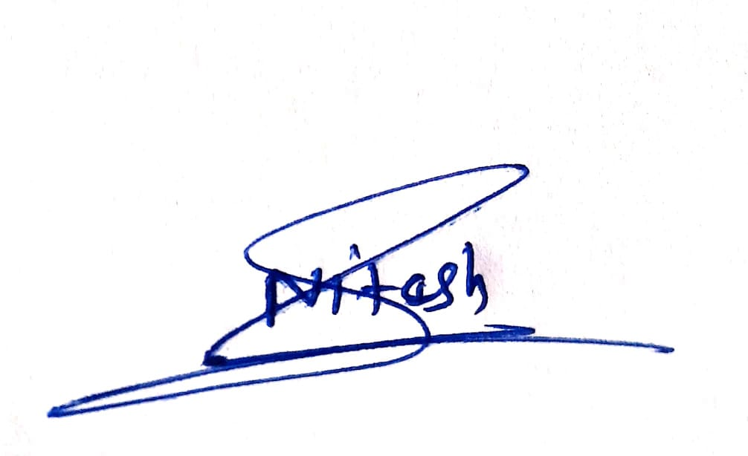

**Nitesh Sharma Rahit Roy**

Admissions & Partnership Associate Boys Campus Facility In-Charge

+91-8962158723 +91-9354978726

Date: {DATED}

**Dear {USERNAME},**

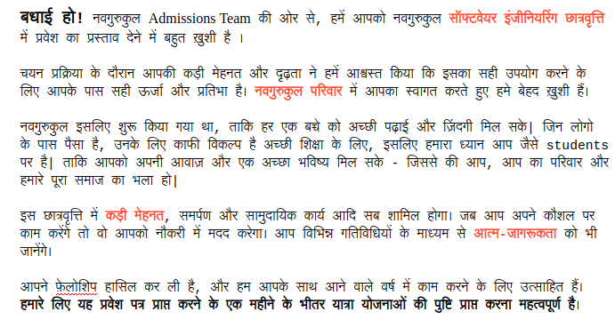

Warmly,



**Nitesh Sharma Rahit Roy**

Admissions & Partnership Associate Boys Campus Facility In-Charge

+91-8962158723 +91-9354978726