Check vm.swappiness on all your nodes Set the value to 1 if necessary  
  
  
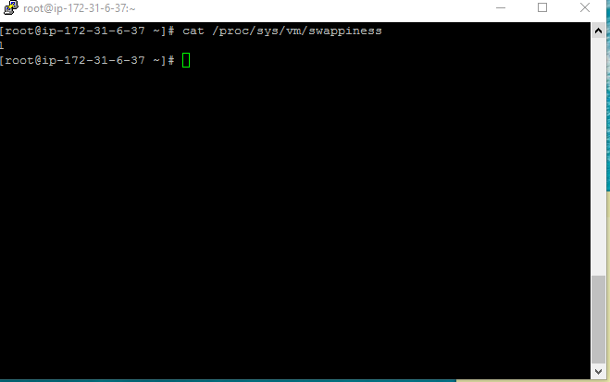

Check that noatime is set on any non-root volumes you have

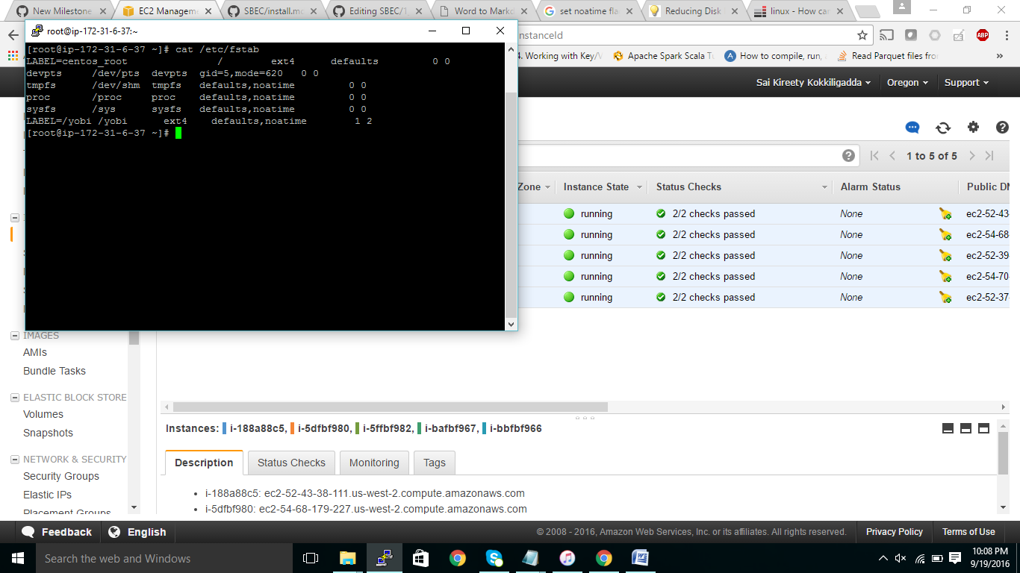



CccCheck that the reserve space of any non-root volumes to 0

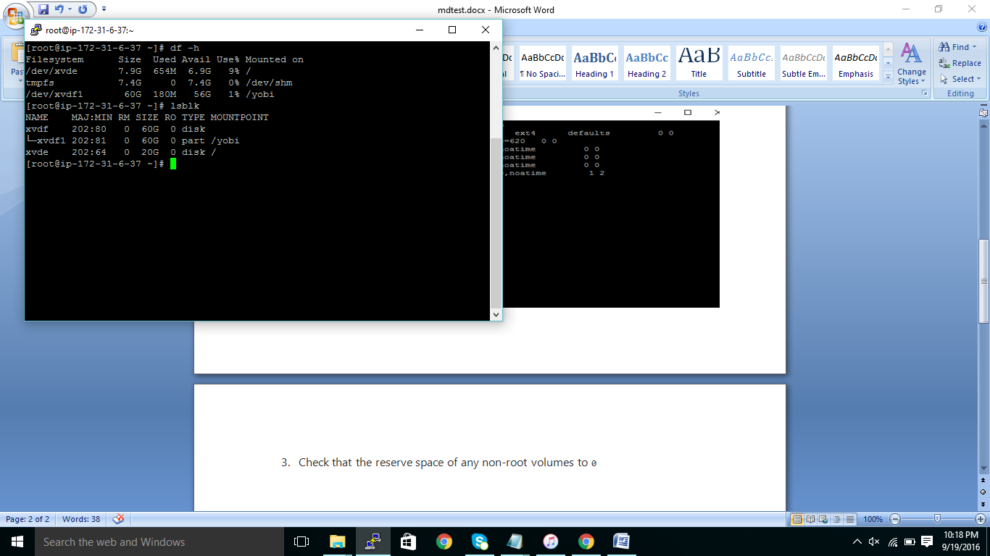

Check the user limits for maximum file descriptors and processes

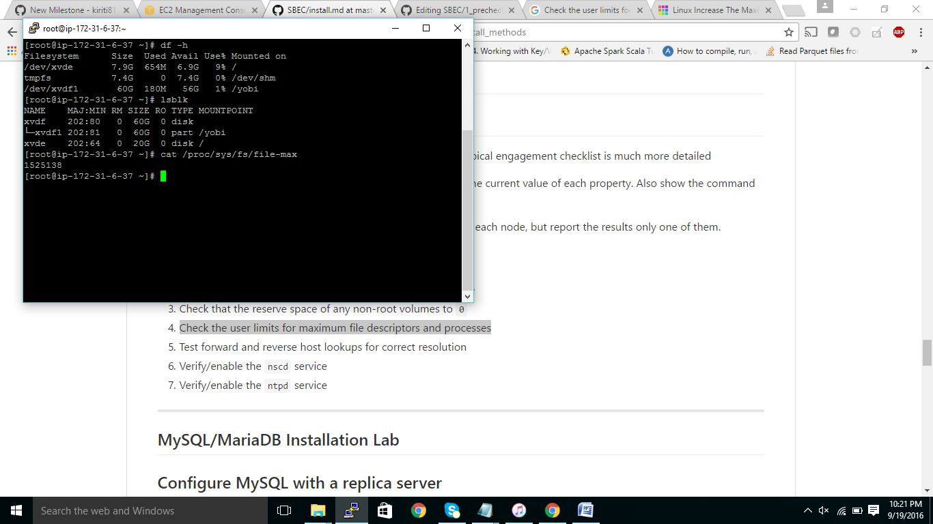

Test forward and reverse host lookups for correct resolution

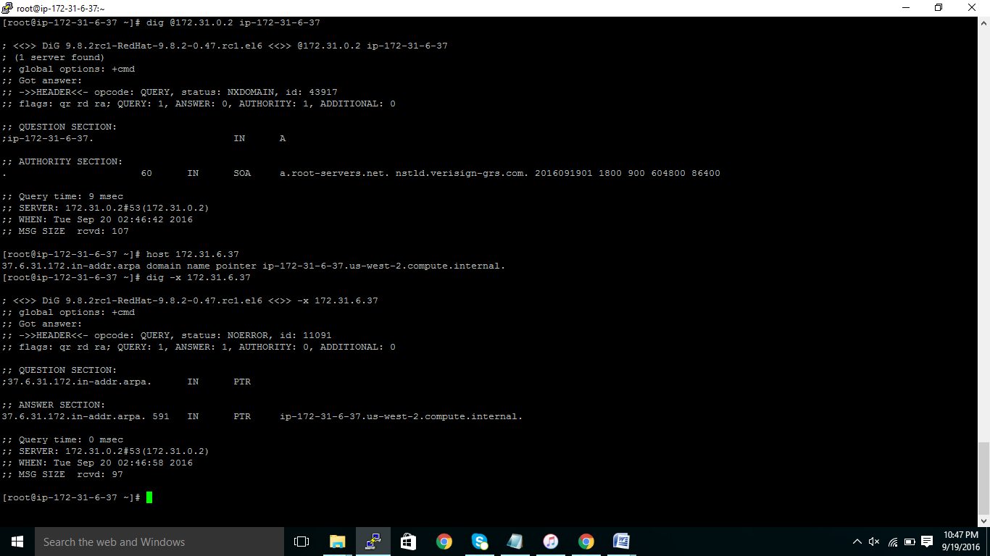

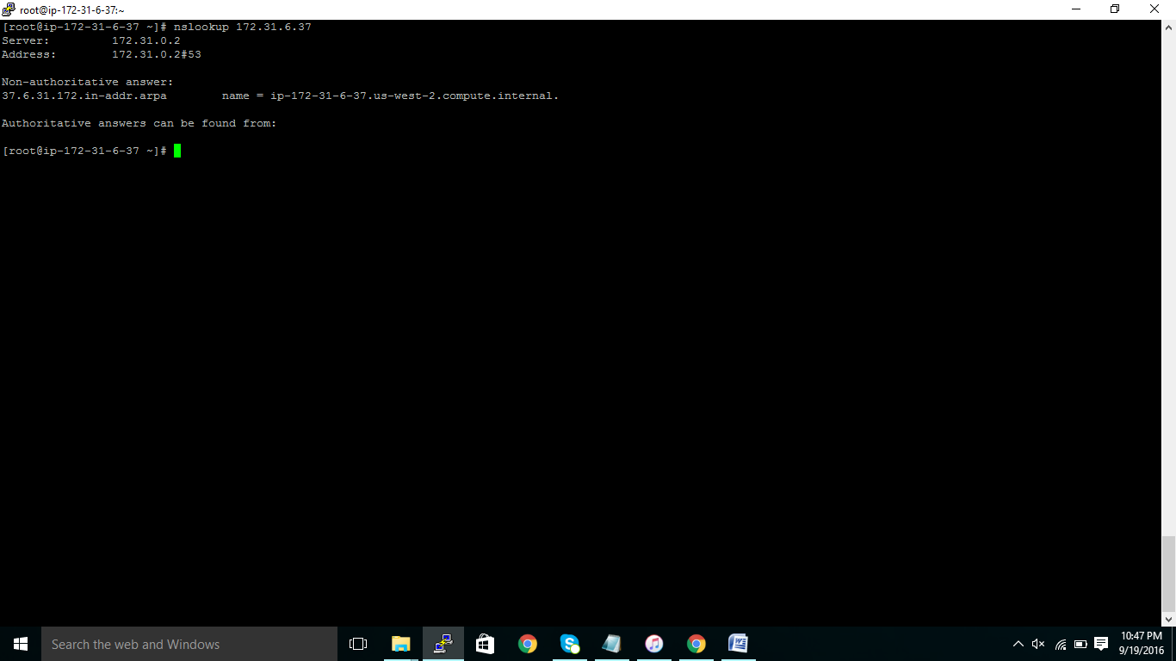

Verify/enable the nscd service

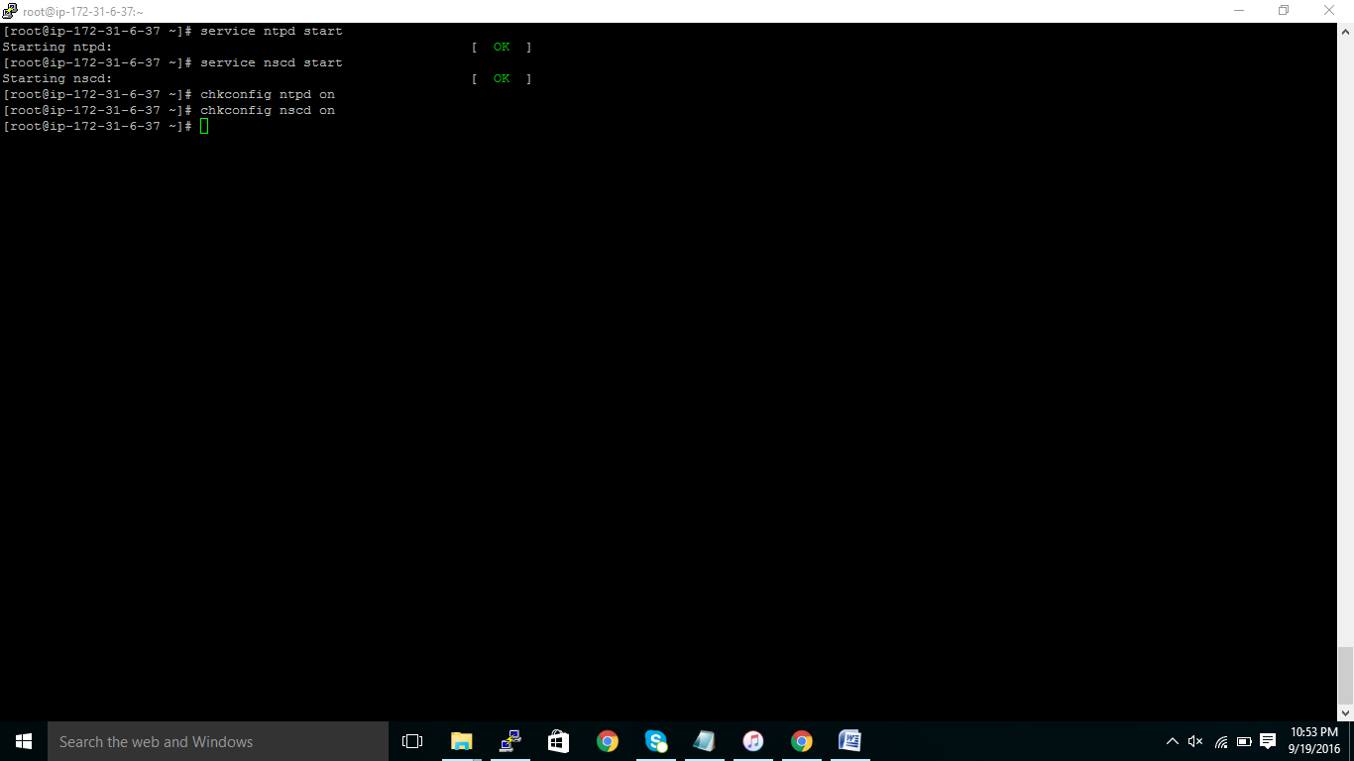

Verify/enable the nscd service

