Computer Communications and Networks (COMN)
2021/22, Semester 2

Assignment 2 Results Sheet

Forename and Surname: | Richard Yuan
Matriculation Number: | S1837624

Question 1 – Number of retransmissions and throughput with different retransmission timeout values with stop-and-wait protocol. For each value of retransmission timeout, run the experiments for 5 times and write down average number of retransmissions and average throughput.

Retransmission timeout (ms) | Average number of  re-transmissions | Average throughput  (Kilobytes per second)
5 | 1121.8 | 60
10 | 608.4 | 54.5
15 | 116.4 | 69.5
20 | 96.2 | 65.3
25 | 99.8 | 60.8
30 | 97.8 | 60.24
40 | 100.8 | 56.9
50 | 104 | 49.6
75 | 96.2 | 42.6
100 | 104.2 | 34.46

Question 2 – Discuss the impact of retransmission timeout value on the number of retransmissions and throughput. Indicate the optimal timeout value from a communication efficiency viewpoint (i.e., the timeout that minimizes the number of retransmissions while ensuring a high throughput).

With the retransmission timeout increasing, when it starts from 5ms to 15ms, there will be a significant drop on the average number of retransmissions. But the situation will change when the retransmission timeout is lager than 15ms, until the timeout goes to 100ms, the average number of retransmissions will remain in the samiliar numbers, so after 15ms timeout, the number of retransmissions will be affected a lot by the retransmission timeout.
The average throughput will remain in the similar values until the retransmission out is 15ms. After that, the average through put will decreasing when the retransmission timeout is larger.
The optimal timeout value for my chart would be 15ms, will it has the highest average throughput and similar numbers of retransmissions.

Question 3 – Experimentation with Go-Back-N. For each value of window size, run the experiments for 5 times and write down average throughput.

 | Average throughput (Kilobytes per second)
Window Size | Delay = 5ms | Delay = 25ms | Delay = 100ms
1 | 26.7 | 16.9 | 4.8
2 | 90.3 | 35.1 | 9.7
4 | 140.7 | 70.5 | 11.9
8 | 196.5 | 84.3 | 16.6
16 | 247.4 | 107.4 | 20.7
32 | 210.7 | 140.7 | 24.6
64 | 119.5 | 109.5 | 21.8
128 | 74.2 | 97.8 | 27.9
256 | 41.8 | 76.9 | 25.7

Create a graph as shown below using the results from the above table: 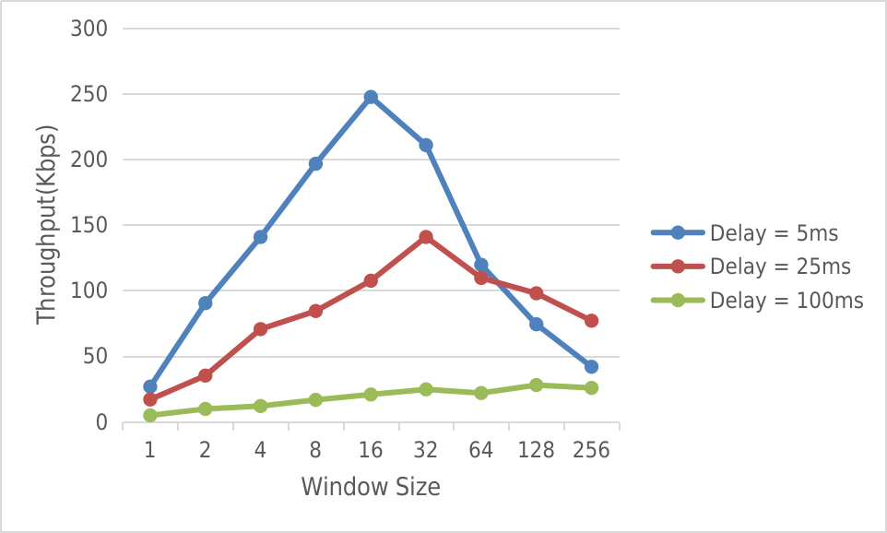
Question 4 – Discuss your results from Question 3.

With retrytimeout for 5ms propagation delay is 15ms since it is the optimal value from Part2. And the retry timeout is 55ms and 205ms for 25ms and 100ms propagation delay respectively. Because the timeout value should be two times larger than the delay with sending packet and receiving ack.
With increasing in window size sould help the throughput become larger. But when the window size is too large, the throughput will drop as the receiver becomes overwhelmed with incoming packets.
When window size is 16 -32, the throughput will be largest. and when the delay is higher, the corresponding windows size with highest through put will be larger.

Question 5 – Experimentation with Selective Repeat. For each value of window size, run the experiments for 5 times and write down average throughput.

 | Average throughput (Kilobytes per second)
Window Size | Delay = 25ms
1 | 17.6
2 | 35.2
4 | 67.3
8 | 132.7
16 | 158.2
32 | 120.2

Question 6 - Compare the throughput obtained when using “Selective Repeat” with the corresponding results you got from the “Go Back N” experiment and explain the reasons behind any differences.

The throughput of Selective Repeat is slightly higher than Go Back N. This could make sense, as in the Selective repeat, it fixes the GBN resending of out of order packets that have already been sent and receive successlly by receiver.
As the window size is lager than 32, the thoughput is droped in Selective repeat.
Question 7 – Experimentation with iperf. For each value of window size, run the experiments for 5 times and write down average throughput.

 | Average throughput (Kilobytes per second)
Window Size (KB) | Delay = 25ms
1 | 14.7
2 | 28.8
4 | 32
8 | 59.3
16 | 74.2
32 | 86.1

Question 8 - Compare the throughput obtained when using “Selective Repeat” and “Go Back N” with the corresponding results you got from the iperf experiment and explain the reasons behind any differences.

Reilable UDP has higher throughput than TCP. Since TCP has conjestion control but in the given problem, for the single file transmission, there is no need to do that much of controls.

