TA for Mobile Applications

Hometask

1. Set up dev environment for Android – see general setup guide at <http://appium.io/slate/en/v1.6.0-beta3/?java#setup>, items 1-8 (mandatory).

2*. Execute existing one of the existing tests for any android app in repository

(see <https://github.com/appium/sample-code>) and run your test on android emulator (optional). Also, see additional steps at <http://appium.io/slate/en/v1.6.0-beta3/?java#setting-up-appium>.

Notes:

A. Deliverables: Each Mentee must provide a MS Word report to Mentor upon task completion. This report should contain detailed explanation of each step according to point 1 above along with the screenshots.

B. Evaluation: If Mentee has delivered detailed report for everything required at point 1 above (env setup only), maximum mark is 5.0. If Mentee has delivered report also for optional point 2*, maximum mark can be 6.0. Evaluation process is dependent upon Mentor’s expertise and experience.

For any issues or questions, feel free to ping me in Skype (ac4bussiness) or via Corp Email ([Vsevolod_Sergienko@epam.com](mailto:Vsevolod_sergienko@epam.com)).

**Part 1**

Install NodeJS

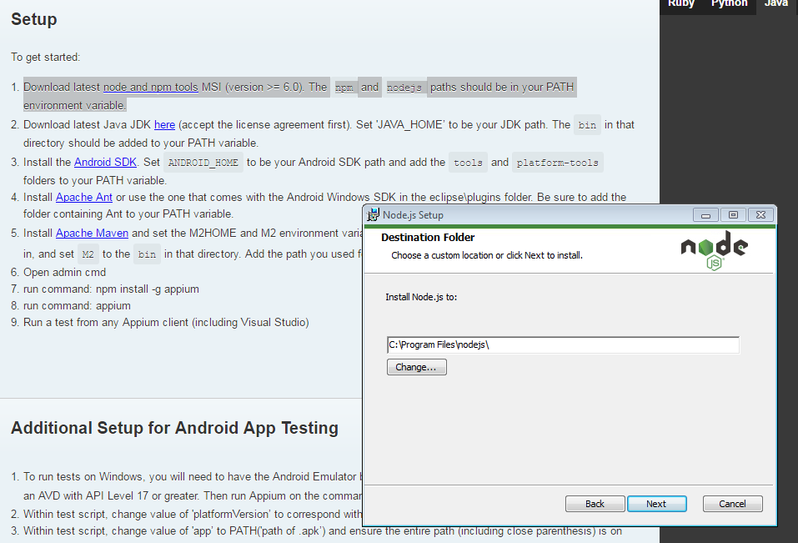

Set Path for npm

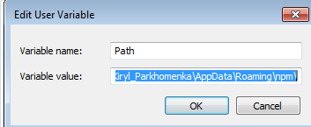

Set Path for nodejs

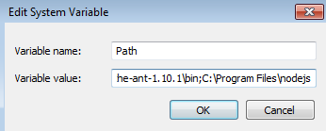

2. JDK was installed earlier.

JAVA_HOME variable

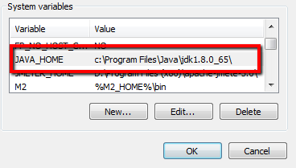

Path to jdk bin

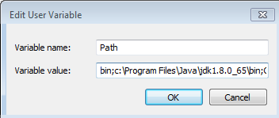

3. Android SDK was installed.

ANDROID_HOME variable

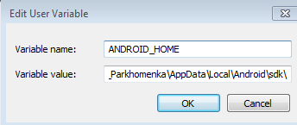

Path to platform-tools

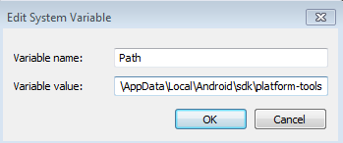

Path to tools

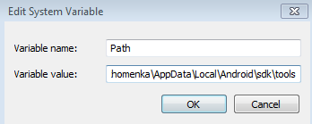

4. Apache Ant was installed.

ANT_HOME variable

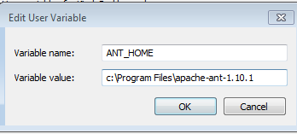

Path to ANT bin

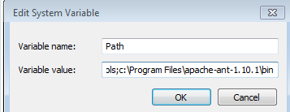

5. Apache Maven was installed earlier.

M2 and M2_HOME variables

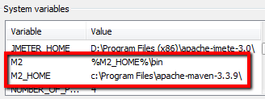

Path to Maven

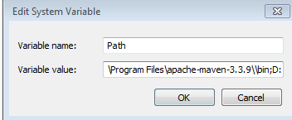

6.

Admin cmd

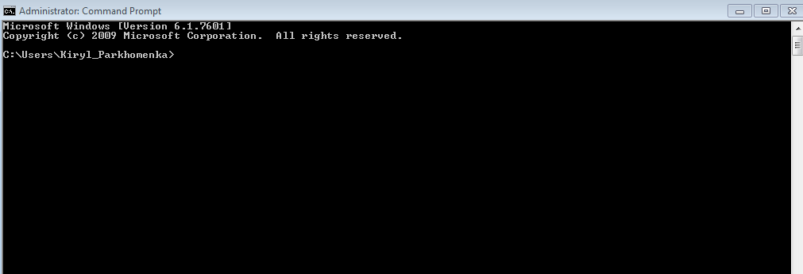

7. npm install -g appium

Appium was installed.

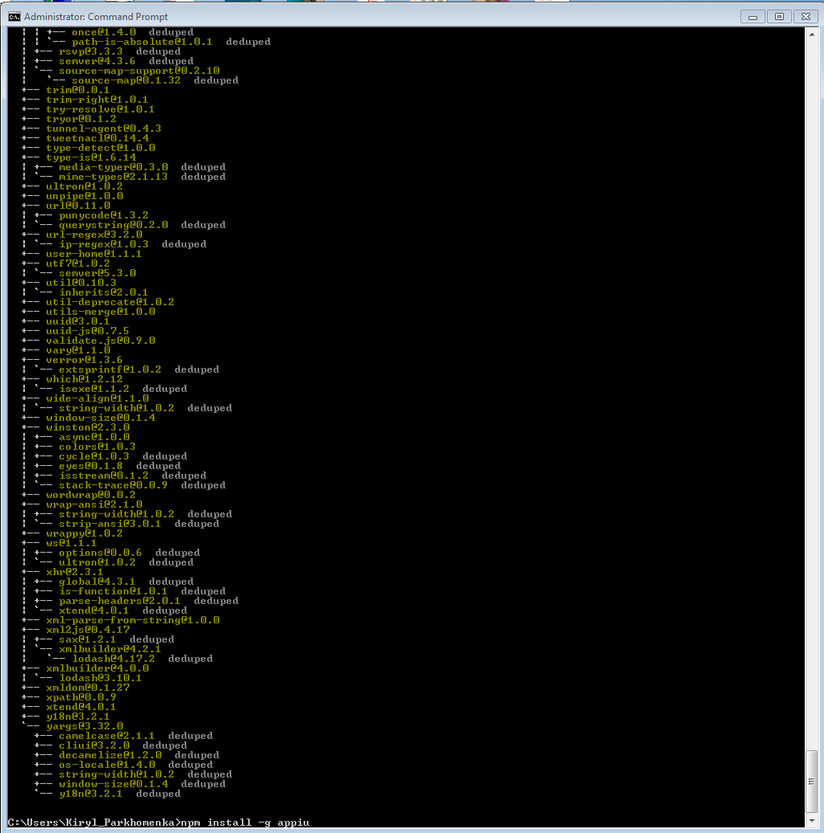

8. Command appium

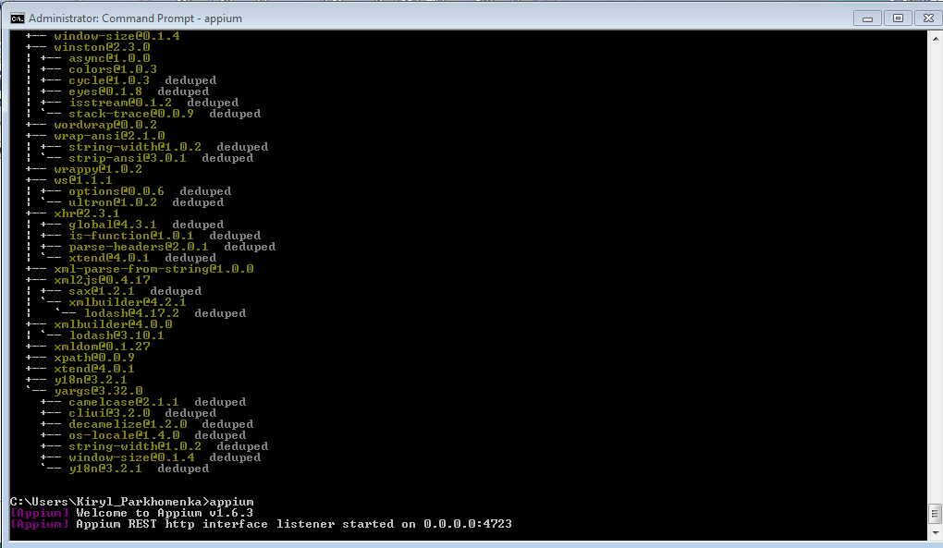

**Part 2**

I chose next app for testing: [ApiDemos-debug.apk](https://github.com/appium/sample-code/blob/master/sample-code/apps/ApiDemos/bin/ApiDemos-debug.apk)

<https://github.com/appium/sample-code/tree/master/sample-code/apps/ApiDemos/bin>

Next .java files were used:

1. **AndroidPageObjectTest_PageObjectLikeComplexElement.java**

<https://github.com/appium/sample-code/blob/master/sample-code/examples/java/junit/src/test/java/com/saucelabs/appium/AndroidPageObjectTest_PageObjectLikeComplexElement.java>

2. **ApiDemosListViewScreenSimple.java**

<https://github.com/appium/sample-code/blob/master/sample-code/examples/java/junit/src/test/java/com/saucelabs/appium/page_object/android/ApiDemosListViewScreenSimple.java>

Appium server was started:

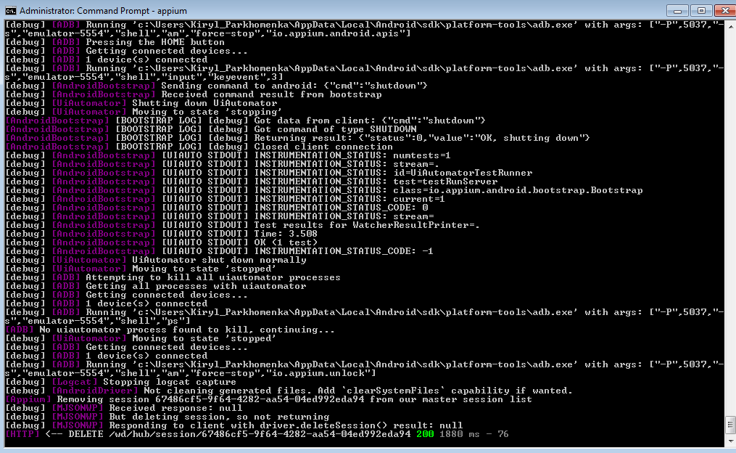

Android Studio was started.

Android Emulator was started:

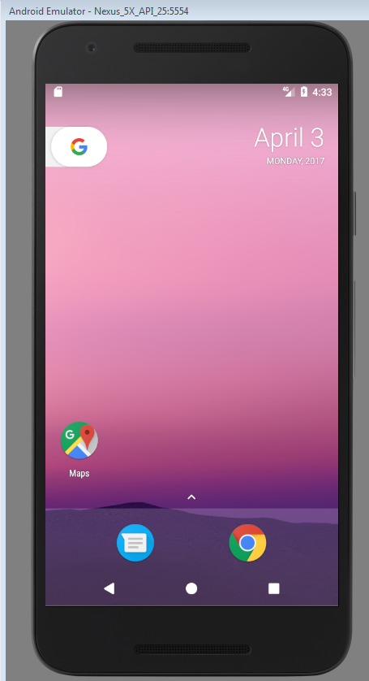

The “ApiDemos-debug.apk” file was put in the ..\Android\sdk\tools\ directory.

Also in the ..\Android\sdk\tools\ directory “run.cmd” file with next script was created:

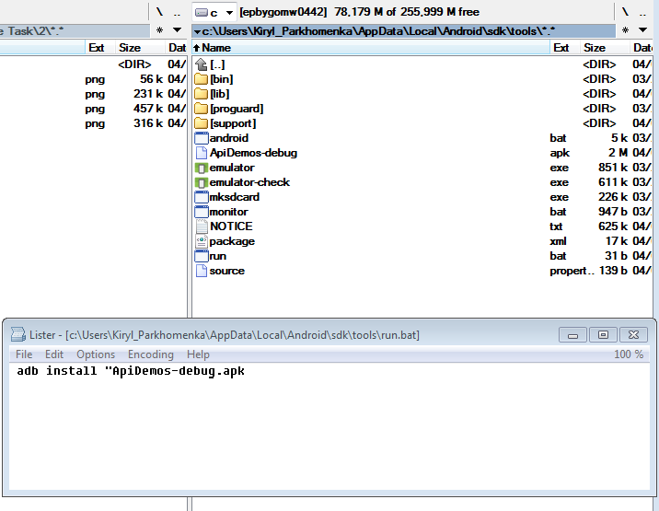

.cmd file was run to install the apk on the emulator.

Then test were run in the Idea.

