Bubble Level Using Icon Blocks
This exercise is to build a couple of levels using just a hub and an LED matrix.

1. Let’s do the build.

Attach the LED matrix to the right side of the hub using two small black connectors.
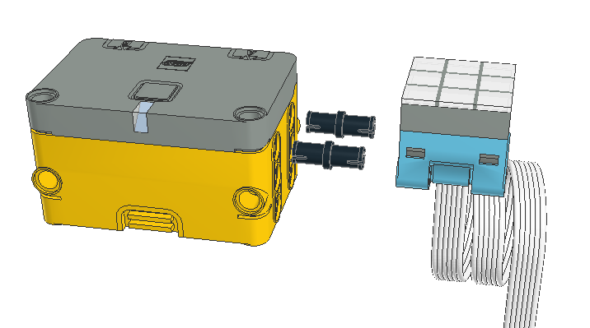

Connect the LED matrix to port A of the hub.
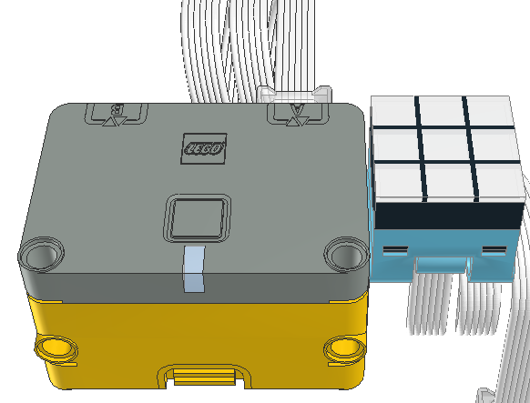

2. Test the build.
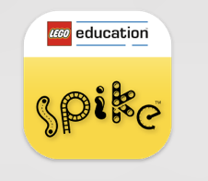
The LED matrix may be installed in one of two orientations. To test that it is correct, we need to turn on a single LED of the matrix. Turn on the host (Mac, iPad, PC), find the Spike App and start it.

When the app starts, select Spike Essentials on the left side of the window.
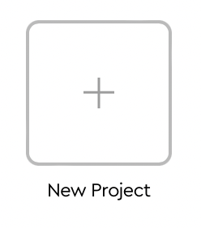
From the center portion the window, select the new project box.

Give the project a name, say “LED Test”.


Click on icon blocks.

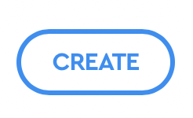
Click on the Create button to open the programming window.

The program is already started for you by supplying a start block:


In the bottom row find the block showing the LED matrix. Click and drag that block next to the start block. When the shadow appears, drop the block and it will attach to the start block.
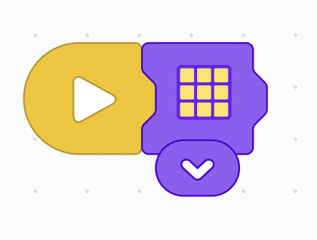

Open the drop down menue of the LED matrix block by clicking on its down arrow.
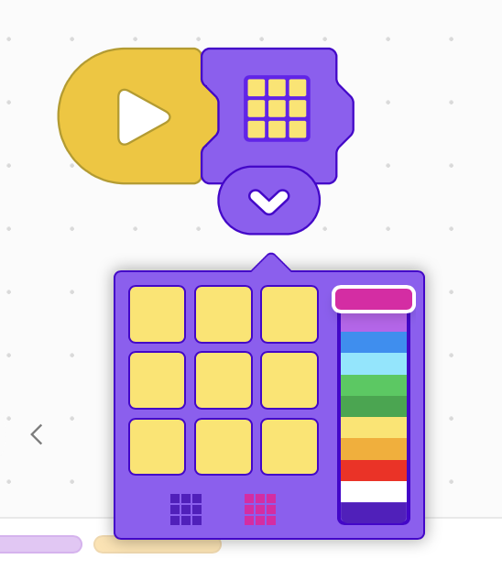

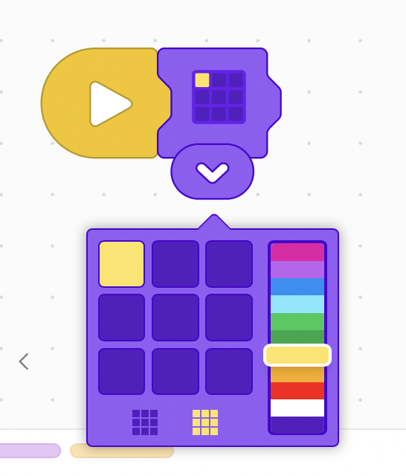
Select the colors of the LEDS so that only the upper left LED is lit. When completed it should look something like:

Close the drop down control menu by clicking anywhere on the window.
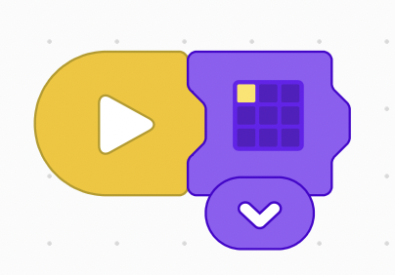

Now we are ready to connect the app to the hub.
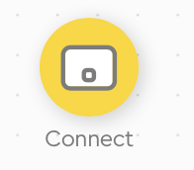
Find and click on the connect icon in the upper left corner of the app window, power up the hub by pressing the button. The LED in front of the button should flash blue.

The app window should change to show at least one hub. Select the hub you want to connect to. The LED on the hub should now light solid blue.

Return to the project window.

Press the start button in the lower right corner of the app window.

Verify that the upper left hand LED of the LED matrix is lit. If it isn’t, change the orientation of the LED display and test again.

3. Program the bubble level
Now it is time to program the bubble level.
The program should:
- When you tilt to the right, the left hand column of LEDs (the high side) light up.
- When you tilt to the left, the, the right hand column of LEDs light up.
- When you tilt forward, the top column of LEDs light up.
- When you tilt backward, the bottom column of LEDs light up.
Create a new project window and create your program.
You can try to program this yourself. (hint: you can use four “on tilt start” blocks to detect tilting. If you need help, an example program is on the next page.)
Save your program.
Test the program to make sure that the LEDs light correctly for the tilt being used.
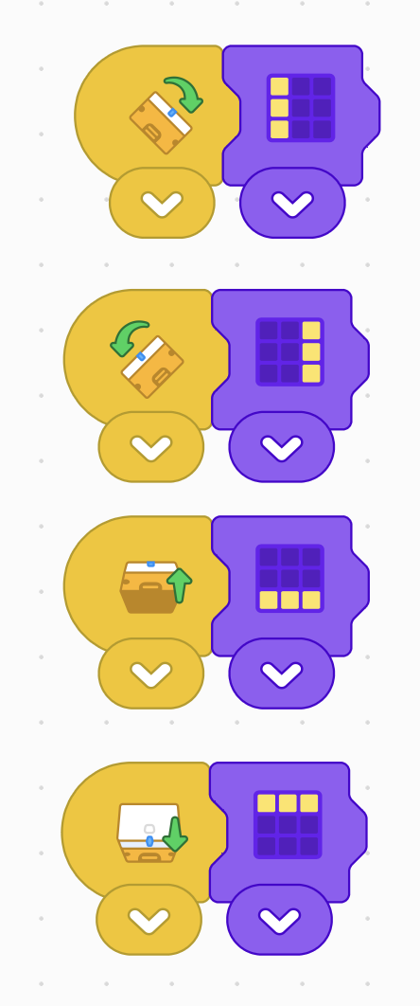
The program below works.

