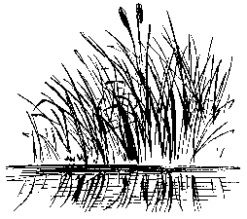

SILVER LAKES OF PASCO HOMEOWNERS’ ASSOCIATION
POST OFFICE BOX 1632
LAND O’ LAKES, FLORIDA 34639

PROXY

BE IT KNOWN, that I/we _____________________________________________, the undersigned, being the owner(s) of Lot ___________, having a street address of __________________________________________________, and the holder of One (1) Membership Interest in SILVER LAKES OF PASCO HOMEOWNERS’ ASSOCIATION, INC., a not-for-profit corporation filed under the laws of Florida (the “Association”), do hereby constitute and appoint ___________________________________ (If no one, stated then the current President of the Association) as my/our proxy and as my/our true and lawful attorney-in-fact and agent. My/Our proxy may attend the meetings of the Members of the Association or any adjournment thereof, and may vote as proxy for and in my/our name, place and stead. My/Our proxy is lawfully allowed to act in full context in and for my/our name as I/we could do if personally present. This proxy holds for any elections or transactions of any and all business which may legally come before said meetings, including the meeting which shall be held on the ______ day of ____________, 2007. Any and all proxies heretofore are hereby revoked.

DATED this _________ day of __________________, 2009.

______________________________________
Member/Lot Owner of Lot _________

______________________________________
Member/Lot Owner of Lot _________

