November 2008

Water Management District Tightens Water Restrictions in
Hillsborough, Pasco, and Pinellas Counties

Extremely low water supplies in storage as region enters dry season.

The Southwest Florida Water Management District's Governing Board voted Tuesday, October 28, 2008, to tighten water restrictions for all of Hillsborough, Pasco, and Pinellas Counties.

The Governing Board has enacted these additional measures at the request of Tampa Bay Water, the region's wholesale water supplier. Tampa Bay Water requested the District's assistance because its water supplies have not returned to pre-drought conditions.

In addition to continuing to restrict lawn watering to one day per week, the new water shortage order calls for local governments to strictly enforce the rules. Additional restrictions include:

- Restricting the time for hand-watering or micro-irrigation for non-lawn landscaping to before 8:00 a.m. or after 6:00 p.m.

- Postponing turf-grass renovation, such as replacing lawns and taking other appropriate steps to avoid an increase in lawn or landscape water use.

- Reducing the 60-day allowance for new plant establishment. During days 31-60, only every-other day watering is allowed.

- Reducing the time aesthetic fountains and waterfalls may operate from eight hours to four hours per day.

- Requiring water utilities and other local enforcement officials to increase their enforcement efforts, including requirements to respond to citizen complaints and issue citations without having first issued a warning.

The Tampa Bay Region is still impacted from two years of drought resulting in more than 16 inches of rainfall deficit for the past 24 months. All of the water resources have declined rapidly during the first month of the dry season, and the U.S. Drought Monitor shows the region in abnormally dry-to-moderate drought conditions. While groundwater levels are at the bottom of normal ranges, all major rivers in the District are below normal and lakes continue to be one to four feet below normal. Moreover, forecasts are calling for drier-than-normal conditions through next spring. Everyone must work together to conserve our water resources and water supply until such time as normal rainfall conditions return.

Do Your Part - Conserve Water
It's a Drought!

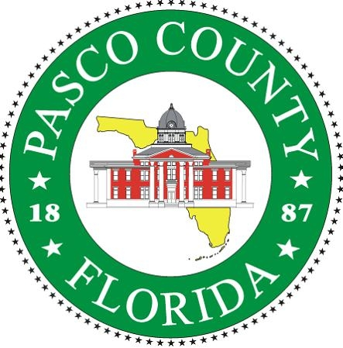 PASCO COUNTY LAWN AND LANDSCAPE WATERING RESTRICTIONS

All Water Users: Utility Customers and Citizens with Private Wells, Pasco County Remains on a One-Day/Week Lawn-Watering Schedule.

Your lawn and landscape irrigation day is based upon the LAST NUMBER of your address.

0-1 Monday | 6-7 Thursday
2-3 Tuesday | 8-9 Friday
4-5 Wednesday | Mixed OR No Address - Friday
Non-Watering Days - Saturday and Sunday

Reclaimed Water Customers Only:

Reclaimed water irrigation remains on a two-day/week schedule and is also based upon the LAST NUMBER of your address.

0-1 Tuesday and Friday | 6-7 Tuesday and Saturday
2-3 Thursday and Sunday | 8-9 Wednesday and Sunday
4-5 Monday and Friday | Mixed OR No Address - Wednesday and Sunday

Lawn/Landscape Watering Times of the Day are Restricted for ALL Water Use.

You may only water from 12:01 a.m. to 8:00 a.m. OR 6:00 p.m. to 11:59 p.m., on your designated day.

(For example, if your address is 4205 Palm Drive, your watering schedule is Wednesday, 12:01 a.m. to 8:00 a.m. OR 6:00 p.m. to 11:59 p.m.)

Violators will be subject to enforcement and fines.

In response to this latest water shortage declaration by the Southwest Florida Water Management District, Pasco County and all other Counties and cities within the Tampa Bay Area must step up enforcement. Pasco County Code Enforcement officers and Utility personnel will increase their joint efforts to enforce water restrictions. No warning will be issued, and all violations are subject to a minimum fine of $30.00, plus court fees.

Questions concerning Pasco County lawn water restrictions can be answered during normal business hours by calling (727) 847-8131 or visiting our website at www.pascocountyfl.net.

Additional information about water restrictions is also available at the Southwest Florida Water Management District's website at www.WaterMatters.org, or call 1-800-423-1476, extension 4498, during normal business hours.

CONSERVE WATER - KNOW YOUR WATERING DAY AND YOUR TIME OF DAY

