**Predicting the Growth Response of Small Douglas-fir and Ponderosa Pine Trees under Varying levels of Overstory Retention, Vegetative Competition and Site Quality**

Colin Patrick Kirkmire

Advised by Dr. David Affleck and Dr. John Goodburn

September 6, 2016

Research Proposal

Inland Northwest Growth and Yield Cooperative

College of Forestry and Conservation

University of Montana

**Introduction:**

The Inland Northwest has been the center of much research concerning the growth of conifer species in managed forests. However, throughout the later 20th century, much of the focus remained on projecting the growth and yield of large trees (4.5 ft and above) regenerating after clearcut systems.

Recent years have witnessed an increase in the use of variable retention harvest systems where structural elements of the harvested stand are left for at least the establishment of the next rotation (Franklin et al., 1997). Management objectives supported by variable retention systems may include aesthetic improvement, rapid restoration of environmental values, legal requirement, wildlife habitat quality or improved rates of natural regeneration.

Managers that are considering partial retention silviculture face a number of questions about how these systems will function over time. How will the growth of regenerated trees respond to the retained overstory? Will the amount of vegetative competition be dependent on the amount of the overstory canopy retained? What is the effect of site productivity in either case?

The Inland Northwest Growth and Yield Cooperative responded to these questions by initiating the Small Tree Competing Vegetation (STCV) study in 1998. Since then, 23 installations have been maintained across many ownerships within Montana, Idaho and eastern Washington. The study was completed in the summer of 2015 and the result is a detailed record of long term small tree growth that spans a wide range of overstory and site conditions.

The four primary relationships that form the biological framework for this analysis are between small tree growth on the one hand and on the other hand the associated site productivity, retained overstory, understory non-tree vegetation and small tree stalking levels.

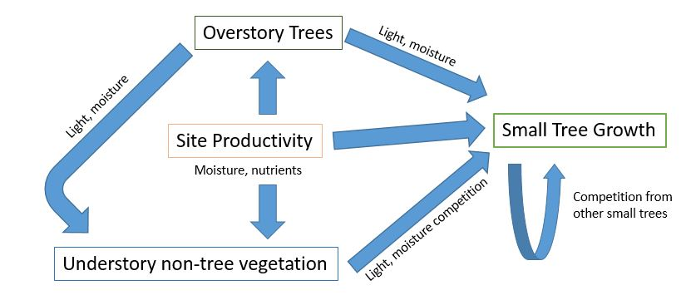

Figure : Biological framework of small tree growth. Small trees are defined as those that have a DBH less than 3.5 in.

Knowledge of small tree growth is vital to projecting when younger cohorts will be recruited into the canopy and what long term growth rates can be expected in partial retention silviculture in the Inland Northwest.

**Data:** Scope and Design of the Small Tree Competing Vegetation Study (STCV)

Study sites (termed “installations”) were established on a variety of cooperative member ownerships ranging from the eastern slopes of the Cascade Mountains to western Montana. The installations fall within three distinct geographic areas; central Washington, eastern Washington/Idaho and western Montana.

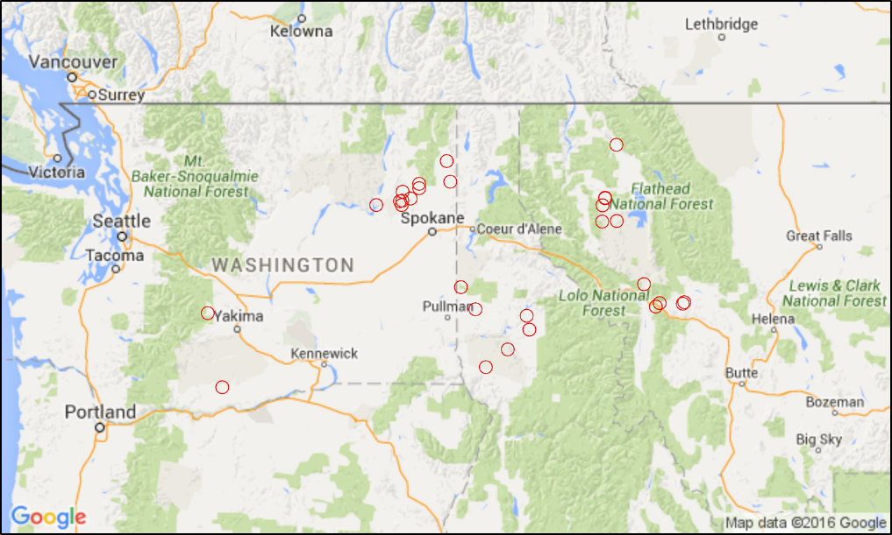

Figure : Geographic location of STCV installations

Installations were established in stands with various forest cover (e.g., mixed ponderosa pine, Douglas-fir, and grand fir types), with each stand exhibiting relatively homogeneous levels of site quality, overstory tree density, and understory competition. Installations were located in recently harvested stands that were either clearcut or harvested with one of the aforementioned variable retention harvest systems: shelterwood, seed tree and heavy thinning.

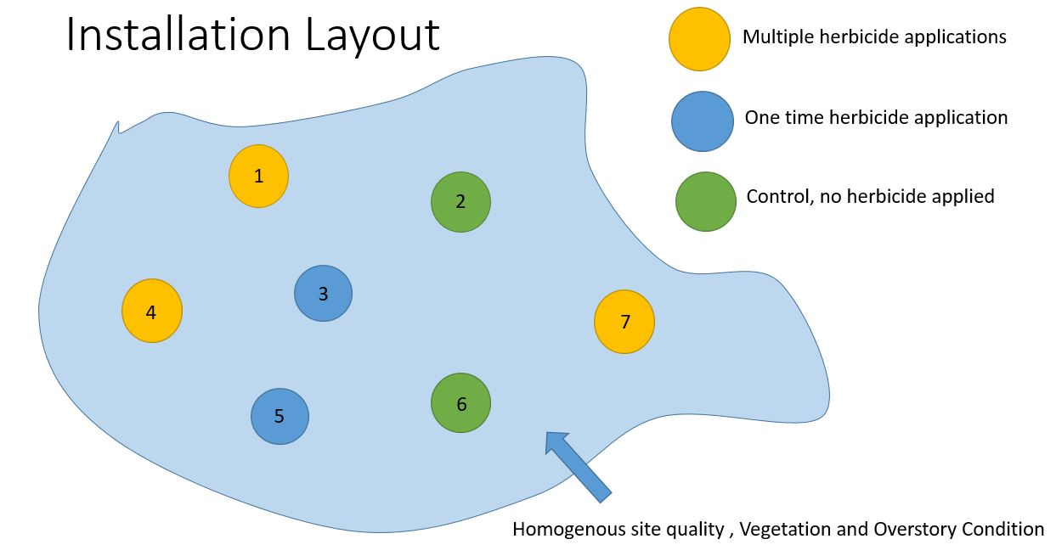

Figure : Example of an STCV Installation

Treatments were randomly assigned to seven plots within each installation (Figure 3). Three plots received multiple applications of regionally effective herbicide. The remaining four plots are split between the one-time treatment group (just one application of herbicide) and control plots which received no herbicide treatment.

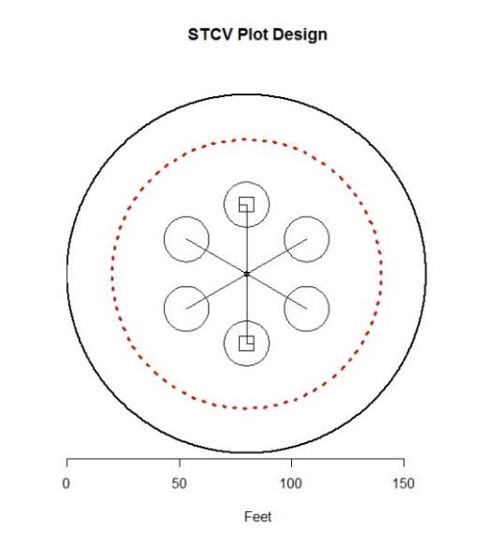The primary objective of the different herbicide treatments is to decouple the direct and indirect effects of removing overstory. The removal of the overstory increases available light which is hypothesized to encourage small tree growth as well as non-tree vegetation. The herbicide treatments allow us to see how small trees grow under reduced overstory without the presence of a corresponding increase in non-tree vegetation.

Each plot contains a series of nested plots that decrease in area with physiologically smaller vegetation units (Figure 4). Starting with the full extent of the plot, overstory trees (> 10.5 in DBH) were measured on an approximately half acre. Medium trees, with DBH greater than 3.5 in but less than 10.5 in were measured on a smaller nested plot of roughly a quarter acre.

Small trees were measured on six .007 acre plots 60 degrees apart from plot center at a distance of approximately 30 feet. Small trees are defined as those that have a DBH less than 3.5 in yet are greater than .5 ft in height for shade tolerant species or 1 ft for shade intolerants at the time of initial measurements.

Figure : Plot Design. Note that each of the six small tree plots has square vegetation plots within it but these are drawn only on two

There were two sampling methods used to measure vegetative competition. The first was transect based where point measurements of vegetation were obtained at one foot intervals along a 40 ft transect. We also took vegetation measurements in the middle of the small tree plots in the form of both 1m2 and 4m2 grids. These vegetation measurements quantified separately the amounts of forbs, grasses and shrubs to the species level. This is an example of how the resolution of the data goes beyond the scope of the proposed analysis though will undoubtedly be of use in future research efforts.

Figure 5 shows the temporal scope of the data collection as well as herbicide applications and overstory measurements. An attempt to capture growth at each installation at four year intervals was successful for many installations but in some cases the intervals are somewhat irregular (i.e., 3-5 years in length). The schedule of measurements was based on the twelve-year projection cycles that were used by participating cooperative members.

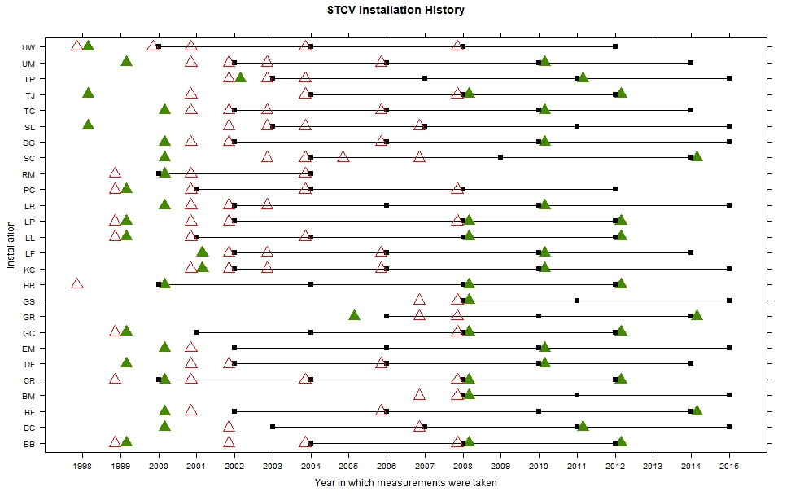

Figure : Measurement, overstory and herbicide application timeline by installation. The black squares are the measurement years that form the proposed measurement intervals (note that additional measurement years were obtained). The green triangles represent years of overstory tree measurements and the red triangles are years of herbicide application.

A point of concern is that some measurements were taken at times that would not have allowed for the herbicide applications to take full effect. That is, several measurements were concurrent with or followed too quickly after the first herbicide application. This necessitates careful selection of the appropriate measurement years on a per installation basis. Ultimately, the growth measurements will be put on the same temporal scale of periodic annual increment regardless of whether they were collected on a 3, 4 or 5-year interval.

**Research Questions:**

**1) Can we accurately quantify the small tree growth rates of *Pseudostuga menziesii* (PSME) and *Pinus ponderosa (PIPO)* in the study installations?**

I am interested in ways to improve predictions of small tree growth in the Inland Northwest. I believe that the ability to closely predict the growth of small trees has the potential to lend itself to further acceptance and refinement of variable retention silviculture. Once forest managers have the ability to anticipate growth of small trees under varying levels of site quality, overstory and vegetative competition they will have a stronger basis for making decisions regarding levels of retention and vegetation control for a given stand.

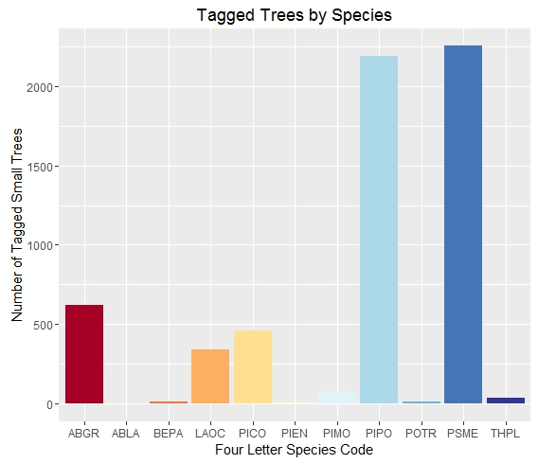A parsimonious model that can provide users the ability to predict the growth rates of juvenile PSME and PIPO would be of great utility for forest managers that employ variable retention silvicutural systems. In addition, the proposed model may benefit those who are investigating such systems and curious about what kind of understory cohort growth rates can be anticipated. PIPO and PSME are the subject species for this analysis because they represent the two most populous and commercially viable species in both the Inland Northwest region and the scope of the study (Figure 6).

Figure : Unique Tagged Small Trees by Species

Past STCV analysis (eg. Keller 2005, McHugh 2009) have attempted to describe growth rates with linear regression models but with data from a much narrower time frame. A three-fold increase in the amount of temporal data will result in a much more reliable picture of how growth rates change over this extended period of time. Furthermore, because this complete dataset includes a large number of tagged trees that have since grown out of the small tree classification (DBH<3.5 in), a model developed from these data will be able to provide a smoother and more reliable transition to large tree models.

An attendee at a recent technical conference remarked that it is common to observe some small trees that “stay small for many years” after being shown the graph below (Figure 7). This brought about considering models that may better represent the full distribution of growth responses and the growth response of the trees that are most likely to be eventually recruited into the larger size classes.

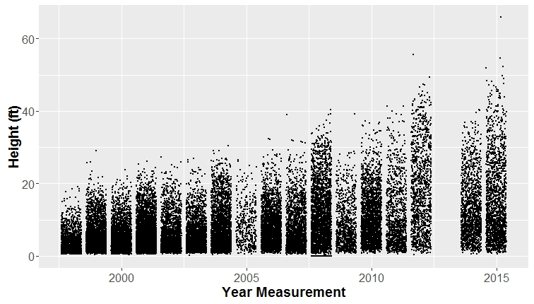

Figure 7: All measured small tree heights across measurement years

The mean response has been the focus of many models of overstory tree growth in homogenous closed-canopy stands. This is justified in that context since mature trees are at a stage in stand development in which observed individual tree growth increments may be near the predicted mean growth response (often expressed as diameter squared increment, see Wykoff et al. 1982)

However, when modeling the growth response of small trees to varying site and stocking conditions, it is very likely that the growth response distribution exhibits heterogenous variance (Figures 7 and 8). As in many statistical models that attempt to describe an ecological process, there are omitted factors that lead to a weak predictive relationship between the mean of the response variable and the measured predictive factors (Cade and Noon 2003).

For example, trees that grow at slow rates may be growing on poor microsites and not limited by understory vegetation or overstory light levels. In contrast, trees on the best microsites, or with better vigor, may demonstrate differential growth rates as a function of vegetation structure. Possible omitted factors in the ecological process of small tree growth include soil, genetic characteristics and spatial information relating to distance from overstory trees.

In addition, the mean growth response of small tree growth is not necessarily of primary interest to land managers since the mean growth may not be representative of the trees that are eventually recruited into the canopy. Many of the smaller and lower vigor trees will die over time as a result of suppression. Only the faster growing trees, perhaps those in the top 20% of growth response (above the .80 quantile) may emerge as the future crop trees.

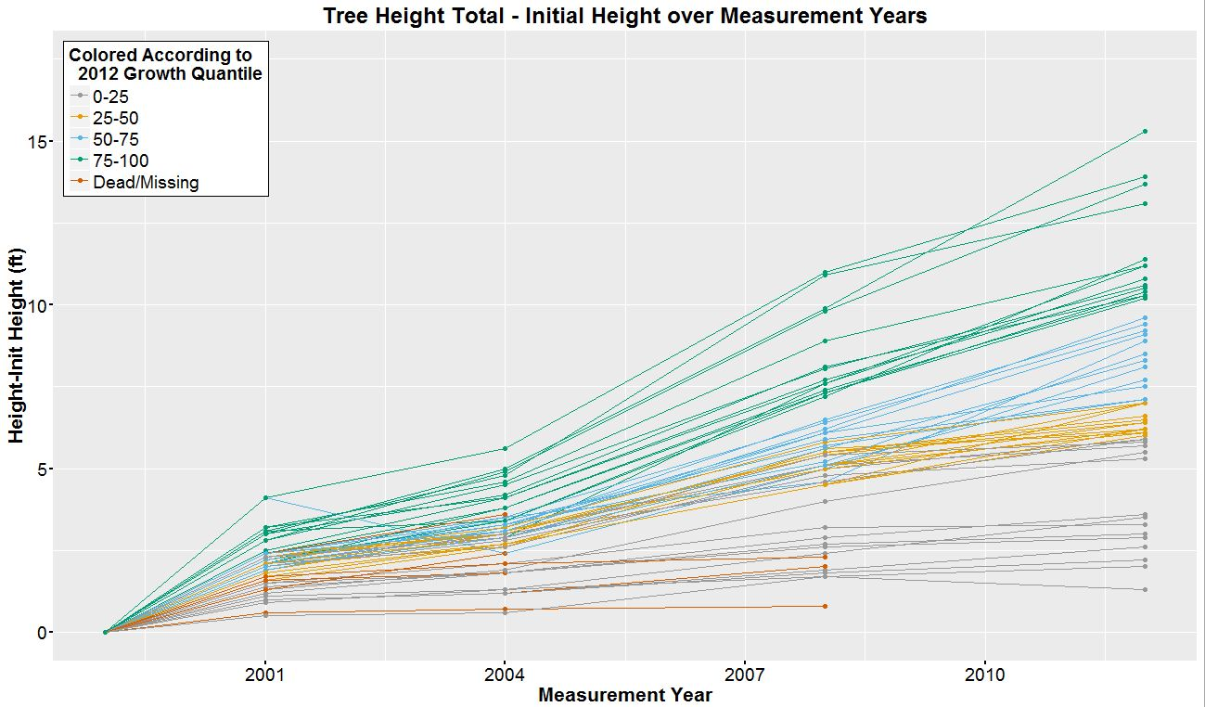

Figure 8: Heights of a sample of individual small trees from a single installation. It is apparent that the trees with the highest growth increment in the later years of measurement were also the fastest growing trees in the previous measurement years. In a practical sense, the trees that will be recruited into the canopy will likely lie in the upper quantiles whereas the lower quantile trees are likely fated to continue to stagnate in the understory and die.

To develop a regression model with multiple rates of estimated change, I propose the use of quantile regression (Koenker and Bassett 1978). This type of regression will estimate the conditional quantiles of the growth response through the simplex linear programing solution that minimizes the sum of weighted absolute deviations. This information is important to incorporate into a model for small tree growth and may provide a better view of causal relationships being examined than using a single rate of change to describe the mean of the growth response variable distribution.

It is important to note that a major objective of the research will be to evaluate quantile regression methodology as a tool for predicting the growth rates of trees. This will require a review of past research that has utilized quantile regression as well as a report on the challenges of utilizing quantile regression for this dataset. Ultimately, it should provide a window into the utility of quantile regression for applications in forestry and ecology models of tree growth with limiting ecological relations.

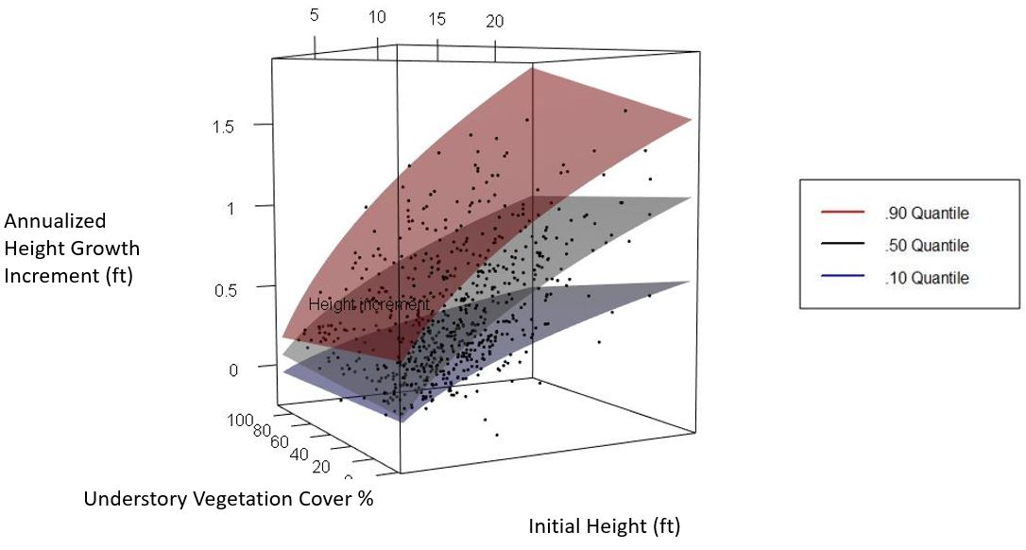

Figure 9: Example of quantile regression from STCV data (PIPO at the Loon Lake installation). From the bottom, the quantiles represented are .10, .50 and .90. The regression term is based on understory vegetation cover, initial height and the interaction between these terms.

Figure 9 shows an example of quantile regression surfaces and how it allows different slopes and intercepts to be estimated at difference quantiles of the response variable distribution. In this example, the trees in the .90 quantile of the growth increment response distribution are much more sensitive to an increase in vegetative cover than the trees in the lower quantiles. In fact, for the trees in the .50 quantile (i.e. median growth), the slope of the growth surface with respect to the understory vegetation cover axis changes sign so that estimated growth decreases with a decrease in understory vegetation cover. This predictor could also be pulled out from the model entirely for this quantile if it is not a significant predictor resulting in qualitatively different models for median and .90 quantile growth.

There are numerous advantages to understanding the growth responses at different quantiles. For example, the small trees that will eventually be of commercial interest will lie in the upper quantiles, so we may want to focus on their growth. We will also be able to better compare the growth responses of these trees of interest across varying conditions (i.e. high to low residual overstory). Additionally, the interval between the .90 and .10 quantiles is an 80% prediction interval for any single future observation and is not dependent on any normal error distribution like in least squares regression (Neter, et al. 1996).

*Which of the predictor variables are best at predicting PSME and PIPO juvenile tree growth over the complete growth period?*

A number of measurements were acquired over the course of the study and can be summarized as pertaining to four distinct categories: overstory measurements, understory measurements, vegetation measurements and site measurements.

Residual Overstory measurements: (Species, Top height, crown ratio, diameter at breast height)

These measurements attempt to describe the retained overstory conditions of each plot. Previous research has found that a decrease in ponderosa pine overstory through thinning reduces belowground competition for soil water and nutrients resulting in a 94% increase in understory aboveground biomass (Riegel, 1992). This resulting increase in understory vegetative biomass means increased competition levels of a different nature for small trees, although the severity may be dependent upon the quality of the site.

Understory tree measurements: (Species, Top height, basal diameter, diameter at breast height, crown length, crown width, number per height class per acre)

Small tree measurements on tagged trees capture the growth in terms of both height, diameter, and crown length. The small tree plots also provide an estimate of small tree density that extends beyond the tagged subject trees by tallying the number of trees in each two-foot height class.

Non-tree Vegetation measurements: (Species, horizontal percentage cover, upper and lower vertical extent, projected leaf area of grasses)

The on-arborescent vegetation measures provide an idea of the level of aboveground biomass that the small trees are competing against. The level of detail in these measurements exceeds the scope of analysis. Busse et al. (1996) examined the effect of understory vegetation on ponderosa pine and found that growth was reduced by heavy understory vegetation during the first 12 to 20 years. However, their results also demonstrated that understory vegetation plays an important role in maintaining soil quality. Thus, perhaps some level of vegetative competition is beneficial for small tree growth.

Figure 10 shows that average vegetative volume is lowest for sites with low site index across values of residual basal area. Site index (SI) is a measure of site productivity defined as the mean height of dominate trees at a base age of 50 years. Residual basal area is the aggregate cross-sectional area of residual overstory trees at 4.5 feet. As the SI increases, the residual overstory appears to play a larger role in determining the volume of understory vegetation. The graph also displays the effectiveness of the herbicide applications since it compares the control and multiple application herbicide treatments at each installation. There is a roughly .1 ft3/ft2 decrease in average vegetative volume between the treatments.

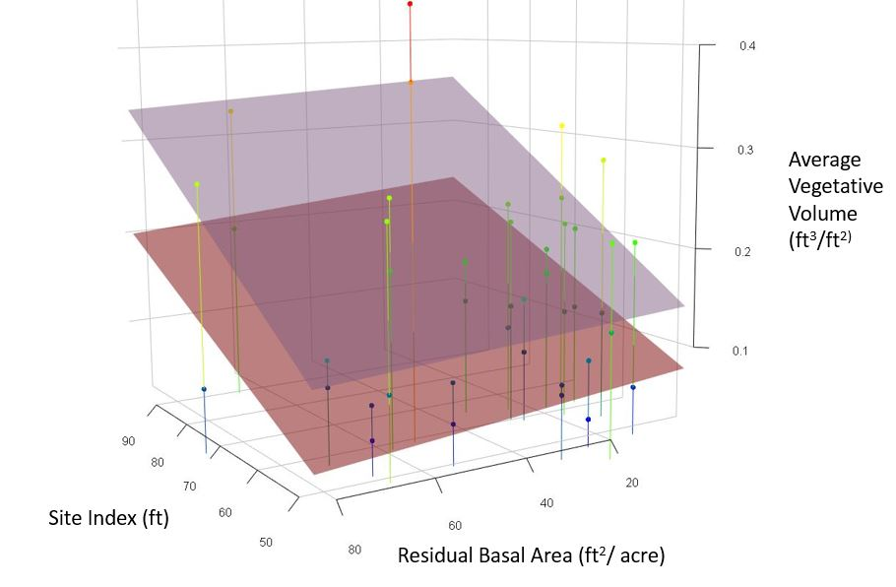

Figure : Site Index and Residual Basal Area per Acre vs Average Vegetative Volume. Each line represents one installation and every dot represents the vegetative volume obtained from the 4m2plots on both the control plots (higher vegetative volume) and the multiple herbicide application plots (lower vegetative volume). The upper and lower plane are fitted to the control and multiple herbicide plots within each installation respectively.

Site Measurements: (site index, elevation, aspect, habitat type)

Site measurements were obtained at the establishment of each installation and attempt to capture installation-wide site characteristics.

*Which vegetation sampling method (line transect vs 4 m2 plot vs 1 m2 plot) is best for giving us an expression that impacts the tree growth across the duration of the study?*

We have two sampling methods of vegetation cover: line transect and fixed area plot. The line transect sampling method involves a higher precision or repeatability in that height measurements are taken on a 1 foot intervals along a 40-foot line. In contrast, the 4m2 and 1m2 plots both involve ocularly estimating percent covers and taking average heights. Between the 4m2 and 1m2 plots, the small size of the 1m2 offers a distinct advantage in practicality and was measured from inception of the study.

As to how these methods capture vegetation that affects the growth of small trees, it may be the case that they are equivalent. However, it would seem as though the 1m2 and 4m2 plots may relate better to the growth of small trees since these plots are placed in the center of the plot of tagged trees and thus are a more spatially informed measure of vegetation that affects the small trees. Although the line transects do terminate in the center of the small tree plots, they mostly capture vegetation levels external to that of the small tree plots.

The selection of appropriate vegetation variables will be achieved by quantile regression of the dependent variable (small tree height growth) as a function of the non-understory vegetation variables for each species then individually adding each understory vegetation variable. The variable that yields the smallest RMSE for each quantile regression is the best for predicting small tree height growth.

Interaction terms that consist of combinations of predictor variables derived from each of the aforementioned categories of measurements will be evaluated through a stepwise quantile regression. This will, for example, allow evaluation of site index effects with or without vegetation.

**2) How do predictions from the proposed model compare to FVS Inland Empire predictions?**

Just as advances in silviculture have led to a greater use of variable retention systems, advances in forest growth models have increased due to the greater availability of personal computers to perform data analysis and simulations (Weiskettel et al., 2011). One of the principal examples of such a model is the Forest Vegetation Simulator (Dixon, 2015) which is used by the USDA Forest Service and is also available for the public.

Once our model for small tree growth is obtained it would make sense to compare its median growth increment projections against that of the USFS Forest Vegetation Simulator Inland Empire Variant (Keyser, 2015).

The Inland Empire Variant defines a small tree as having a DBH less than 3 in. Mean height growth is driven by height, species, stand crown competition factor, slope, aspect, location, habitat type and basal area of trees larger than the subject tree (Keyser, 2015). As small trees approach a minimum DBH, alternative large-tree growth equations are used in conjunction with the small tree equation in an effort to smooth the transition between the estimates for the two classifications (Keyser, 2015).

If our model more closely approximates the attained heights of small trees it is arguable that the model developed using STCV data should be used to improve the small tree growth regiment of the FVS Inland Empire Variant. For validation and comparison against FVS estimates, I propose that the sixth small tree plot of every plot in every installation be withheld from the model building process.

**Literature Cited:**

Busse, M.D., Cochran, P.H., Barrett, J.W., 1996. Changes in ponderosa pine productivity following removal of understory vegetation. Soil. Sci. Soc. Am. J. 60, 1614-1621.

Cade, Brian S. "A Gentle Introduction to Quantile Regression for Ecologists." Front Ecol Environ

1.8 (2003): 412-20. Web.

Dixon, Gary E. Essential FVS: A User's Guide for the Forest Vegetation Simulator. Rep. USDA Forest Service,

Nov. 2015. Web. 2 June 2016.

Gregg M. Riegel, R. F. M. and W. C. K. (1992). Competition for Resources Between Understory

Vegetation and Overstory Pinus Ponderosa in Northeastern Oregon. Ecological

Applications, 2(1), 71-85

Franklin, J.F., D.R. Berg, D.A Thornburgh, and J.C. Tappeiner. 1997. Alternative silvicultural

approaches to timber harvesting: variable retention harvest systems. In K. Kohm and J.F.

Franklin, Creating a Forestry for the 21st Century. Island Press, Washington, DC

Keller, Kathryn A. "Applying the Prediction of Four-Year Height Growth of Douglas-fir and

Ponderosa Pine Saplings to an Existing Growth Simulator." Thesis. University of Montana,

2005. Print.

Keyser, Chad E., comp. 2008 (revised November 2, 2015). Inland Empire (IE) Variant Overview – Forest

Vegetation Simulator. Internal Rep. Fort Collins, CO: U. S. Department of Agriculture, Forest

Service, Forest Management Service Center. 58p.

Koenker, Roger, and Gilbert Bassett. "Regression Quantiles." Econometrica 46.1 (1978): 33. Web.

Koenker (2016). quantreg: Quantile Regression. R package version 5.24.

<https://CRAN.R-project.org/package=quantreg>

McHugh, R.P. 2009. Effects of overstory retention and understory vegetation on small tree height growth

in the Inland Northwest. M.S. Thesis, University of Montana, Missoula.

McLeod, S. D. and Running, S. W.: Comparing site quality indices and productivity in ponderosa

pine stands of western Montana, Can. J. For. Res., 18, 346-352, 1988.

Neter, J. Kutner M. H. Applied Linear Statistical Models. Boston: WCB/MacGraw-Hill, 1996.

Weiskittel, Aaron R., David W. Hann, John A. Kershaw, and Jerome K. Vanclay. Forest Growth and Yield

Modeling. N.p.: John Wiley & Sons, 2011. Print.

Wykoff, William R., Nicholas L. Crookston, and Albert R. Stage. "User's Guide to the Stand Prognosis

Model." (1982): n. pag. USDA Forest Service. Web.