Name: Kirk (Jack) Partridge

Title: Stock Tracker

Project Summary: A GUI application that will aid with tracking stock purchases and sales. Will allow users input recent stock transactions and will keep track of performance of said stocks. Users will also be able to request a dump of all previous transactions as well as import transactions from a csv file.

Project Requirements:

|  |  |
| --- | --- |
| ID | Description |
| US-01 | As a user, I want to be able to sign up to use the application. |
| US-02 | As a user, I want to be able to login using credentials established during sign up. |
| US-03 | As a user, I want to be able to input a new stock transaction. |
| US-04 | As a user, I want to be able to remove old stock transactions. |
| US-05 | As a user, I want to be able to view details of a specific stock transaction. |
| US-06 | As a user, I want to be able to view current stock performance. |
| US-07 | As a user, I want to be able to search for transactions by ticker symbol. |
| US-08 | As a user, I want to be able to view search results in a single window. |
| US-09 | As a user, I want to be able to select from search results to display a specific transactions details. |
| US-10 | As a user, I want to be able to request a csv download of all transaction data. |
| US-11 | As a user, I want to be able to import a csv of transaction data. |
| US-12 | As a user, I want to be able to follow a URL hyperlink for a specific stock. |

UI Mockups:

Each page will have a home button that will return the user to the home screen. Many functions are in the File / Import / Export tool bar at the top of each window. This will be written in C++ using QT. If these pictures are hard to see / read, see github for fullsize images.

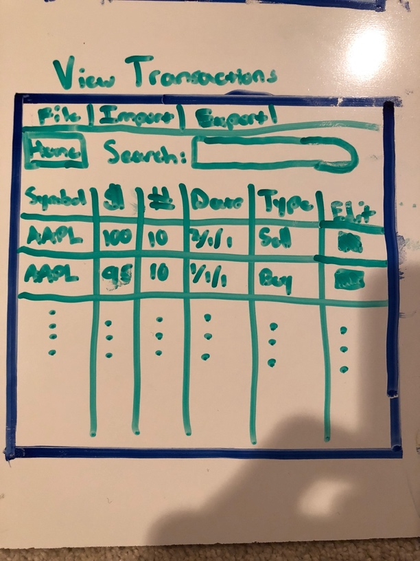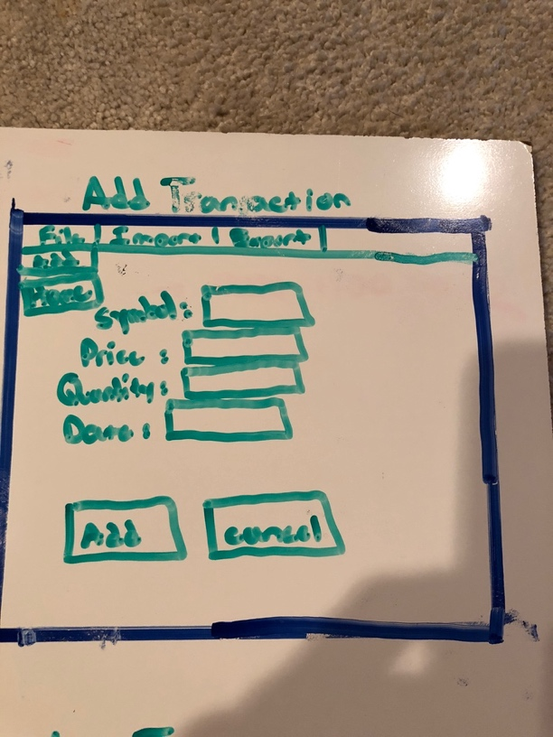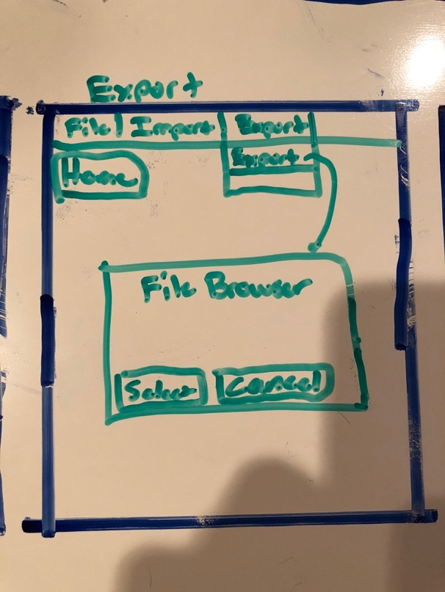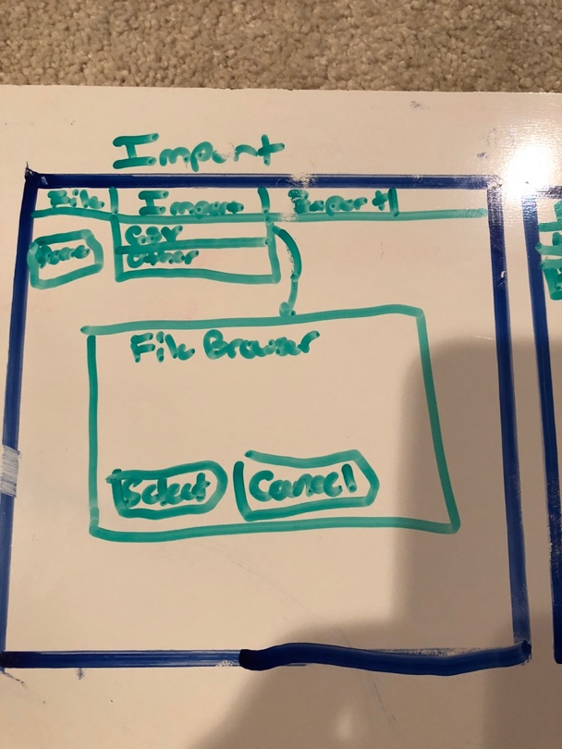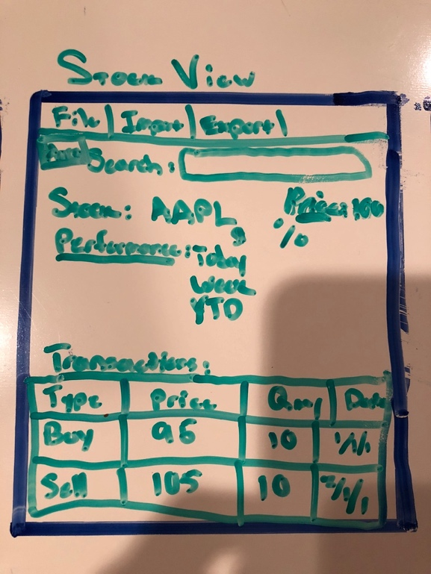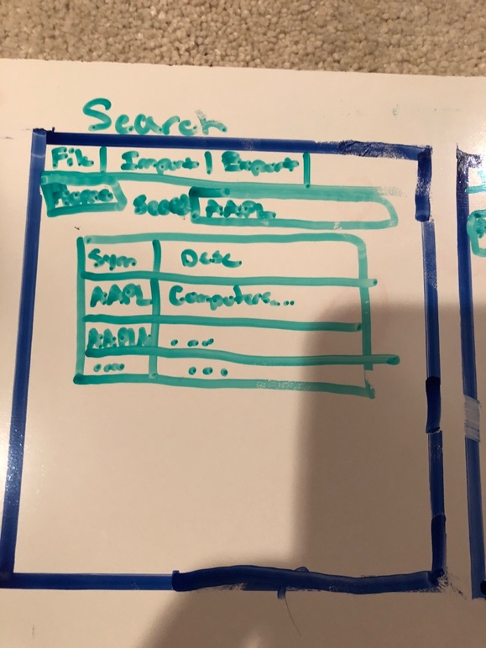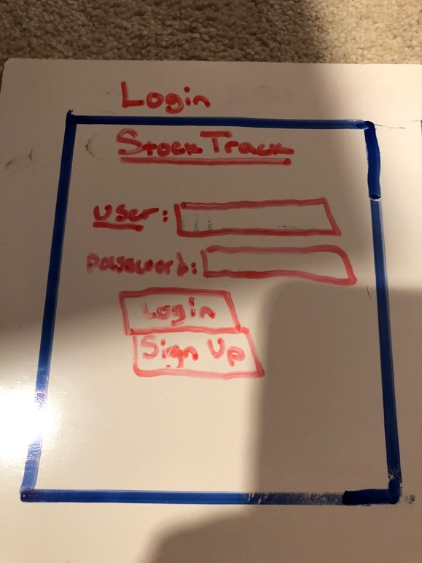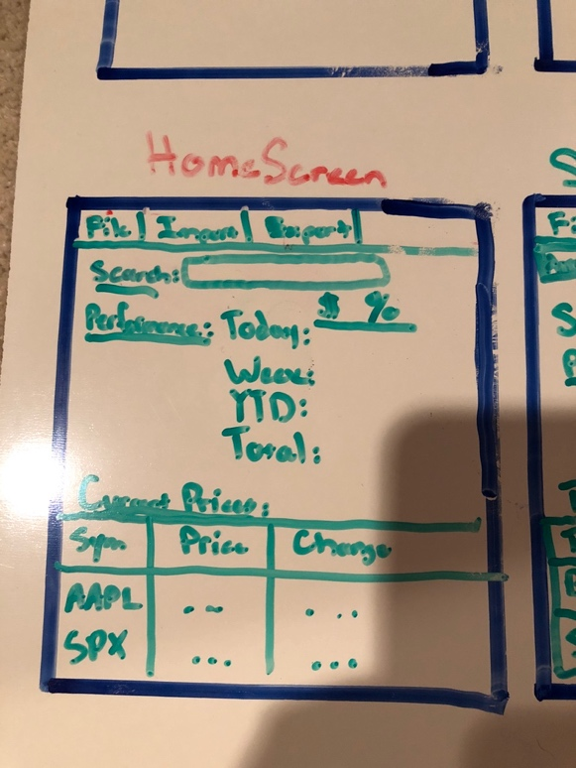

Class Diagram:

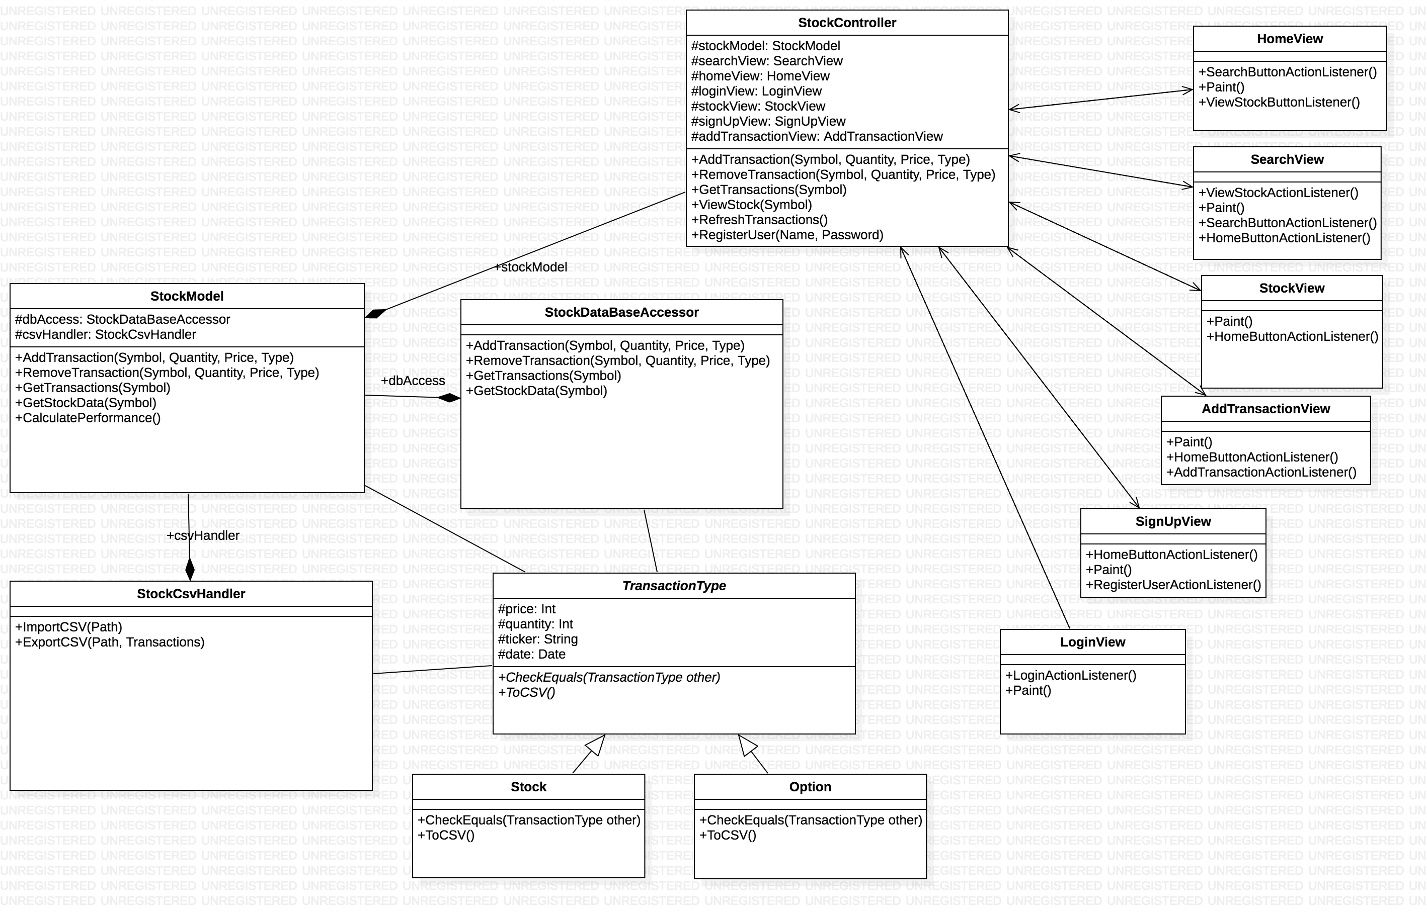

Bigger image available in github.

Design Patterns: In Work – MVC, Template, Another TBD.