CPE403 – Advanced Embedded Systems

# Design Assignment #06

DO NOT REMOVE THIS PAGE DURING SUBMISSION:

Name: Cameron Kirk

Email: kirkc1@unlv.nevada.edu

Github Repository link (root): https://github.com/kirkster96/DqF514-not-embedded

Youtube Playlist link (root):

<https://www.youtube.com/playlist?list=PLiqmqQ7XKuf7ArV7lO6b20D1ES5SUp0Yk>

**Follow the submission guideline to be awarded points for this Assignment.**

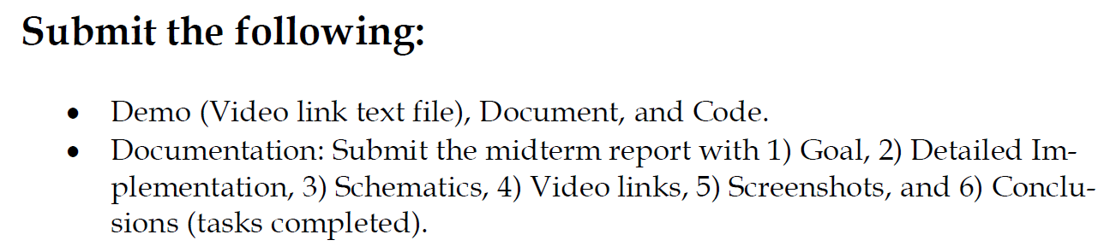

1. Goal

The goal of this assignment was to use the Beagle Bone Enhanced to connect the LAUNCHPAD-XL as a coprocessor and connect a sensor to the network. The Linux gateway will then host a node.js web application that can display the sensor data in the network to the user.

1. Detailed Implementation

My implementation was achieved by the coprocessor project provided by the resource explorer to take the role of the collector. The sensor tag used the same code as the previous assignment 05 and is able to connect to the network and transmit data from the LPSTK sensors. The Beagle Bone Enhanced was programed using the TI evm image that was recommended by the Linux Gateway

1. Schematics

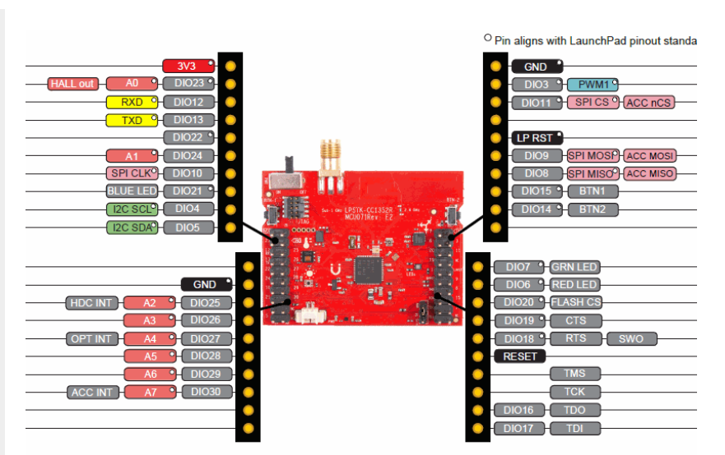

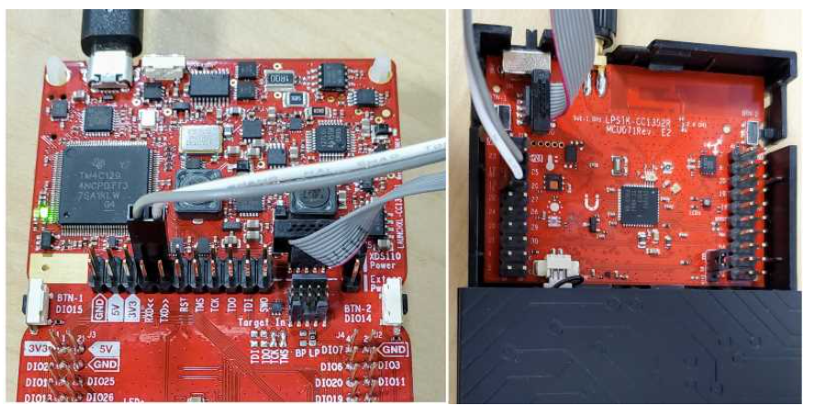

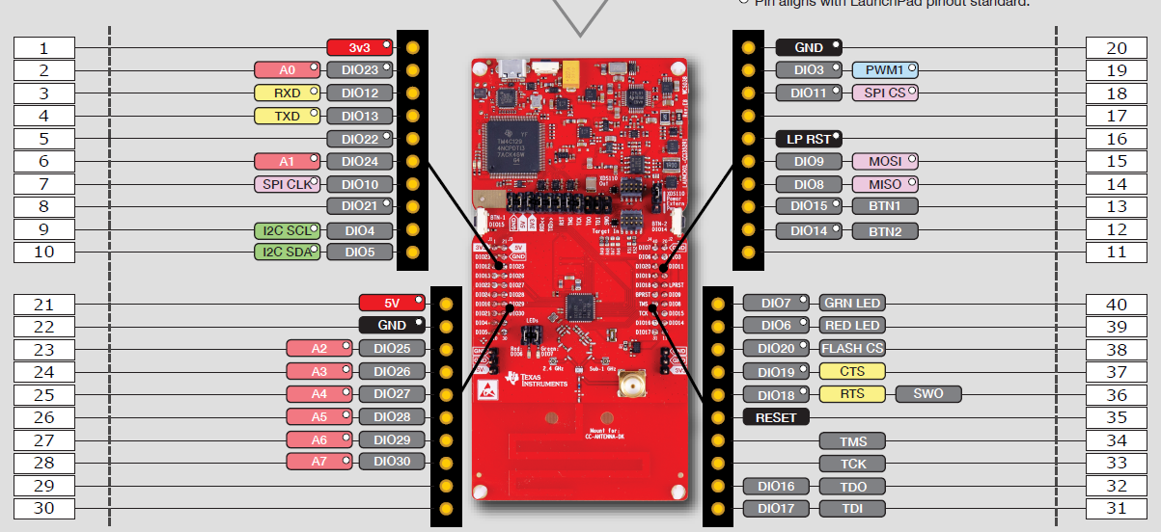

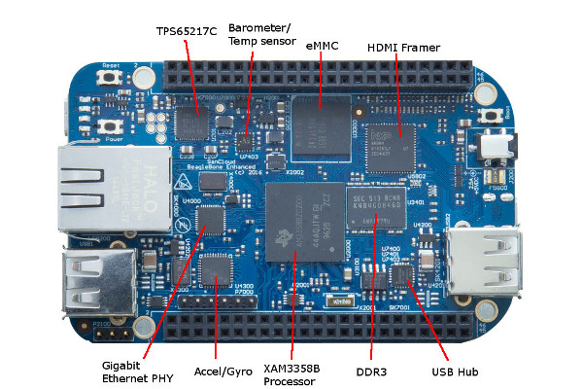

1. Screenshots

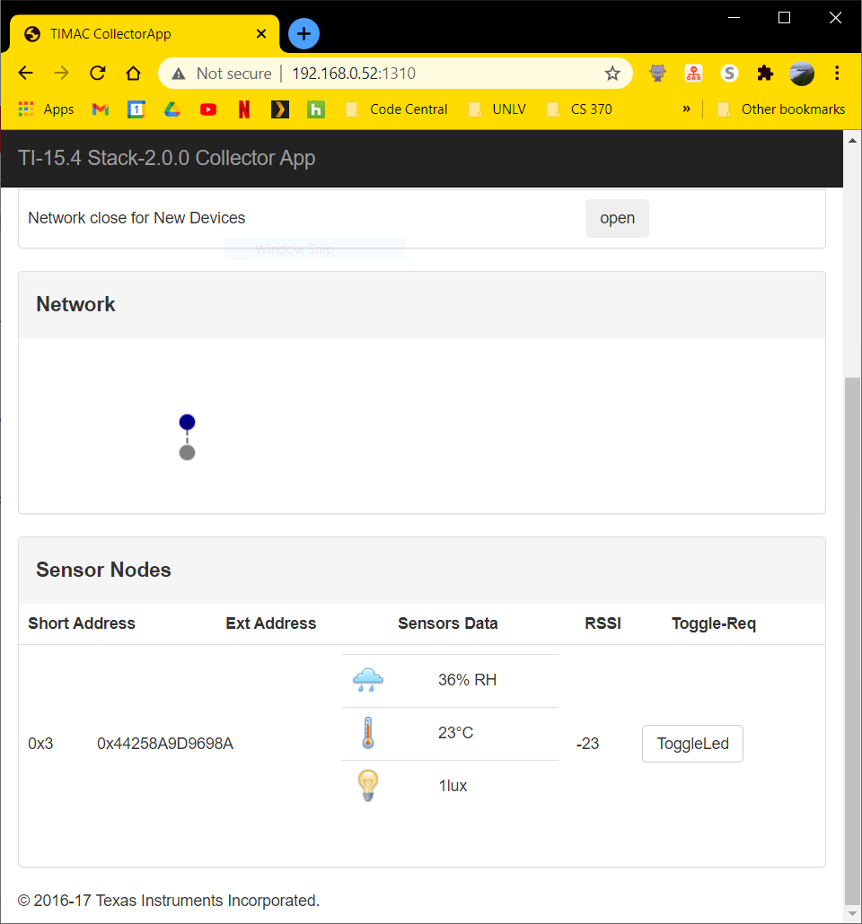

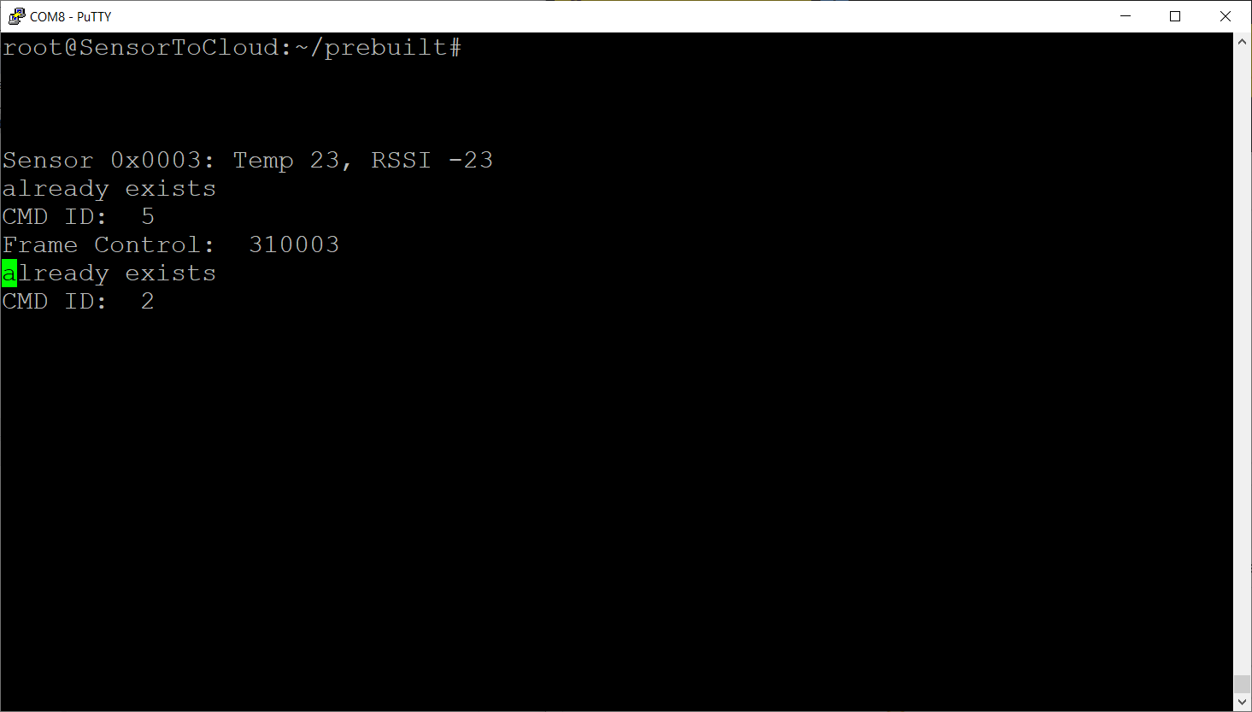

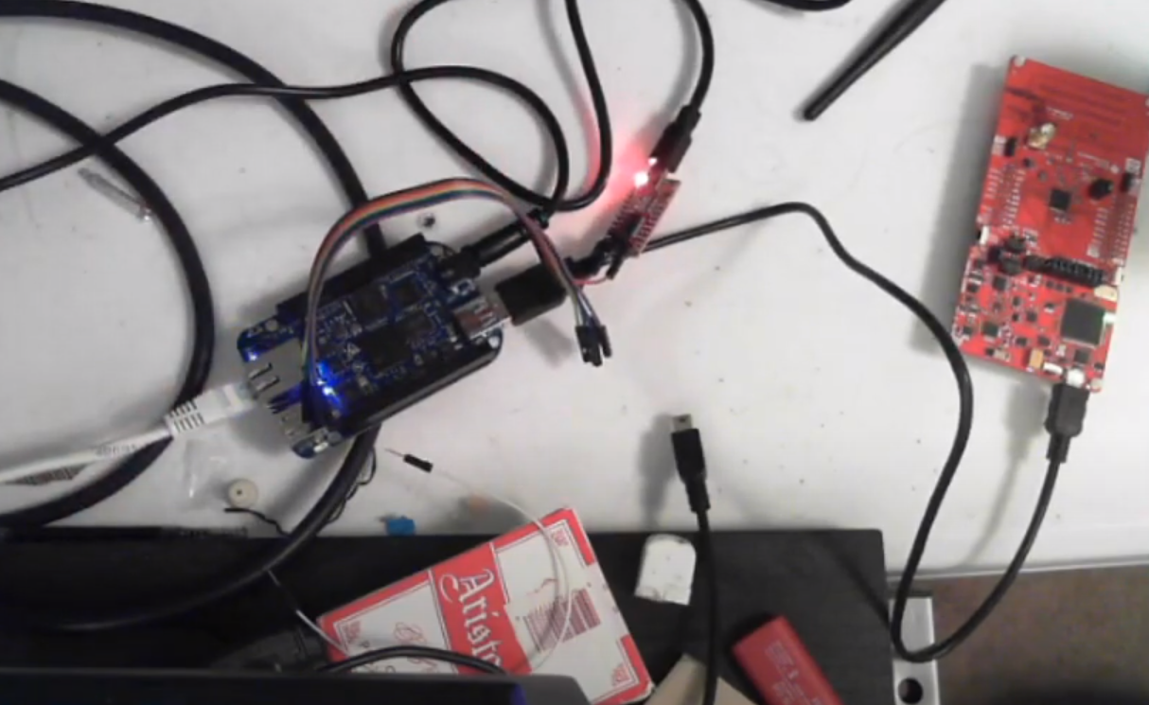

1. Video Links

<https://youtu.be/Av-i3C2hCrI>

1. Conclusion

In conclusion, the TI 15.4 Stack continues to prove to be very versatile in it’s capabilities. It is capable of also handling coprocessor capabilities with minimal modification to the code in the rest of the sensor network topology. Having this sort of robust connectivity allows for the networking of many different systems together and allows for rapid development and prototyping.

I understand the Student Academic Misconduct Policy - http://studentconduct.unlv.edu/misconduct/policy.html

“This assignment submission is my own, original work”.

Cameron Kirk