CPE403 – Advanced Embedded Systems

# Design Assignment #03

DO NOT REMOVE THIS PAGE DURING SUBMISSION:

Name: Cameron Kirk

Email: kirkc1@unlv.nevada.edu

Github Repository link (root): https://github.com/kirkster96/DqF514-not-embedded

Youtube Playlist link (root):

<https://www.youtube.com/playlist?list=PLiqmqQ7XKuf7ArV7lO6b20D1ES5SUp0Yk>

**Follow the submission guideline to be awarded points for this Assignment.**

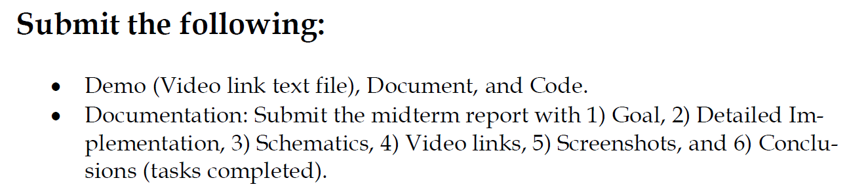

1. Goal

The goal of this assignment was to combine the TM4C123GXL with the Educational BoosterPack MKII and to implement TI-RTOS to interface the two devices. There is to be a task for the ADC to read from the Analog stick, a task to print the ADC value to the terminal via UART, and a task to check the status of the switches to adjust the PWM. These tasks should be synchronized using a timer Hardware Interrupt every 5ms. There should also be a heartbeat idle task that blinks the LED throughout the execution of the program.

1. Detailed Implementation

Educational BoosterPack MKII Launchpad configuration with the Tiva C 123. ADC0 is used on pin PD3. The LED on the BoostPack is controlled on pin PF3. The UART code was developed using the TI uartecho.c example code and the UART_write API. The ADC task code was developed using the TI usb_dev_gamepad example project. The heartbeat function was created from the TI empty_min.c example project. The timer HWI code was developed using CpE 403 lab demo video and uses Timer 2. The semaphores are defined in the asgn3c.cfg GUI.

1. Schematics

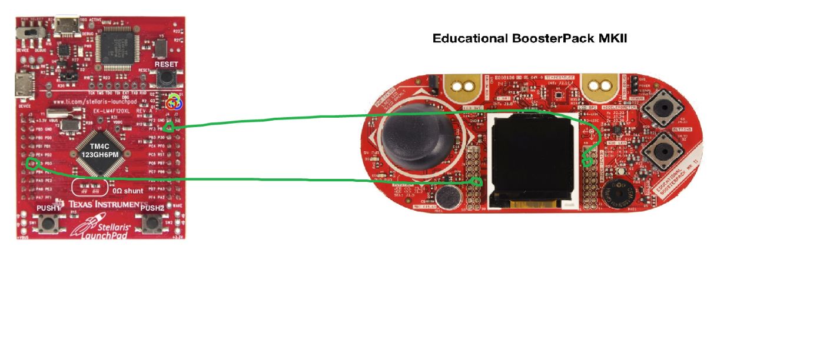

1. Screenshots

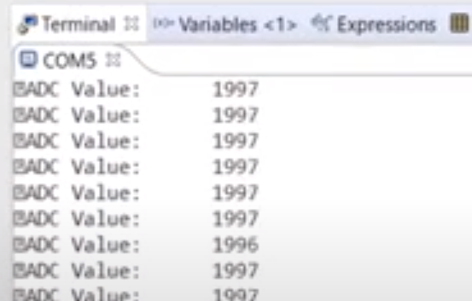

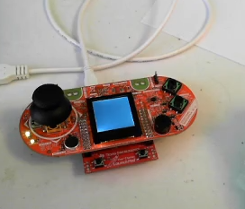

1. Video Links

<https://youtu.be/H3G0yv_HQrM>

1. Conclusion

In conclusion, TI-RTOS can significantly speed up the development process for complicated applications and allow for seamless integration and orchestration of multiple tasks to be performed by a microcontroller CPU. The important thing to recognize when using a RTOS is that your tasks are now each going to be scheduled and share execution time on the CPU. This means that the context switching and priority of tasks need to be taken into consideration. There are circumstances where a task can enter a critical section and if this is overlooked then the program will fail.

The ADC, UART, Timer HWI, and Heartbeat task have been successfully implemented. The Switch Read task was not implemented due to time constraints of the assignment.

I understand the Student Academic Misconduct Policy - http://studentconduct.unlv.edu/misconduct/policy.html

“This assignment submission is my own, original work”.

Cameron Kirk