CPE301 – FALL 2019

Design Assignment 1A

Student Name: Cameron Kirk

Student #: 2000660135

Student Email: [kirkc1@unlv.nevada.edu](mailto:kirkc1@unlv.nevada.edu)

Primary Github address: <https://github.com/kirkster96/submission_da>

Directory: …\DesignAssignment\DA1_a

1. **INITIAL/MODIFIED/DEVELOPED CODE OF TASK 1/A**

;

; DA_1.asm

;

; Created: 9/19/2019 7:49:40 PM

; Author : Kirks

;

;R25:R24 hold the 16-bit multiplicand, R23:R22 hold 16-bit multiplier, and R20:R19:R18:R17 should hold the result.

.include <m328pdef.inc>

.EQU MYLOC = 0x200

.ORG 0

LDI R16,0x00

LDI R24,0x53 ;lower multiplicand

LDI R25,0x41 ;upper multiplicand

LDI R22,0x00 ;lower multiplier

LDI R23,0x34 ;upper multiplier

loop:

CP R22,R16

BREQ reload ;dec LSB from upper multiplier and set lower multiplier to 0xFF

SUBI R22,0b1

loopb:

ADD R17,R24 ;add lower to lowest answer

ADC R18,R25 ;add upper to 2nd lowest answer, include the carry from the lowest addition

ADC R19,R16 ;add the next register with zero and the carry from the most recent addition

ADC R20,R16 ;add the next register with zero and the carry from the most recent addition

JMP loop ;loop to check if done

reload:

CP R23,R16

BREQ done ;compare with zero, this means [R23,R22] is all zero and we are done

DEC R23

LDI R22, 0xFF

JMP loopb ;branch to adding another multiplicand to the answer for this decrement

done:

NEXT: JMP NEXT

1. **SCREENSHOTS OF EACH TASK OUTPUT (ATMEL STUDIO OUTPUT)**

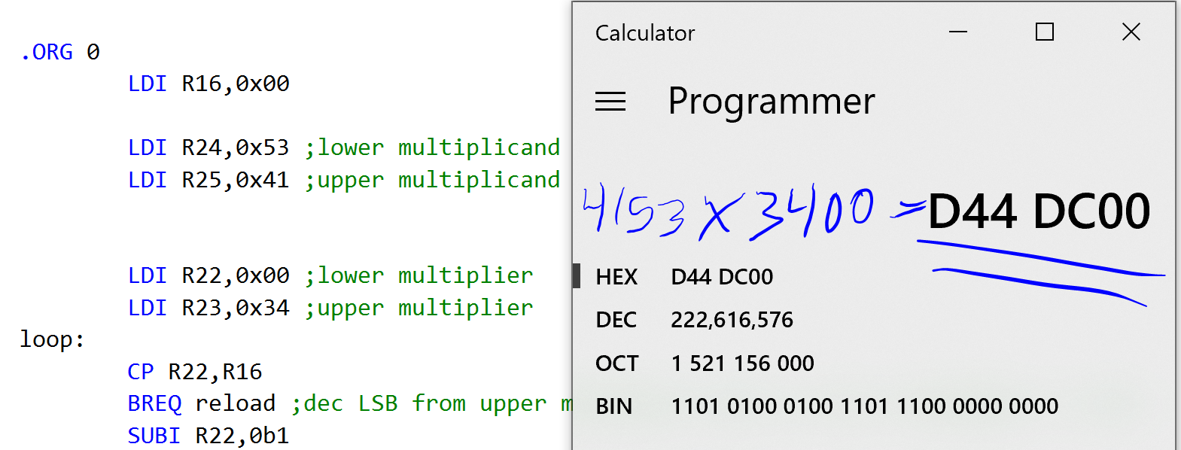

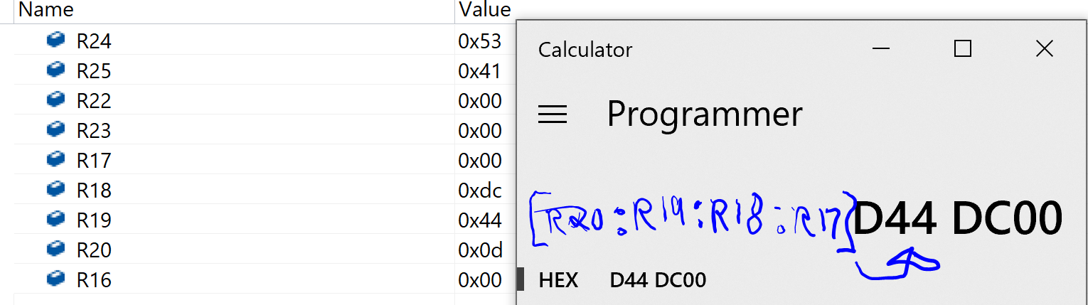

1. **GITHUB LINK OF THIS DA**

<https://github.com/kirkster96/submission_da/tree/master/DesignAssignment/DA1_a>

**Student Academic Misconduct Policy**

<http://studentconduct.unlv.edu/misconduct/policy.html>

“This assignment submission is my own, original work”.

NAME OF THE STUDENT