CPE301 – FALL 2019

Design Assignment 1B

Student Name: Cameron Kirk

Student #: 2000660135

Student Email: kirkc1@unlv.nevada.edu

Primary Github address: <https://github.com/kirkster96/submission_da>

Directory: […/DesignAssignment/DA1_b](https://github.com/kirkster96/submission_da/tree/master/DesignAssignment/DA1_b)

1. **COMPONENTS LIST AND CONNECTION BLOCK DIAGRAM w/ PINS**

List of Components used

NONE

Block diagram with pins used in the Atmega328P

NONE

1. **INITIAL/MODIFIED/DEVELOPED CODE OF TASK 1**

.include <m328pdef.inc>

.EQU STARTADDS = 0x0200

.ORG 0

;load up pointers

LDI XL,LOW(STARTADDS)

LDI XH,HIGH(STARTADDS)

LDI YL,LOW(0x0300)

LDI YH,HIGH(0x0300)

LDI ZL,LOW(0x0500)

LDI ZH,HIGH(0x0500)

;X starting address of 250 numbers

;Y divisible by 5

;Z else

LDI R20,0x00 ;current number

LDI R21,0xFA ;iterations

LDI R22,0x00;

;load 250 numbers into memory

loop:

ST X+, R20

INC R20

DEC R21

BRNE loop

1. **DEVELOPED MODIFIED CODE OF TASK 2 from TASK 1**

.include <m328pdef.inc>

.EQU STARTADDS = 0x0200

.ORG 0

;load up pointers

LDI XL,LOW(STARTADDS)

LDI XH,HIGH(STARTADDS)

LDI YL,LOW(0x0300)

LDI YH,HIGH(0x0300)

LDI ZL,LOW(0x0500)

LDI ZH,HIGH(0x0500)

;X starting address of 250 numbers

;Y divisible by 5

;Z else

LDI R20,0x00 ;current number

LDI R21,0xFA ;iterations

LDI R22,0x00;

;load 250 numbers into memory

loop:

ST X+, R20

INC R20

DEC R21

BRNE loop

LDI R21,0xFB ;iterations

nextnum:

DEC R21

CP R21, R22

BREQ done

LD R20, -X

CBR R20, 0xF8

SUBI R20, 5

BREQ divisible

JMP notdiv

divisible:

LD R20,X

ST Y+,R20

JMP nextnum

notdiv:

LD R20,X

ST Z+,R20

JMP nextnum

done:

NEXT: JMP NEXT

1. **DEVELOPED MODIFIED CODE OF TASK 3 from TASK 2**

.include <m328pdef.inc>

.EQU STARTADDS = 0x0200

.ORG 0

;load up pointers

LDI XL,LOW(STARTADDS)

LDI XH,HIGH(STARTADDS)

LDI YL,LOW(0x0300)

LDI YH,HIGH(0x0300)

LDI ZL,LOW(0x0500)

LDI ZH,HIGH(0x0500)

;X starting address of 250 numbers

;Y divisible by 5

;Z else

LDI R20,0x00 ;current number

LDI R21,0xFA ;iterations

LDI R22,0x00;

;load 250 numbers into memory

loop:

ST X+, R20

INC R20

DEC R21

BRNE loop

LDI R21,0xFB ;iterations

nextnum:

DEC R21

CP R21, R22

BREQ done

LD R20, -X

CBR R20, 0xF8

SUBI R20, 5

BREQ divisible

JMP notdiv

divisible:

LD R20,X

ST Y+,R20

;running sum into R17:R16

ADD R16,R20

ADC R17, R22

JMP nextnum

notdiv:

LD R20,X

ST Z+,R20

;running sum into R19:R18

ADD R18,R20

ADC R19, R22

JMP nextnum

done:

NEXT: JMP NEXT

1. **SCHEMATICS**

Use fritzing.org

NONE

1. **SCREENSHOTS OF EACH TASK OUTPUT (ATMEL STUDIO OUTPUT)**

# Task 1

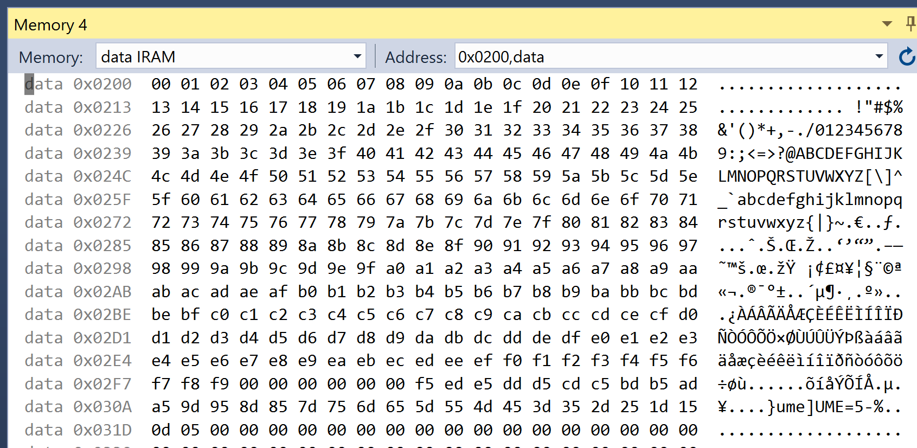

# Task 2

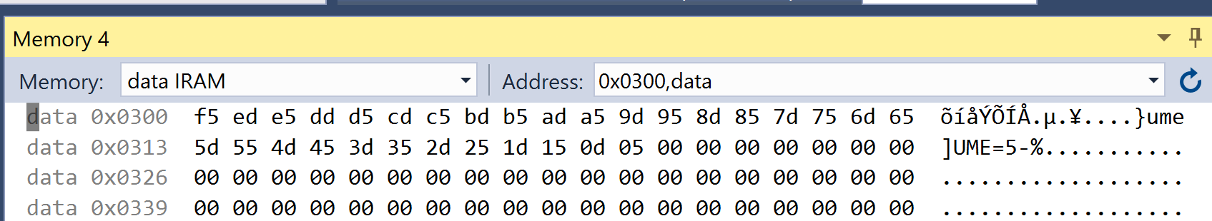

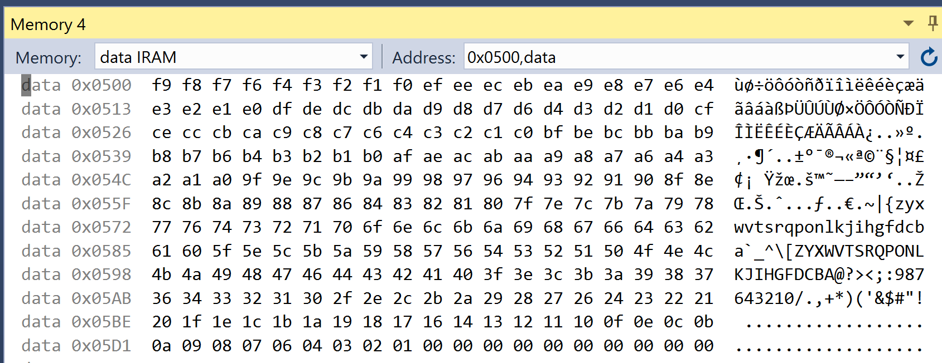

# Task 3

1. **SCREENSHOT OF EACH DEMO (BOARD SETUP)**

NONE

1. **VIDEO LINKS OF EACH DEMO**

NONE

1. **GITHUB LINK OF THIS DA**

<https://github.com/kirkster96/submission_da/tree/master/DesignAssignment/DA1_b>

**Student Academic Misconduct Policy**

<http://studentconduct.unlv.edu/misconduct/policy.html>

“This assignment submission is my own, original work”.

NAME OF THE STUDENT