CPE301 – FALL 2019

Design Assignment 2B

Student Name: Cameron Kirk

Student #: 2000660135

Student Email: kirkc1@unlv.nevada.edu

Primary Github address: <https://github.com/kirkster96/submission_da>

Directory: <https://github.com/kirkster96/submission_da/tree/master/DesignAssignment/DA2_b>

1. **COMPONENTS LIST AND CONNECTION BLOCK DIAGRAM w/ PINS**

Atmega328PB

Multi-function Shield

Block diagram with pins used in the Atmega328P

1. **AVR ASM DEVELOPED CODE OF TASK 1**

;

; DA2_a.asm

;

; Created: 9/30/2019 10:07:47 PM

; Author : Kirks

;

.INCLUDE "M328PBDEF.INC"

.ORG 0 ;location for reset

JMP main

.ORG 0x02 ;location for EXT_INT0

JMP EX0_ISR

main:

;initialize the stack pointer

LDI R20,HIGH(RAMEND)

OUT SPH,R20

LDI R20,LOW(RAMEND)

OUT SPL,R20

ldi r16,0x00

out DDRB, r16

out DDRC, r16

out DDRD, r16

out PortB,r16

out PortD,r16

out PortC,r16

CBI DDRC,3;make PC3 an input

CBI portC,3;make PC3 pull up resistor to active high

SBI DDRB,2

SBI PORTB,2

;LDI R20, 0x2 ;ENABLE INT0

;OUT EICRA, R20

LDI R20, 1<<INT0 ;ENABLE INT0

OUT EIMSK, R20

SEI

HERE: JMP HERE

EX0_ISR: LDI R20, 1<<INTF0

OUT EIFR, R20

CBi PortB,2

call DelaySubroutine

SBI PORTB,2

RETI

DelaySubroutine:

ldi R19,108 ; cycle = 1

delay0: ldi R20,255 ;cycle = 1 * 108

nop ;cycle = 1 * 108

delay1: ldi R21,255 ;cycle = 1 * 108 * 255

nop ;cycle = 1 * 108 * 255

nop ;cycle = 1 * 108 * 255

nop ;cycle = 1 * 108 * 255

nop ;cycle = 1 * 108 * 255

nop ;cycle = 1 * 108 * 255

delay2: dec R21 ;cycle = 1 * 108 * 255 * 255

brne delay2 ;cycle = 2/1 * 108 * 255 * 255 => 105*255(254*2)+105*255(1*1)

dec R20 ;cycle = 1 * 108 * 255

brne delay1 ;cycle = 2/1 * 108 * 255=> 105(254*2)+105(1*1)

dec R19 ;cycle = 1 * 108 * 255

brne delay0 ;cycle = 2/1 * 108 * 255=> 105(254*2)+105(1*1)

ret ;cycle = 1

;1.33 sec delay. 16MHz clock. 0.0625us/instruction. 21280000 instructions is 1.33 seconds

1. **AVR C DEVELOPED CODE OF TASK 1**

#define *F_CPU* 16000000UL

#include <avr/io.h>

#include <avr/interrupt.h>

#include <util/delay.h>

int main (void)

{

DDRB |= (1<<2);//PB5 as output

PORTB |= (1<<2);//PB5 as output

EIMSK = (1<<INT0);

sei();

while (1)

{

PORTB |= (1<<2);//PB5 as output

}

}

ISR (INT0_vect)

{

PORTB &= ~(1<<2);

*_delay_ms*(1330);

}

1. **SCHEMATICS**

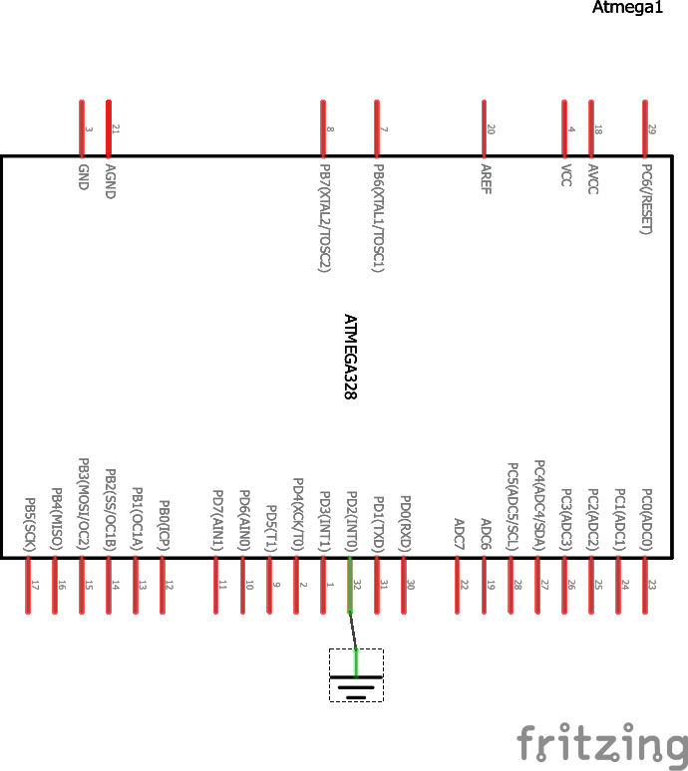

1. **VIDEO LINKS OF EACH DEMO**

AVR C Demo

https://drive.google.com/file/d/14ERAwQuLLEKZczYLbTtPCu0-B5_3XwPF/view?usp=sharing

AVR ASM Demo

<https://drive.google.com/file/d/14IXbhQCFBhu6AMjQVUmgzKAX6JJ_IHRk/view?usp=sharing>

1. **GITHUB LINK OF THIS DA**

**Student Academic Misconduct Policy**

<http://studentconduct.unlv.edu/misconduct/policy.html>

“This assignment submission is my own, original work”.

NAME OF THE STUDENT