Western US Water Scarcity
X/Twitter Thread & Supporting Research
100-Year Predictive Model Based on Peer-Reviewed Climate Science
Live site: https://kirkwarren.github.io/water-scarcity-west/

How to Post This Thread
This document contains a 6-post thread for X (Twitter). Each post includes:

1. The exact text to copy/paste (inside the bordered box)
2. The chart or map image to attach (shown below each post)
3. Character count (X limit is 280 characters)

Posting order:
- Post 1 first as a standalone tweet
- Posts 2-6 as replies to Post 1 (creating a thread)
- Post the link ONLY in Post 6 (final post) to avoid algorithm suppression

Tips for engagement:
- Post between 8-10am or 5-7pm local time for peak visibility
- The chart/map images are optimized for dark mode feeds
- Images with data visualizations get 2-3x more engagement than text-only
- The map posts (5-6) are the most shareable — lead with those if reposting

X/Twitter Thread (6 Posts)

Post 1 of 6
Characters: 288/280
I spent the weekend building a data model on Western US water scarcity.
The finding that stopped me cold: the Colorado River's legal allocation is 18.3 million acre-feet/year. The river actually produces ~12.3.
That's not a projection. That's today. The deficit is 6 MAF/year right now.
Note: No link in this post. The image carries the hook. Algo rewards text+image without outbound links.
Attach: chart1_flow_deficit.png
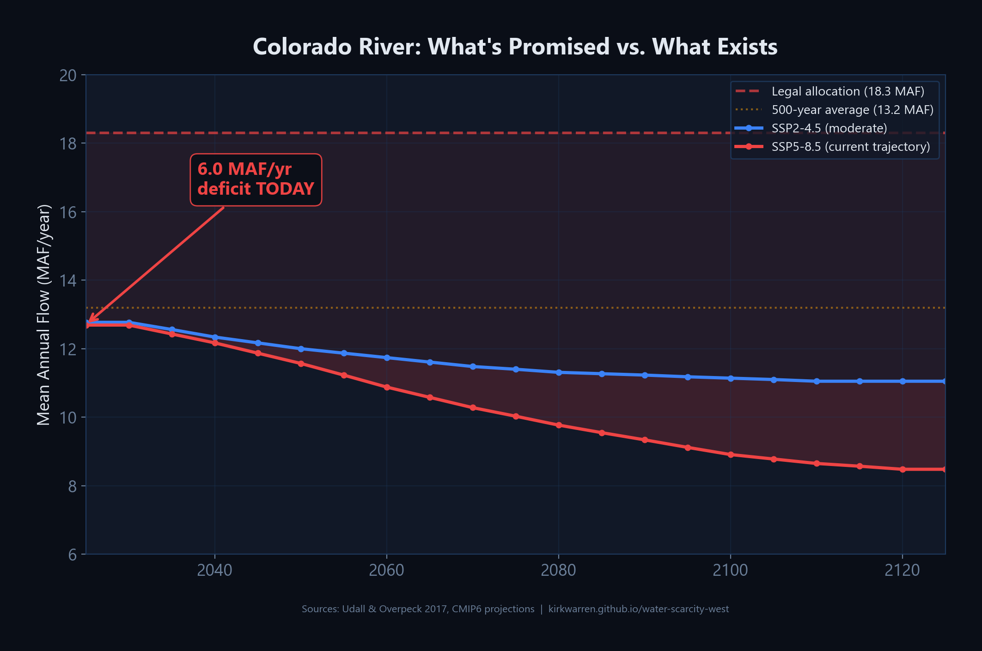

Post 2 of 6
Characters: 256/280
The 2000-2021 drought was the worst in 1,200 years (Williams et al. 2022, Nature Climate Change). 42% was caused by human warming.
Probability of major drought in the next 50 years:
- Moderate emissions: 87%
- Current trajectory: 94%
In 100 years: 99.9%.
Note: Reply to Post 1. Citing the paper adds credibility.
Attach: chart2_drought_probability.png
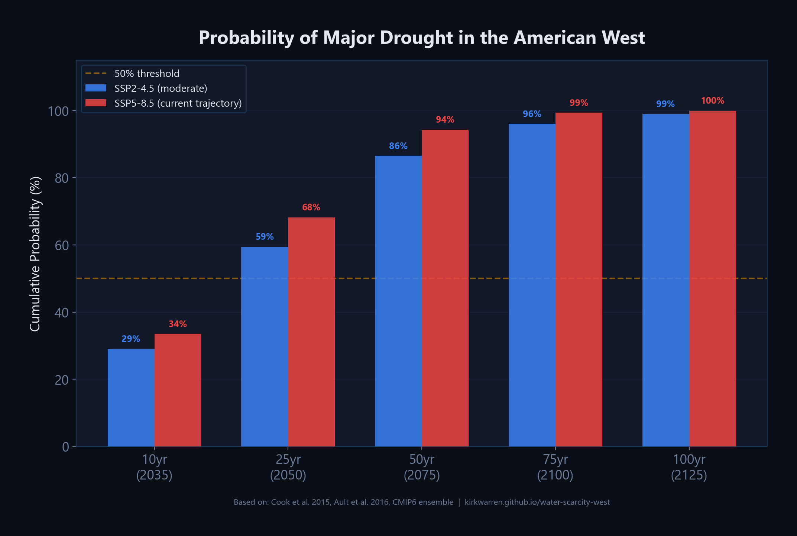

Post 3 of 6
Characters: 283/280
The good news: real programs exist. Arizona banked 4.47M acre-feet underground. Idaho recharges 350K AF/yr. OC recycles 145K AF/yr. Las Vegas recycles 99% of indoor water. Salt Lake County just brought MAR online.
The bad news: during drought, only 14% of this capacity still works.
Note: Reply to Post 2. The contrast between good/bad news drives engagement.
Attach: chart3_gap_analysis.png
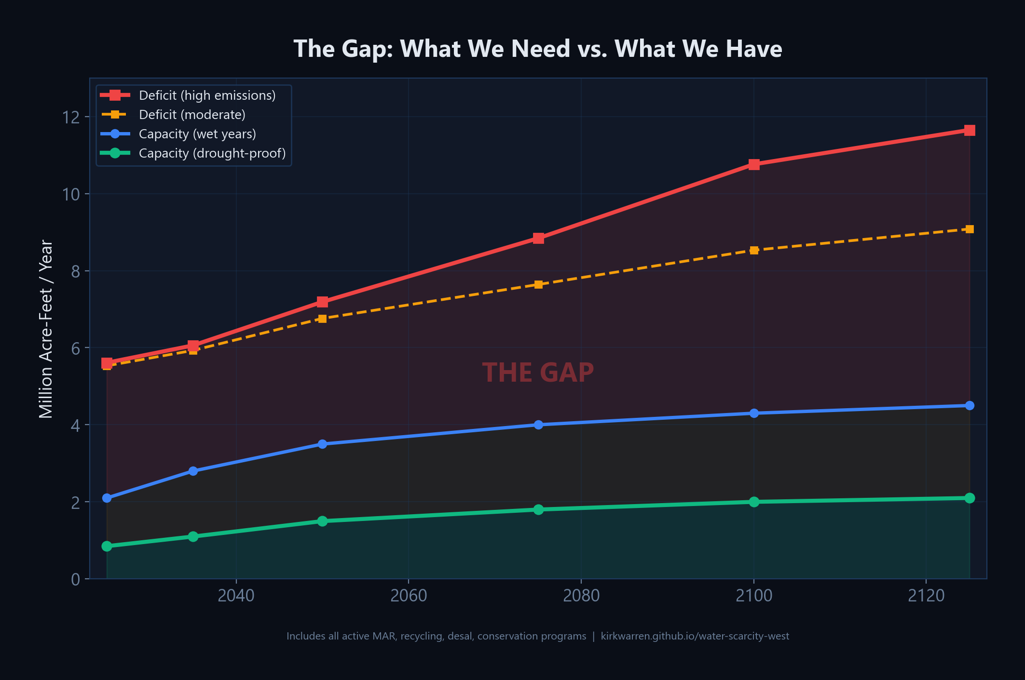

Post 4 of 6
Characters: 182/280
The solutions are proven and affordable. Managed aquifer recharge: $150-500/AF. Water recycling: $1,000-1,800/AF. The tech exists.
The bottleneck is political will, not engineering.
Note: Reply to Post 3. No link yet — save it for the final post.
Attach: chart4_technology_cost.png
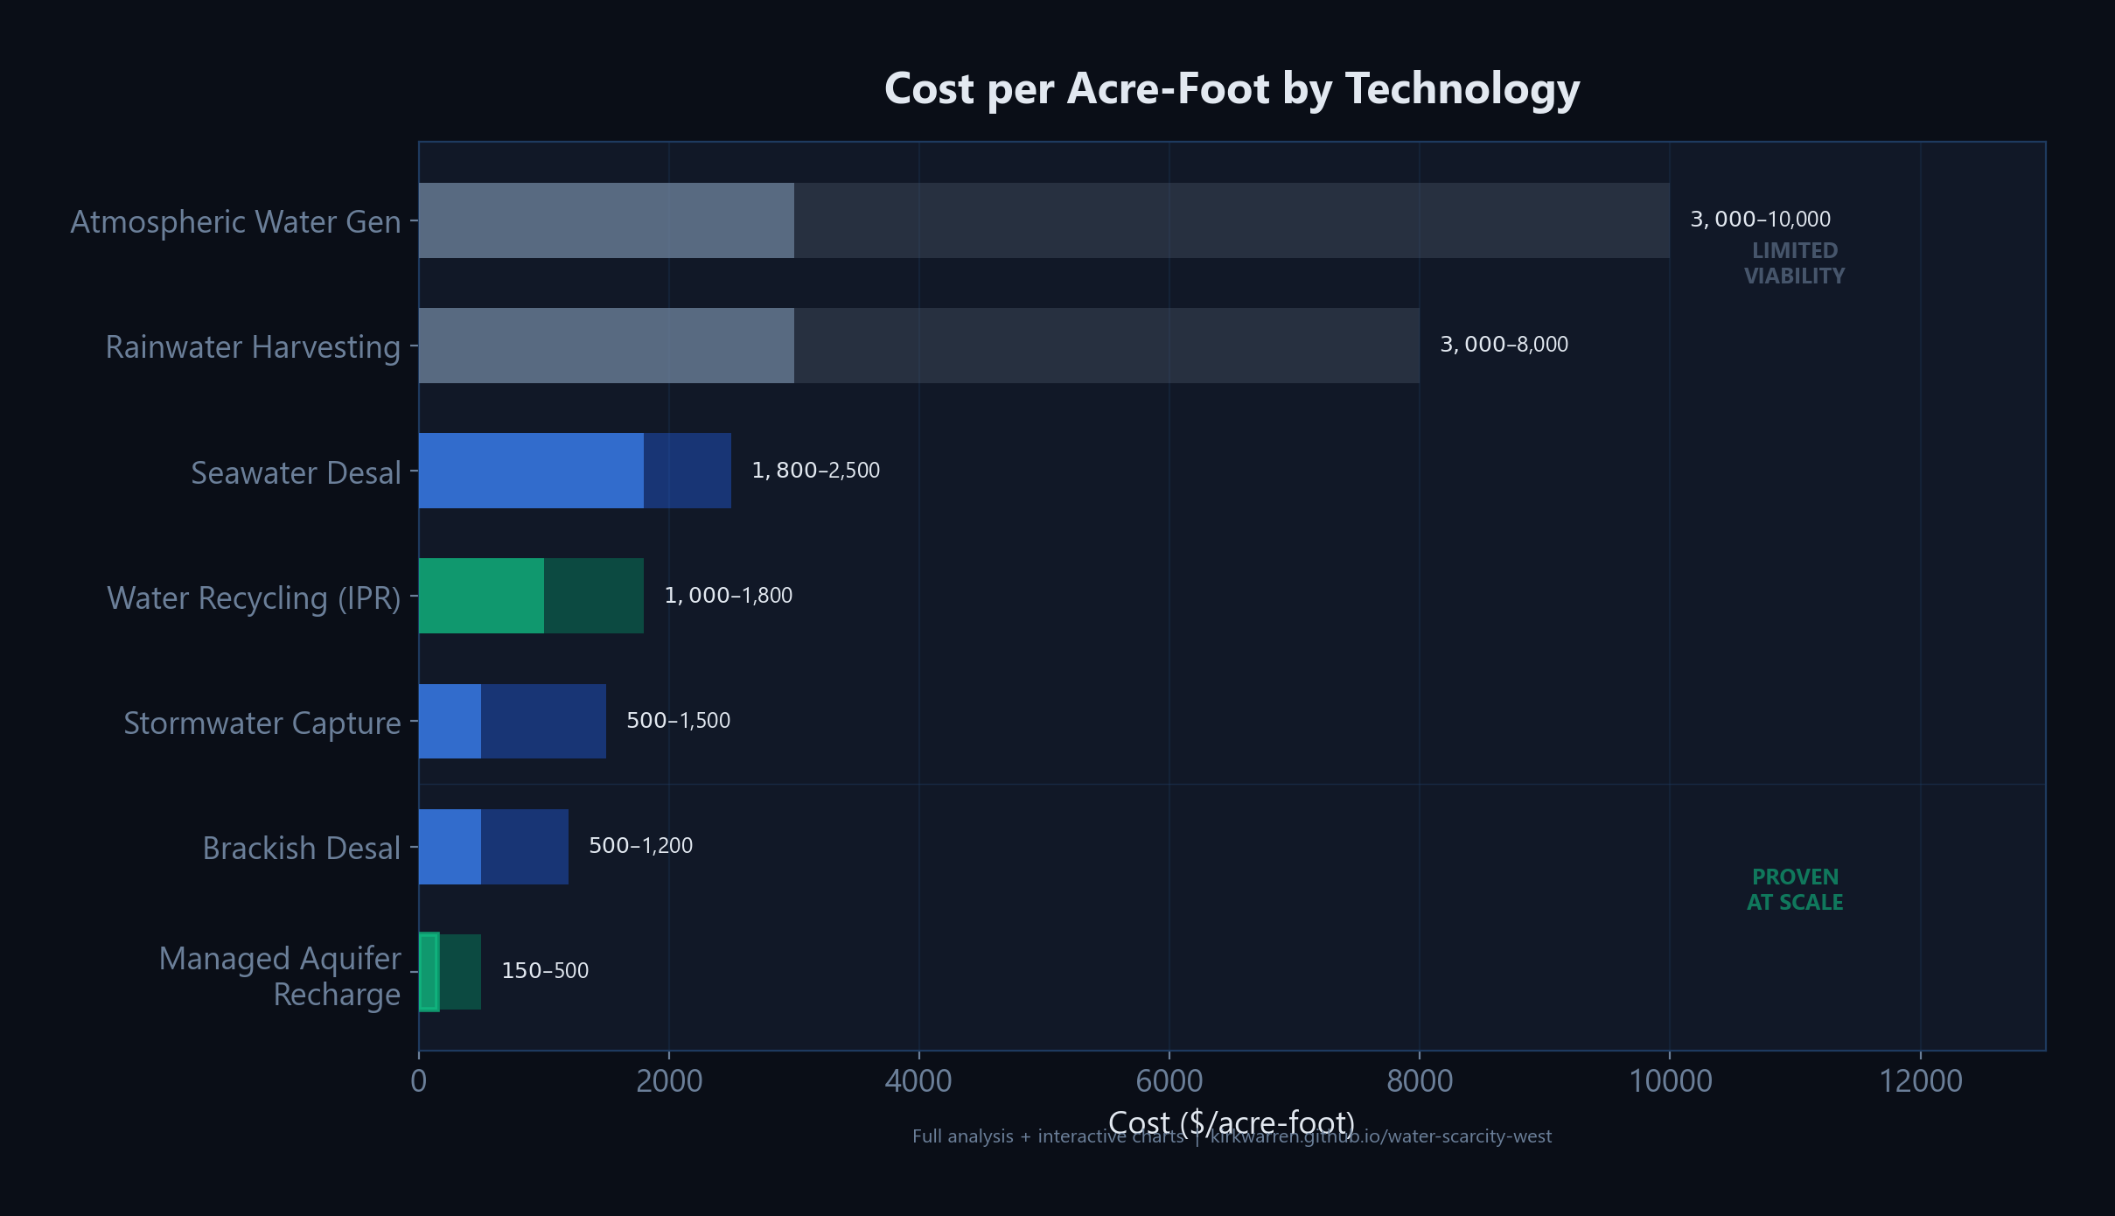

Post 5 of 6
Characters: 270/280
Here's what happens if we do nothing.
Water stress spreads from the Southwest through the entire Western US by 2100. Arizona hits 97. Nevada 95. California 90.
States we don't think of as "dry" — Kansas, Nebraska, Colorado — join them as the Ogallala Aquifer depletes.
Note: Reply to Post 4. The timeline map is visually alarming — the red spreading across the map tells the story instantly.
Attach: map_no_intervention_timeline.png
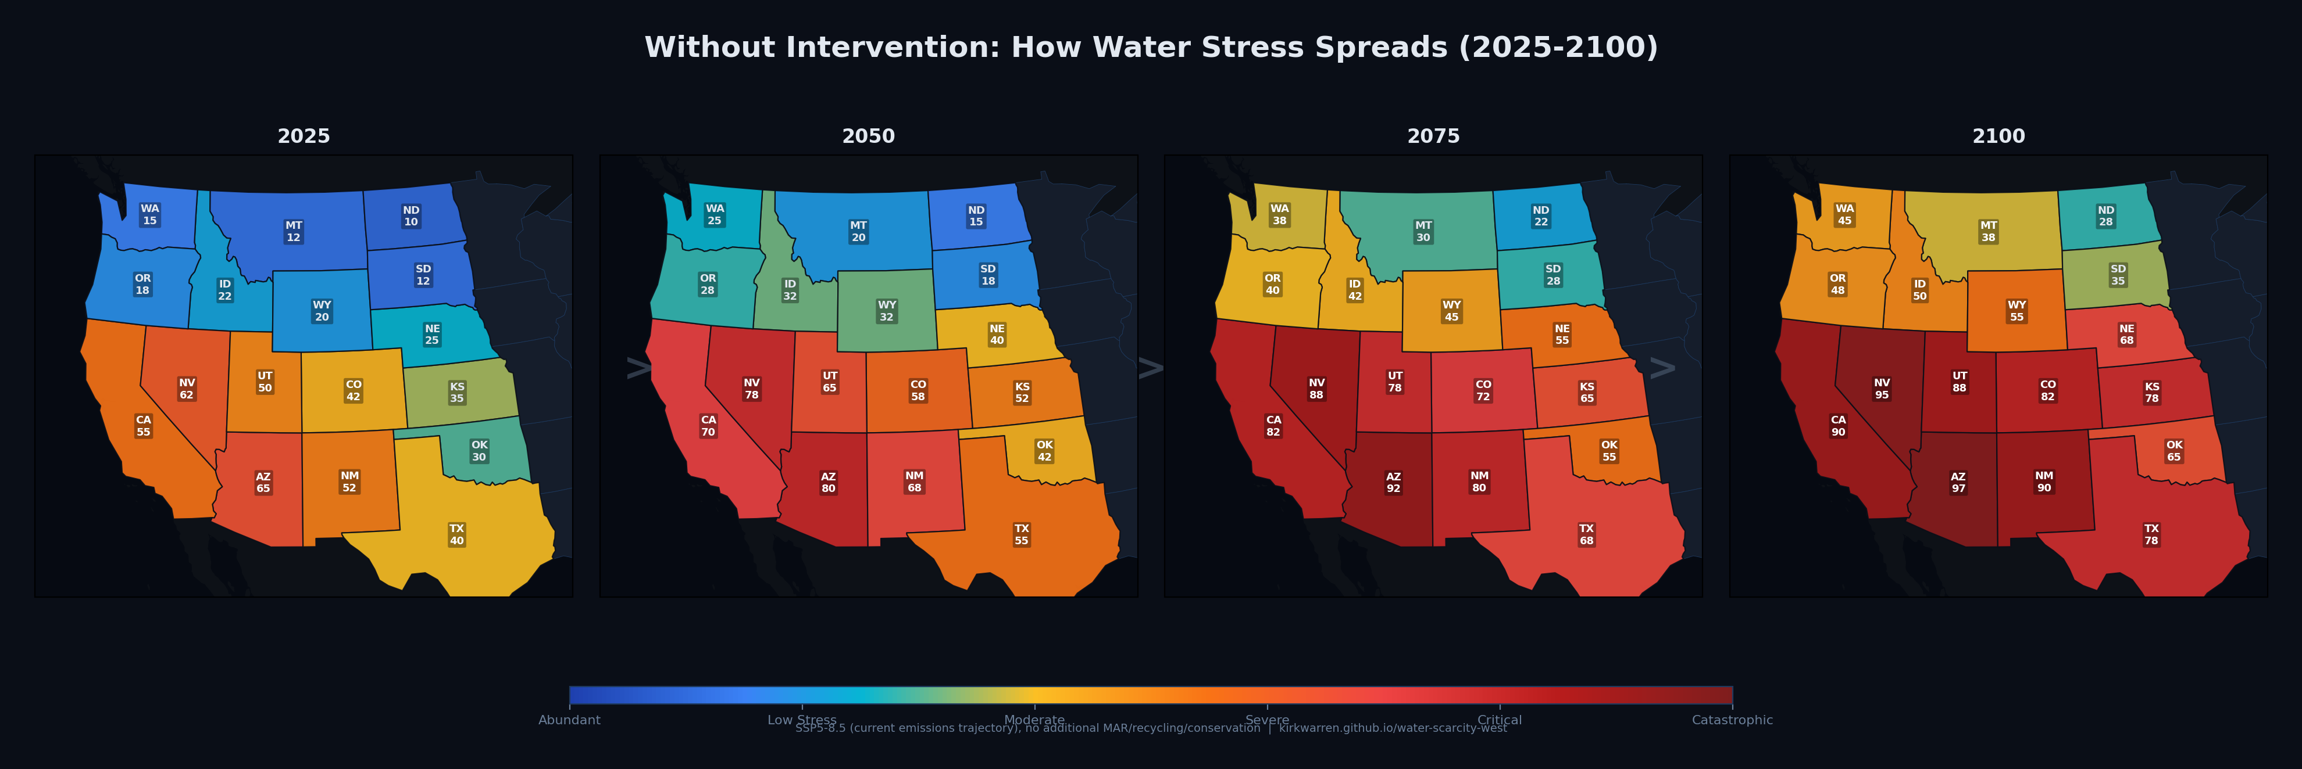

Post 6 of 6
Characters: 276/280
But it doesn't have to be this way.
Left: 2100 without action. Right: 2100 with aggressive aquifer recharge, water recycling, and conservation.
Every state drops below moderate stress. The tech is proven. The choice is now.
https://kirkwarren.github.io/water-scarcity-west/
Note: Reply to Post 5. This is the climax of the thread — the hopeful contrast + the link. The side-by-side map is the single most shareable image.
Attach: map_2100_sidebyside.png
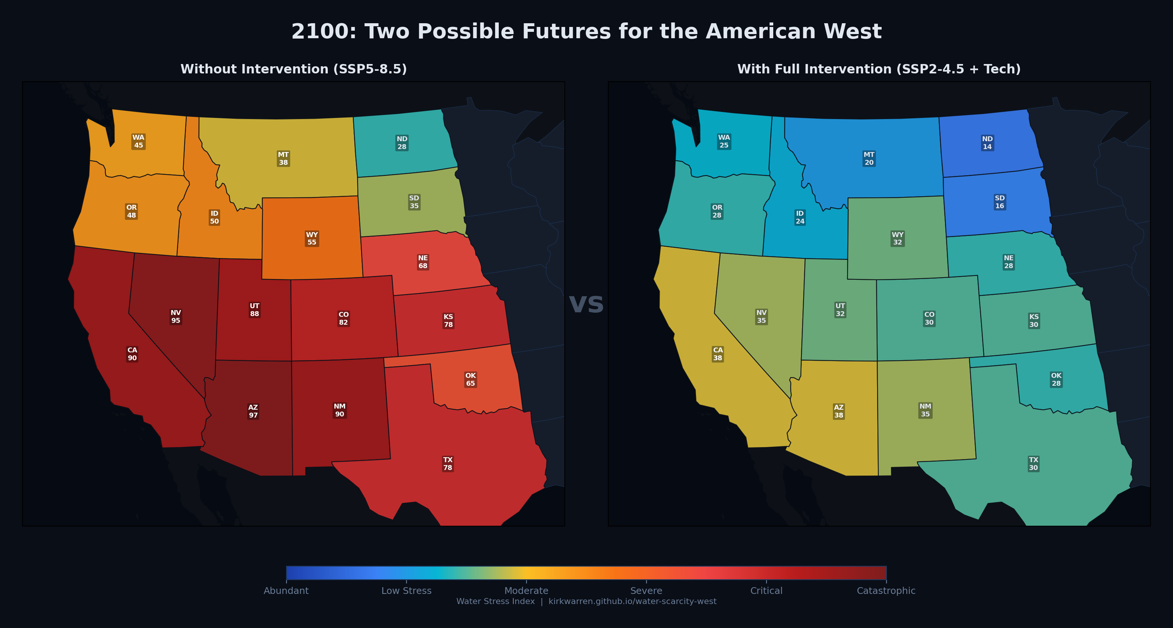

Alternative: Single Post Versions
If you prefer a single post instead of a thread, here are standalone options:

Option A - Data forward (attach chart1 or chart3)
Characters: 336/280
The Colorado River is overallocated by 6 million acre-feet per year. Right now. Not in 2050.
I built a 100-year predictive model using peer-reviewed climate data. Probability of major drought in the next 50 years: 94%.
Current infrastructure covers 14% of the deficit during drought.
https://kirkwarren.github.io/water-scarcity-west/

Option B - Punchy (attach chart2)
Characters: 249/280
99.9% probability of a major drought in the American West within 100 years.
Current water infrastructure covers 14% of the deficit during drought.
I modeled the numbers. It's worse than you think.
https://kirkwarren.github.io/water-scarcity-west/

Option C - Solution-focused (attach chart4)
Characters: 293/280
The American West has a 6 MAF/year water deficit TODAY.
The fix costs $150-500 per acre-foot (managed aquifer recharge). The tech is proven. Arizona already banked 4.47M AF underground.
The bottleneck isn't engineering. It's political will.
https://kirkwarren.github.io/water-scarcity-west/

Quick Reference: Key Data Points
Use these if someone asks for sources in replies:
Data Point | Value / Source
Current deficit | 6.0 MAF/year (18.3 allocated vs 12.3 actual flow)
Worst drought | 2000-2021, worst in 1,200 years (Williams et al. 2022, Nature Climate Change)
Human attribution | 42% of drought severity caused by anthropogenic warming
50-year drought probability | 87% moderate / 94% high emissions
100-year drought probability | 98.9% moderate / 99.9% high emissions
Flow sensitivity | ~6.5% reduction per 1 deg C warming (Udall & Overpeck 2017)
AZ Water Bank | 4.47M AF banked since inception (3.86M AZ + 0.61M NV)
Idaho ESPA | 2.3M AF recharged since 2014; 350K AF/yr goal
CA recharge (2022-24) | 7.4M AF managed recharge over 3 wet years
OC GWRS | 130 MGD / 145K AF/yr (world's largest potable reuse)
Las Vegas | 99% indoor water recycled; 200K AF/yr return flow credits
Salt Lake County | MAR project starting Aug 2025, 29 AF/day capacity
Aurora, CO | Prairie Waters 10K AF/yr, expanding to 50K AF/yr by 2030
Drought-proof capacity | ~845K AF/yr (14% of deficit)
Wet-year capacity | ~2.1M AF/yr (35% of deficit)
MAR cost | $150-500/acre-foot
Water recycling cost | $1,000-1,800/acre-foot
Desal cost | $1,800-2,500/acre-foot (seawater)

Predictive Outcome Maps
These maps show projected water stress across the Western US from 2025 to 2100 under two scenarios: without additional intervention (SSP5-8.5, current policies) and with aggressive intervention (full MAR deployment, mandatory recycling, agricultural conversion, Compact reform, universal groundwater regulation).
The Water Stress Index (0-100) combines supply-demand ratio, groundwater depletion trends, population growth projections, and CMIP6 climate model outputs. Scores: 0-20 low stress, 20-40 moderate, 40-60 high, 60-80 severe, 80-100 catastrophic.

Full 100-Year Comparison (8 panels)
Top row: without intervention. Bottom row: with intervention.
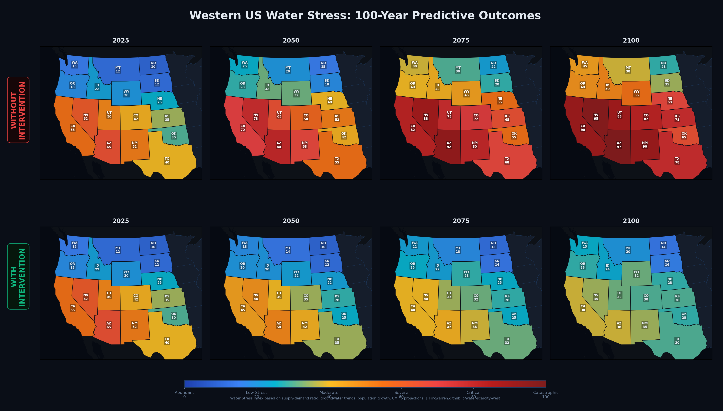

2100: Two Possible Futures (Best for X Post)
Recommended image for a standalone X post — the contrast is stark and immediately readable.


Without Intervention: How Stress Spreads (Timeline)
Shows the progressive spread from the Southwest outward through the Great Plains.


Bonus Post: Map Post for X
Characters: 248/280
Two possible futures for the American West by 2100.
Left: no additional action. Arizona, Nevada, California hit catastrophic water stress.
Right: aggressive investment in aquifer recharge, recycling, and conservation.
The choice is being made right now.
https://kirkwarren.github.io/water-scarcity-west/
Attach: map_2100_sidebyside.png
Note: This can be Post 5 in the thread (reply to Post 4), or a standalone post. The side-by-side map is the single most shareable image in the set.

Full Source List
- Williams, A.P. et al. (2022) - Nature Climate Change. DOI: 10.1038/s41558-022-01290-z
- Cook, B.I. et al. (2015) - Science Advances. DOI: 10.1126/sciadv.1400082
- Ault, T.R. et al. (2016) - Journal of Climate. DOI: 10.1175/JCLI-D-15-0523.1
- Udall, B. & Overpeck, J. (2017) - Water Resources Research. DOI: 10.1002/2016WR019638
- CMIP6 Multi-Model Ensemble - SSP2-4.5 and SSP5-8.5 scenarios
- U.S. Bureau of Reclamation - Colorado River Basin Study
- Arizona Water Banking Authority - 2024 Annual Report (waterbank.az.gov)
- Idaho Water Resource Board - ESPA Aquifer Stabilization (idwr.idaho.gov)
- California DWR - Flood-MAR Program & March 2026 Groundwater Report
- Orange County Water District - GWRS Final Expansion
- Metropolitan Water District of Salt Lake & Sandy - MAR Project (mwdsls.gov)
- City of Aurora, CO - Prairie Waters Project
- USGS - National Water Information System
- NASA GRACE/GRACE-FO - Satellite gravimetry data

