Asset Logger Design

# By Michael Hale, Devin Doman, Bryon Rogers

# Basic Layout

The basic layout of the Asset Logger Project is shown here, along with an overview of each component:

Server

Client

Scheduler

UI

Database

## Database

The Database contains tables for the assets, borrowers, and logs of when assets were borrowed and by whom. In this way, the Database component serves as both the source of asset availability data and the system of record for asset accountability. There is only one master database, which is maintained on a server. In addition to the actual data in the Database, the Database component includes methods with which the Scheduler can manipulate the Data therein. Once in place, the database code is designed to be changed very seldom, if ever.

## Scheduler

The Scheduler is responsible for utilizing the data in the database to service requests for the User made via the UI. The Scheduler code runs on the client machine, and returns data requested by the UI in a form that is ready for display. The Scheduler also contains logic and helper classes that enable Asset Logger to enforce borrowing and usage policies. The Scheduler may change a little based on the needs of a type of UI or the needs of a particular organization.

## UI

The UI receives input from the user and displays schedules, assets, and borrowers accordingly. It also allows users to checkout and check-in assets via its accompanying scheduler. This is done so that the UI may be easily changed to suit different situations.

# Database Design

## Database Schema:

This section contains the basic design of the database that will store the faculty/student and asset data.

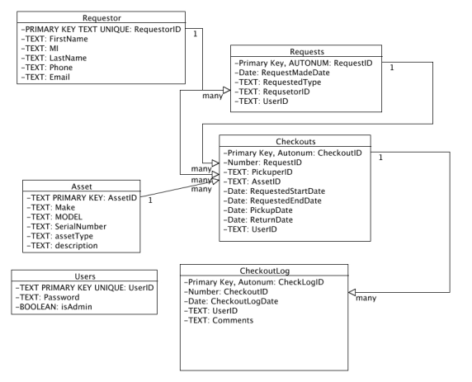

## Field Description

Requestor:

{

-RequestorID: Represents a unique identifier for the requestor.

-FirstName

-MI

-LastName

-Phone

-Email

}

Requestor contains field data to represent a requestor of an asset. A single requestor can make multiple requests.

Requests:

{

-RequestID

-RequestMadeDate

-RequestedType

-RequsetorID

-UserID

}

Contains field data to make an asset request with. A single request can make multiple checkouts.

Checkouts:

{

-CheckoutID

-RequestID

-PickuperID

-AssetID

-RequestedStartDate

-RequestedEndDate

-PickupDate

-ReturnDate

-UserID

}

Stores data for making an asset checkout. A single checkout produces multiple logs.

Asset:

{

-AssetID

-Make

-MODEL

-SerialNumber

-assetType

-description

}

Represents the item to be checked out. A single asset can be checked out multiple times.

CheckoutLog:

{

-CheckLogID

-CheckoutID

-CheckoutLogDate

-UserID

-Comments

}

Contains a log of when an asset is checked out to whom.

Users:

{

-UserID

-Password

-isAdmin

}

Contains data representing the user of the application and their administrative rights and password.

## Method Summary

# Scheduler Design