Devin Doman

Bryon Rogers

Mike Hale

Design Document

Laptop Checkout

Database Design

This section contains the basic design of the database that will store the faculty/student and asset data.

**1.1 Database Schema**

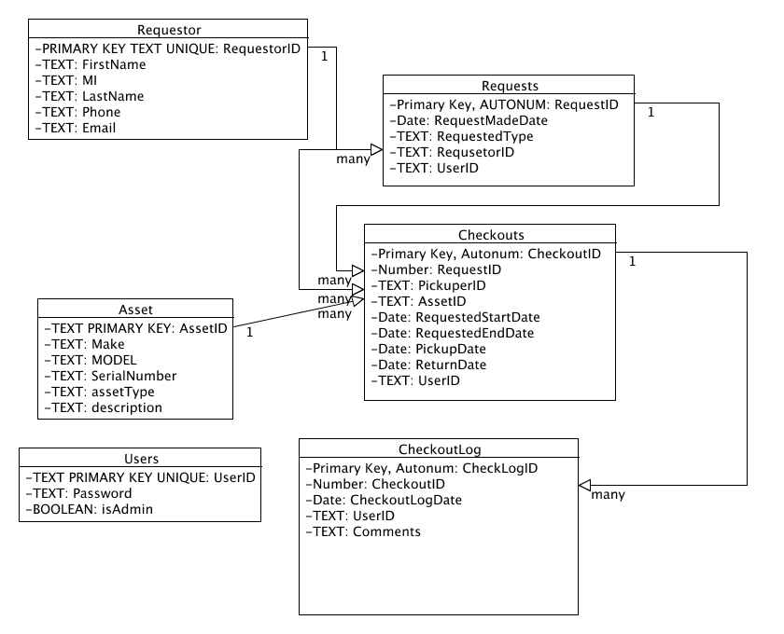

**1.2 Field Description**

Requestor:

{

-RequestorID: Represents a unique identifier for the requestor.

-FirstName

-MI

-LastName

-Phone

-Email

}

Requestor contains field data to represent a requestor of an asset. A single requestor can make multiple requests.

Requests:

{

-RequestID

-RequestMadeDate

-RequestedType

-RequsetorID

-UserID

}

Contains field data to make an asset request with. A single request can make multiple checkouts.

Checkouts:

{

-CheckoutID

-RequestID

-PickuperID

-AssetID

-RequestedStartDate

-RequestedEndDate

-PickupDate

-ReturnDate

-UserID

}

Stores data for making an asset checkout. A single checkout produces multiple logs.

Asset:

{

-AssetID

-Make

-MODEL

-SerialNumber

-assetType

-description

}

Represents the item to be checked out. A single asset can be checked out multiple times.

CheckoutLog:

{

-CheckLogID

-CheckoutID

-CheckoutLogDate

-UserID

-Comments

}

Contains a log of when an asset is checked out to whom.

Users:

{

-UserID

-Password

-isAdmin

}

Contains data representing the user of the application and their administrative rights and password.

**1.3 Database Objects**

Person

Laptop

Request

We will have one database that contains tables representing the faculty and students as well as the laptops. We will query the school's database of faculty/students first. If the individual is found it will pull and update our database. If an individual is not found then it will be keyed into our database manually. If there is a conflict between the data in the school and ours we will ask for the most current and update ours with that data.

The only time the schoools database will be queried would be when a laptop needs to be scheduled/checkedout. When we need to konw a history we would query our database.