5.1 Problem Definition:

Business Problem:
Football clubs spend millions on player transfers every year, yet many of them are considered failures, and fail to meet expectations resulting in big financial loss and poor performance. The main problem is the high financial risk of player transfers blindly or with poor research.

Stakeholders:
The primary stakeholder is the board of directors in the football club. They are responsible for deciding which players to sign and at what prices, they need tools to help them filter candidates and measure the risk of transfers.

Classification Justification:
This is treated as a supervised classification problem which predicts a clear category to measure the risk of player transfer, instead of predicting expected goals or future market value which may be inaccurate.

Decision-making Impact:
Using this model will have a positive effect on how recruitment decisions are made, as it gives stakeholders a probability for a successful transfer to take into account besides other basic variables like performance and value, and can give a warning to investigate further for riskier transfers.

5.5 Exploratory Data Analysis (EDA)
The EDA is split across two stages, general analysis on original Kaggle dataset and feature to target analysis on the labeled modeling dataset

General Market Analysis:

Transfer Fee Distribution:
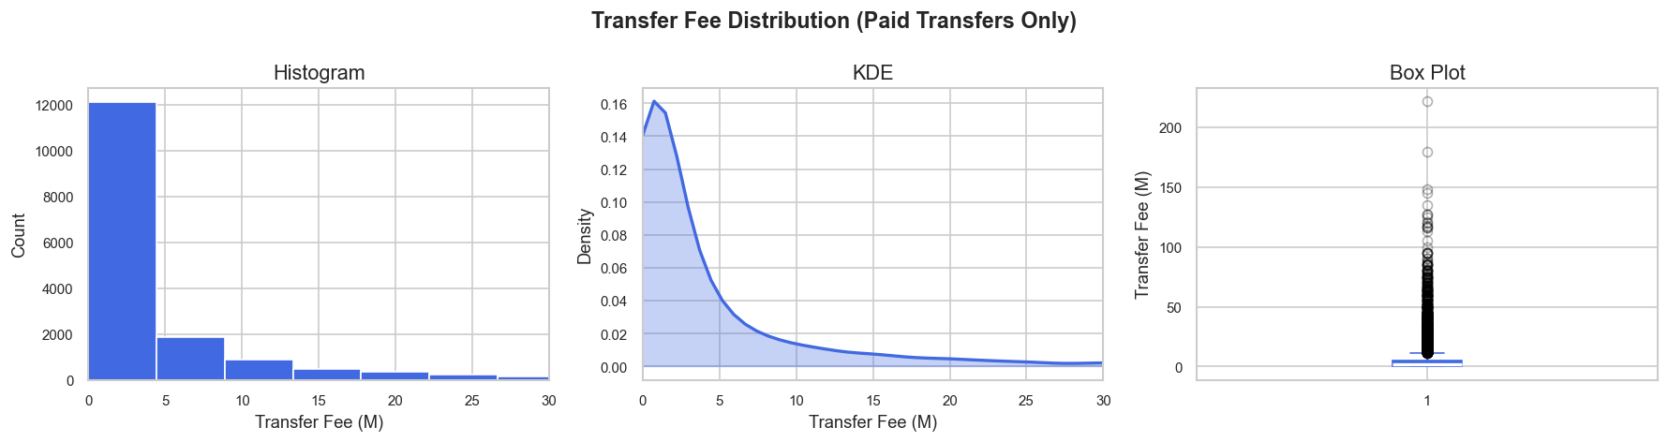
The transfer fee distribution is right skewed as the mean(4.97M) is highly above the median(1.5M), and most of the transfers are below around 10M while a few deals are high outliers making asymmetric distribution, skewness indicates that transfer fee features will require data transformation in modeling to prevent disproportionate weights

Transfer fee vs Market Value:
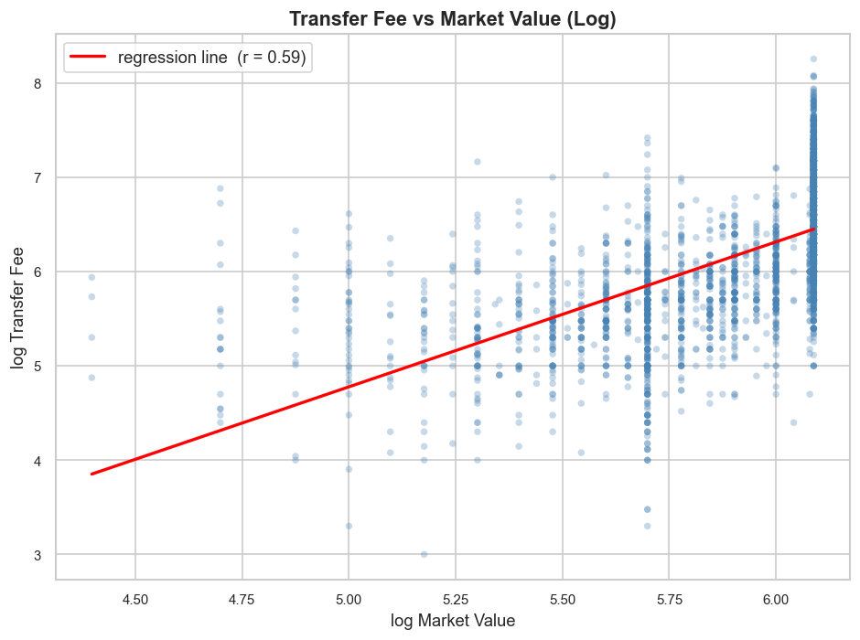
The scatter plot compares transfer fee against market value and show positive correlation(r= 0.59), which shows that in general clubs pay more for high value players but also show that there is noise, and for a certain market value, clubs can pay different transfer fees, and that reveals other factors besides market value like age or position are also important in determining transfer fee

Transfer Fee by Position:
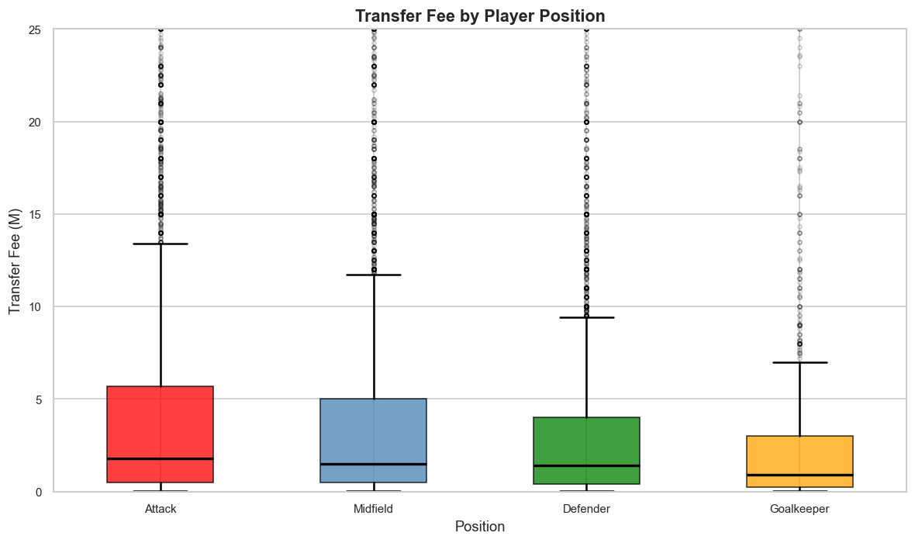
The box plots reveal transfer costs for each position in the transfer market, Attacking players has the highest median transfer fee while the goalkeeper position has the lowest, which indicates that clubs generally prefer goal scoring and threat, regardless of whether that transfer will be successful.

Position | Median transfer fee(M)
Attack | 1.8
Midfield | 1.5
Defender | 1.4
Goalkeeper | 0.9

Feature to target analysis:

Transfer Success rate by season:
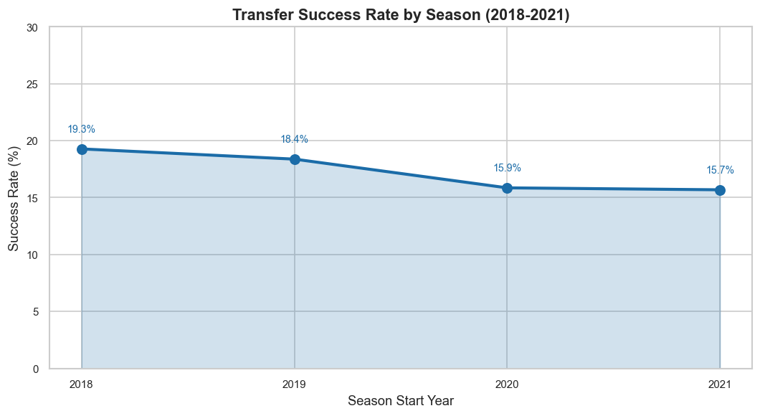
The success rate among transfers shows downward trend which declined from 19.3% in 2018 to 15.7% to 2021, which indicates that it is getting more difficult with time for clubs to predict and make successful transfers

Transfer Success Rate by position:
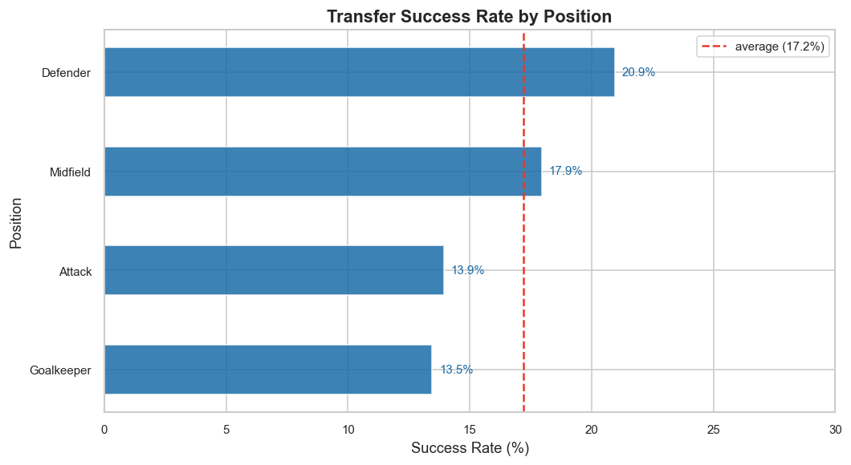
The bar chart shows that defender position has the highest transfer success rate and attackers and goalkeepers has the lowest rate, which contradicts attack position having the highest transfer fee, that indicate that clubs often take higher risks with attack position transfers due to high demand, while defenders can offer better value as they have higher impact of mistakes as a defender mistake can result in a goal scored against the team

Transfer success rate by Age, Pretransfer market value:

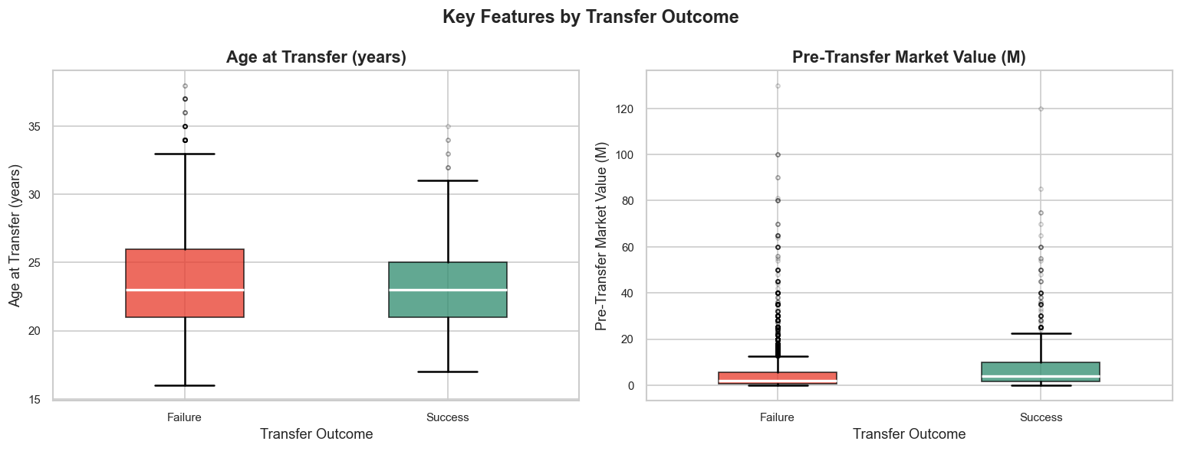

Age and pre-transfer market value were compared between successful and failed transfers, for age both groups show a similar median(23 years), for pre-transfer market value, successful transfers has higher median(4M) than failed transfers(2M), which shows that proven players in the market is safer than risking with cheaper unknown players, and it’s more difficult to predict success rate using player age by itself.

Feature Correlation heatmap with target:
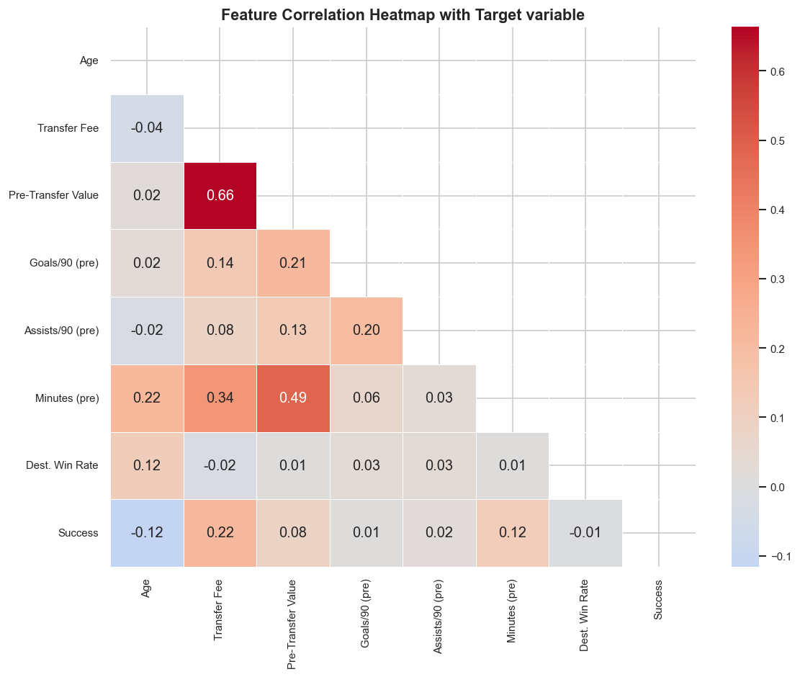
Correlation heatmap with important features and the target variable, the strongest correlators with transfer success rate are transfer fee and pre-transfer minutes played, while age shows a slight negative correlation which indicates risk with older players, and goals/90 and assists/90 show zero correlation which reveals that raw performance indicators alone are weak predictors.

Insights Influencing modeling:
- The class distribution of the target variable is unbalanced with only 17.2% labeled as successful transfers, which means that class balancing before model training is required as training without balancing will produce a biased classifier towards the majority class
- The zero correlation of features like goals and assists with the target confirms that raw statistics are not sufficient, and encourage engineered features and relying on broader features with performance features

Dashboard:
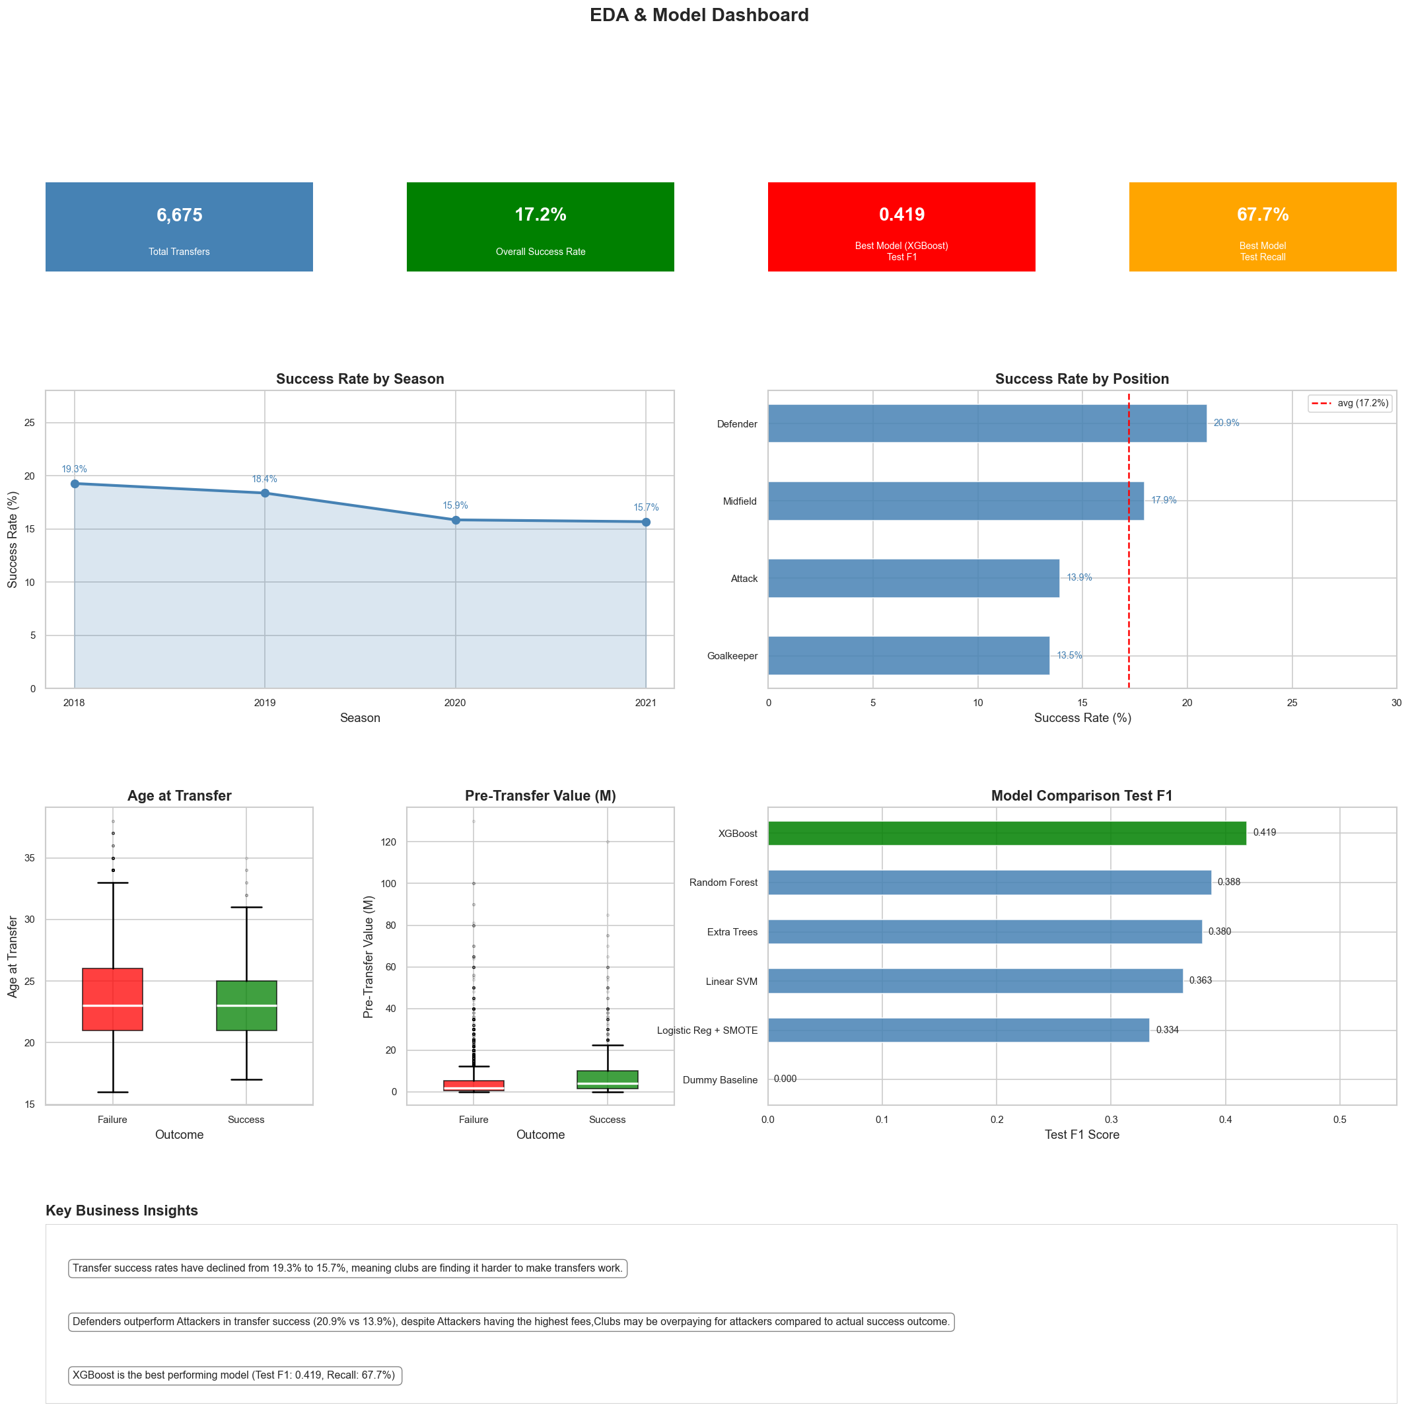

5.13 Team Contributions

Name | Contribution
Kirollos Baghdad | 5.3 Data Validation & Documentation (Phase 1)  5.8 Testing: (Pytest pipeline coverage & mock-data fixtures).  5.10 Code Automation: (Built Makefile workflows for linting/formatting).  5.11 Continuous Integration: (Created .github/workflows/ci.yml).  5.4 Preprocessing, Transformation & Engineering
Rawan Ahmed | 5.6 Model Development  5.9 Results & Evaluation
Ahmed Elsayed | 5.1 Problem Definition & Business Context  5.5 Exploratory Data Analysis (EDA)
Ali Samy | 5.7 Experiment Tracking with MLflow  5.6 Model Development  5.2 Data Acquisition & Integration

