

**PROJECT PROGRESS PRESENTATION FOR FINAL YEAR STUDY IN**

**Bachelor of Science in Information Technology**

**BY**

**Mwendia Paul Mwenda**

**PROJECT TITLE**

**Afya Mobile First Aid Application**

**Supervisor: Cyrus Kamau**

# 

# Chapter 1.0 Introduction

An Expert System is a knowledge-based computer program containing expert domain knowledge about objects, events, situations and courses of action, which emulates the process of human experts in the particular domain. In other words, expert system is a computer application that performs a task that would otherwise be performed by a human expert. Expert systems are extensively used in the medical field.

Expert system facilitates organization of knowledge in such a manner, which fills up the gap of the absence of an expert in any field. An expert system with hypertext facility will be particularly useful in organizing knowledge in logical manner and facilitates storing of large amount of information with a very effective retrieval mechanism.

## 1.1 Problem Definition

Medical care which is not only giving medicine but also educating people on how to take care of themselves is essential to helping people improve the quality of their lives. Lack of the basic knowledge about medication for example on how to handle people in case of accidents, how to take care of pregnancies and attack by poisonous animals has led to loss of many lives.

After an extensive research in both rural and urban areas on the understanding on how to handle emergency medical conditions and other health conditions that affect people, it was evident that most people lack knowledge on this field. Though this information is got by those that have gone to school, many forget how to handle such situations after leaving school.

## 1.2 Objectives

1. Educate people on how to handle emergency medical situations.
2. Provide an easy, cheap and efficient way to access first aid information.
3. Improve and accelerate quality care
4. Advice on the best way to seek medical attention

### Functional Requirements

* This system will have an administrator to update the database and also administer its operation.
* The system will provide a user friendly mobile phone interface to enhance easy usage by users.
* The system will have a database with detailed information to satisfy user needs.
* The device running the interface application will need to have internet connectivity to be able to access the server to retrieve information.

### Non-functional Requirements

The retrieval speed of information will depend on the speed of the internet connectivity.

### Fact Finding Techniques

To collect information that helped in building an the system, the following methods were used.

#### Primary Sources:

1. Questionnaires.

Below is the format of the proposal used;

I’m a fourth year student undertaking a project on knowledge management system to provide information on how to administer various first aid services. To be able to accomplish this, I need to collect data to be able to determine how to come up with a good system.

Please answer the following questions.

**Section A**:

1. Do you have knowledge on what first aid is?

No

Yes

1. Do you have knowledge on how to administer first aid?

No

Yes

1. If YES, have you ever administered first aid to anyone?

No

Yes

1. If NO, is it because you lacked information on how to administer.

No

Yes

**Section B**

1. Are there any places you can access information on how to administer first aid?

No

Yes

1. How long would it take you to access the information?

……………………………………………………………………………………………

1. Do you think that many deaths have been caused by lack of knowledge on how to administer first aid?

No

Yes

**Section C**

1. Would you prefer having an application that would provide information on how to administer first aid rather than referring on books?

No

Yes

1. Since the application will rely on internet, do you have access to internet?

No

Yes

1. How often do you access the internet?

……………………………………………………………………………………………………….

1. What would you expect of an application providing first aid information?

…………………………………………………………………………………………………………

#### Secondary Sources:

1. The internet
2. Books and literature from various authors

**Process Analysis**

**Data flow digaram**

Flow Chart

**Administrator**

**User**

**Start**

**Yes**

**No**

**Login**

**Database**

**Inference engine**

**Login Verification**

**Data Analysis**

To be able to collect information that was essential in the development of this system I designed a questionnaire of ten questions divided into three sections depending on the questions format. After collecting information from a sample of ten people the following is the analysis that enabled get to conclusions from where the development of my project is based.

On the first question where I asked on whether the respondents know what first aid is this is how they responded.

From the response on that question, everybody was aware of what first aid is. This was not the case to the second question that inquired from the respondents whether they have knowledge on how to administer first aid in case there was an emergency. From all the respondents who responded to that question only few gave a positive response.

This is possible considering the fact that people may have learnt on how to administer first aid and could have forgotten since they don’t do it so often. From the respondents who could administer first aid, almost all of them have administered first aid to effected people.

To be able to know why so many of the respondents could not administer first aid I had included a question on whether it was because of lack of reference point where they could refer to each time they wanted get information on it.

From the response provided, this was the main problem probably because to many people this was only mentioned in primary schools therefor they could have forgotten.

For anyone to be able to remember or keep in mind what they have learnt there must be a reference point from where they refer to keep it fresh in their minds. This led me to including another important question from where I could gather information on whether they have access to information that would guide them in administering first aid on persons that can need to be given emergency care due to various conditions which can occur anywhere at any time. The response was as represented below;

From the above response, the respondents who have access to this information get it from books from libraries and others from the internet hence it takes reasonably much time to refer from the books since they don’t own the books plus the information is not consolidated at one place.

On the question on whether most deaths that happen to people whose life’s would have been saved if first aid was administered to them early enough the positive responses and the negative responses were 60% to 40% respectively.

The question to the respondents on whether they would like to have an application that can provide an easy way to access consolidated information on administration of first aid was to be able to capture the expeditions of user to such an application. The response was as shown below;

Based on the above response, getting information from the respondents on whether they have access to the internet and on what means was important since the application proposed is to rely on internet connectivity.

The response was not bad as over half of the respondents have access to internet as represented below;

On how often the access to internet is made, the average of the respondents’ access to the internet was at least once in a week. The expectations of many users was that the application be simple and provide sufficient information on how to administer first aid concerning different conditions.

**Preliminary Design**

Interface to select first aid category to get first aid procedure

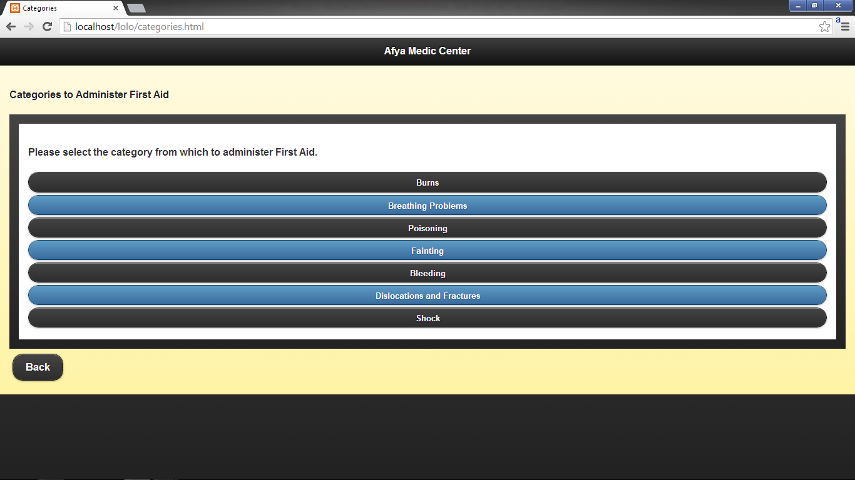

Interface to select symptoms for the medical condition

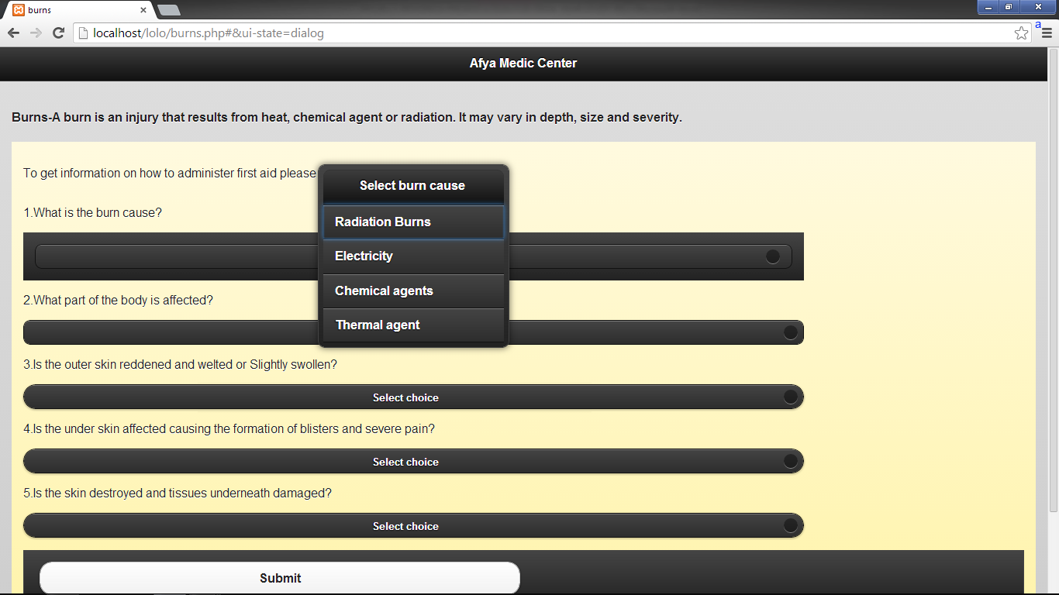

Interface to add first aid information to the database

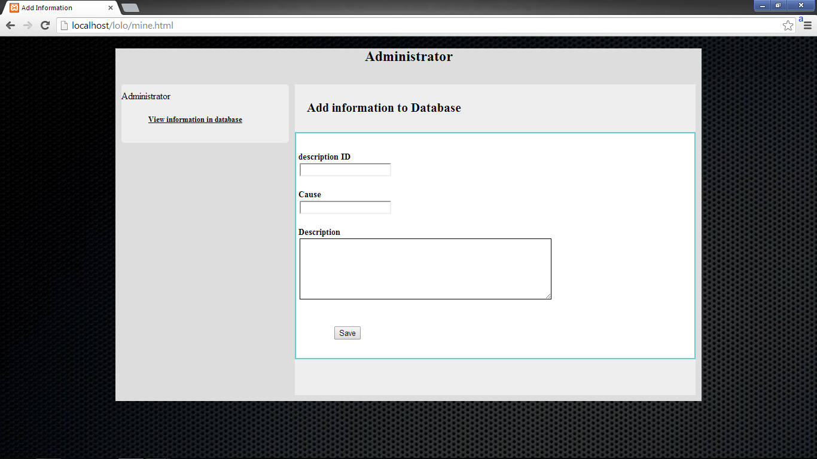

Interface to view first aid information in the database

