

**PROJECT PROPOSAL FOR FINAL YEAR STUDY IN**

**Bachelor of Science in Information Technology**

**BY**

**Mwendia Paul Mwenda**

**PROJECT TITLE**

**Mobile Medic Application**

**Supervisor: Cyrus Kamau**

# Abstract

Expert system is a computer system that emulates the decision making ability of a human expert. It acts in all respects like a human expert and uses human knowledge to solve problems that would require human intelligence. The expert system represents expertise knowledge as data or rules within the computer. These rules and data can be called upon when needed to solve problems.

The Mobile Medic System is applications that will provide easy way too access consolidated medical information to users. As technology finds way to capture knowledge of human experts and make it available to people when they need it anywhere and anytime, the effort of capturing this knowledge is a sub-field of computer science “artificial intelligence (AI)” that is an attempts to develop computer system that can simulate human through processes and action.

This paper presents the design and development of Mobile medic knowledge management system for diseases and support diagnosis. It also gives information on emergency medical conditions “First Aid” in case of accidents. It used rule based approach to collect data and forward chaining inference technique. In diagnosing the system will ask a bunch of questions about the symptoms and risk factors to the expert system user and user should give yes or no answer. According to the answer the system will make judgment about the possibility of illness.

For easy, cheap and efficient access the system will be accessed remotely through mobile application which will be implemented by JQuery which is an open source system, that enables a developer to use and modify the functionalities as per his/her system requirements by extending changes to the source code.

Table of Contents

Abstract 2

Chapter 1.0 Introduction 4

1.1 Problem Definition 4

1.2 Objectives 5

1.3 Justification 5

1.4 General Scope and Application of the project 5

Chapter 2.0 Literature Review 6

2.1 Case Study 1 7

2.2 Case Study 2 7

2.3 Case study 3 7

Chapter 3.0 Methodology 8

3.1 Waterfall Model 8

Requirement 9

Fact Finding Techniques 9

Design 10

Coding 10

Testing and maintenance 10

4.1 Analysis and Design 10

System Requirements 10

Functional Requirements 10

Non-functional Requirements 10

System Design 11

Introduction 11

Logical Design 11

4.0 The system resources requirements and Budget: 15

Items and Description 15

Chapter 5.0 Schedule 16

Chapter 6.0 References 17

# Chapter 1.0 Introduction

An Expert System is a knowledge-based computer program containing expert domain knowledge about objects, events, situations and courses of action, which emulates the process of human experts in the particular domain. In other words, expert system is a computer application that performs a task that would otherwise be performed by a human expert. Expert systems are extensively used in the medical field.

Expert system facilitates organization of knowledge in such a manner, which fills up the gap of the absence of an expert in any field. An expert system with hypertext facility will be particularly useful in organizing knowledge in logical manner and facilitates storing of large amount of information with a very effective retrieval mechanism.

## 1.1 Problem Definition

Medical care which is not only giving medicine but also educating people on how to take care of themselves is essential to helping people improve the quality of their lives. Lack of the basic knowledge about medication for example on how to handle people in case of accidents, how to take care of pregnancies and attack by poisonous animals has led to loss of many lives.

After an extensive research in both rural and urban areas on the understanding on how to handle emergency medical conditions and other health conditions that affect people, it was evident that most people lack knowledge on this field. Though this information is got by those that have gone to school, many forget how to handle such situations after leaving school.

## 1.2 Objectives

1. Educate people on how to handle emergency medical situations.
2. Improve and accelerate quality care
3. Provide an easy, cheap and efficient way to access medical information.
4. Advice on the best way to seek medical attention

## 1.3 Justification

This system will use a rule based approach to collect data and forward chaining inference technique. In diagnosing the system will ask a bunch of questions about the symptoms and risk factors to the expert system user and user should give yes or no answer. According to the answer the system will make judgment about the possibility of illness.

This system will be handled by an administrator who will have the privileges of updating the system with the current medical information needed by users. On the user interface, through an android application the users will have to input their age and gender for them to proceed to the next level where they will choose from the given two choices of either getting info on first aid or disease diagnosis after which the system will advise accordingly.

## 1.4 General Scope and Application of the project

Due to time constraint and the broadness of the medicine field, this project will not cover all what concerns the medical field. This expert system will consists of information for twenty five diseases, each comprising of three parts namely ‘General Descriptions’, ‘Signs and Symptoms’ and ‘Treatment’

#### Constraints / Limitations

* Time: There was a limited time constraint set to research, design and implement the system.
* Lack of adequate knowledge on the medical field due its broad area of study.

# Chapter 2.0 Literature Review

An expert system is an intelligent computer program that uses knowledge and inference procedures to solve problems at the level of a human expert. It emulates the decision making ability of a human expert. That is the expert system is intended to act in all respects like a human expert in a particular field. It is a branch of artificial intelligence which is a branch of computer Science concerned with the automation of intelligent behavior.

Expert systems have developed from a branch of computer science known as artificial intelligence (AI). AI is primarily concerned with knowledge representation, problem solving, learning, robotics, and the development of computers that can speak and understand humanlike languages (Townsend,1987). An expert system is a computer program that uses knowledge and reference procedures to solve problems that are difficult enough to require significant human expertise for their solution (Townsend, 1987). Simply stated, expert systems are computer programs designed to mimic the thought and reasoning processes of a human expert.

Expert system can be developed for many kinds of applications involving diagnosis, prediction, consultation, information retrieval, control, planning, interpretation and instruction (Edmunds, 1988; Lie bowitz and De Salvo, 1989;Peart, 1989). However, diagnosis still remains the primary application of expert systems, particularly for personal computers (Townsend, 1987). They are used in applications where the procedures or algorithms for the problem do not exist or are poorly defined, but good rules of thumb or heuristics are available. Although the use of expert systems in horticulture is still limited and their primary function is as a tool for human experts, expert systems are rapidly being accepted for use by the non-expert to solve problems when human expertise is expensive, untimely or unavailable. Today, better development tools are available and closer interdisciplinary cooperation resulting in agricultural researchers gaining more insight into the theory and concepts necessary to build effective systems (Crass weller et al., 1993;Holt, 1989).

Several notable expert systems have been developed in recent years. For example,

## 2.1 Case Study 1

CALEX is an expert system which was developed for the diagnosis of peach and nectarine disorders by the University of California (Plantet al., 1989). Like most experts systems, CALEX is rule-based system and uses certainty factors, so that the knowledge-base consists of production rules in the form of IF, THEN statements. The inference engine pieces together chains of rules in an attempt to reach a conclusion. The knowledge base of the CALEX/Peaches diagnostic system contains approximately 600 rules for the diagnosis of 120 disorders of peaches and nectarines, representing most of the disorders in California (Plant et al., 1989). CITPATH, a computerized diagnostic key and information system, was developed to identify five major fungal disease of citrus foliage and fruit in Florida (Ferguson et al.,1995). CITPATH also utilizes a rule-based approach which provides hypertext-linked descriptions and graphic displays of symptoms with reference to chemical control methods (Ferguson et al., 1995).

## 2.2 Case Study 2

An Expert system for diabetes diagnosis by Smitha V (2010) designed and built an Expert for Diabetes Mellitus diagnosis which is a common health disorders in many people. This expert system interacts with user with plain English language where user needs to answer only yes or no. Internally the system classifies user input as primary symptoms, hereditary symptoms, complication symptoms, other symptoms to analysis. The expert system uses a score accumulation method to decide the level of impact of diabetes in individual. The different levels are classified as slight chance, moderate chance, high chance, very high chance, or already diabetic or not.

The above case studies are evidence on how expert systems can be of good help to people in need of medical information. Afya medic expert system intends to cover more than one field in medicine unlike the above that only concentrated on a specific field. In addition the users of Afya medic will be able to access it remotely using a mobile application.

## 2.3 Case study 3

Greenway PrimeMOBILE enables physicians and other staff to access comprehensive patient information from the PrimeSUITE EHR through their Android-based smart devices from virtually any remote location, improving care delivery and both clinical and financial workflows. PrimeMOBILE puts patient information at your fingertips, turning any location into your mobile clinic. It provides you with complete remote access to your patients’ data housed in our flagship PrimeSUITE® electronic health record (EHR). This application enables the viewing of clinical documents and lab results, access patient data and enhances easy communication.

Unlike this application which main objective is to enhance management of patients registered to a specific medical center, Afya application will serve anybody who can access its services with an objective to inform and advise the user.

# Chapter 3.0 Methodology

Methodologies allow development of the system with minimal time and allow development of different versions of the system developed sequentially with improved functionality as the users provides additional needs. This leads to development of an efficient system that satisfies the needs of the user. Due to this, I decided to implement the system with the waterfall model which is a popular version of the systems development life cycle model for software engineering.

## 3.1 Waterfall Model

Often considered the classic approach to the systems development life cycle, the waterfall model describes a development method that is linear and sequential. Waterfall development has distinct goals for each phase of development.

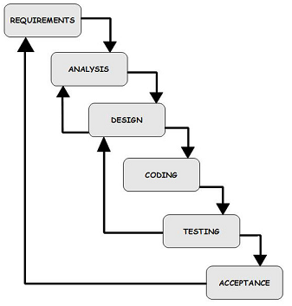

I conducted a research on the requirements of the system and collected and analyzes every detail I got from the research so as to implement it into the system.

### Requirement

This system will advise its users on the best way to seek medication attention or how to respond to emergency health conditions. The input by the users from an android gadget will prompt the expert the system to output the most appropriate information.

This system will require the following to function;

* An expert system that will run from a server.
* An android device from where an application will run remotely to access the server.

### Fact Finding Techniques

To collect information that will help in building an efficient system, the following methods will be used.

#### Primary Sources:

1. Questionnaires.

#### Secondary Sources:

1. The internet
2. Books and literature from various authors

### Design

During this phase, the architecture of the product (hardware and software) are established, along with the parameters for security and performance, storage constraints for data, programming language and the IDE, and others. Also, the product’s user interface will be decided on the course of this phase.

### Coding

This phase involves building of the product according to the specifications and requirements established in the first two phases.

This system will be implemented using the following tools;

### Testing and maintenance

Testing verifies that the product is performing the way it was designed to, and that clients would be satisfied with it.

# 4.1 Analysis and Design

## System Requirements

### Functional Requirements

* This system will have an administrator to update the database and also administer its operation.
* The users will be required to input their age and gender to enhance the accuracy of the output information.
* The system will provide a user friendly mobilephone interface to enhance easy usage by users.
* The system will have a database with detailed information to satisfy user needs.
* The android device running the interface application will need to have internet connectivity to be able to access the server to retrieve information.

### Non-functional Requirements

The retrieval speed of information will depend on the speed of the internet connectivity.

## System Design

### Introduction

This stage will involve defining the architecture, components, modules, interfaces and data for this system to satisfy the requirements for this system.

### Logical Design

The abstract representation of this system is as follows

#### Data Flow Diagram

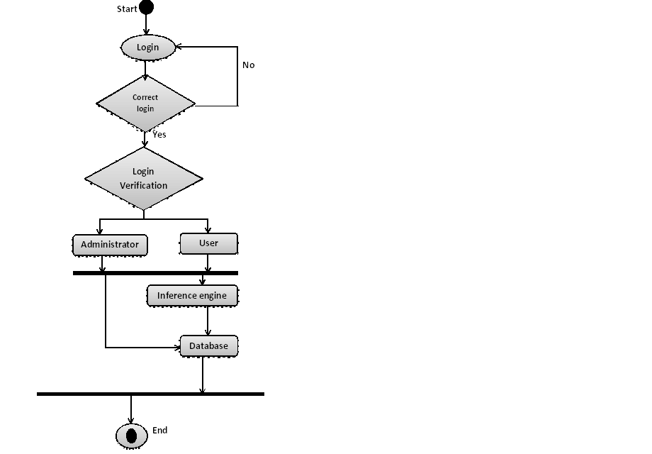

#### Process Analysis

This relates the actual input and output processes of the system.

**Context Data Flow Diagram (Level 1)**

Inputs

Outputs

Questions

User details

Probable diagnosis

Medical condition

#### Context Data Flow Diagram (Level 2)C:\Users\Pamwenda\Desktop\lol.png

Entity Relationship Diagram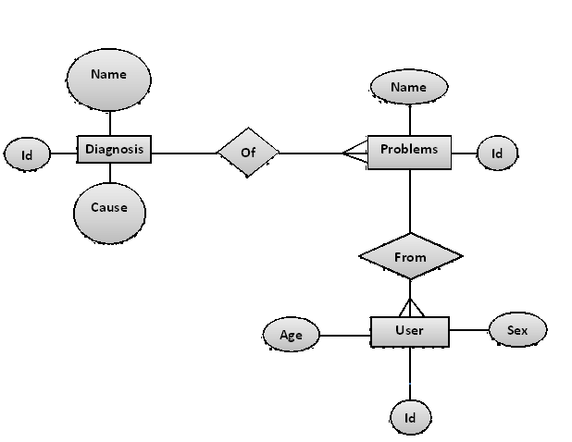

# 4.0 The system resources requirements and Budget:

|  |  |  |  |  |
| --- | --- | --- | --- | --- |
| **No. of Items** | Items and Description | | **Amount/ Item**  **(KShs.)** | **Subtotal**  **(KShs.)** |
| 1. | Hardware | 1. At least Intel Pentium IV processor, 2. 1 GB RAM at least DDR2 of 667 MHz 3. Keyboard and Mouse 4. Android Phone | 10,000  5,500  2,000  7,000 | **24,500** |
| 2. | Software | 1. Operating System: - Windows vista or above. 2. Android Development Tools (ADT) 3. Wamp server 4. Prolog (Programming in Logic) | 10,000 | **10,000** |
|  |  |  |  |  |
| GRAND TOTAL | | | | **Appr. 34,500** |

# Chapter 5.0 Schedule

|  |  |  |  |  |  |  |  |  |
| --- | --- | --- | --- | --- | --- | --- | --- | --- |
| Duration  Waterfall  Model Phases | May | June | July | August | September | October | November | December |
| Fact finding/ Proposal Writing |  |  |  |  |  |  |  |  |
| Requirements Analysis |  |  |  |  |  |  |  |  |
| Design |  |  |  |  |  |  |  |  |
| Coding |  |  |  |  |  |  |  |  |
| Testing/Presentation |  |  |  |  |  |  |  |  |
| Report Writing |  |  |  |  |  |  |  |  |

# Chapter 6.0 References

1. Turban, E. (1992). Expert System and Applied Artificial Intelligence. New York: MacmillanPublishing Company. Retrieved May 22, 2013 from <http://eil.stanford.edu/xpan/adaptive_expert.pdf>
2. 5G Mobile Evolution Lab Emergency Medical Support Application. Retrieved May 20, 2013, from http://www.greenway medical.com/solutions/primemobile/android-phone
3. Townsend, C. (1987) Mastering Expert Systems with Turbo Prolog Author,. Publisher, Howard W. Sams & Company. Company. Retrieved May 22, 2013 from <http://eil.stanford.edu/xpan/adaptive_expert.pdf>
4. Liebowitz, J. and DeSalvo, D. (1989). Structuring Expert Systems. YourdonPress journal, Englewood Cliffs, NJ. Retrieved May 22, 2013 from [www.cieer.org/mthomas/papers/hortech.htm](http://www.cieer.org/mthomas/papers/hortech.htm)
5. Peart, R.M. 1989. Applications of expert systems in agriculture. Chapter10. pp. 163-179. In: Barret, J.R. and D.D. Jones (eds.). Knowledge Engineeringin Agriculture. ASAE Monograph No. 8, Amer. Soc. of Agric. Eng., St. Joseph,MI. Retrieved May 26,2013 from <http://www.cieer.org/mthomas/papers/hortech.html>
6. Smitha V (2010) Expert system for diabetes diagnosis Retrieved May 27, 2013 from [http://repository.christuniversity.in/1812/1/AN_EXPERT_SYSTEM_FOR_DIABETES_DIAGNOSIS BY SMITHA V.pdf](http://repository.christuniversity.in/1812/1/AN_EXPERT_SYSTEM_FOR_DIABETES_DIAGNOSIS%20BY%20SMITHA%20V.pdf)