Original graphs (same as in Justus’ presentation, but for the final set of observations/cases)

From here onwards, no more prehuawei or transition cases.
Lag graphs

Pools and worldwide

Patent Validity graphs (updated results via Darts IP, confirming dates with Espacenet. For those missing the decisions, they were also missing from the Bundespatentgericht and the one at Espacenet continued to be uncheckable, that is why it was not filled, neither was the decision’s date for the patent validity proceedings)
Here we keep Prehuawei and transition cases.

FRAND Defense (no prehuawei nor transition cases)
count unique top freq
Injunction 35 3 Yes 19
Dominant position 35 3 Yes 32
Abuse of dominant position 35 4 No 18
Notice of Infringement 35 2 Yes 34
Willingness to license 35 3 Yes 21
FRAND offer 35 4 No 14
Formal 35 5 No 10
Substantially 35 4 - 19

Frequency Table for Landgericht:
Injunction No Yes n./a. Total
Landgericht
Duesseldorf 7 7 1 15
Mannheim 8 7 0 15
Munich 0 5 0 5
Total 15 19 1 35

Frequency Table for Pool:
Injunction No Yes n./a. Total
Pool
? 15 8 0 23
Yes 0 11 1 12
Total 15 19 1 35

Frequency Table for Worldwide:
Injunction No Yes n./a. Total
Worldwide
? 5 5 1 11
Yes 10 14 0 24
Total 15 19 1 35

Frequency Table for Further proceedings:
Injunction No Yes n./a. Total
Further proceedings
No 11 13 1 25
Yes 4 6 0 10
Total 15 19 1 35

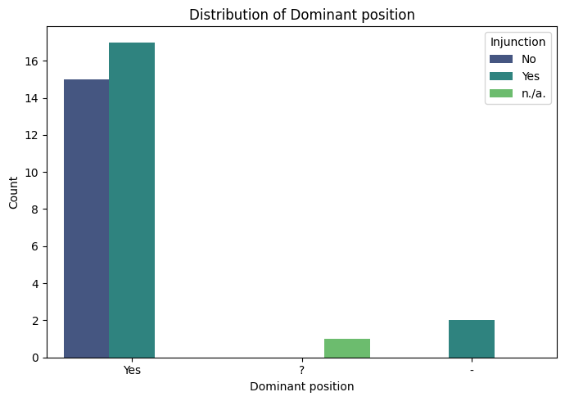
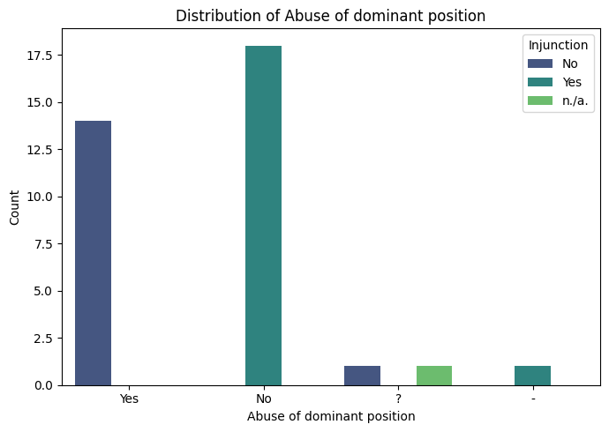
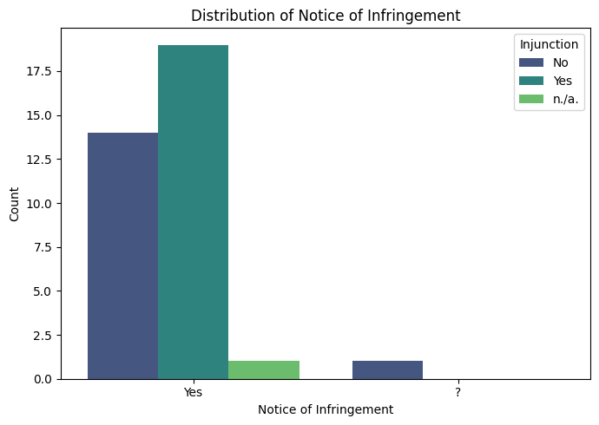
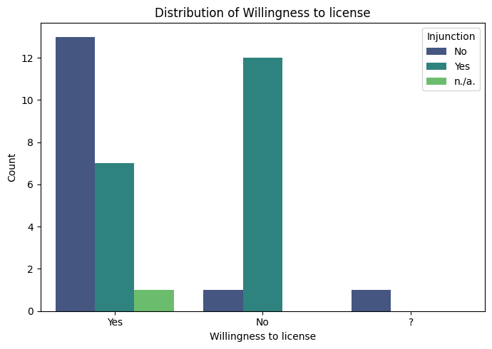
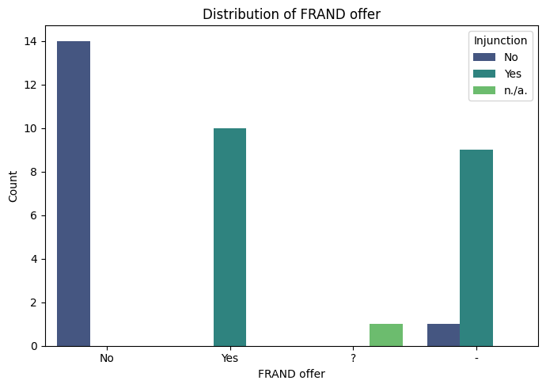
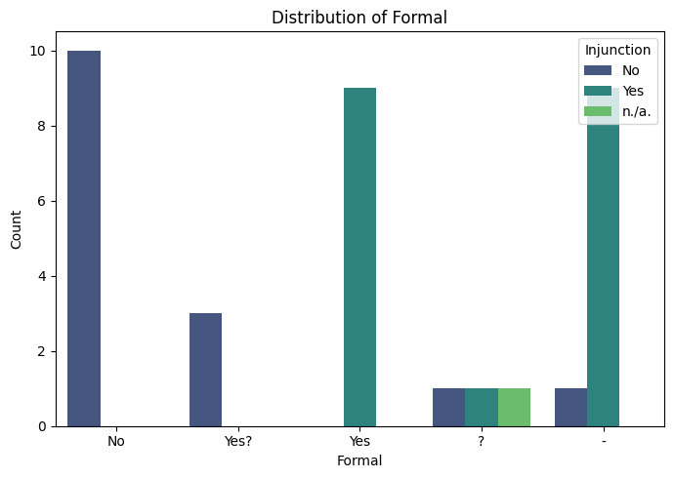
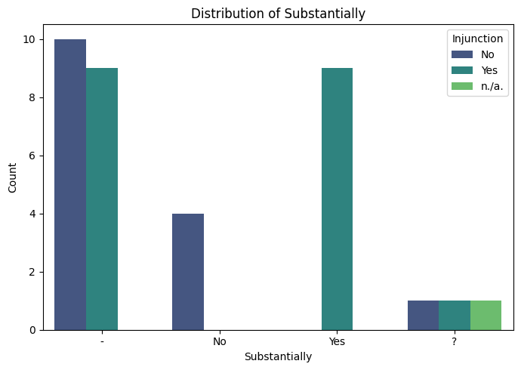
We also have the crosstabulation for each variable and the injunction one, if you wanted to show that in a tabular manner.
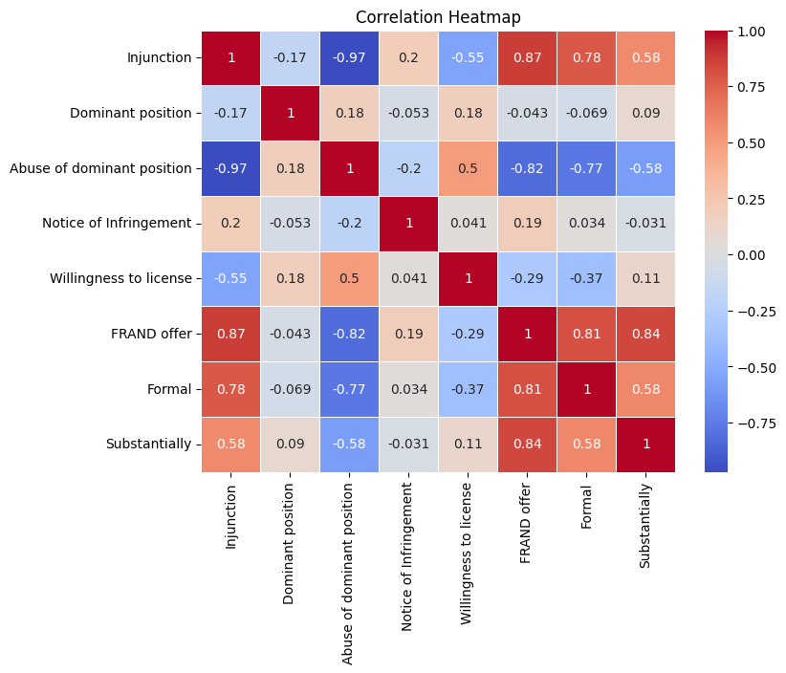
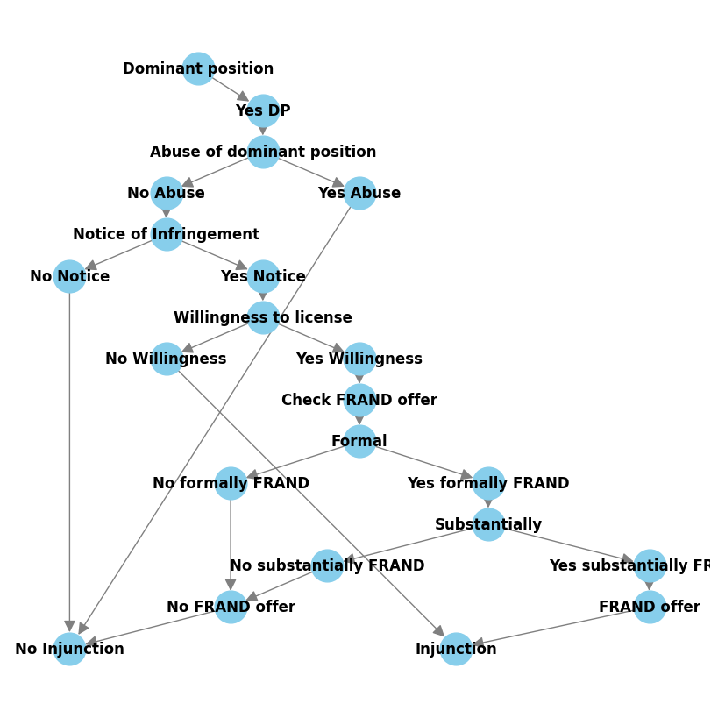
THIS THREE GRAPHS ARE THE SAME, ONLY CHANGING IN WIDTH. WORD ADJUSTS THE ZOOM ACCORDINGLY.
