Lab-Worksheet-CT-2021-086

**CTEC 22043 - Object Oriented Programming**

Q-01-code

package Q_01;  
  
import javax.swing.*;  
  
public class Q_1 {  
 public static void main(String[] args) {  
 JFrame jframe = new JFrame();  
 jframe.setSize(800,600);   
 jframe.setTitle("Welcome to java");  
 jframe.setVisible(true);  
 }  
  
}

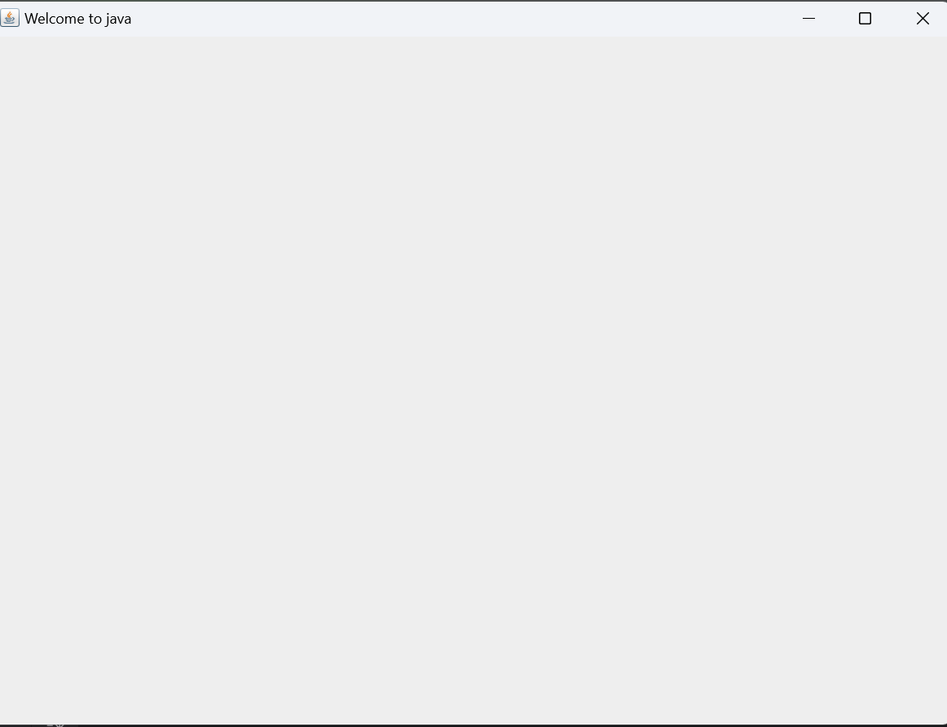

Q-02-code

package Q_02;  
  
import javax.swing.*;  
import java.util.Scanner;  
  
public class Q_02 {  
 public static void main(String[] args) {  
 Scanner scanner = new Scanner(System.*in*);  
 JFrame jframe = new JFrame();  
 String firstname;  
 System.*out*.println("Enter your first name:");  
 firstname=scanner.next();  
 String lastname;  
 System.*out*.println("Enter your last name:");  
 lastname=scanner.next();  
 String fullname;  
 fullname=firstname + lastname;  
 jframe.setTitle(fullname);  
 jframe.setVisible(true);  
 jframe.setSize(300,300);  
  
  
  
 }  
}

Q-02-output

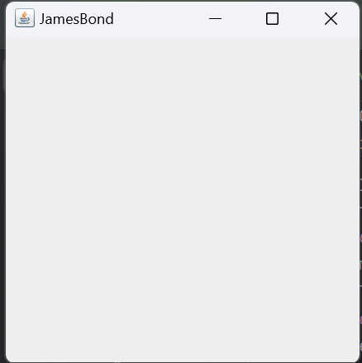

Q-03-code

package Q_03;  
  
import java.util.Scanner;  
  
public class Q_03 {  
 public static void main(String[] args) {  
 Scanner scanner = new Scanner(System.*in*);  
 String firstname;  
 System.*out*.println("Enter your first name:");  
 firstname= scanner.next();  
 String middlename;  
 System.*out*.println("Enter your middle name:");  
 middlename= scanner.next();  
 String lastname;  
 System.*out*.println("Enter your last name:");  
 lastname= scanner.next();  
 String initial;  
 initial= middlename.substring(0,1);  
 System.*out*.println(firstname + " "+ initial+"."+lastname+".");  
  
  
 }  
}

Q-03-output

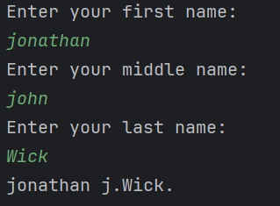

Q-04-code

package Q_04;  
  
import javax.xml.crypto.Data;  
import java.text.SimpleDateFormat;  
import java.util.Date;  
  
public class Q_04 {  
 public static void main(String[] args) {  
 Date today = new Date();  
 SimpleDateFormat sdf = new SimpleDateFormat("dd MMM yyyy"+".");  
 System.*out*.println(sdf.format(today));  
  
 }  
}

Q-04-output

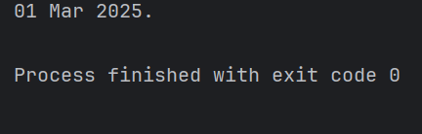

Q-05-code

package Q_05;  
  
import java.text.SimpleDateFormat;  
import java.util.Date;  
  
public class Q_05 {  
 public static void main(String[] args) {  
 Date today = new Date();  
 SimpleDateFormat sdf = new SimpleDateFormat("EEEE,MMM dd,yyyy");  
 System.*out*.println(sdf.format(today));  
  
 }  
}

Q-05-output

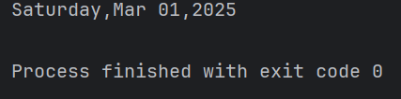

Q-06-code

package Q_06;  
  
import javax.swing.*;  
import java.util.Scanner;  
  
public class Q_06 {  
 public static void main(String[] args) {  
 JFrame jframe = new JFrame();  
 Scanner scanner = new Scanner(System.*in*);  
 String title;  
 System.*out*.println("Enter the frame window tittle:");  
 title= scanner.nextLine();  
 int width;  
 System.*out*.println("enter frame window width:");  
 width= scanner.nextInt();  
 int height;  
 System.*out*.println("enter frame window height:");  
 height= scanner.nextInt();  
  
 jframe.setTitle(title);  
 jframe.setSize(height,width);  
 jframe.setVisible(true);  
  
 }  
}

Q-06-outout

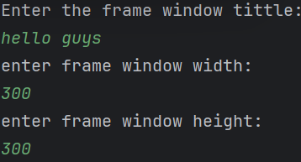

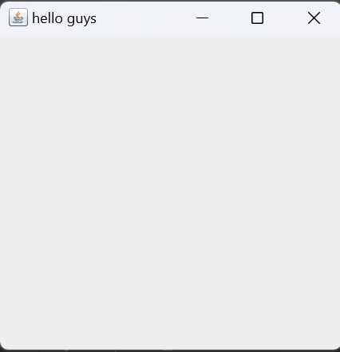

Q-07-code

package Q_7;  
  
import javax.swing.*;  
import java.text.SimpleDateFormat;  
import java.util.Date;  
  
public class Q_7 {  
 public static void main(String[] args) {  
 JFrame jframe = new JFrame();  
 Date today = new Date();  
 SimpleDateFormat sdf = new SimpleDateFormat("hh:mm:ss a.");  
 System.*out*.println(sdf.format(today));  
  
 }

}

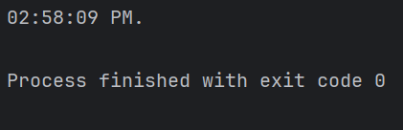

Q-08-code

package Q_08;  
  
import java.util.Scanner;  
  
public class Q_08 {  
 public static void main(String[] args) {  
 Scanner scanner = new Scanner(System.*in*);  
 String line;  
 System.*out*.println("Enter a string with a single exclamation mark:");  
 line= scanner.nextLine();  
  
 int index = line.indexOf('!');  
  
 String before = line.substring(0, index).trim();  
 String after = line.substring(index + 1).trim();  
 System.*out*.println(before);  
 System.*out*.println(after);  
  
  
 }  
}

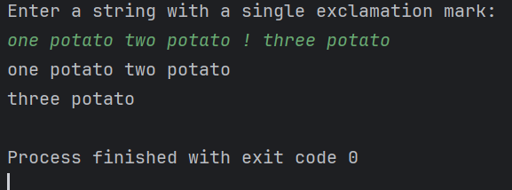

Q-09-code

package Q_09;  
  
import java.util.Scanner;  
  
public class Q_09 {  
 public static void main(String[] args) {  
 Scanner sentence = new Scanner(System.*in*);  
 System.*out*.println("Enter the sentence:");  
 String cha;  
 cha= sentence.nextLine();  
  
 int count = cha.length();  
  
 String initial;  
 initial=cha.substring(0,1);  
  
 String last = String.*valueOf*(cha.charAt(cha.length()-1));  
  
  
  
 System.*out*.println(count);  
 System.*out*.println(initial);  
 System.*out*.println(last);  
  
  
  
  
  
  
 }  
}

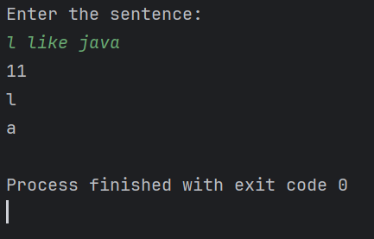

Q-10-code

package Q_10;  
  
import java.util.Scanner;  
  
public class Q_10 {  
 public static void main(String[] args) {  
 Scanner scanner = new Scanner(System.*in*);  
 System.*out*.println("Enter the any sentances:");  
 String sentance;  
 sentance=scanner.nextLine();  
  
 int length = sentance.length();  
  
 if (length % 2 == 1)  
 {  
 int middle = length / 2;  
 System.*out*.println(sentance.charAt(middle));  
 }  
 else  
 System.*out*.println("enter valid odd number off characters.");  
  
  
  
  
  
 }  
}

Q-10-output

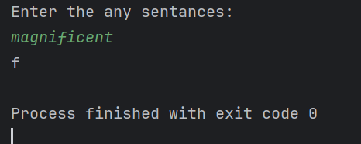

Q-11-code

package Q_11;  
  
import java.util.Scanner;  
  
public class Q_11 {  
 public static void main(String[] args) {  
 Scanner scanner = new Scanner(System.*in*);  
 String firstname;  
 System.*out*.println("Enter your first name:");  
 firstname= scanner.next();  
 String middle;  
 System.*out*.println("Enter your middle name:");  
 middle= scanner.next();  
 String last;  
 System.*out*.println("Enter your last name:");  
 last= scanner.next();  
  
 String initial = middle.substring(0,1);  
  
 System.*out*.println(last+","+firstname+" "+initial+".");  
  
  
  
  
 }  
}

Q-11-output

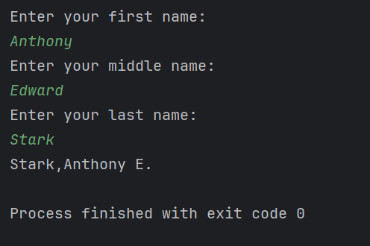

Q-12-code

package Q_12;  
  
import javax.swing.*;  
  
public class Q_12 {  
 public static void main(String[] args) {  
 JFrame jframe = new JFrame();  
 jframe.setSize(300,200);  
 jframe.setTitle("My First Frame");  
 jframe.setLocation(50,100);  
 jframe.setVisible(true);  
  
  
 }  
}

Q-12-output

