Q-01.

Q-01-A-code:

package Q_01;  
  
import java.text.DecimalFormat;  
import java.util.Scanner;  
  
public class Q_01_a {  
 public static void main(String[] args) {  
 Scanner scanner = new Scanner(System.*in*);  
 DecimalFormat df = new DecimalFormat("0.00");  
 double A,B,C;  
 System.*out*.println("Enter A:");  
 A = scanner.nextDouble();  
 System.*out*.println("Enter B:");  
 B = scanner.nextDouble();  
 System.*out*.println("Enter C:");  
 C = scanner.nextDouble();  
  
 System.*out*.println(df.format(Math.*sqrt*(Math.*pow*(B,2)+4*A*C)));  
  
  
 }  
}

Q-01-A-output:

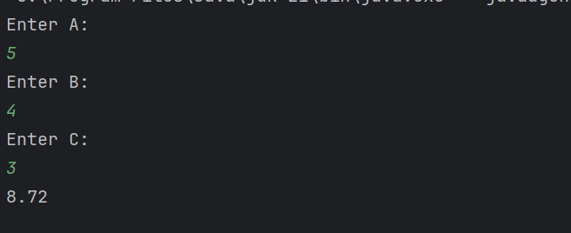

Q-01-B-code:

package Q_01;  
  
import java.text.DecimalFormat;  
import java.util.Scanner;  
  
public class Q_01_b {  
 public static void main(String[] args) {  
 Scanner scanner = new Scanner(System.*in*);  
 DecimalFormat df = new DecimalFormat("0.00");  
 double X,Y;  
 System.*out*.print("Enter X:");  
 X = scanner.nextDouble();  
 System.*out*.print("Enter Y:");  
 Y = scanner.nextDouble();  
 System.*out*.print(df.format(Math.*sqrt*(X + 4*Math.*pow*(Y,3))));  
 }  
}

Q-01-B-output:

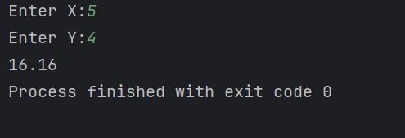

Q-01-C-code:

package Q_01;  
  
import java.text.DecimalFormat;  
import java.util.Scanner;  
  
public class Q_01_c {  
 public static void main(String[] args) {  
 Scanner scanner = new Scanner(System.*in*);  
 DecimalFormat df = new DecimalFormat("0.00");  
 double X,Y;  
 System.*out*.println("Enter X:");  
 X = scanner.nextDouble();  
 System.*out*.println("Enter Y:");  
 Y = scanner.nextDouble();  
 System.*out*.println(df.format(Math.*cbrt*(X*Y)));  
 }  
}

Q-01-C-output:

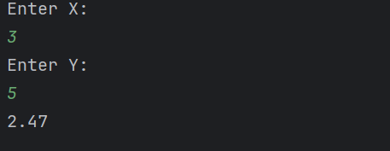

Q-01-D-code:

package Q_01;  
  
import java.text.DecimalFormat;  
import java.util.Scanner;  
  
public class Q_01_d {  
 public static void main(String[] args) {  
 Scanner scanner = new Scanner(System.*in*);  
 DecimalFormat df = new DecimalFormat("0.00");  
 double R;  
 System.*out*.println("Enter Radius:");  
 R = scanner.nextDouble();  
 final double PI = 3.14159;  
 System.*out*.println("Area of the circle is: "+df.format(PI*R*R));  
 }  
}

Q-01-D-output:

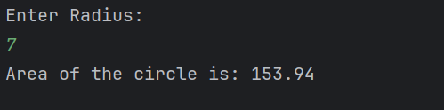

Q-02-code.

package Q_02;  
  
import java.text.DecimalFormat;  
import java.util.Scanner;  
  
public class Q_02 {  
 public static void main(String[] args) {  
 Scanner scanner = new Scanner(System.*in*);  
 DecimalFormat df = new DecimalFormat("0.00");  
 float cm;  
 System.*out*.print("Enter centimeter:");  
 cm= scanner.nextFloat();  
 float feet = cm/30;  
 float inch = cm % 30 * 0.3937f;  
 System.*out*.print(feet +"ft "+df.format(inch)+"in");  
 }  
}

Q-02-output:

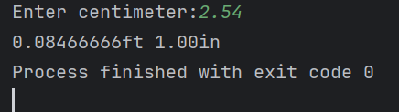

Q-03-code.

package Q_03;  
  
import java.text.DecimalFormat;  
import java.util.Scanner;  
  
public class Q_03 {  
 public static void main(String[] args) {  
 Scanner scanner = new Scanner(System.*in*);  
 DecimalFormat df = new DecimalFormat("0.0");  
 double C,F;  
 System.*out*.println("Enter the Temperature in celsius:");  
 C = scanner.nextDouble();  
 F = (1.8*C)+32;  
 System.*out*.println("Temperature is fahrenheit: " + df.format(F)+"f");  
 }  
}

Q-03-output:

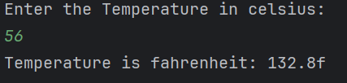

Q-04-code.

package Q_04;  
  
import java.text.DecimalFormat;  
import java.util.Scanner;  
  
public class Q_04 {  
 public static void main(String[] args) {  
 Scanner scanner = new Scanner(System.*in*);  
 DecimalFormat df = new DecimalFormat("0.0");  
 double weight;  
 System.*out*.println("Enter your weight in pounds:");  
 weight= scanner.nextDouble();  
  
 System.*out*.println("you need " + df.format(weight*19)+ "calories per day");  
 }  
}

Q-04-output:

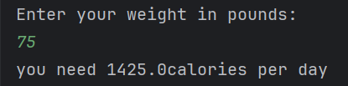

Q-05-code.

package Q_05;  
  
import java.text.DecimalFormat;  
import java.util.Scanner;  
  
public class Q_05 {  
 public static void main(String[] args) {  
 Scanner scanner = new Scanner(System.*in*);  
 DecimalFormat df = new DecimalFormat("0.0");  
 double C,F;  
 System.*out*.println("Enter the Temperature in Fahrenheit:");  
 F= scanner.nextDouble();  
 C= (F-32)*5/9;  
 System.*out*.println("Temperature is fahrenheit: " + df.format(C)+"c");  
 }  
}

Q-05-output:

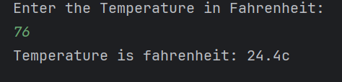

Q-06-code.

package Q_06;  
  
import java.time.Year;  
import java.util.Scanner;  
  
public class Q_06 {  
 public static void main(String[] args) {  
 Scanner scanner =new Scanner(System.*in*);  
 int currentYear = Year.*now*().getValue();  
 System.*out*.print("Enter the year you were born: ");  
 int birthYear = scanner.nextInt();  
 int age = currentYear - birthYear;  
 System.*out*.println("You were born in " + birthYear + " and will be (are) " + age + " this year.");  
 }  
}

Q-06-output:

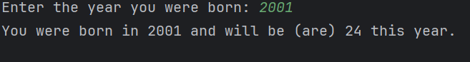

Q-07-code.

package Q_07;  
  
import java.util.Scanner;  
  
public class Q_07 {  
 public static void main(String[] args) {  
 Scanner scanner = new Scanner(System.*in*);  
 System.*out*.print("Enter your weight in kg: ");  
 int weight = scanner.nextInt();  
 System.*out*.print("Enter your height in cm: ");  
 int height = scanner.nextInt();  
 double bmi = weight / Math.*pow*((height / 100.0), 2);  
 if (bmi >= 20 && bmi <= 25) {  
 System.*out*.println("Your BMI is in the normal range.");  
 } else {  
 System.*out*.println("Your BMI is outside the normal range.");  
 }  
 }  
}

Q-07-output:

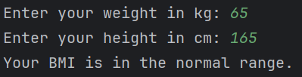

Q-08-code.

package Q_08;  
  
import java.util.Scanner;  
  
public class Q_08 {  
 public static void main(String[] args) {  
 Scanner scanner = new Scanner(System.*in*);  
 final double PI = 3.14;  
 System.*out*.print("Enter the radius of the sphere: ");  
 double radius = scanner.nextDouble();  
 double volume = (4.0 / 3.0) * PI * Math.*pow*(radius, 3);  
 System.*out*.printf("The volume of the sphere is: %.2f%n", volume);  
  
  
  
 }  
}

Q-08-output:

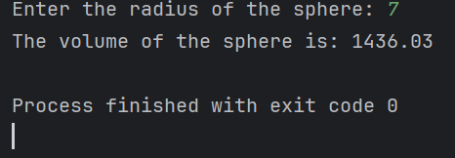

Q-09-code.

package Q_09;  
  
import java.text.DecimalFormat;  
import java.util.Scanner;  
  
public class Q_09 {  
 public static void main(String[] args) {  
 Scanner scanner = new Scanner(System.*in*);  
 DecimalFormat df = new DecimalFormat("0.00");  
 double P,R,N;  
 System.*out*.print("Enter the amount: ");  
 P = scanner.nextDouble();  
 System.*out*.print("Enter the interest rate: ");  
 R= scanner.nextDouble();  
 System.*out*.print("Enter the number of years: ");  
 N = scanner.nextDouble();  
 double TotalAmount = (P * Math.*pow*((1+(R/100)),N));  
 double TotalInterest = TotalAmount - P;  
 System.*out*.println("Total Interest Of " + N + "years is: " + df.format(TotalInterest));  
 System.*out*.println("Total Amount Of After" + N + "years is: " + df.format(TotalAmount));  
 }  
}

Q-09-output:

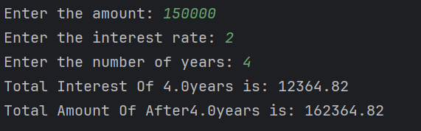

Q-09-code.

package Q_10;  
  
import java.text.DecimalFormat;  
import java.util.Scanner;  
  
public class Q_10 {  
 public static void main(String[] args) {  
 Scanner input = new Scanner(System.*in*);  
 DecimalFormat df = new DecimalFormat("0.000");  
  
 System.*out*.print("Enter loan amount: ");  
 double loanAmount = input.nextDouble();  
  
 System.*out*.print("Enter annual interest rate: ");  
 double annualInterestRate = input.nextDouble();  
  
 System.*out*.print("Enter loan period in years: ");  
 int loanPeriod = input.nextInt();  
  
 final int MONTHS_IN_YEAR = 12;  
  
 double monthlyInterestRate = annualInterestRate / 100.0 / MONTHS_IN_YEAR;  
  
  
 int numberOfPayments = loanPeriod * MONTHS_IN_YEAR;  
  
 double monthlyPayment = (loanAmount * monthlyInterestRate) /  
 (1 - Math.*pow*(1 / (1 + monthlyInterestRate), numberOfPayments));  
  
  
 double totalPayment = monthlyPayment * numberOfPayments;  
  
  
 System.*out*.println("Monthly Payment:" +df.format(monthlyPayment)+"Rs");  
 System.*out*.print("Total Payment:"+df.format(totalPayment)+"Rs");  
  
  
 }  
}

Q-10-output:

