[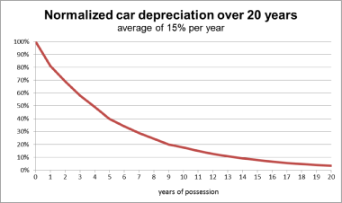](https://en.wikipedia.org/wiki/File:Depreciation_car.svg)

A typical vehicle depreciation over 20 years