**Instructions per second** (**IPS**) is a measure of a [computer](https://en.wikipedia.org/wiki/Computer)'s processor speed. Many reported IPS values have represented "peak" execution rates on artificial instruction sequences with few branches, whereas realistic workloads typically lead to significantly lower IPS values. [Memory hierarchy](https://en.wikipedia.org/wiki/Memory_hierarchy) also greatly affects processor performance, an issue barely considered in IPS calculations. Because of these problems, synthetic [benchmarks](https://en.wikipedia.org/wiki/Benchmark_%28computing%29) such as [Dhrystone](https://en.wikipedia.org/wiki/Dhrystone) are now generally used to estimate [computer performance](https://en.wikipedia.org/wiki/Computer_performance) in commonly used applications, and raw IPS has fallen into disuse.

The term is commonly used in association with a numeric value such as **thousand instructions per second** (**TIPS**), **million instructions per second** (**MIPS**), and **billion instructions per second** (**GIPS**).

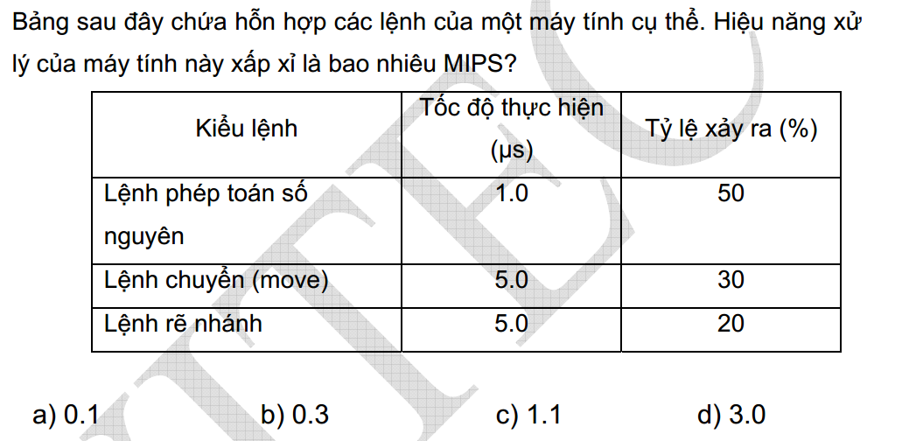

1*0.5 + 5*0.3 + 5*0.2 = 0.5+1.5+1=3

1 lệnh mất 3 microseconds

1 s (1 000 000 microseconds)

=> 1 000 000 / 3 = 0.3 MIPS

Tốc độ xử lý của CPU là 0.3 MIPS. Nghĩa là CPU này thực hiện được 300 000 lệnh 1 giây