**Matchbox Keyboard - Raspberry Pi Touchscreen Keyboard**

September 04, 2015

So you’ve got a shiny new touchscreen for your raspberry pi but are a little miffed that you still need to plug a keyboard in to be able to type… Well after this tutorial there will be no need!

We will assume you have installed Raspbian and that you have booted to the GUI (or run the command startx)

All the commands listed are run in Terminal. **Make sure you have an internet connection!**

Start off by making sure you Raspberry Pi is up-to-date

*sudo apt-get update  
sudo apt-get upgrade*

Now simply install the matchbox-keyboard package

*sudo apt-get install matchbox-keyboard*

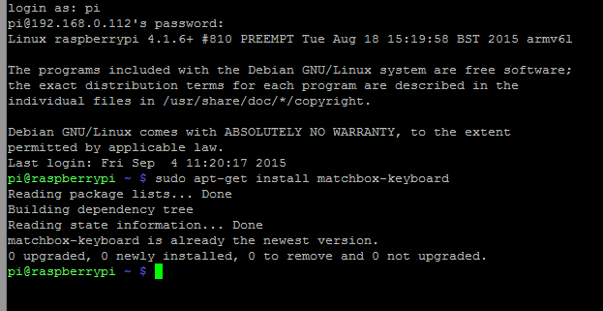

Now boot to the GUI, using the command:

*startx*

To enable up the keyboard, simply go MENU >> ACCESSORIES >> KEYBOARD

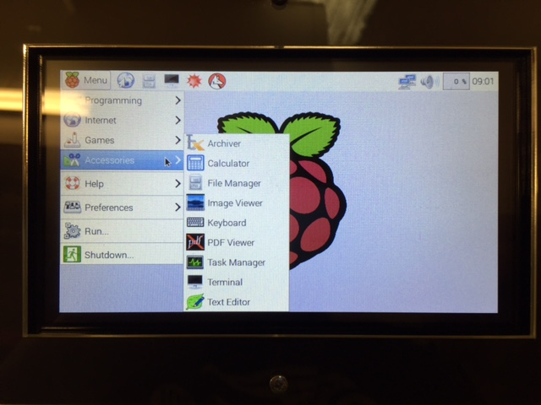

To make sure the keyboard is always on top, click the little file icon next to “keyboard”, where our mouse is hovering:

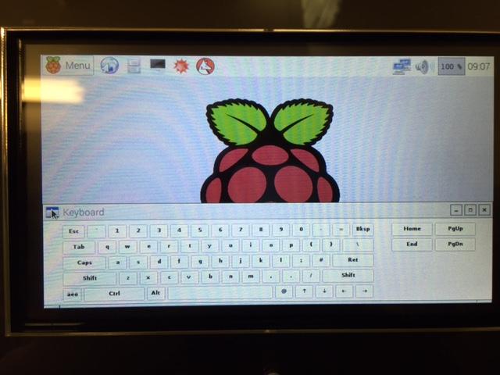

Then go to “layer” then select “Always on top”

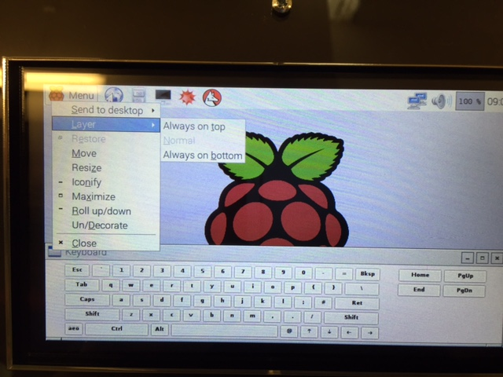

Job Done!

Now, you might want to create a shortcut on your desktop to make it nice and easy to start up the keyboard when you need it. To do this start by creating a file on the desktop

*cd Desktop  
nano keyboard.sh*

Now write the following code

*#!/bin/bash  
matchbox-keyboard*

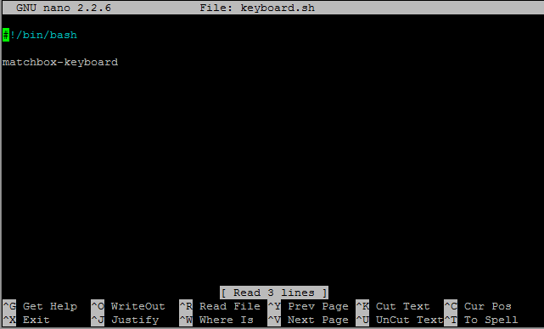

Press Ctrl+X and then Y to close and save the file

Now we need to make the file we just created executable

*chmod +x keyboard.sh*

That’s it, we now have a shortcut on the desktop that we can double click to load up the on screen keyboard.