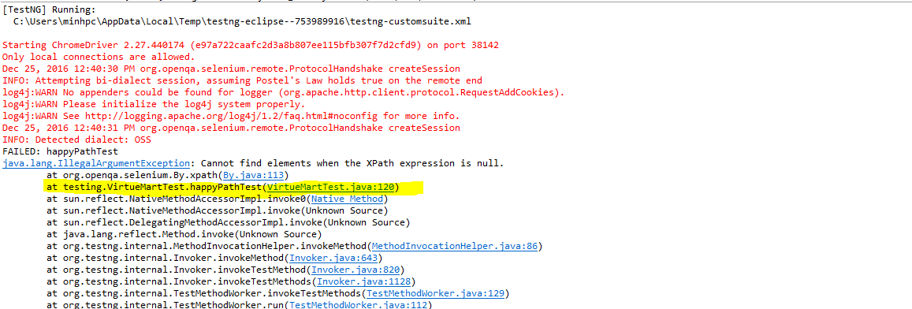

The error in the above happens because of xpath method, and it happens in line 120 of happyPathTest file.