http://www.avajava.com/tutorials/lessons/what-is-log4j-and-how-do-i-use-it.html

At its most basic level, you can think of it as a replacement for System.out.println's in your code. Why is it better than System.out.println's? The reasons are numerous.
To begin with, System.out.println outputs to standard output, which typically is a console window. The output from Log4j can go to the console, but it can also go to an email server, a databaseW table, a log file, or various other destinations.
Another great benefit of Log4j is that different levels of logging can be set. The levels are hierarchical and are as follows: TRACE, DEBUG, INFO, WARN, ERROR, and FATAL. If you set a particular log level, messages will get logged for that level and all levels above it, and not for any log levels below that. As an example, if your log level is set to ERROR, you will log messages that are errors and fatals. If your log level is set to INFO, you will log messages that are infos, warns, errors, and fatals. Typically, when you develop on your local machine, it's good to set the log level to DEBUG, and when you deploy a web application, you should set the log level to INFO or higher so that you don't fill up your error logs with debug messages.
Log4j can do other great things. For instance, you can set levels for particular Java classes, so that if a particular class spits out lots of warnings, you can set the log level for that class to ERROR to suppress all the warning messages.
Typically, you can configure Log4j via a configuration file. This means that you can change your logging configuration without requiring code updates. If you need to do something like set the log level to DEBUG for your deployed application in order to track down a particular bug, you can do this without redeploying your application. Instead, you can change your log configuration file, reread the configuration file, and your logging configuration gets updated.

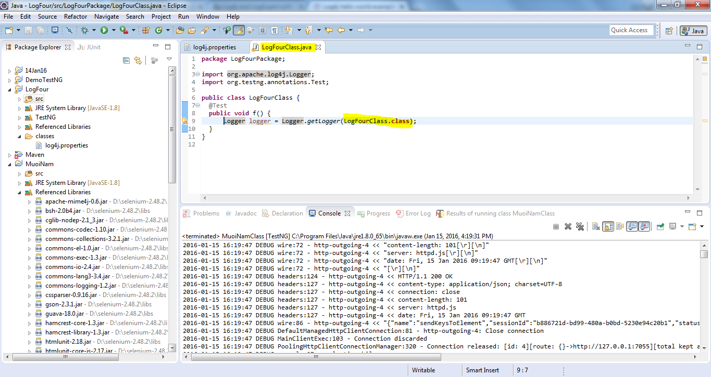

Event Level | LoggerConfig Level
 | TRACE | DEBUG | INFO | WARN | ERROR | FATAL | OFF
TRACE | YES | NO | NO | NO | NO | NO | NO
DEBUG | YES | YES | NO | NO | NO | NO | NO
INFO | YES | YES | YES | NO | NO | NO | NO
WARN | YES | YES | YES | YES | NO | NO | NO
ERROR | YES | YES | YES | YES | YES | NO | NO
FATAL | YES | YES | YES | YES | YES | YES | NO

log4j.rootLogger=INFO, theConsoleAppender
if the log level is set to INFO, meaning that log.debug() messages won't be logged, but log.info(), log.warn(), log.error(), and log.fatal() will be logged.

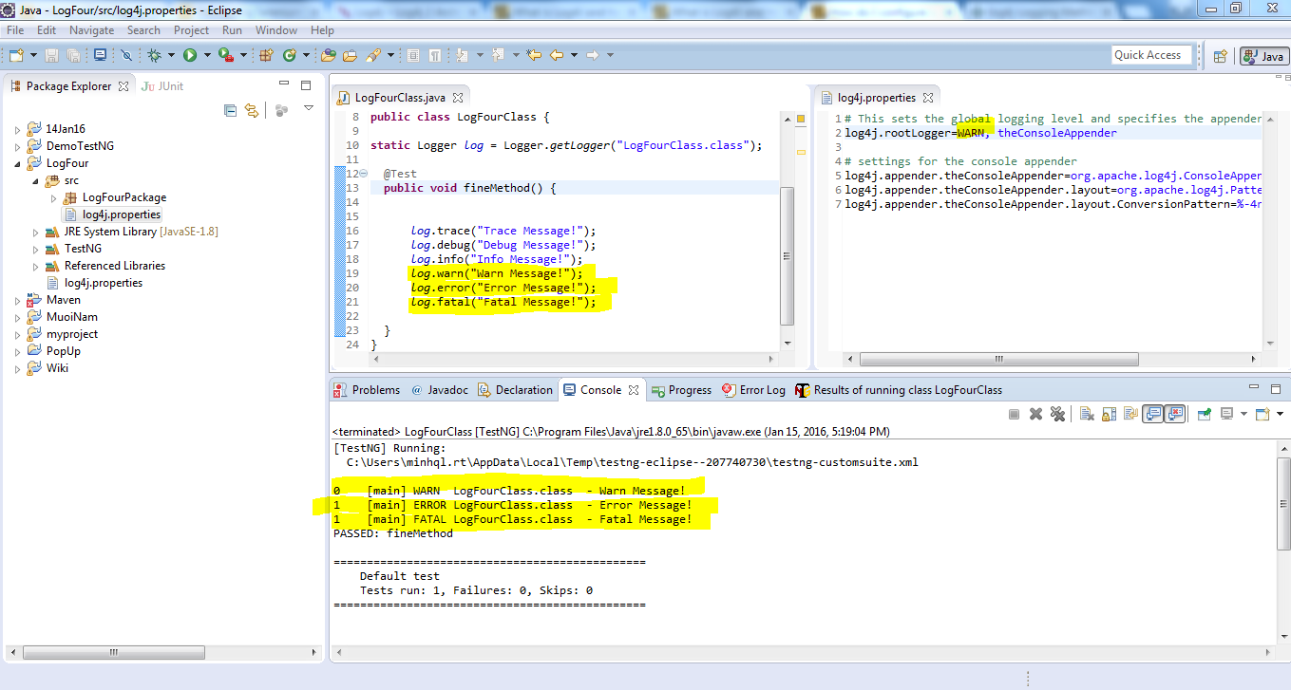

Log4j cannot find properties file in a simple application
To solve your issue place your your log4j configuration file(i.e. log4j.xml or log4j.properties) in the src folder and it should work fine.

PropertyConfigurator.configure("mylog4j.properties");
Use above line to configure the location of log4j.properties file.

log.debug("Debug Message!");
log.info("Info Message!");
log.warn("Warn Message!");
log.error("Error Message!");
log.fatal("Fatal Message!");
Above method would generate the following result −
Debug Message!
Info Message!
Warn Message!
Error Message!
Fatal Message!

# This sets the global logging level and specifies the appenders
log4j.rootLogger=INFO, theFileAppender

# settings for the console appender
log4j.appender.theFileAppender=org.apache.log4j.RollingFileAppender
log4j.appender.theFileAppender.File=TestLog.log
log4j.appender.theFileAppender.layout=org.apache.log4j.PatternLayout
log4j.appender.theFileAppender.layout.ConversionPattern=%d %-4r [%t] %-5p %c %x %m%n

# %n: xuống hàng
%m: nội dung text. Ví dụ:log.info("Input searched keys") thì nội dung sẽ là Input searched keys
%d: thời gian
%c: tên class

