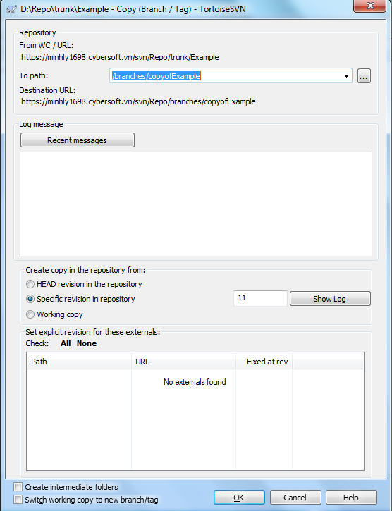

After creating branch, unless you have serious bandwidth issues, I would stay away from the switching step and just check out branches directly. After checking out, you can use update and confirm normally

