EIS analysis report
Model: Randles (Rs + Rct‖Cdl)
Data file: randles_Rs10_Rct100_C10uF.csv
Generated on 2026-10-12 13:03

1. Equivalent-circuit fit
Electrical parameters of the chosen model, found by least-squares fitting. They describe the circuit, not yet the chemistry.
R_{s}: 10.01 Ω
R_{c}t: 99.94 Ω
C_{d}l: 9.994 × 10⁻⁶ F
RMSE (complex): 0.1801 Ω
χ² (σ = 1): 9.606

2. Measured EIS features (no model)
Read directly from the data. If the system behaves like a Randles circuit: R_{high} ≈ R_{s}, R_{low} - R_{high} ≈ R_{ct}, and f_{apex} is related to R_{ct} and C_{dl} as below.
R_{high}: 10.19 Ω
R_{low}: 110.1 Ω
R_{low} - R_{high}: 99.96 Ω
f_{apex}: 154.5 Hz
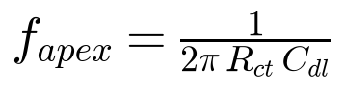
LaTeX: f_{apex} = \frac{1}{2 \pi \, R_{ct} \, C_{dl}}

3. Electrochemical interpretation
Derived quantities. Each one is valid only under the assumptions listed with it.

Inputs provided
- Temperature: 25 °C
- Electrode area: 1 cm²
- Number of electrons n: 1

Shared assumptions
- A1: The fitted circuit is R_{s} + (R_{ct} / C_{dl}): one semicircle, and C_{dl} is an ideal capacitor (no CPE / non-ideal behaviour).

Time constant τ
Value: 0.0009988 s
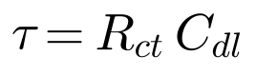
LaTeX: \tau = R_{ct} \, C_{dl}
Relies on shared assumption(s): A1
Notes:
- Describes how fast the interface charges/discharges. It is a property of the fit, not yet a chemical statement.

Characteristic frequency f_{c}
Value: 159.3 Hz
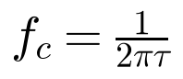
LaTeX: f_c = \frac{1}{2 \pi \tau}
Relies on shared assumption(s): A1
Notes:
- Should match the apex frequency measured directly from the Nyquist plot (f_{apex}); a large mismatch means the single-semicircle model does not describe the data well.

Specific double-layer capacitance
Value: 9.994 × 10⁻⁶ F/cm²
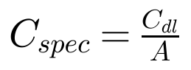
LaTeX: C_{spec} = \frac{C_{dl}}{A}
Relies on shared assumption(s): A1
Additional assumptions:
- A is the true electroactive area, not just the geometric area.
- The fitted capacitance is really the double layer (not adsorption pseudocapacitance or a coating).

Exchange current density j₀
Value: 0.0002571 A/cm²
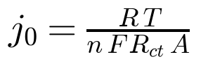
LaTeX: j_0 = \frac{R\,T}{n\,F\,R_{ct}\,A}
Relies on shared assumption(s): A1
Additional assumptions:
- Measured at equilibrium (open-circuit) with both the oxidised and reduced species present, small AC amplitude (linearised Butler-Volmer).
- R_{ct} is purely the charge-transfer resistance: no diffusion (Warburg) or film resistance mixed into it.
- Single, simple electron-transfer reaction; n is the number of electrons of that reaction (ambiguous for multi-step mechanisms).
- A is the true electroactive area.
- T = 298.15 K.
Notes:
- If R_{ct} also contains other resistive contributions, j₀ is underestimated.

Consistency check: fit vs data
f_{c} (fit): 159.3 Hz
f_{apex} (data): 154.5 Hz
Difference: 3.1 %
The fit and the data agree on the time constant. This supports the single-semicircle model but does not prove it.

4. Figures
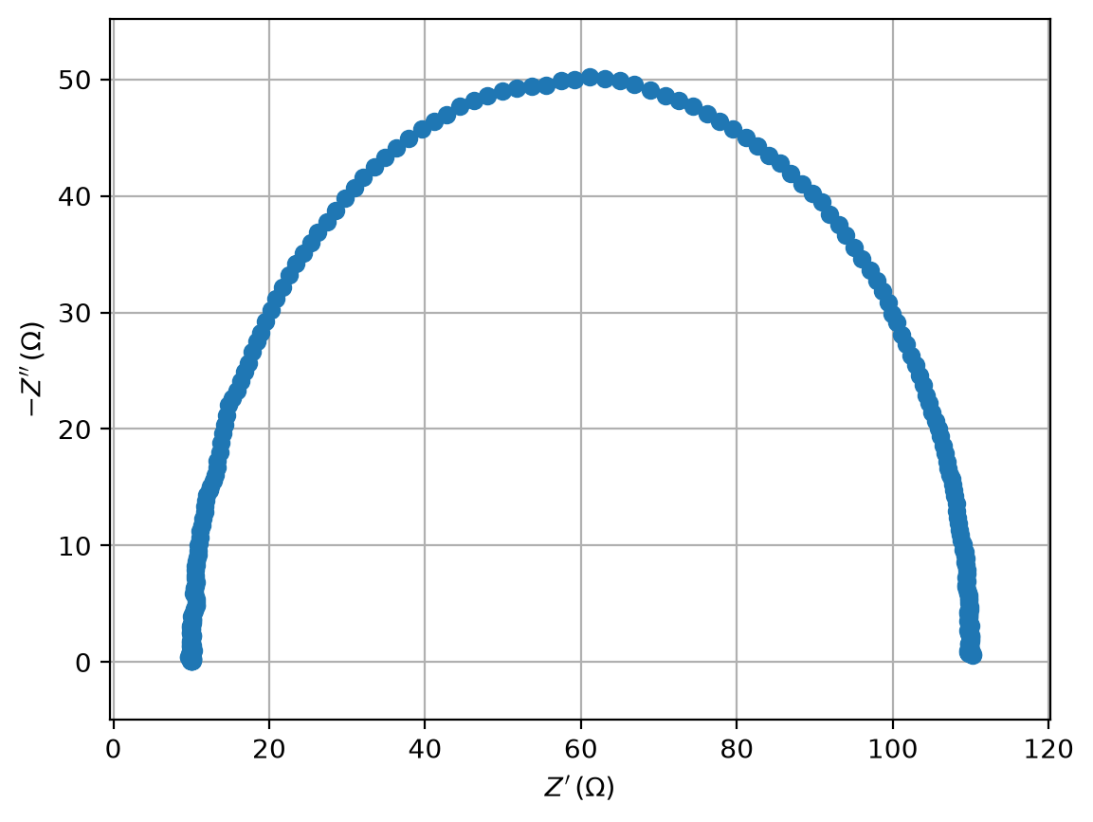 | 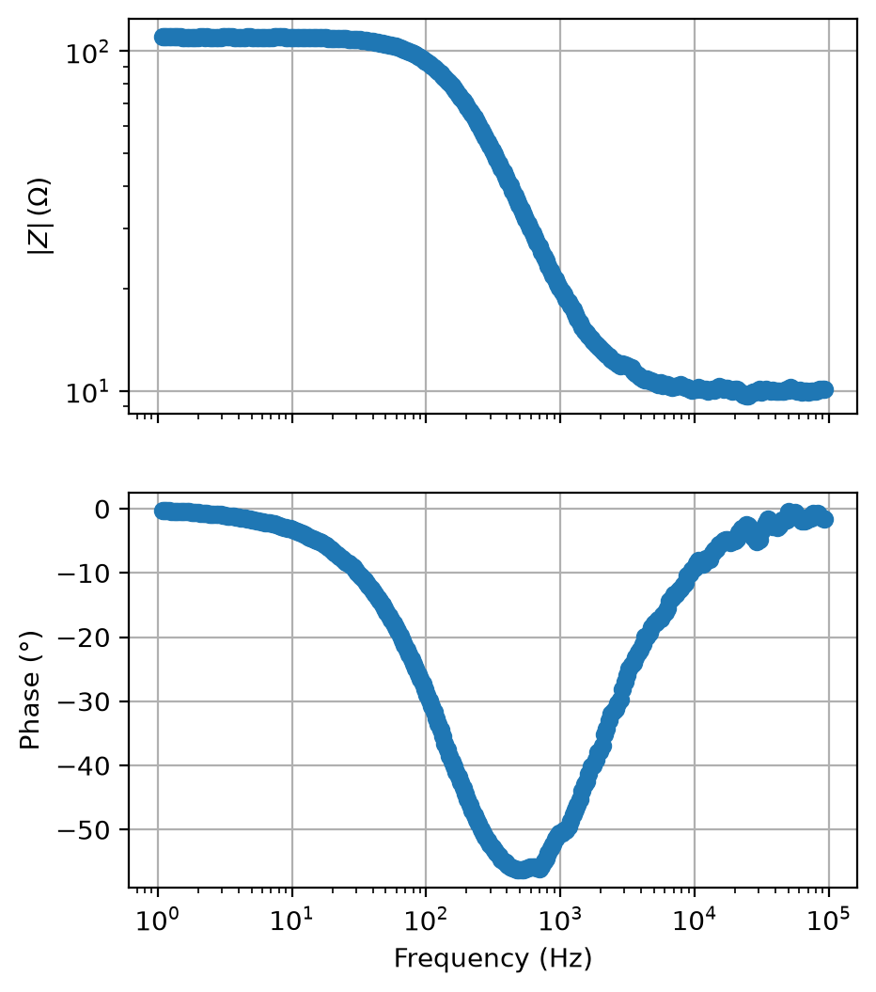
Nyquist plot (data) | Bode plot (data)

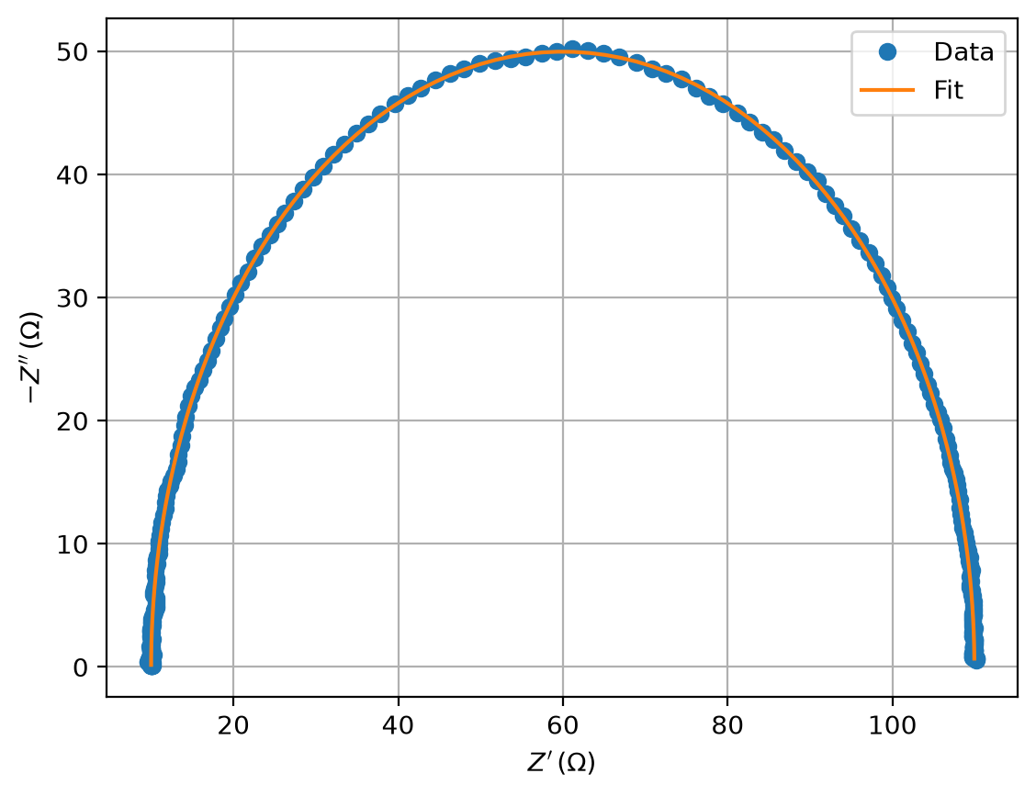 | 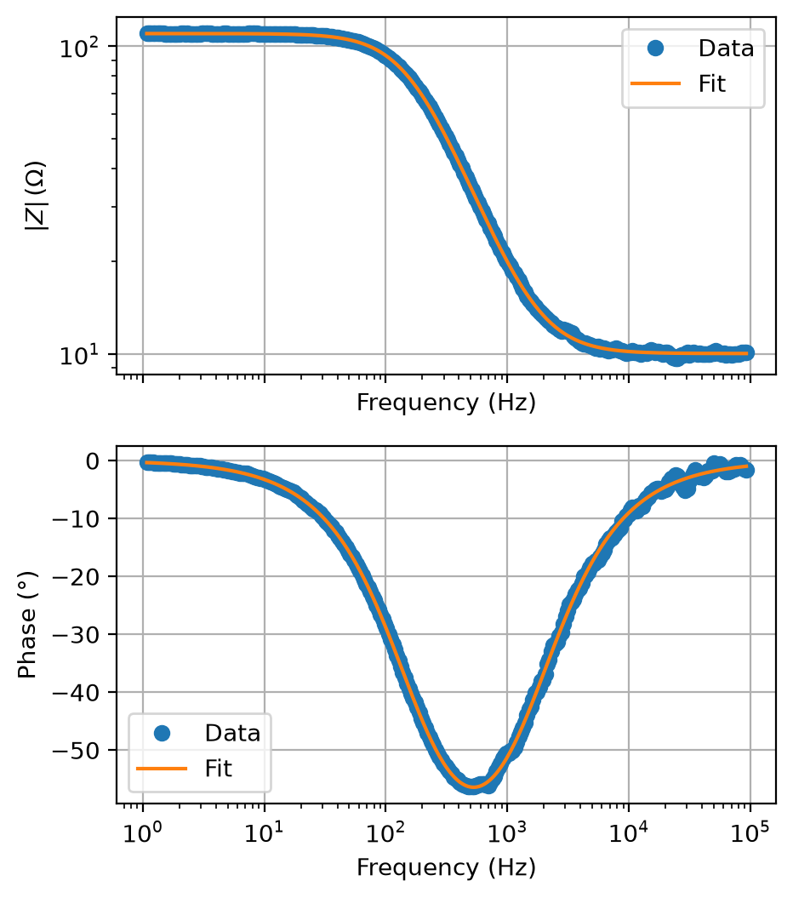
Nyquist: data vs fitted model | Bode: data vs fitted model

