EIS analysis report
Model: Randles (Rs + Rct‖Cdl)
Data file: randles_Rs10_Rct30_C100mF.csv
Generated on 2026-10-12 13:23

1. Equivalent-circuit fit
Electrical parameters of the chosen model, found by least-squares fitting. They describe the circuit, not yet the chemistry.
R_{s}: 10 Ω
R_{ct}: 29.98 Ω
C_{dl}: 0.0001002 F
RMSE (complex): 0.06258 Ω
χ² (σ = 1): 3.9

2. Measured EIS features (no model)
Read directly from the data. If the system behaves like a Randles circuit: R_{high} ≈ R_{s}, R_{low} - R_{high} ≈ R_{ct}, and f_{apex} is related to R_{ct} and C_{dl} as below.
R_{high}: 10.11 Ω
R_{low}: 39.89 Ω
R_{low} - R_{high}: 29.78 Ω
f_{apex}: 52.11 Hz
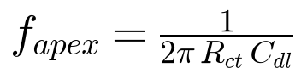
LaTeX: f_{apex} = \frac{1}{2 \pi \, R_{ct} \, C_{dl}}

3. Electrochemical interpretation
Derived quantities. Each one is valid only under the assumptions listed with it.

Inputs provided
- Temperature: 25 °C
- Electrode area: 1 cm²
- Number of electrons n: 1
- Electrode spacing L: 1 cm
- Electrolyte cross-section: 1 cm²

Shared assumptions
- A1: The fitted circuit is R_{s} + (R_{ct} ‖ C_{dl}): one semicircle, and C_{dl} is an ideal capacitor (no CPE / non-ideal behaviour).

Time constant τ
Value: 0.003004 s
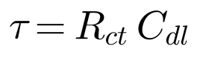
LaTeX: \tau = R_{ct} \, C_{dl}
Relies on shared assumption(s): A1
Notes:
- Describes how fast the interface charges/discharges. It is a property of the fit, not yet a chemical statement.

Characteristic frequency f_{c}
Value: 52.98 Hz
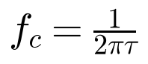
LaTeX: f_c = \frac{1}{2 \pi \tau}
Relies on shared assumption(s): A1
Notes:
- Should match the apex frequency measured directly from the Nyquist plot (f_{apex}); a large mismatch means the single-semicircle model does not describe the data well.

Specific double-layer capacitance
Value: 0.0001002 F/cm²
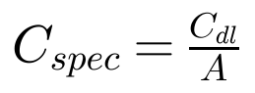
LaTeX: C_{spec} = \frac{C_{dl}}{A}
Relies on shared assumption(s): A1
Additional assumptions:
- A is the true electroactive area, not just the geometric area.
- The fitted capacitance is really the double layer (not adsorption pseudocapacitance or a coating).
Notes:
- 100 µ F/cm² is outside the usual ~5-100 µ F/cm² range for flat electrodes in aqueous electrolyte. Possible reasons: real area differs from the area you entered (roughness, porosity), a surface film or functionalised layer, a non-aqueous electrolyte, or a non-ideal (CPE) interface. EIS alone cannot tell which.

Exchange current density j₀
Value: 0.0008569 A/cm²
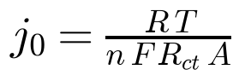
LaTeX: j_0 = \frac{R\,T}{n\,F\,R_{ct}\,A}
Relies on shared assumption(s): A1
Additional assumptions:
- Measured at equilibrium (open-circuit) with both the oxidised and reduced species present, small AC amplitude (linearised Butler-Volmer).
- R_{ct} is purely the charge-transfer resistance: no diffusion (Warburg) or film resistance mixed into it.
- Single, simple electron-transfer reaction; n is the number of electrons of that reaction (ambiguous for multi-step mechanisms).
- A is the true electroactive area.
- T = 298.15 K.
Notes:
- If R_{ct} also contains other resistive contributions, j₀ is underestimated.

Electrolyte conductivity
Value: 0.09999 S/cm
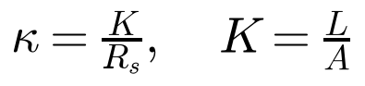
LaTeX: \kappa = \frac{K}{R_s}, \quad K = \frac{L}{A}
Additional assumptions:
- R_{s} is entirely electrolyte resistance (wires, contacts and reference-electrode junction add to it).
- Uniform current distribution between electrodes, so that the cell constant K = L/A is valid.
- R_{s} is read at high frequency, where the cell is purely resistive.
Notes:
- 1 S/cm = 1000 mS/cm. Compare to a calibrated standard solution to validate the cell constant.

Consistency check: fit vs data
f_{c} (fit): 52.98 Hz
f_{apex} (data): 52.11 Hz
Difference: 1.7 %
The fit and the data agree on the time constant. This supports the single-semicircle model but does not prove it.

4. Figures
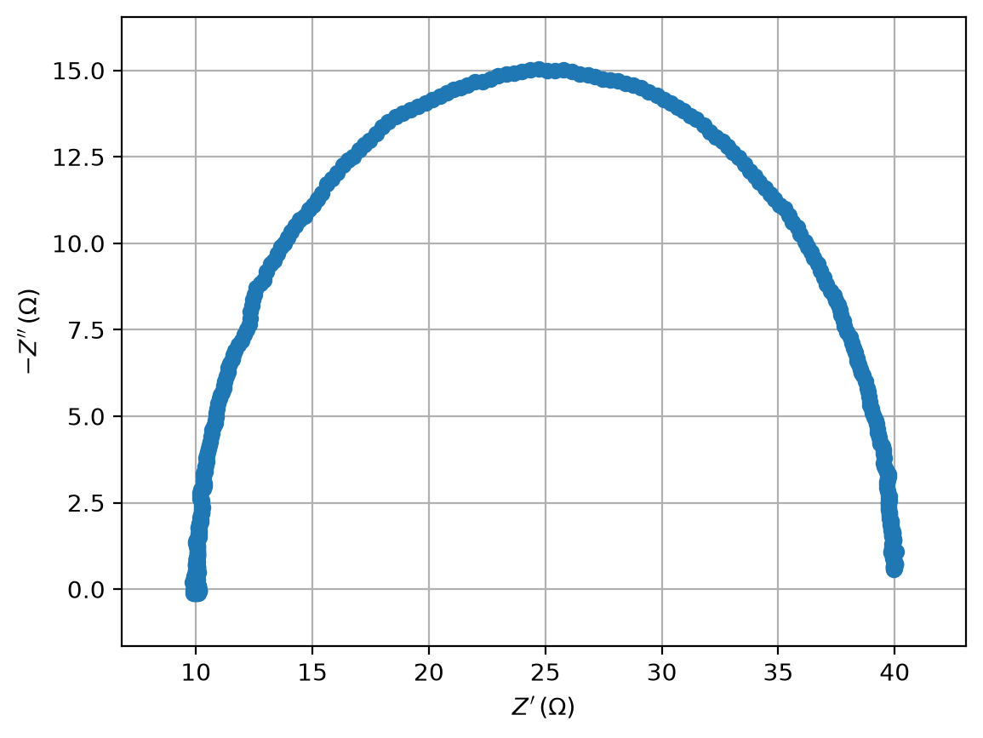 | 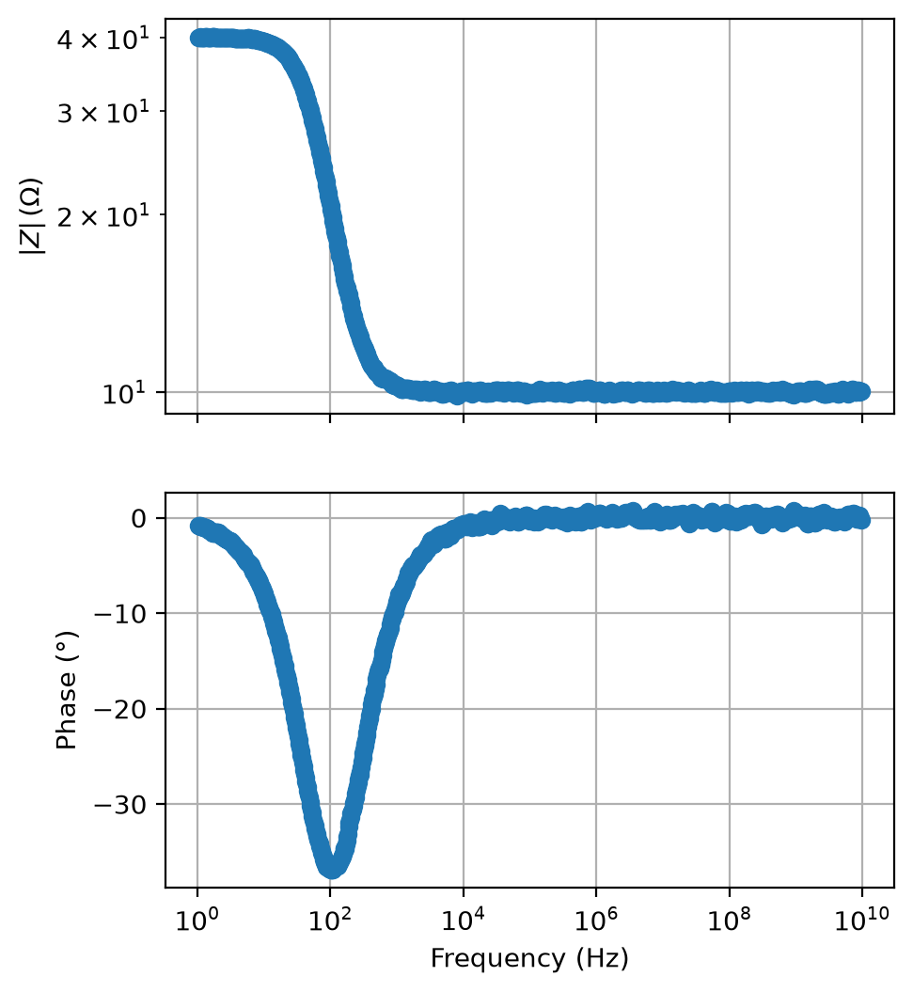
Nyquist plot (data) | Bode plot (data)

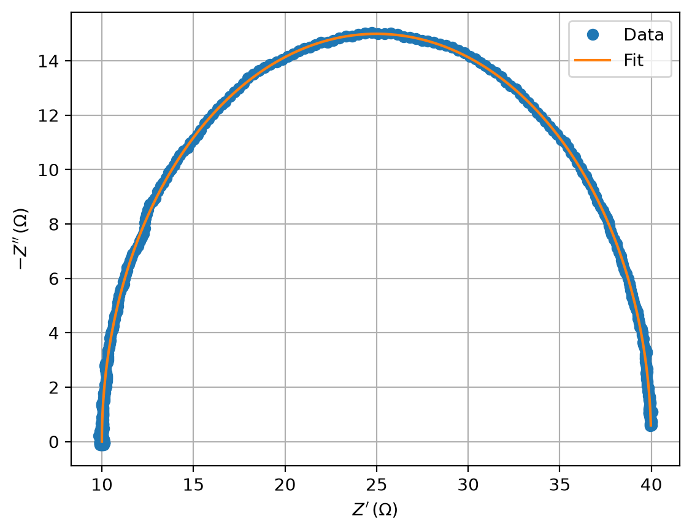 | 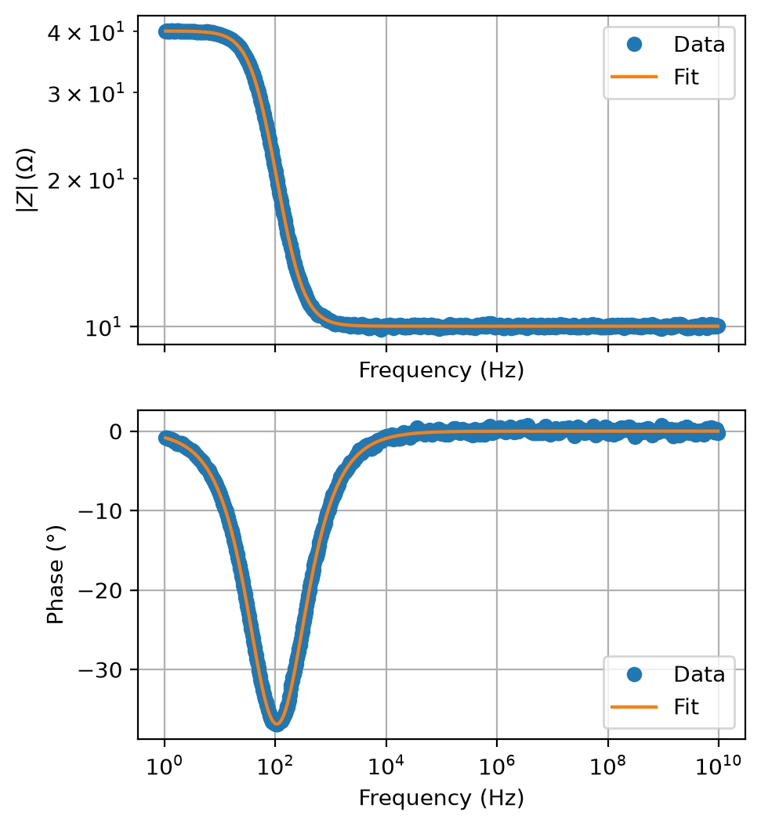
Nyquist: data vs fitted model | Bode: data vs fitted model

