Follow-up email swipe file
Module 05, Where to find jobs | Aussie Grad Careers

Seven days after you apply, if you have not heard anything, send email 1. You are checking that your application arrived. You are not asking for the job.
Most candidates never follow up. That is the whole advantage here. You are not being pushy, you are being the one applicant who is organised, and it moves you to the top of a pile nobody else is touching.

How to use these
- Anything in [square brackets] gets replaced. Nothing else needs changing.
- Send from the same email address you applied with.
- Reply to your original application email where you can, so the whole history sits in one thread. If you applied through Seek or a company portal, send a fresh email to the recruiter or the careers inbox.
- Keep them short. A follow-up that takes 20 seconds to read gets read.
- Tuesday to Thursday, in the morning. Not Friday afternoon.
- Seven days means seven plain days, not working days. Apply on a Tuesday, chase the following Tuesday.
Email 1: the 7 day check in
When: 7 days after you applied, with no reply. Your tracker turns the row red on the right day. That is what the red is for.
Subject: Application for [Role title], submitted [date]

Hi [Name],

I submitted an application for [Role title] on [date] and wanted to check if it arrived. I remain very interested, happy to provide any additional information if helpful.

Kind regards,
[Your name]
[Phone] | [LinkedIn URL]

Those two sentences are word for word from the video. Resist the urge to add a third. Every extra line you write here is a line that can be held against you, and none of them make the email work better.

If you do not have a name: open with "Hello," and send it to the careers inbox. Do not write "To whom it may concern".
Realistic time: about 4 minutes, and most of that is digging back through your email to find the date you applied and who to send it to. You will send roughly 25 of these a week.
Email 2: after an interview
When: within 24 hours of the interview. Same day is better.
Subject: Thank you, [Role title] interview

Hi [Name],

Thank you for your time [today / yesterday]. I enjoyed hearing about [one specific thing they told you about the role or the team].

It confirmed my interest, particularly [the part of the job you know you can do well]. [Optional: one sentence properly answering the question you fumbled.]

Happy to provide anything further. I look forward to hearing how the process goes.

Kind regards,
[Your name]

The optional sentence is the valuable part of this email. If a question caught you out, this is your one legitimate chance to answer it properly, and doing it calmly in writing often reads better than the answer you would have given on the spot. One sentence. Do not relitigate the whole interview.

The specific detail matters. "I enjoyed hearing about the migration to the new claims platform" proves you were listening. "I enjoyed our conversation" proves nothing and every other candidate wrote it.
Email 3: the second chase
When: 7 days after email 1, and only once. Reply to your own email 1 so the subject line and the history stay together.
Subject: Re: Application for [Role title], submitted [date]

Hi [Name],

Following up on my note from [date] about [Role title]. I understand these processes take time.

If the role has moved on, that is no problem at all, and I would appreciate knowing so I can plan accordingly. If it is still open, I remain interested.

Kind regards,
[Your name]

Then stop. Two follow-ups is the limit. A third does not get you the job, it gets you remembered for the wrong reason, and recruiters talk to each other. Mark the application closed in your tracker and keep the company on your target list. Roles reopen, and the person who was gracious about a no is the person they contact next time.
Doing this at 25 applications a week
Twenty five applications a week means about twenty five of these emails a week, and each one needs the company, the role title, the date you applied and the right person to send it to. Call it four minutes each once you have gone back through your inbox to find all four. That is roughly 100 minutes a week, near enough seven hours a month, spent retyping things you already knew.
JobHub knows which applications are past 7 days and drafts the email with those details already in it. Here is what that looks like:
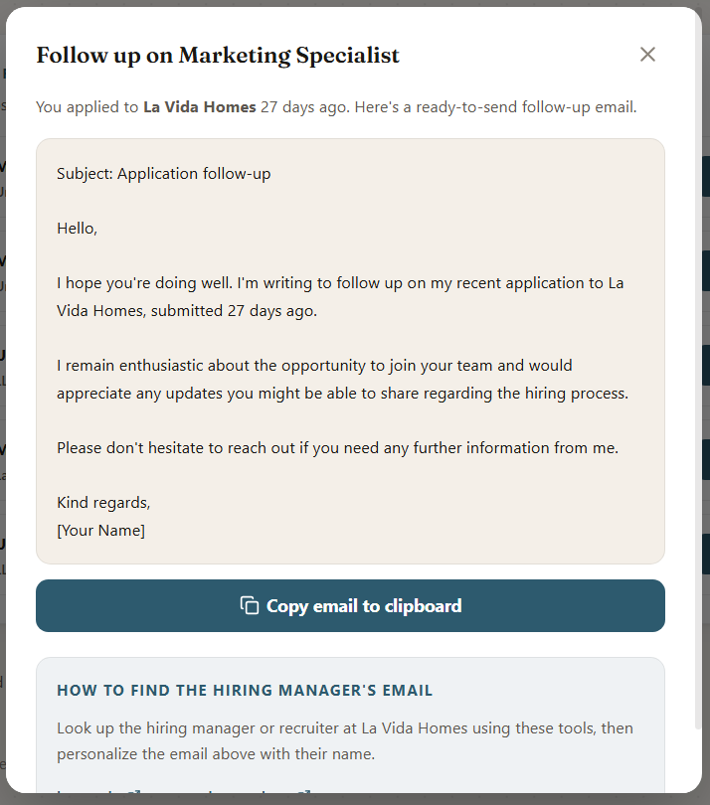
The application that went quiet, 27 days in this case, with the email already written and the company, role and date filled in.
These templates work perfectly well on their own. You are just paying for them in about seven hours a month. If you are applying at five a week instead of twenty five, that is your call to make.
What not to do
- Do not ask for the job in a follow-up. The purpose is to confirm your application arrived and to stay visible. Asking makes it easy to say no.
- Do not attach your resume again. It is already in their system, and a second copy reads as though you think they lost the first one.
- Do not apologise. "Sorry to bother you" tells them you think you are a bother. Following up is a normal professional act.
- Do not chase an application you sent yesterday. Seven days is the rule, and it exists because a week is genuinely how long a first sift takes.
- Do not send the same email to five people at the same company on the same day. Pick one. They forward things.
- Do not write a follow-up longer than the templates above. Length reads as anxiety.

Free diagnostic: theaussiegradcareers.com.au/welcome
Pairs with the application tracker from this module, which works out the 7 day date for you and turns the row red when it is due.

