Interview scripts and question bank
Module 07, The Interview | Aussie Grad Careers

By the time you are in the room they have read your resume, your cover letter and probably your LinkedIn. They already believe you can do the work. The interview is answering a different question entirely: am I going to sit next to this person eight hours a day, five days a week, and enjoy it?
Australian panels expect directness. First names, not sir or madam. Evidence-based claims, not adjectives. Short answers rather than long rehearsed speeches that avoid the question. Be certain of what you have actually done, and let that carry it.
Question 1: tell me about yourself
You know this one is coming and most people still get it wrong, usually by starting at birth. It is a test of brevity. Can you deliver what matters without wandering?
Present, past, future. Ninety seconds.
Part | What goes in it | Roughly
Present | What you are now, professionally. Job title, field, the thing you are good at. | 2 sentences
Past | One line on what brought you here. Not your life story. | 1 sentence
Future | How you will contribute to THIS company. The part everyone leaves out, and the only part they are really listening for. | 2 sentences

Worked answer
I'm a customer operations specialist. For the last three years I've run high volume phone and written support, most recently handling around 95 calls a day at a 90% satisfaction rate, and I've moved into fixing the processes behind the queue rather than just working it.

I came to Melbourne in 2024 to finish my Master's, and I've kept working in operations here while I did it.

What drew me to this role is that you're scaling the support team and the ad mentions building out escalation process. That is exactly the work I did at Meridian when we lost two people and I rebuilt the queue to hold the deadline. I'd like to do that properly, with a team, rather than as an emergency.

Count the sentences: five. It answers the question, it lands one number, and it ends on them rather than on you. If you cannot say yours in ninety seconds, it is too long.
Question 2: strengths and weaknesses
Strengths
Pick one that matches the job, and bring a proof story with an outcome in it. A strength with no evidence is an adjective, and adjectives are free.
I'm good at finding the process problem underneath a workload problem. [Then a 30 second STAR story that demonstrates exactly that, ending in a number.]

Weaknesses
Never say you are a perfectionist, that you work too hard, or that you care too much. Every panel has heard it, and all it demonstrates is that you were not willing to answer the question.

This question is measuring self-awareness. Do you know what you are not good at? So pick something real, non-fatal for this job, and finish on what you did about it. The structure is: the weakness, how you noticed it, what you changed.
I used to take on too much rather than flag that a deadline was at risk, because I thought asking for help looked like I could not cope.

It came to a head when I held a complaints backlog for two weeks without escalating, and by the time I did we were close to breaching. My team leader was fine about it, which was the lesson.

Now I flag early by default. On the tracker I built, anything inside three days of deadline goes to my team leader automatically, whether I think I can handle it or not, because that decision is not really mine to make alone.

Notice it is a genuine weakness with a genuine cost, and the answer ends somewhere better than it started. That arc is what is being scored.

Question 3: tell me about a time when
Behavioural questions are the meat of the interview. They take the most time and carry the most weight, and they all have the same answer: STAR.
 | What it does | Time
Situation | Context only. Where, what organisation, what was going on. | 10%
Task | What you were asked to achieve. | 10%
Action | What YOU did, step by step, including what went wrong. This signals competence and it is what they are actually listening to. | 60%
Result | What changed, with a number. Including when it fell short. | 20%

Speaking well and communicating well are different things. People who speak well ramble. People who are nervous ramble harder, because when we do not know what to say we try to say everything. STAR is what keeps you safe: it gives you an ending, so you stop.
Build four stories before you go in
Not scripts to recite. Four situations from your own history, already sorted into STAR in your head, that you can reach for when a question lands. Almost every behavioural question is one of these four wearing a different hat.
Story | Covers the questions about
1. A problem you solved | Initiative, problem solving, analysis, working unsupervised, process improvement
2. A time you worked with difficult people | Conflict, stakeholders, influencing, teamwork, communication
3. A time you were under real pressure | Deadlines, competing priorities, resilience, prioritisation
4. A time you got it wrong | Failure, feedback, learning, accountability, self-awareness

Story 4 is the one people refuse to prepare, and it is the one that most reliably separates candidates. A person who can describe their own mistake calmly, and what they changed, reads as someone safe to hire.
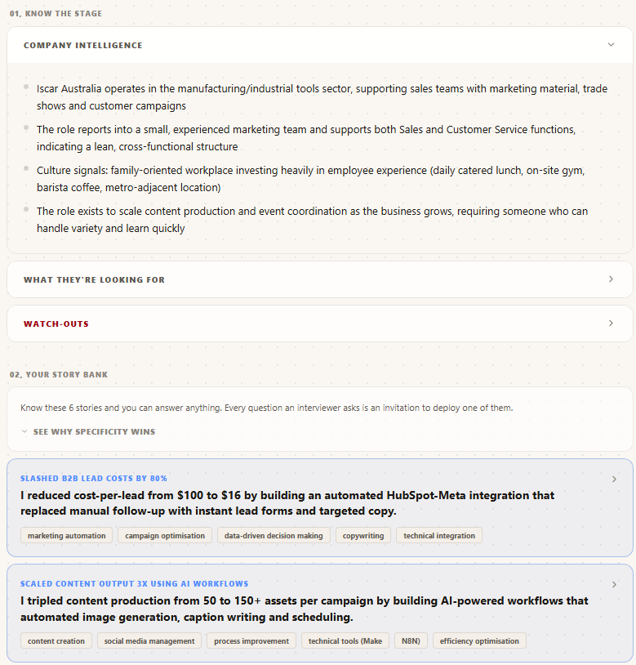
A prepared story bank: the company research, then each story with its outcome already quantified and tagged to the skills it evidences.

The question bank
Map each question to one of your four stories before you go in. Write the story number in the margin. That is the entire preparation.
Almost certain
- Tell me about yourself.
- Why do you want to work here?
- Why this role, and why now?
- What are your strengths?
- What is your biggest weakness?
- Where do you see yourself in three years?
- Do you have any questions for us?
Behavioural, expect three or four of these
- Tell me about a time you had to meet a tight deadline.
- Describe a situation where you had to deal with a difficult colleague or customer.
- Give me an example of a time you improved a process.
- Tell me about a time you made a mistake. What happened?
- Describe a time you had to influence someone without authority over them.
- Tell me about a time you had to learn something quickly.
- Give me an example of juggling competing priorities.
- Tell me about a time you disagreed with your manager.
- Describe a time you received difficult feedback.
- Tell me about a time you worked with someone from a very different background.
Australian workplace specific
- How do you handle direct feedback?
- This team is quite flat, with no one checking your work daily. How do you operate in that?
- What do you know about our industry here in Australia?
- How have you found adjusting to working in Australia?
- What are your salary expectations?
For international candidates
- What is your current visa status?
- How long are your work rights valid for?
- Will you require sponsorship?
- Do you have Australian experience?

The visa question
The most common question this audience worries about, and the anxiety around it does more damage than the question does. Understand what they are actually asking: can this person work with us for at least the next year?
If you have more than 12 months of work rights
Lead with the work rights. Answer the question they asked, and stop.
I have full working rights until March 2028, so there's no restriction on this role. I'm working with a migration lawyer on permanent residency after that.

That is the whole answer. You are not asking them for anything, so there is nothing for them to say no to. You have more than a year to demonstrate your value and make the sponsorship conversation later, from a much stronger position, as someone they already do not want to lose.

If you have less than 12 months, or you are on a bridging visa
Different situation, and it is genuinely harder, so do not pretend otherwise. The move is to make the value case before the cost case, and to be the one who raises it rather than letting them discover it.
My current work rights run to [date], and beyond that I would need sponsorship. I want to be upfront about that early rather than have it surface later.

What I'd say is this: the work I described earlier took a six day resolution time down to two, on a team of fourteen. If I can do the same here, the value of that inside a year is considerably more than the cost of a nomination. I'm happy to talk through what the process involves, because I've looked into it properly.

Two things make that answer work. You raised it yourself, which reads as confidence rather than concealment. And you did the arithmetic for them: sponsorship is a cost, so put a number of your own next to it. Know the actual process before you say this, because the follow-up question is how it works.

- Do not open the interview with your visa status. Answer it when asked, or raise it once you have demonstrated something.
- Never apologise for your visa. It is a fact about paperwork, not a character flaw.
- Know your actual dates. Fumbling your own visa expiry is the one part of this that genuinely damages you.
How you come across
Most communication is not the words. They already know you are qualified, so what is being assessed is whether you are calm, straight with people, and pleasant to work beside.
- Sit up straight. It reads as confidence and it changes how your voice sounds.
- Slow down. Nervousness speeds people up. Nothing is improved by rushing.
- Ask for a moment. "Can I take a second to think about that?" is one of the strongest things you can say. It signals you do not answer questions you have not thought about. Almost nobody uses it.
- Say you do not know. Then say how you would find out. The grace to admit a gap is being tested deliberately.
- First names, and dress to the job. Not every role expects a suit. Match what the workplace actually looks like.
Afterwards
Send the thank you within 24 hours. It is short, it names one specific thing from the conversation, and it is your one legitimate chance to properly answer a question you fumbled. The wording is in the follow-up email swipe file from module 05.
Preparing properly means researching the company, building four stories with real numbers in them, and mapping the likely questions onto those stories. That is a couple of hours per interview, done honestly, and it is why most people arrive having done none of it. JobHub assembles the company intelligence and pulls your stories out of the achievements already in your profile, so you are rehearsing rather than excavating. Everything in this document is the method, and it works with a pen. It just costs you the evening.

Free diagnostic: theaussiegradcareers.com.au/welcome
Pairs with the selection criteria worksheet from module 03, which uses the same STAR framework in writing, and the follow-up swipe file from module 05.

