LinkedIn outreach templates
Module 04, LinkedIn | Aussie Grad Careers

A recruiter at 9am on a Monday types a role title into people search. The profiles on that list get contacted. The ones that are not on it do not. Whether you appear has very little to do with how qualified you are.
Correction to the video: the connection note limit is stated as 300 words on camera. It is 300 CHARACTERS, and only on LinkedIn Premium. On a free account you get 200 characters. Everything in this document is written to 200, because a note written to 200 sends for everyone and a note written to 300 silently fails for most people. Roughly 200 characters is 30 to 35 words.
Fix the profile before you send anything
Outreach to a thin profile fails, because the first thing anyone does after reading your note is click your name. There is nothing there to respond to.
Field | What most people have | What it should be
Headline | Operations graduate, University of Melbourne 2024 | Operations Coordinator | Supply Chain & Logistics | Open to Melbourne roles
About | Blank. It is empty on roughly 40% of profiles. | Four short paragraphs: who you are professionally, what you are best at, what you are looking for plus location and availability, and one human line.
Photo | Graduation gown, group shot, holiday crop | Clean headshot, natural expression, decent light. A gown says not yet in the workforce.
Open to work | Off, because someone said it looks desperate | On. Recruiters filter for it specifically. It is a feature, not a flag.
Activity | Nothing for 18 months | One comment or post a week. Nobody knocks on a house with no one living in it.
Skills | Three generic ones | Every relevant technical and soft skill. Top three pinned must match the roles you want, because they feed the search.

Your headline is the single most valuable field you own. It is searchable text, and it follows you everywhere: under your name, under every comment you leave. Put the job title you WANT in it, not the one you just left. A recruiter searches Operations Coordinator. Nobody searches Operations Graduate.

The outreach chain
Four steps, in order. The discipline is that the first three ask for nothing. Most people jump straight to step four and wonder why nobody replies.
Step | When | What it does
1. Connection note | The moment you find them | Buys the connection. 200 characters.
2. The thank you | Same day they accept | Proves you were not farming connections. No ask.
3. Engage publicly | The next 2 to 3 weeks | You become a familiar name before you need anything.
4. The ask | After step 3, once | Specific, small, easy to say yes to.
Step 1: the connection note
Limit: 200 characters on free LinkedIn. Count them. LinkedIn will silently truncate or refuse.
Hi [First name], I came across your work on [specific thing: a post, a project, their team's remit]. I'm [one line: what you do / are training in] and would love to follow along.

That template is 168 characters with short substitutions. Here it is filled in, at 157:
Hi Sarah, I came across your work scaling engineering teams at Atlassian. I'm exploring product-engineering collaboration in tech and would love to connect.

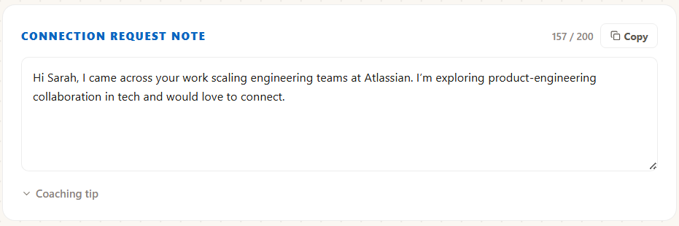
The same note with a live character count running against the 200 limit as you type, so you never guess.
Lead with the specific thing about them. Never open with "I'd love to connect" or "I am seeking opportunities". The first is empty and the second makes the note an ask, which is what you are deliberately avoiding at this stage.
Step 2: the same day they accept
When: the day they accept, not a week later. Still no ask.
Hi [First name],

Thanks for connecting.

I wanted to come back to your point about [specific thing from their content]. [Your honest reaction in one sentence: what resonated, what you would want to dig into, what you thought about afterwards.]

Not after anything, just wanted to say hello properly. Looking forward to following your work while I get established in [your field] here.

[Your first name]

This message exists to stop you asking too early. That is its entire function. Send it, then go quiet and do step 3.
Step 3: engage in public for two to three weeks
- Comment on their posts where you have something real to add. A sentence of substance beats a paragraph of agreement.
- Never comment "Great post" or "Insightful, thanks for sharing." It reads as engagement farming and it is worse than silence.
- Post once a week yourself. A short observation about your field is enough. It does not need to perform.
- By the time you send step 4, your name should be familiar to them. That is the whole purpose of the wait.

Step 4: the ask
When: after two to three weeks of genuine engagement. Once. If the answer is no or silence, you leave it there.
Hi [First name],

I've been following your posts on [topic] for a few weeks now and they have shaped how I'm thinking about [specific thing].

I'm currently [your situation in one line] and I'm trying to understand [specific question you genuinely cannot answer from the internet]. Would you be open to 15 minutes some time in the next fortnight? Happy to work entirely around your schedule, and equally happy if now is not a good time.

[Your first name]

Ask for 15 minutes and a specific question. "Can I pick your brain" is a request for unbounded time and gets declined. "Would you be open to 15 minutes on how teams here weigh overseas experience" is a defined favour with an obvious end.

Never ask a stranger to refer you, review your resume, or forward you to their hiring manager in a first ask. Those are favours that cost them reputation. They come later, if at all, and usually offered rather than requested.
A separate template: recruiters
Recruiters are a different audience. They are not doing you a favour, they are looking for placeable candidates, so being direct is correct here.
Hi [Name], I see you place [specialty] people in [city]. I'm a [role title] with [X] years in [field], currently in [city] with full working rights. Open to a quick chat?

Two or three specialist recruiters in your field beats ten generalists. One recruiter who knows you and advocates for you is worth more than fifty cold applications.
Doing this at volume
The chain works because each message references something specific and real about that person, which means reading their profile and their recent posts before you write. Four or five minutes each, and you are running four steps per contact across twenty or thirty people. The counting is the boring part: who accepted, who you thanked, who is due for the ask, who you have already asked. JobHub keeps that state and counts the note against the limit as you type. The chain here is the whole method and it works with a notepad. It just costs you the counting.
Rules to live by
- Write connection notes to 200 characters, not 300, unless you are certain you are on Premium.
- Never lead with the ask. Steps 1 to 3 request nothing.
- Specific beats polite. One real detail about their work outperforms three sentences of courtesy.
- Connect with everyone you meet in person the same day, with a note that says where you met.
- One Australian recommendation is worth more than five from overseas. Ask this week if you have anyone to ask.
- If someone does not reply, that is the end of it. There is no follow-up chase on a networking ask.

Free diagnostic: theaussiegradcareers.com.au/welcome
Pairs with the networking pack from module 06, which tracks who you have contacted and what stage each conversation is at.

