Networking pack
Module 06, Networking | Aussie Grad Careers

Job boards get you part of the way. The rest of the market moves through conversations, and the only way in is to have them. This pack is the message sequence, who to send it to, and how to keep track without it turning into a second job.
Networking is the process of making friends, professionally, at scale. You may get nothing from a given friendship, ever. You do it anyway, because at scale the losses stop mattering and the wins stack. The moment you enter a conversation expecting something from it, the other person can feel it.
The mistake that ends the conversation
Sir/Madam, my name is [name], I have a degree in [field]. Can you please give me a job? Can you please let me know if there are any openings?
It feels polite. Look at what it actually asks: a total stranger, who knows nothing about you, is being asked to spend their reputation on you. There is no version of that they can say yes to comfortably, so they say nothing.
You are also making them uncomfortable, which is the part people miss. They probably cannot help you at that moment. You have handed them a problem and no way out of it, so the cheapest move available is to ignore you.
Junior or senior: decide before you write
The classification changes the ask entirely, so make it fast and move on.
 | Junior contact | Senior contact
Who | One to two years ahead of you. Often in the job you want, a year or two in. Same university or same country is common. | Management level. Runs a team, has executive function and real decision making power.
What they can do | Recommend you internally. Tell you what the team is actually like, what the hiring process was, what got them in. | Create or fill a role. Remember you when something opens.
Your ask | Small and practical. How did you find the process, what would you do differently. | Smaller still. Perspective on the market or the function. Never a job.
Reply rate | High. They remember being where you are. | Lower, and slower. Worth it when it lands.
Many Australian companies pay a referral bonus, often between $500 and $2,000, for a hire that comes through an employee. Mention this to nobody. It matters only because it should change how you feel when you make contact: you are not begging, you are a candidate who could be worth money to them. Approach from that footing and the messages come out differently.
Finding the people, two methods
Method 1: companies first
- List 20 companies you would genuinely work for, in your city.
- For each, find the people already doing your job there. A 15 person company might have one. A 400 person company has a dozen.
- Mark each one junior or senior and move on. Do not research them deeply yet.
Method 2: people first
- LinkedIn search: your city plus your target role title.
- Filter by seniority to split juniors from seniors quickly.
- Work down the list.
Use both. Two methods is what makes this a process rather than a mood, and a process is something you can do on a day when you do not feel like it.
Then prioritise by what you share
The people most likely to reply are the people whose story looks like yours. Same university. Same home country. Same degree. Same city and same year of arrival. Each shared thread is a reason for them to read to the end, and they are the difference between a 5% reply rate and a 30% one.

The three message sequence
Three is the cap. Not because relationships have a limit, but because you are here for a reason and an endless polite conversation helps nobody.
Message 1: the connection request
The ask: so small that accepting IS the answer. They click accept and they have fully satisfied your request.
Hi [First name], I saw [specific thing about them: their post, their team, the product they work on]. I'm [one line about you]. I'd like to be part of your network.

200 characters on a free LinkedIn account, 300 on Premium. The video says 300 words: that is characters, not words. Write to 200 and it sends either way. Free accounts are also limited in how many notes they can send, so spend them on people with a shared thread.
Message 2: still about them
When: after they accept. Give it a day or two.
Hi [First name],

Thanks for connecting. I saw you worked on [specific project or area]. I did something similar at [your context] and I've been curious how you approached [the specific problem].

What has your experience of [the team / the industry / that transition] been like?

[Your first name]

Note what this does. It gives before it takes: you have said what you did, so there is something of yours on the table. Then it asks an open question they can answer in one line or five, whichever suits them. No pressure either way.
Message 3: the declaration
When: once a rapport exists. Do not stretch past three.
Hi [First name],

Thanks, that was genuinely useful, particularly [the specific thing they said].

I'm at the point where I'm looking for a [role type] role in [city]. I'm not asking you to place me anywhere, but I would really value your guidance on how you got to where you are, and what you would do in my position.

If it is easier to talk than type, I'd be happy to send a Google Meet link for 15 minutes at whatever time suits you.

[Your first name]

Suggest a Google Meet, and send the link yourself. Never ask for someone's phone number: it is a privacy ask that makes people wary. Coffee sounds friendlier but it costs them travel, an hour and the price of a coffee, so it gets declined more often than a 15 minute call that costs them nothing.

On that call, nobody is going to offer you a job, and you should not want them to. The purpose is that you become the person they think of when something opens. That is the whole mechanism of the hidden job market: not favours, recall.
If they post content, start there instead
- Comment with something real. Read the post, understand it, add a point or a counterpoint or an experience.
- Do two or three of these over a couple of weeks and you become a familiar name before you ever send a message.
- "Great post" and "Thanks for sharing" do nothing. Everyone can tell.
- This route has a far higher acceptance rate than a cold note, because by the time you connect they already recognise you.

Keeping track
Twenty to thirty conversations, each at a different stage, each with a different next step and a different date. This is exactly the kind of thing that quietly falls apart after two weeks, and when it falls apart people conclude that networking does not work.
There is a Networking tab in the application tracker from module 05. It has the columns below, the same dropdowns, and it flags who is due. Use it, or rebuild these columns wherever you prefer:
Column | Why it earns its place
Name and company | Obvious, but write the company: you will forget.
Junior or senior | Determines the ask. Set it when you add the row.
Shared thread | Same uni, same country, same course. This is why they replied, and it is what you open with.
Topic | What their work is about. Without this, message 2 is impossible to write three weeks later.
Stage | Connected, message 2 sent, message 3 sent, call booked, closed.
Last contact | The date. Everything else is calculated from it.
Next step due | So a conversation never dies because you forgot it existed.
Replied | The honest metric. Track it and you will see which shared threads actually work for you.
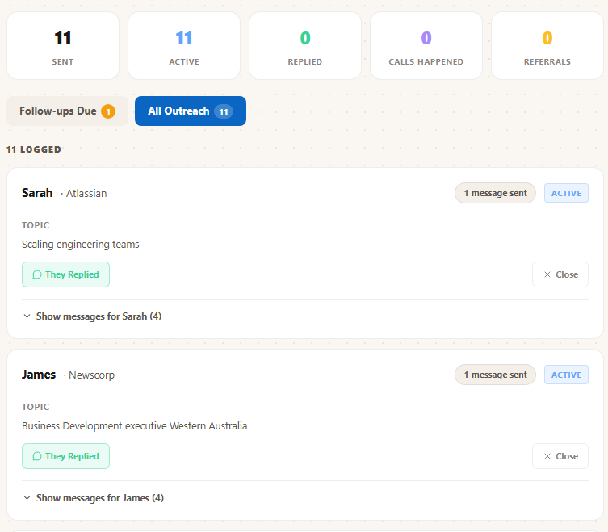
An outreach log in use: 11 contacted, who replied, what each conversation was about, and one follow-up falling due.
The tracking is the part that decides whether this works, and it is also the part everyone abandons. Twenty five conversations across four stages is a hundred small facts to hold, and the cost of losing one is a relationship that quietly ends. JobHub logs each message, holds the topic and the shared thread, and tells you who is owed a reply today. A spreadsheet does the same job as long as you keep it up. That is the whole difference, and it is a real one.
Rules to live by
- Never ask a stranger for a job, a referral or a resume review. Ever.
- Small asks. The first one should be answerable by clicking a button.
- Three messages, then either a call or you leave it warm and move on.
- Lead with the shared thread. Same university beats a clever opening line.
- Comment before you connect where you can. Familiarity outperforms charm.
- Send the Meet link yourself. Never ask for a phone number.
- Silence is not rejection and it is not an invitation to chase. Move on.
- Do a fixed number a day. Five good messages daily beats forty in a burst and then nothing for a month.

Free diagnostic: theaussiegradcareers.com.au/welcome
Pairs with the LinkedIn templates from module 04 and the application tracker from module 05, which carries the Networking tab described here.

