The system, end to end
Module 08, The System End to End | Aussie Grad Careers

This is the boring one. Targeting, speed, tracking and a goal you can actually control. It is also the module that decides whether any of the others matter, because a good resume sent randomly is still a random job search.
1. Targeting: the 80% rule
Read the job description and count how much of the criteria you meet. If it is 80% or more, you are a good fit and you should apply. The people who wrote that ad know nobody meets 100%.
This rule cuts both ways, and most people only apply it in one direction. It stops you wasting a morning on a role you meet 40% of. It also stops you disqualifying yourself from a role you meet 85% of, which is the far more expensive mistake and the one almost everybody makes.
Apply in this order
Match | What to do | Why
100% | Apply first, same day. | This is where your odds are highest. Spend your best energy here.
80 to 99% | Apply once the 100% list is clear. | Still a genuinely strong application.
60 to 79% | Park it. Come back only if you have not hit your target for the day. | Worth doing when the alternative is doing nothing. Not worth doing instead of a better fit.
Under 60% | Leave it. | The time costs more than the lottery ticket is worth.

Targeting is positioning. Position yourself well and your odds move more than any amount of rewriting will.
2. Speed: tailor without starting over
You can get away with a near identical resume. You cannot get away with a generic cover letter, and a recycled selection criteria is worse still. Both are obvious to the reader.
Use an LLM to get the drafting down to about five minutes per application. That is a realistic target and it is what makes volume survivable.
The warning that matters more than the prompt: give a language model the wrong instructions and it will faithfully, fluently and extremely confidently hand you the wrong answer. It will not tell you it is wrong. The consequence lands on you, not on the tool, so you have to know what good looks like before you ask for it. That is what modules 02 and 03 were for.
A starting prompt
You are helping me tailor an application for the Australian job market. Australian English spelling throughout.

Here is the job ad:
[paste the full ad]

Here is my resume:
[paste your resume]

Do three things:

1. List the criteria from the ad and tell me honestly what percentage I meet, and which ones I do not. Do not flatter me.
2. Rewrite my professional summary for this specific role, five or six sentences, no adjectives about me, evidence only, and do not call me a graduate.
3. Draft a one page cover letter in five paragraphs: how I help them, why this company specifically, my strongest quantified achievement, a bridge using the ad's own wording, and a plain close.

Rules: never invent a number, an employer, a date or a qualification. If you do not have the evidence for a claim, leave a [gap] marker and tell me what to supply. Achievements not duties: action plus result plus context.

The last rule is the important one. Left alone, these tools invent plausible numbers, and a fabricated metric in a cover letter becomes a question you cannot answer in an interview. Ask for gap markers instead and fill them yourself.

3. Tracking: why it is not optional
- You know what you claimed, and to whom. When they ring three weeks later you can speak to the exact resume and cover letter you sent. Without this you are guessing on the phone.
- You can see your own volume. Ten applications feels like a lot of work, and it is. Do it for thirty days and you completely lose track of how much you have done. A folder of downloaded PDFs tells you nothing.
- It protects your sanity. On the bad weeks, the tracker is the evidence that you have been working. That matters more than it sounds like it should.
- It shows you what is working. Filter by source after a month and you find out which channel actually produces replies for you, rather than which one feels productive.
The application tracker from module 05 does all of this and calculates the follow-up dates. Use that, or rebuild the same columns anywhere you like.
4. A goal you can actually control
You cannot control whether you get hired. There may have been an internal candidate, or a referral, or someone genuinely better. None of that is a verdict on you, and treating it as one is what breaks people around week six.
So set the target on the input, because the input is the only part you own.
 | Target | Notes
Applications | 25 a week | Quality applications, tailored. This is the number the tracker counts against.
Daily equivalent | 5 a day, five days a week | Easier to hold than a weekly sprint. If casual work makes daily impossible, run it weekly.
Upper limit | 25 in a single day | Beyond that the quality is gone and so are you. Volume without tailoring is just exhaustion.
Follow-ups | Every application, at 7 days | The single highest return habit in the whole system, and almost nobody does it.
Networking | 5 messages a day | Half your search time should be conversations, not applications.
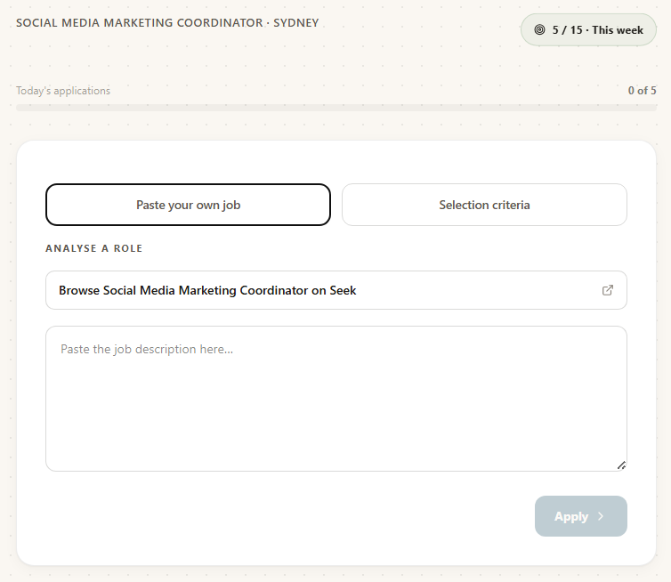
Progress against a weekly goal, with the day's applications counted underneath it. Set the number yourself and let something else keep score.

The week, laid out
A template, not a law. The point is that the work is scheduled rather than waited for.
When | What | How long
Every morning | Check saved searches and job alerts. Anything posted in the last 24 hours gets applied for today, because most screening happens in the first 48 hours. | 20 min
Every morning | Clear anything the tracker has flagged red: follow-ups past 7 days. | 15 min
Weekdays | Five tailored applications. 100% matches first. | 1 to 2 hrs
Weekdays | Five networking messages. New connection notes, or the next step on conversations already open. | 30 min
Weekly | Check your 20 to 30 target company careers pages. | 30 min
Weekly | Post or comment once on LinkedIn so the profile is not dormant. | 10 min
Fortnightly | Check in with your two or three specialist recruiters. | 15 min
Monthly | Read your own numbers. Which source produced replies? What is your reply rate? Change one thing. | 30 min

Note the 50 / 30 / 20 split underneath that table: roughly half your time on direct outreach and relationships, thirty percent on applications, twenty on recruiters. It feels wrong when you are used to applying online, but the hidden job market is real and conversations are the only door into it.
Where people fall off
- Week 3. The applications are out, nothing has come back, and the follow-ups are quietly abandoned. This is precisely when the follow-ups start working.
- Chasing the perfect application. A full day on one role you match 100% of is still one application. Get it good, then send it.
- Stopping the networking once applications are flowing. The applications are the visible 20% of the market. The conversations are the rest.
- Treating a rejection as a verdict. You will never know why, and usually it was not about you.
- Letting the tracker go stale. Once it is two weeks out of date it stops being useful and you stop opening it. Update it as you send, never later.
Every part of this is a thing you can do with a spreadsheet, a calendar and some discipline, and people have. What JobHub removes is the admin around the edges: the logging, the follow-up dates, the counting, the remembering who is owed a reply. On the weeks when the discipline is thin, that is the difference between a system and a folder of PDFs. The method is the same either way, and it is all in this document.

Free diagnostic: theaussiegradcareers.com.au/welcome
Pairs with the application tracker from module 05, which implements the tracking and goal sections of this document.

