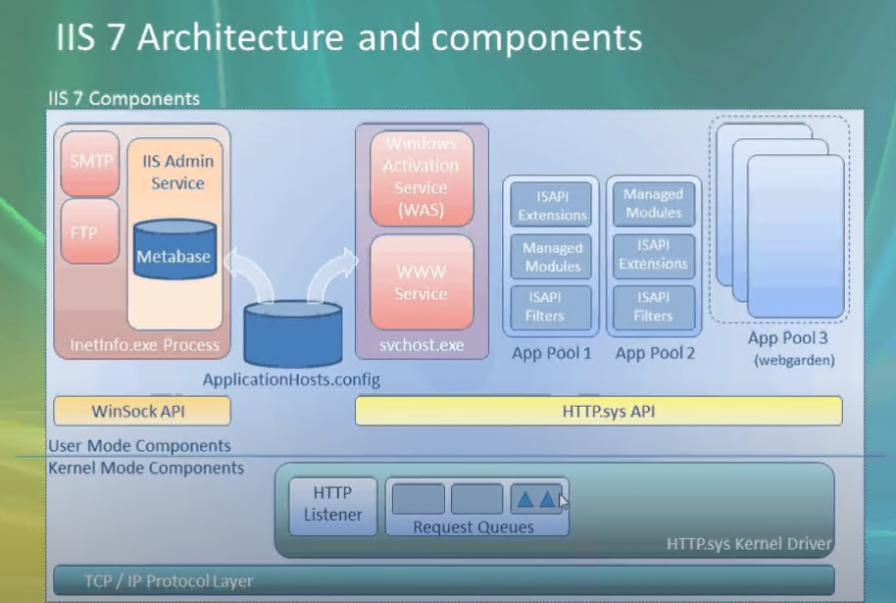

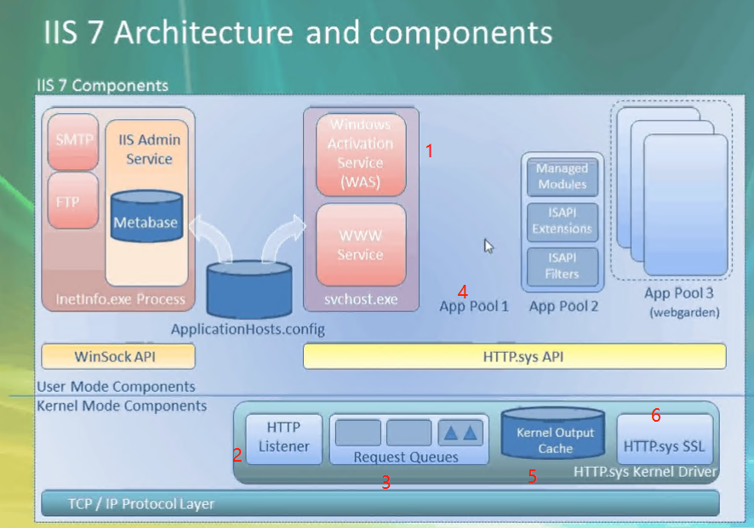

**IIS:**

**What:**

1. Web Server

**What it does:**

1. Serve Web site
2. FTP file share

**How IT works:**

1. When you write: [www.microsoft.com](http://www.microsoft.com)
2. And Hit Enter



**How IIS Process the request:**

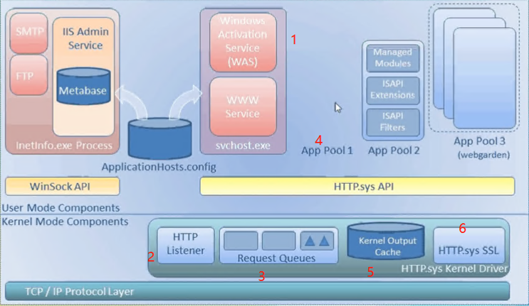

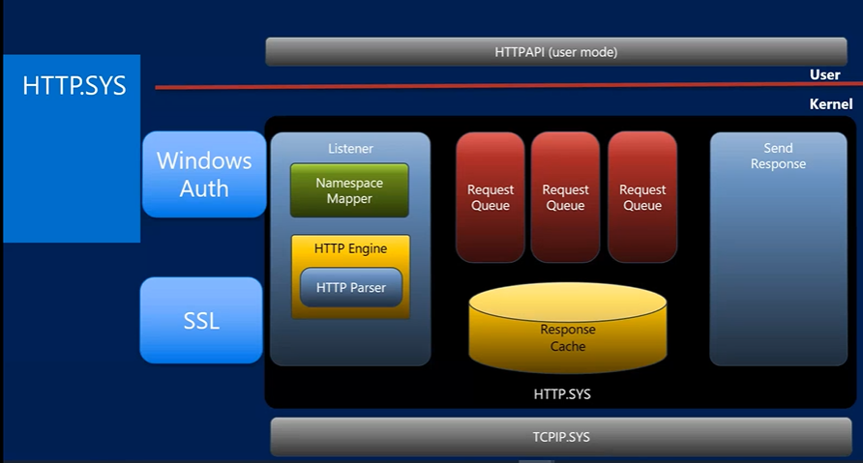

**Steps How IIS Process the request:**

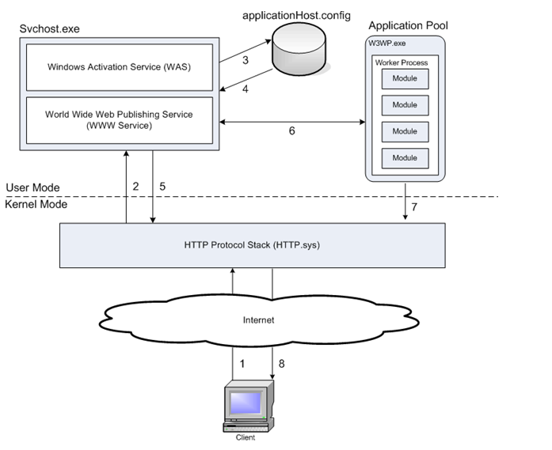

1. When a client browser initiates an HTTP request for a resource on the Web server, HTTP.sys intercepts the request.
2. HTTP.sys contacts WAS to obtain information from the configuration store.
3. WAS requests configuration information from the configuration store, applicationHost.config.
4. The WWW Service receives configuration information, such as application pool and site configuration.
5. The WWW Service uses the configuration information to configure HTTP.sys.
6. WAS starts a worker process for the application pool to which the request was made.
7. The worker process processes the request and returns a response to HTTP.sys.
8. The client receives a response.

**How to read fail request tracing file:**

**Why fail request tracing:**

* Request tracing is a significant feature in IIS
* Request trancing determines what exactly is happening with the requests.
* Why it is happening,
* Help to reproduce the problem being experienced.

**Uses of fail request tracing file:**

* Problems like poor performance on requests
* Authentication-related failures
* Server 500 error from ASP or ASP.NET

**Steps of collecting fail request-tracing file:**

[**https://docs.microsoft.com/en-gb/iis/troubleshoot/using-failed-request-tracing/troubleshooting-failed-requests-using-tracing-in-iis-85#enable-failed-request-tracing**](https://docs.microsoft.com/en-gb/iis/troubleshoot/using-failed-request-tracing/troubleshooting-failed-requests-using-tracing-in-iis-85#enable-failed-request-tracing)

* **IIS**
  + **What It is**
  + **What it does**
* **How IT works**
  + **How IIS Process the request**
  + **Steps To Process the request**
* **IIS Failed Request Trace**
  + **Why fail request tracing:**
  + **Uses of fail request tracing file:**
  + **Steps of collecting fail request-tracing file:**
* **Troubleshooting Performance Issue**
  + **Why fail request tracing:**
  + **Uses of fail request tracing file:**
  + **Steps of collecting fail request-tracing file:**