Analysis: 2023-09-05
Summary: This mini-project " will compare and contrast the distributions of the net values for the women and for the men" in the 2005 Cherry Blossom Ten Mile Race using some of R's base histogram plot capabilities.
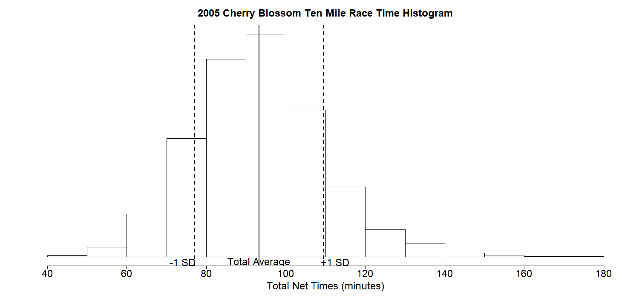
Figure 1. Single-Histogram Plot – 2005 Cherry Blossom Race ‘net’ Completion Times (minutes)

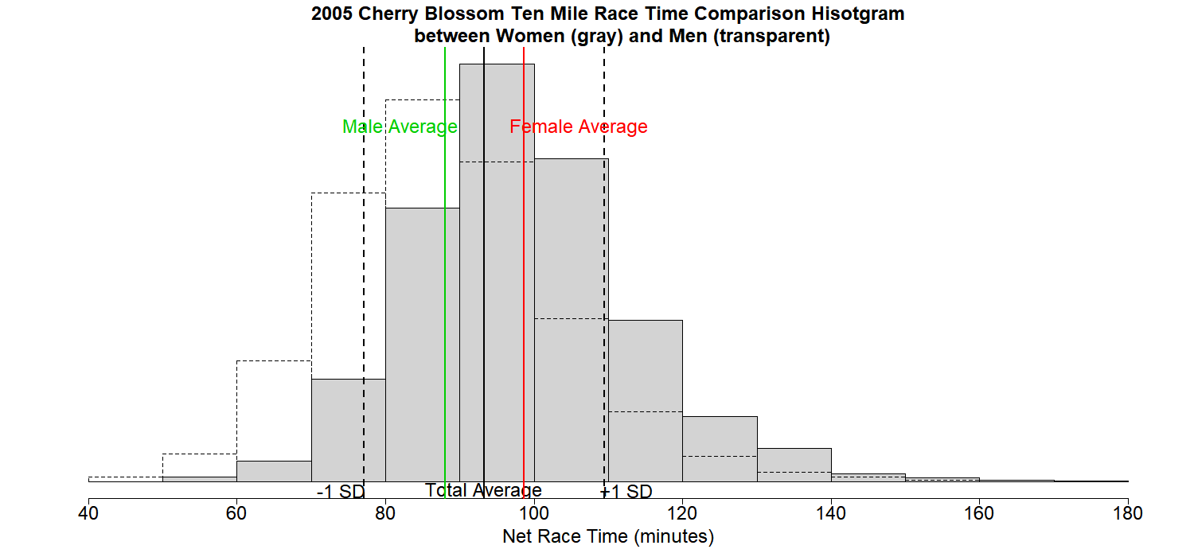
Figure 2. Two-Histogram Plot – 2005 Cherry Blossom Race ‘net’ Completion Time Comparison between Women and Men (minutes)

Figure 3. Table of Summary Statistics – 2005 Cherry Blossom Race ‘net’ Completion Time Comparison between Women and Men (minutes)
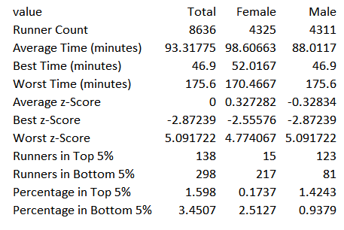
Brief Discussion: The general shapes of the Female and Male histograms are alike in that they both have a normal distribution about the average for their ‘net’ race time subset. However, the male distribution of times shifts to the left of the average for all race times, while the female distribution shifts to the right of center. Z-score comparison as shown in Figure 3 supports this observation, highlighting average male and female z-scores that are close to polar opposites of each other with respect to the total average for all runners; -0.32834 and +0.327282 respectively.

This data may not conclusively show that one group is faster than the other in general, it does show that more male racers clocked faster race times on average when compared to females for this race. It also shows that more men finished in the top 95% of all racers (z-score below -2), while 15 women achieved this same feat. It is curious that the worst z-scores were well beyond the ‘very rare’ 3 standard deviation boundary (e.g. 5.091722). I intuitively believe such outliers may occur in a voluntary endurance race like this where some may run just to participate and not necessarily to compete, returning more leisurely completion times. I would need to analyze the data from more races to test this theory and to understand scores beyond 3 standard deviations.

References

Manipulation of Directories and File Permissions. R Documentation. https://search.r-project.org/R/refmans/base/html/files2.html

Parker (PhD), Jason. (2023). Output an R data frame table to CSV. Lecture 1 R Script. BUAM 6356.0W1 - Business Analytics with R. University of Texas at Dallas.

Saving a Plot in R. DataMentor. https://www.datamentor.io/r-programming/saving-plot

Zach. (2021). The Complete Guide: How to Change Font Size in Base R Plots. Statology. https://www.statology.org/r-plot-font-size/

Zach. (2023). How to Add Label to abline in R (With Examples). Statology. https://www.statology.org/label-abline-in-r

# Title: R Script for Mini-Project 01 - Histograms
# Author: Kirpatrick Dorsey, MS
# Date: 2023-09-05

# Project: Option 1 - The Cherry Blossom Ten Mile Race:
# Net Racing Times for Women and Men

# Summary: Provided by Dr. Tristan Whalen, PhD, Professor BUAN 6359.005
#
# "Every year on April there is a 10-mile road race in Washington
# D.C., among the famous cherry blossom trees." This mini-project
# will "compare and contrast the distributions of the net values
# for the women and for the men" in the 2005 race using some of
# R's base histogram plot capabilities.

# Data: TenMileRace.rds - Made available by Dr. Whalen, and is also part
# of the 'mosaicData'R package.

# Tech Stack: R version 4.3.1 (2023-06-16 ucrt) -- "Beagle Scouts"
# Platform: x86_64-w64-mingw32/x64 (64-bit)
#
# RStudio 2023.06.0 Build 421

# Execution: - This script installs two packages; mosaicData and data.table.
# - Execution is line-by-line, and can be run in RStudio by
# (1) highlighting the entire script (Ctrl+A) and (2) clicking the
# 'Run' button.

# Output: - ./figures directory
# - figure1_cherry-blossom-single-histogram-plot.png
# - figure2_cherry-blossom-two-histogram-plot.png
# - figure3_cherry-blossom-summary-table-comparison.csv
# ------------------------------------------------------------------------------

# Create 'figures' directory to store analysis output.
dir.create("figures")
# Reference: R Documentation,
# https://search.r-project.org/R/refmans/base/html/files2.html

# Connect to the Cherry Blossom Ten Mile Race Data
install.packages("mosaicData")
library(mosaicData)

## Explore The Data
str(TenMileRace)# What is the data structure
# 'data.frame': 8636 obs. of 5 variables:
# $ state: Factor w/ 62 levels "","AK","AL","AR",..: 57 31 57 31 31 57 57 57 ...
# $ time : int 6060 4515 5026 4229 5293 6234 6286 6335 4098 4855 ...
# $ net : int 5978 4457 4928 4229 5076 5968 5928 5939 4077 4634 ...
# $ age : int 12 13 13 14 14 14 14 14 15 15 ...
# $ sex : Factor w/ 2 levels "F","M": 2 2 2 2 2 2 2 2 2 2 ...
?TenMileRace# How is each field interpreted
# state : State of residence of runner.
# time : Official time from starting gun to finish line.
# net : The recorded time (in seconds) from when the runner crossed the
# starting line to when the runner crossed the finish line. ...
# age : Age of runner in years.
# sex : A factor with levels F M.

# Check the field values of interest (I.e. net and sex) for any surprises!
unique(TenMileRace$sex)
# [1] M F
# Levels: F M
max(TenMileRace$net)# [1] 10536 Seconds
min(TenMileRace$net)# [1] 2814 seconds

# NOTE: It will be more useful to convert seconds to minutes for analysis.
max(round(TenMileRace$net/60, 4))# [1] 175.6 minutes
min(round(TenMileRace$net/60, 4))# [1] 46.9 minutes
# Create vectors for the total run times, omitting any 'na' values
total_net_times_minutes <- na.omit(round(TenMileRace$net/60, 4))
female_net_times_minutes <- na.omit(
round(TenMileRace[TenMileRace$sex=="F",]$net/60, 4))
male_net_times_minutes <- na.omit(
round(TenMileRace[TenMileRace$sex=="M",]$net/60, 4))

# NOTE: There is no change to the total record count of 8636
length(total_net_times_minutes)# [1] 8636
length(female_net_times_minutes)# [1] 4325 rows
length(male_net_times_minutes)# [1] 4311 rows

## Explore Statistics
# Disable Scientific Notation to better read histogram densities
options(scipen = 999) # Scientific Notation off/0n -> 999/0

# Load custom functions, average, standard deviation, and z-score,
# provided by Dr. Whalen; Lecture 2 - Shape, Center, and Spread
avg <- function(x){sum(x)/length(x)}
SD <- function(v){sqrt(sum((v-mean(v))^2)/length(v))}
z_score <- function(net_time_minutes){
(net_time_minutes-total_net_avg)/total_net_SD}

# Total Net Time Analysis
max(total_net_times_minutes)# [1] 175.6 minutes
min(total_net_times_minutes)# [1] 46.9 minutes
total_net_avg <- avg(total_net_times_minutes)# [1] 93.31775
total_net_SD <- SD(total_net_times_minutes)# [1] 16.16
hist(total_net_times_minutes, prob = TRUE)# Observe the shape
hist(total_net_times_minutes, plot = FALSE)
# $breaks
# [1] 40 50 60 70 80 90 100 110 120 130 140 150 160 170 180
# $counts
# [1] 15 99 431 1191 1993 2246 1480 706 278 132 40 17 5 3
# $density
# [1] 0.00017369152 0.00114636406 0.00499073645 0.01379110699 0.02307781380
# [6] 0.02600741084 0.01713756369 0.00817508106 0.00321908291 0.00152848541
# [11] 0.00046317740 0.00019685039 0.00005789717 0.00003473830
# $mids
# [1] 45 55 65 75 85 95 105 115 125 135 145 155 165 175

# Requirement 1. The single-histogram plot. Output to './figures'file directory
png(filename = "./figures/figure1_cherry-blossom-single-histogram-plot.png",
width = 1500,height = 700)
hist(total_net_times_minutes,
breaks=seq(from=40, to=180, by=10),
col="white",
prob=TRUE,
xlab="Total Net Times (minutes)",
main="2005 Cherry Blossom Ten Mile Race Time Histogram",
cex.main=2,
cex.sub=2,
cex.axis=2,
cex.lab=2,
yaxt='n',
ylab=NULL)
abline(v=total_net_avg, lwd=2,
text(x=total_net_avg, y=-0.0006, "Total Average",cex=2))
abline(v=total_net_avg-total_net_SD, lty=2,lwd=2,
text(x=total_net_avg-total_net_SD-3, y=-0.0006, "-1 SD",cex=2))
abline(v=total_net_avg+total_net_SD, lty=2,lwd=2,
text(x=total_net_avg+total_net_SD+3, y=-0.0006, "+1 SD",cex=2))
dev.off()
# Reference: 'How to Add Label to abline in R (With Examples)',
# February 22, 2023, https://www.statology.org/label-abline-in-r
# Reference: 'Saving a Plot in R',
# https://www.datamentor.io/r-programming/saving-plot
# Reference: 'The Complete Guide: How to Change Font Size in Base R Plots',
# October 8, 2021, https://www.statology.org/r-plot-font-size/

# Female Net Time Analysis
female_net_max_time <- max(female_net_times_minutes)# [1] 170.4667 minutes
female_net_min_time <- min(female_net_times_minutes)# [1] 52.0167 minutes
female_net_avg_time <- avg(female_net_times_minutes)# [1] 98.60663 minutes
SD(female_net_times_minutes)# [1] 15.03341 minutes
hist(female_net_times_minutes, prob = TRUE)
hist(female_net_times_minutes, plot = FALSE)
# $breaks
# [1] 50 60 70 80 90 100 110 120 130 140 150 160 170 180
# $counts
# [1] 14 64 314 834 1274 985 493 200 102 25 13 5 2
# $density
# [1] 0.00032369942 0.00147976879 0.00726011561 0.01928323699 0.02945664740
# [6] 0.02277456647 0.01139884393 0.00462427746 0.00235838150 0.00057803468
# [11] 0.00030057803 0.00011560694 0.00004624277
# $mids
# [1] 55 65 75 85 95 105 115 125 135 145 155 165 175
hist(female_net_times_minutes,
breaks=seq(from=50, to=180, by=10),
col="lightgray",
prob=TRUE,
xlab="Female Net Times (minutes)",
main=NULL,
yaxt='n',
ylab=NULL)
abline(v=female_net_avg_time, lwd=2, col="red")

# Male Net Time Analysis
male_net_max_time <- max(male_net_times_minutes)# [1] 175.6
male_net_min_time <- min(male_net_times_minutes)# [1] 46.9
male_net_avg_time <- avg(male_net_times_minutes)# [1] 88.0117
SD(male_net_times_minutes)# [1] 15.4979 minutes
hist(male_net_times_minutes, prob = TRUE)
hist(male_net_times_minutes, plot = FALSE)
# $breaks
# [1] 40 50 60 70 80 90 100 110 120 130 140 150 160 170 180
# $counts
# [1] 15 85 367 877 1159 972 495 213 78 30 15 4 0 1
# $density
# [1] 0.00034794711 0.00197170030 0.00851310601 0.02034330782 0.02688471352
# [6] 0.02254697286 0.01148225470 0.00494084899 0.00180932498 0.00069589422
# [11] 0.00034794711 0.00009278590 0.00000000000 0.00002319647
# $mids
# [1] 45 55 65 75 85 95 105 115 125 135 145 155 165 175
hist(male_net_times_minutes,
breaks=seq(from=40, to=180, by=10),
col="white",
prob=TRUE,
xlab="Male Net Times (minutes)",
main=NULL,
yaxt='n',
ylab=NULL,
lty=2)
abline(v=male_net_avg_time, lwd=2, col="green3")

# Requirement 2. The two-histogram plot. Output to './figures' file directory
png(filename = "./figures/figure2_cherry-blossom-two-histogram-plot.png",
width = 1500,height = 700)
hist(female_net_times_minutes,
breaks=seq(from=40, to=180, by=10),
prob=TRUE,
yaxt='n',
ylab=NULL,
xlab="Net Race Time (minutes)",
main="2005 Cherry Blossom Ten Mile Race Time Comparison Hisotgram
between Women (gray) and Men (transparent)",
cex.main=2,
cex.sub=2,
cex.axis=2,
cex.lab=2,
col="lightgray")
hist(male_net_times_minutes,
breaks=seq(from=40, to=180, by=10),
add=TRUE,
col=NULL,
prob=TRUE,
lty=2)
abline(v=total_net_avg, lwd=2,
text(x=total_net_avg, y=-0.0006,"Total Average",cex=2))
abline(v=total_net_avg-total_net_SD, lty=2,lwd=2,
text(x=total_net_avg-total_net_SD-3, y=-0.0006, "-1 SD",cex=2))
abline(v=total_net_avg+total_net_SD, lty=2,lwd=2,
text(x=total_net_avg+total_net_SD+3, y=-0.0006, "+1 SD",cex=2))
abline(v=female_net_avg_time, lwd=2, col="red",
text(x=106, y=0.025, "Female Average", col="red",cex=2))
abline(v=male_net_avg_time, lwd=2, col="green3",
text(x=82, y=0.025, "Male Average", col="green3",cex=2))
dev.off()
# Reference: 'How to Add Label to abline in R (With Examples)',
# February 22, 2023, https://www.statology.org/label-abline-in-r
# Reference: 'Saving a Plot in R',
# https://www.datamentor.io/r-programming/saving-plot
# Reference: 'The Complete Guide: How to Change Font Size in Base R Plots',
# October 8, 2021, https://www.statology.org/r-plot-font-size/

## Observations based on the stacked histogram and the z-scores...

# The average net race times, for both females and males, fell
# within 1 standard deviation from the average:
z_score(female_net_avg_time)# [1] 0.3272819 the "red" line
z_score(male_net_avg_time)# [1] -0.3283448 the "green" line

# The negative z-score for the men's average time represents an average faster
# net runtime for male runners when compared to the average overall, as well as
# to the average for females.

# The fastest net runtime, recorded by a male participant, is almost 3 standard
# deviations away from the average. The fastest female time is just over
# 2.5 deviations away from the average:
z_score(male_net_min_time) # [1] -2.872385
z_score(female_net_min_time)# [1] -2.555758

# These best female and male finish times fall approximately within the top 5%
# of this data set, when following the general guidance that "roughly 95% of the
# numbers in a list will have a z-score between -2 and 2".

# Racers with net times more than 2 standard deviations from the average:

# All Runners...
runners_top_5_percent <- length(total_net_times_minutes[
total_net_times_minutes < total_net_avg-(total_net_SD*2)])# [1] 138
percentage_top_5_percent <- round(
(runners_top_5_percent/length(total_net_times_minutes))*100, 4)# [1] 1.598%
runners_bottom_5_percent<-length(total_net_times_minutes[
total_net_times_minutes > total_net_avg+(total_net_SD*2)])# [1] 298
percentage_bottom_5_percent<-round(
(runners_bottom_5_percent/length(total_net_times_minutes))*100, 4)# [1] 3.4507

# Female Runners...
females_top_5_percent <- length(female_net_times_minutes[
female_net_times_minutes < total_net_avg-(total_net_SD*2)])# [1] 15
percentage_females_top_5_percent <- round(
(females_top_5_percent/length(total_net_times_minutes))*100, 4)#[1] 0.1737%
females_bottom_5_percent<-length(female_net_times_minutes[
female_net_times_minutes > total_net_avg+(total_net_SD*2)])# [1] 217
percentage_females_bottom_5_percent<-round(
(females_bottom_5_percent/length(total_net_times_minutes))*100, 4)#[1] 2.5127%

# Male Runners...
males_top_5_percent<-length(male_net_times_minutes[
male_net_times_minutes < total_net_avg-(total_net_SD*2)])# [1] 123
percentage_males_top_5_percent<-round(
(males_top_5_percent/length(total_net_times_minutes))*100, 4)#[1] 1.4243%
males_bottom_5_percent<-length(male_net_times_minutes[
male_net_times_minutes > total_net_avg+(total_net_SD*2)])# [1] 81
percentage_males_bottom_5_percent<-round(
(males_bottom_5_percent/length(total_net_times_minutes))*100, 4)#[1] 0.9379%

# Compile and store a summary of the observations
Cherry_Blossom_Summary <- data.frame(
value=c("Runner Count",
"Average Time (minutes)","Best Time (minutes)", "Worst Time (minutes)",
"Average z-Score", "Best z-Score", "Worst z-Score",
"Runners in Top 5%", "Runners in Bottom 5%",
"Percentage in Top 5%", "Percentage in Bottom 5%"),
Total=c(length(total_net_times_minutes),
total_net_avg,min(total_net_times_minutes),max(total_net_times_minutes),
z_score(total_net_avg),
z_score(min(total_net_times_minutes)),
z_score(max(total_net_times_minutes)),
runners_top_5_percent, runners_bottom_5_percent,
percentage_top_5_percent, percentage_bottom_5_percent),
Female=c(length(female_net_times_minutes),
female_net_avg_time, female_net_min_time, female_net_max_time,
z_score(female_net_avg_time),
z_score(female_net_min_time),
z_score(female_net_max_time),
females_top_5_percent, females_bottom_5_percent,
percentage_females_top_5_percent, percentage_females_bottom_5_percent),
Male=c(length(male_net_times_minutes),
male_net_avg_time, male_net_min_time, male_net_max_time,
z_score(male_net_avg_time),
z_score(male_net_min_time),
z_score(male_net_max_time),
males_top_5_percent, males_bottom_5_percent,
percentage_males_top_5_percent, percentage_males_bottom_5_percent)
)
Cherry_Blossom_Summary

# Save the summary as a .csv file to the './figures' file directory
install.packages("data.table")
library(data.table)
fwrite(Cherry_Blossom_Summary,
"./figures/figure3_cherry-blossom-summary-table-comparison.csv")
# Reference: BUAM 6356.0W1 - Business Analytics with R, Lecture 1 R Script,
# Jason Parker, PhD, Professor

