Analysis: 2023-10-27
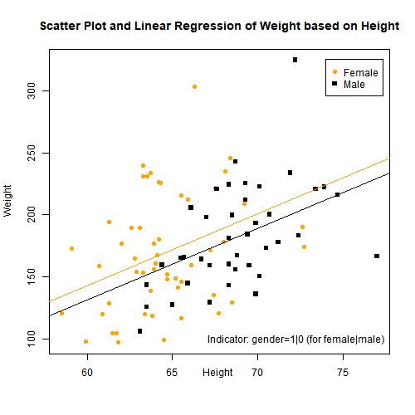
Summary: The purpose of this project is to practice making scatter plots and regression equations with data software.

$$average weight = intercept + (slope1)(height) + (slope2)(indicator:female|male)$$
$y = b + m_{1}x_{1} + m_{2}x_{2}$ , $x_{2}=\left\{\begin{aligned}1 &if female \\ 0 &if male\end{aligned}\right.$
$$y = -214.805 + 5.772x_{1} + 11.615x_{2}$$
Coefficient of Determination = 0.1741

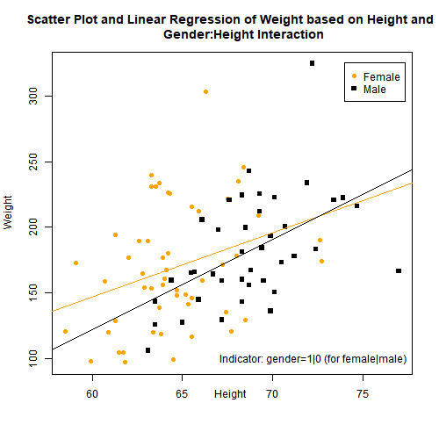

$$average weight = intercept + (slope1)(height) + (slope2)(indicator:female|male)+ (slope3)(indicator:female|male)(height)$$
$y = b + m_{1}x_{1} + m_{2}x_{2} + m_{3}x_{2}x_{1}$ , $x_{2}=\left\{\begin{aligned}1 &if female \\ 0 &if male\end{aligned}\right.$
$$y = -289.141 + 6.852x_{1} + 145.143x_{2} -1.998x_{2}x_{1}$$
Coefficient of Determination = 0.1786

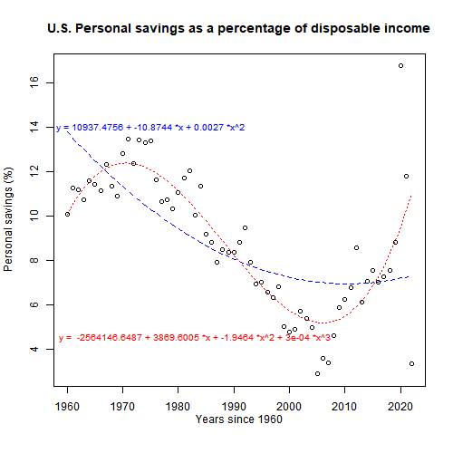

$$average personal savings (\%)1 = intercept1 + (slope1)(year) + (slope2)({year}^{2})$$
$y_{1}= b_{1}+m_{1}x_{1} + m_{2}{x_{1}}^{2}$
$$y_{1}=10937.4756286 -10.8744179x_{1}+0.0027046{x_{1}}^{2}$$
Coefficient of Determination1 = 0.4601892

$$average personal savings (\%)2 = intercept2 + (slope3)(year) + (slope4)({year}^{2})+ (slope5)({year}^{3})$$
$y_{2}= b_{2}+m_{3}x_{1} + m_{4}{x_{1}}^{2}$ $+ m_{5}{x_{1}}^{3}$
$y_{2}=-2564146.6486955+3869.6004782x_{1}-1.9464009{x_{1}}^{2}$+$0.0003263{x_{1}}^{3}$
Coefficient of Determination2 = 0.7166567

References

Add Legend to Plot in R. Geeks For Geeks. https://www.geeksforgeeks.org/add-legend-to-plot-in-r/
R plot pch symbols : The different point shapes available in R. Statistical tools for high-throughput data analysis (STHDA). http://www.sthda.com/english/wiki/r-plot-pch-symbols-the-different-point-shapes-available-in-r
Zach. (2020). How to Find Coefficient of Determination (R-Squared) in R. Statology. https://www.statology.org/r-squared-in-r/

# Title: R Script for Mini-Project 02 - Scatterplots ----
# Author: Kirpatrick Dorsey, MSBA Graduate Student ----
# Date: 2023-10-29

# Note: This work is best viewed in RStudio, as an R script, using the
# 'outline' view.

# Summary: ....----
# Provided by Dr. Tristan Whalen, PhD, Professor BUAN 6359.005
#
# The purpose of this project is to practice making scatter plots
# and regression equations with data software. You will use R to
# make a total of three scatterplots, each with a graph of a
# regression equation.

# --- --- --- --- --- --- --- --- --- --- --- --- --- --- --- --- --- --- --- #
# Tech Stack: ----
## R version 4.3.1 (2023-06-16 ucrt) ----
# -- "Beagle Scouts"
# Platform: x86_64-w64-mingw32/x64 (64-bit)
#
## RStudio 2023.09.0+463 "Desert Sunflower" ----

# --- --- --- --- --- --- --- --- --- --- --- --- --- --- --- --- --- --- --- #
# Libraries: ----

## data.table ----
# # data.table _1.14.8
# install.packages("data.table")
library(data.table)

# --- --- --- --- --- --- --- --- --- --- --- --- --- --- --- --- --- --- --- #
# Output: See the ./figures directory ----
# - scatter_wt_basedOn_ht.png
# - scatter_wt_basedOn_ht_interaction.png
# - personal_savings_scatter.png
# Create 'figures' directory to store analysis output.
dir.create("figures")

# _________________________________________________________________________ ----
# Responses: ----

# Plot 1: from the hanes data,... ----
# a plot of weight, based on height, and a regression line with an indicator
# variable for male or female.
#
## Health and Nutrition Examination Survey (hanes)
# 2005 sample, provided by Dr. Whalen.
# Additional reference: https://www.cdc.gov/nchs/nhanes/index.htm
#
# Read in hanes data. Remove nulls (or na) values. Store gender as an integer.
hanes <- readRDS("hanes.rds")
hanes_clean <- na.omit(hanes)
hanes_clean$genderInt <-as.numeric(hanes_clean$gender=="F")
# hanes_clean$genderInt
# Attach the data set for convenience
attach(hanes_clean)

# 1. The regression line plus indicator scatter plot.

## a. Make a scatter plot of weight... ----
# From the hanes data, make a scatter plot of weight (y) based on height (x).
plot(height,weight)

## b. Distinguish the men and the women in the scatter plot... ----
# ...with two different symbols and colors. Please use entries of the form
# pch=ifelse(…) and col=ifelse(…) in the plot function to make this
# distinction.
#
plot(height,weight, pch=ifelse(gender=="F",19,15),
col=ifelse(gender=="F","orange","black"))
### REF: 'pch' - Statistical tools for high-throughput data analysis (STHDA) ----
# http://www.sthda.com/english/wiki/r-plot-pch-symbols-the-different-point-shapes-available-in-r

## c. Find the regression equation... ----
# ...of weight based on height plus a gender indicator. Write down (type out)
# the equation.
#
model1 <- lm(weight~height+genderInt)
# summary(model1)
y_intercept1 <- model1$coefficients[1]
height_coeff <- model1$coefficients[2]
gender_coeff <- model1$coefficients[3]
regression_equation <- paste("Regression Equation: y =",
round(y_intercept1,3), "+",
round(height_coeff,3), "*height +",
round(gender_coeff,3), "*gender")
regression_equation
# "Regression Equation: y = -214.805 + 5.772 *height + 11.615 *gender"

## d. Add a graph of the equation to the scatter plot. ----
# (it will be two parallel lines). Hint: find the equations of the two lines
# by substituting 1 or 0 for the indicator. Then use abline twice, same slope,
# but different intercept.
#
# When gender = 1 (for female)
# y = -214.805 + 5.772 *height + 11.615 *gender
# = -214.805 + 5.772 *height + 11.615 *1
# = (-214.805 + 11.615) + 5.772 *height
# = -203.1897 + 5.772 *height
# or
# = (y_intercept1 + gender_coeff) + height_coeff*height
#
y_intercept1_female <- y_intercept1 + gender_coeff
slope1_female <- height_coeff # No change to slope
abline(a=y_intercept1_female, b=slope1_female, col="orange")
#
#
# When gender = 0 (for male)
# y = -214.805 + 5.772 *height + 11.615 *gender
# = -214.805 + 5.772 *height + 11.615 *0
# = -214.805 + 5.772 *height
# or
# = y_intercept1 + height_coeff*height
#
y_intercept1_male <- y_intercept1
slope1_male <- height_coeff # No change to slope
abline(a=y_intercept1_male, b=slope1_male, col="black")

## e. Paste the plot into your document editor. ----
# With math typesetting, provide the regression equation and the coefficient
# of determination below the plot.
#
r_squared <- summary(model1)$r.squared
# REF: Extract R-Squared
# https://www.statology.org/r-squared-in-r/
#
coefficient_of_determination <- paste(" Coefficient of Determination: ",
round(r_squared,4))
coefficient_of_determination
#
# Save Scatter Plot
png(filename = "./figures/scatter_wt_basedOn_ht.png", width = 500,height = 500)
plot(height,weight,
pch=ifelse(gender=="F",19,15),
col=ifelse(gender=="F","orange","black"),
main = "Scatter Plot and Linear Regression of Weight based on Height",
xlab="Height \n\n",
ylab="Weight"
# sub = paste(regression_equation,"\n", coefficient_of_determination)
)
abline(a=y_intercept1_female, b=slope1_female, col="orange")
abline(a=y_intercept1_male, b=slope1_male, col="black")
legend(74,325, legend=c("Female","Male"), pch=c(19,15), col=c("orange","black"))
legend(66,110, box.lty=0,
legend="Indicator: gender=1|0 (for female|male)",)
### REF: Add a Legend to Plot in R ----
# https://www.geeksforgeeks.org/add-legend-to-plot-in-r/
dev.off()

# --- --- --- --- ---
dev.off(dev.list()["RStudioGD"])
# --- --- --- --- ---

# Plot 2: From the hanes data... ----
# a plot of weight, based on height, and a regression line with an indicator
# variable for male or female, plus one interaction term for gender:height.

# 2. The regression line plus indicator plus interaction.

## a. Repeat part 1, but this time add... ----
# ...the interaction term gender:height to the regression equation.
# Write down (type out) the equation.
#
# Re-create the base scatter plot, from part1, of weight based on height
plot(height,weight, pch=ifelse(gender=="F",19,15),
col=ifelse(gender=="F","orange","black"))
#
# Build the new model to generate the regression equation coefficients,
# including the coefficient for the interaction term gender:height.
model2 <- lm(weight~height+genderInt+genderInt:height)
# summary(model2)
y_intercept2 <- model2$coefficients[1]
height_coeff2 <- model2$coefficients[2]
gender_coeff2 <- model2$coefficients[3]
genderHeight_coeff <- model2$coefficients[4]
regression_equation2 <- paste("Regression Equation: y =",
round(y_intercept2,3), "+",
round(height_coeff2,3), "*height +",
round(gender_coeff2,3), "*gender +",
round(genderHeight_coeff,3), "*gender*height")
regression_equation2
# "Regression Equation:
# y = -289.141 + 6.852 *height + 145.143 *gender + -1.998 *gender*height"

## b. Add a graph of the equation to the scatter plot ----
# (it will be two lines, but not parallel). Hint: find the equations of the two
# lines by substituting 1 or 0 for the indicator and collecting like terms. Then
# use abline twice, different slopes, different intercepts.
#
# Find equation of the two liines ----
#
# When gender = 1 (for female)
# y = -289.141 + 6.852*height + 145.143*gender + -1.998*gender*height"
# = -289.141 + 6.852*height + 145.143*(1) + -1.998 *(1)*height
# = -289.141 + 6.852*height + 145.143 + -1.998*height
# = -289.141 + 145.143 + 6.852*height + -1.998*height
# = (-289.141 + 145.143) + (6.852 + -1.998)height
# = -143.9979 + 4.853928*height
# or
# y = (y_intercept2 + gender_coeff2) + (height_coeff2 + genderHeight_coeff)height
#
y_intercept2_female <- y_intercept2 + gender_coeff2
slope2_female <- height_coeff2 + genderHeight_coeff
#
# When gender = 0 (for male)
# y = -289.141 + 6.852 *height + 145.143 *gender + -1.998 *gender*height
# = -289.141 + 6.852 *height + 145.143 *(0) + -1.998 *(0)*height
# = -289.141 + 6.852 *height
# or
# = y_intercept2 + height_coeff2*height
#
y_intercept2_male <- y_intercept2
slope2_male <- height_coeff2
#
# Add the two lines to the scatter plot ----
abline(a=y_intercept2_female, b=slope2_female)
abline(a=y_intercept2_male, b=slope2_male)

## c. Which line is for which gender? ----
# Distinguish between them using lty and/or col within the abline command.
abline(a=y_intercept2_female, b=slope2_female, col="orange")
abline(a=y_intercept2_male, b=slope2_male, col="black")
legend(74,325, legend=c("Female","Male"), pch=c(19,15), col=c("orange","black"))
legend(68,105, box.lty=0,
legend="Indicator: female=1|0 (for female|male)",)

## d. Paste the plot into your document editor. ----
# With math typesetting, provide the regression equation and the coefficient
# of determination below the plot.
#
r_squared2 <- summary(model2)$r.squared
coefficient_of_determination2 <- paste(" Coefficient of Determination: ",
round(r_squared2,4))
coefficient_of_determination2
#
# Save Scatter Plot
png(filename = "./figures/scatter_wt_basedOn_ht_interaction.png", width = 500,
height = 500)
plot(height,weight,
pch=ifelse(gender=="F",19,15),
col=ifelse(gender=="F","orange","black"),
main = "Scatter Plot and Linear Regression of Weight based on Height and
Gender:Height Interaction",
xlab="Height \n\n",
ylab="Weight"
#sub = paste(regression_equation2,"\n", coefficient_of_determination2)
)
abline(a=y_intercept2_female, b=slope2_female, col="orange")
abline(a=y_intercept2_male, b=slope2_male, col="black")
legend(74,325, legend=c("Female","Male"), pch=c(19,15), col=c("orange","black"))
legend(66,110, box.lty=0,
legend="Indicator: gender=1|0 (for female|male)",)
dev.off()

# --- --- --- --- ---
detach(hanes_clean)
dev.off(dev.list()["RStudioGD"])
rm(list = ls())
# --- --- --- --- ---

# Plot 3: on your own,... ----
# find population data for at least ten years for a city, region, state, or
# country of your choice at statistista.com. Find two different regression
# polynomials and plot graphs of both.

# 3. Population polynomial

## a. At statista.com, find population data... ----
# by year for a city, region, state, or country of your choice. Ideally, find
# one with an interesting trend, where a polynomial rather than a line would be
# helpful. There must be at least 10 years recorded, up to a recent year
# (say, 2021).
#
### U.S. Personal savings as a percentage of disposable income ----
# The statistic presents the average personal saving rate in the United States
# from 1960 to 2022.
# The saving rate is defined as the ratio of money saved by individuals or
# families to their disposable income (income after taxes).
# https://www.statista.com/statistics/246234/personal-savings-rate-in-the-united-states/

## b. Store the data in R. ----
# The simplest way is to store two vectors (lists of numbers combined with
# c(…)), one for the years, and another for the population values. The years
# can be the absolute year numbers or a counting number starting at 0.
# Alternatively, you could look into storing it as a data.frame. Or, you could
# type (or download) the data into an Excel file and import the Excel file.
#
# Original Data Import: The information was (1) downloaded as an excel file, and
# then (2) manually copy/pasted/saved to a separate .csv file (since it was a
# small data set).
#
# statista <- fread("statista.csv")
#
# Revised Data Import for no external data import
statista <- data.table(
year = c(1960,1961,1962,1963,1964,1965,1966,1967,1968,1969,1970,1971,1972,1973,
1974,1975,1976,1977,1978,1979,1980,1981,1982,1983,1984,1985,1986,1987,
1988,1989,1990,1991,1992,1993,1994,1995,1996,1997,1998,1999,2000,2001,
2002,2003,2004,2005,2006,2007,2008,2009,2010,2011,2012,2013,2014,2015,
2016,2017,2018,2019,2020,2021,2022),
personal_savings_percentage = c(10.07,11.28,11.2,10.73,11.59,11.44,11.16,
12.33,11.33,10.9,12.8,13.48,12.35,13.45,
13.3,13.41,11.63,10.66,10.73,10.32,11.06,
11.72,12.04,10.05,11.33,9.17,8.83,7.91,
8.48,8.38,8.37,8.8,9.45,7.93,6.91,
6.99,6.56,6.33,6.8,5,4.74,4.9,
5.7,5.38,4.95,2.86,3.56,3.35,4.58,
5.87,6.23,6.78,8.57,6.13,7.05,7.54,
7,7.25,7.55,8.83,16.78,11.78,3.31))
#
attach(statista)
nrow(statista)# 63
min(year)# 1960
max(year)# 2022
statista

## c. Make a plot of the population... ----
# based on the year.
plot(year,personal_savings_percentage)

## d. You must include an x-axis label, ----
# something like “Year” or “Years since _____” with the blank filled in with
# the starting year.
plot(year,personal_savings_percentage,
xlab="Years since 1960")

## e. You must include a y-axis label. ----
# This may be “Population” or “Population (thousands)” or “Population
# (millions)” and so on.
plot(year,personal_savings_percentage,
xlab="Years since 1960",
ylab="Personal savings (%)")

## f. You must include a main title... ---
# that says what place in the world the data represents.
plot(year,personal_savings_percentage,
xlab="Years since 1960",
ylab="Personal savings (%)",
main = "U.S. Personal savings as a percentage of disposable income")

## g. Find the least-squares polynomial... ----
# Following the Galileo example in Lesson 06, find the least-squares
# polynomial of degree two (or higher). Type out the equation.
Year2 <- year^2
model1 <- lm(personal_savings_percentage~year+Year2)
# model1
model1.equation <- paste("y =", round(model1$coefficients[1],4),
"+",round(model1$coefficients[2],4),"*x",
"+",round(model1$coefficients[3],4),"*x^2")
model1.equation
# "y = 10937.4756286 + -10.8744179 *x + 0.0027046 *x^2"

## h. Add the polynomial to your scatterplot. ----
# Use curve to add the polynomial to your population scatter plot.
curve(model1$coefficients[1] + model1$coefficients[2]*x
+ model1$coefficients[3]*x^2,
add=TRUE,
col="blue",
lty=2)

## i. Find the least-squares polynomial with one more degree ----
# (so, if you found a degree 2 polynomial, now find a degree 3 polynomial).
# Type out the equation.
Year3 <- year^3
model2 <- lm(personal_savings_percentage~year+Year2+Year3)
# model2
model2.equation <- paste("y = ", round(model2$coefficients[1],4),
"+",round(model2$coefficients[2],4),"*x",
"+",round(model2$coefficients[3],4),"*x^2",
"+",round(model2$coefficients[4],4),"*x^3")
model2.equation
# "y = -2564146.6486955 + 3869.6004782 *x + -1.9464009 *x^2 + 0.0003263 *x^3"

## j. Add this polynomial to the scatter plot... ----
# using a different col and lty.
curve(model2$coefficients[1]+model2$coefficients[2]*x
+ model2$coefficients[3]*x^2
+ model2$coefficients[4]*x^3,
add=TRUE,
col="red",
lty=3)

## k. Paste the plot into your document editor. ----
# Paste the plot (with the population dots and graphs of two polynomials)
# into your document editor (Word). With math typesetting, provide the
# equations of the two polynomials below the plot, along with the coefficients
# of determination for each.
#
# Find the coefficients of determination for each of the previous models.
paste("2nd Degree Coefficient of Determination: ", summary(model1)$r.squared)
paste("3rd Degree Coefficient of Determination: ", summary(model2)$r.squared)
#
# Save Scatter Plot
png(filename = "./figures/personal_savings_scatter.png",
width = 500,height = 500)
plot(year,personal_savings_percentage,
xlab="Years since 1960\n",
ylab="Personal savings (%)",
main = "U.S. Personal savings as a percentage of disposable income"
# sub = paste(
# model1.equation, "Coefficient of Determination: ",
# summary(model1)$r.squared, "\n",
# model2.equation, "Coefficient of Determination: ",
# summary(model2)$r.squared
# )
)
curve(model1$coefficients[1]+
model1$coefficients[2]*x+
model1$coefficients[3]*x^2,
add=TRUE,
col="blue",
lty=2,
text(x=1975, y=14, model1.equation,cex=.80,col="blue"))
curve(model2$coefficients[1]+
model2$coefficients[2]*x+
model2$coefficients[3]*x^2+
model2$coefficients[4]*x^3,
add=TRUE,
col="red",
lty=3,
text(x=1983, y=4.5, model2.equation,cex=.80,col="red"))
dev.off()

# --- --- --- --- ---
detach(statista)
rm(list = ls())
dev.off(dev.list()["RStudioGD"])
# --- --- --- --- ---

