Title: Stock Market Data Analysis – Summary Results Screenshots

Researcher: Kirpatrick Dorsey

Date: December 9, 2019

Source: [Multiple_year_stock_data_analysis.xlsm](https://github.com/kirpatrick/vba-challenge/blob/master/VBAStocks/Multiple_year_stock_data_analysis.xlsm)

Summary

The following images are a summarization of stock market data analysis for years 2014 – 2016. Please see the project repository [README](https://github.com/kirpatrick/vba-challenge/blob/master/README.md) file for details.

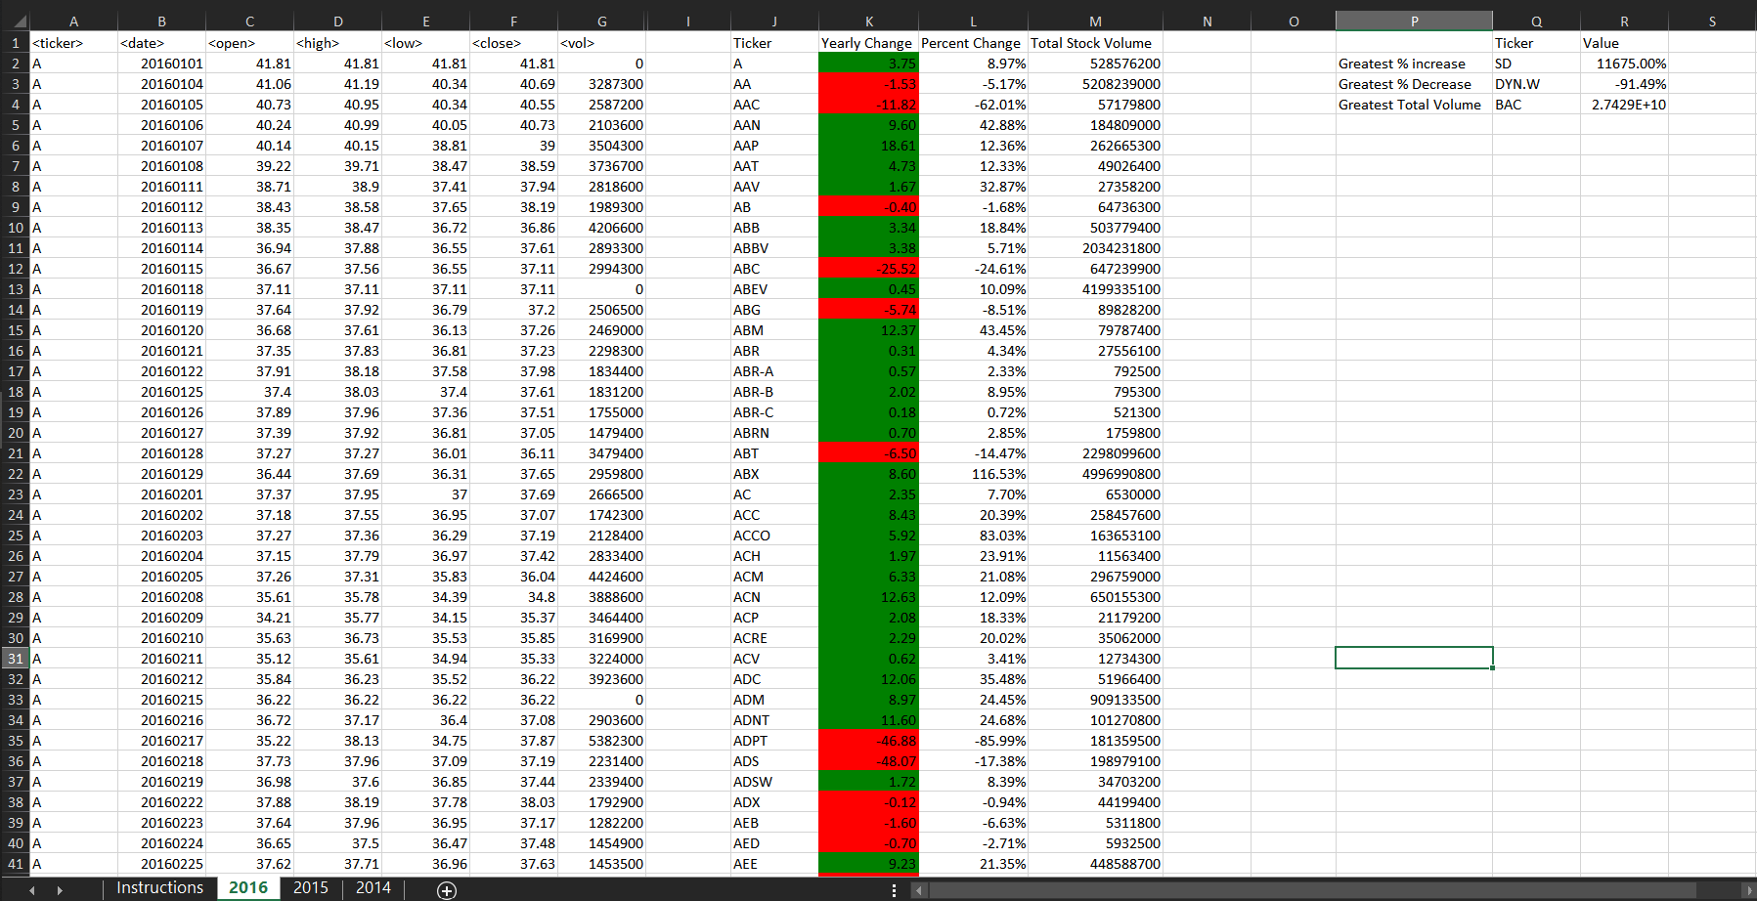  
**Fig. 1** 2016 Stock Analysis

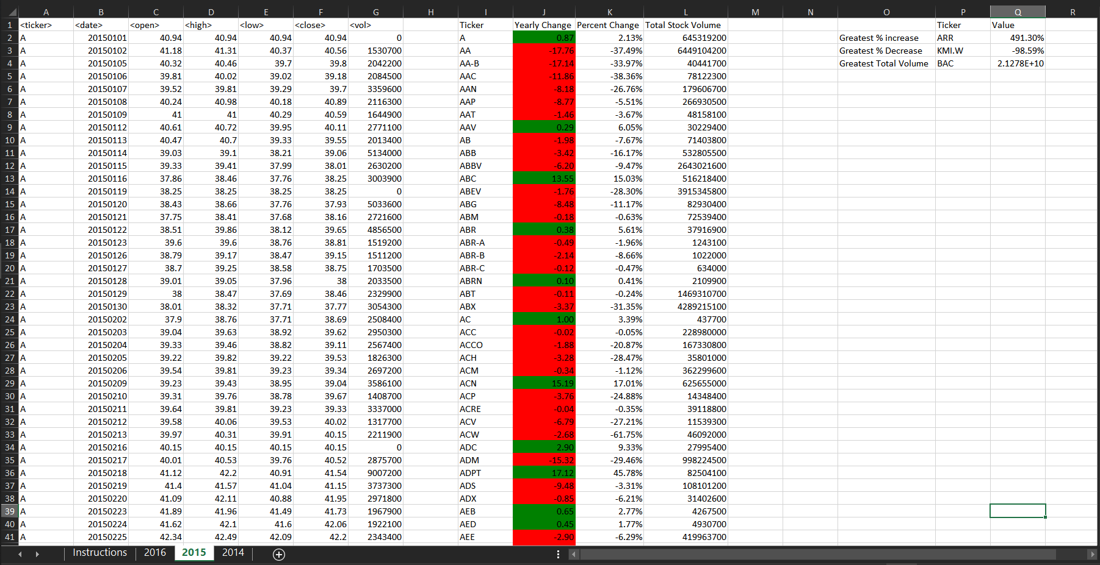  
**Fig. 2** 2015 Stock Analysis

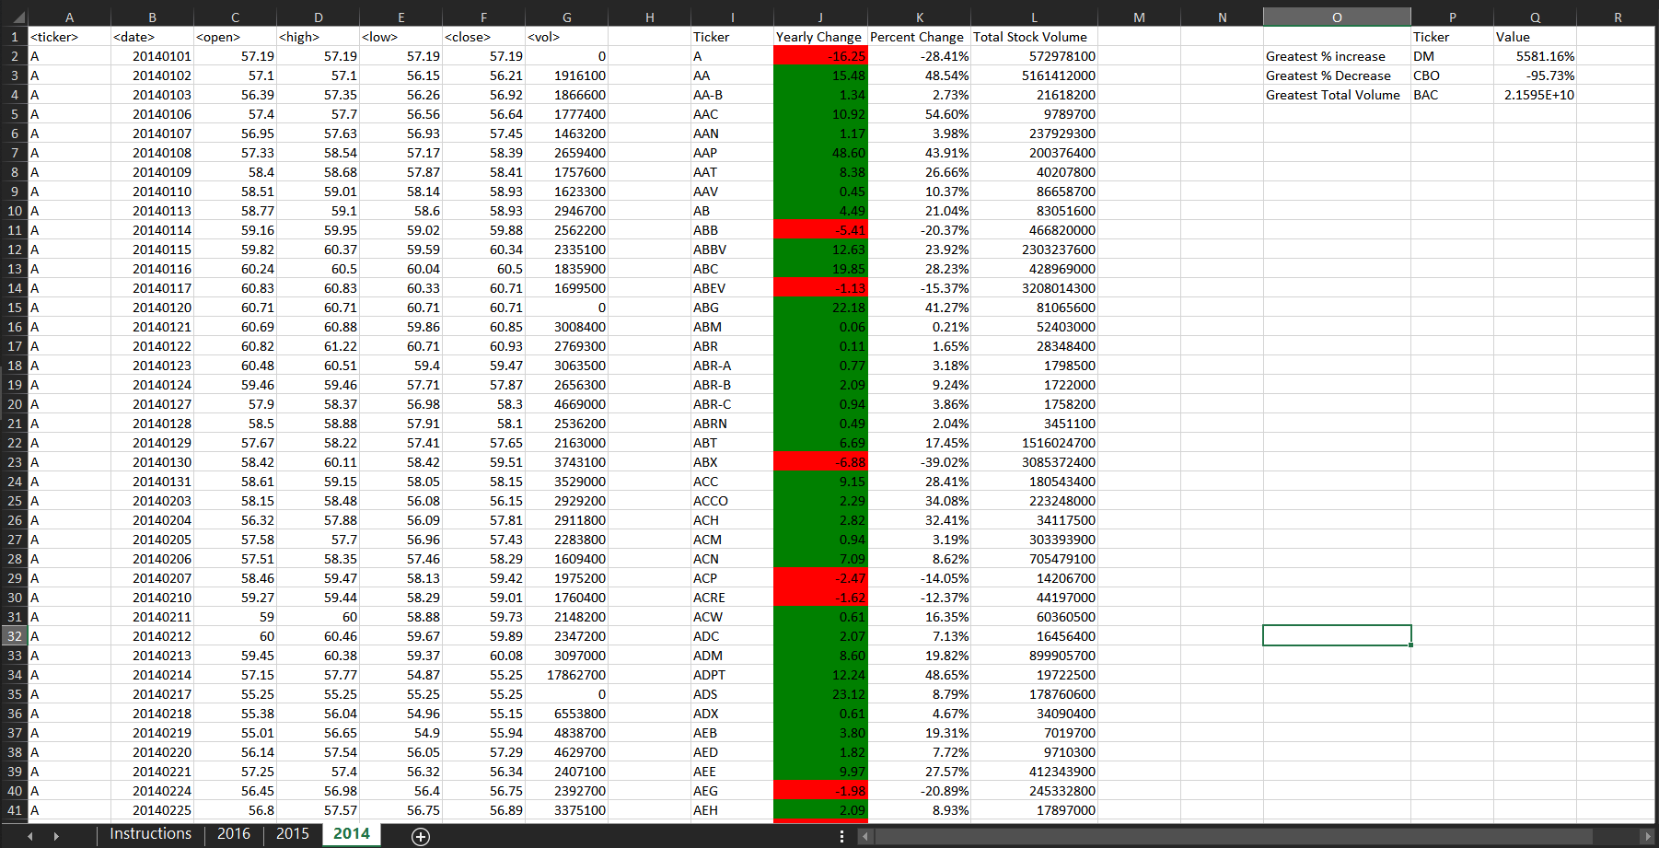  
**Fig. 3** 2014 Stock Analysis